**🛑You do not need permission to download this file🛑  
Google Doc: To make a copy of this document: Go to File and select- “Make a copy”.   
Word Doc: To download a copy of this document- Go to File and select “Download as” choose .doc or .rtf. Save it on your computer and you can then complete your work. You may need to click “enable editing”.  
  
3.01 Interpreting History Template**  
[Click here for an Assignment Explanation Video](https://drive.google.com/file/d/1-HnNjsmxXJYusc6oNnJMAa1BAc-2e491/view?usp=sharing)   
  
Different Perspectives  
Consider the two different perspectives on the soda tax issue—those in favor of the tax and those opposed to it—to respond to the prompts. You may conduct outside research. You must write your answers in at least two to three complete sentences. Please answer the questions in your own words.

| **Supporters of the Soda Tax** | **Opposition to the Soda Tax** |
| --- | --- |
| **Who might support the soda tax?** | **Who might be opposed to the soda tax?** |
|  |  |
| **What might be their reasons for supporting the soda tax?** | **What might be their reasons for opposing the soda tax?** |
|  |  |

**Reflection Question**

Would you support or oppose a soda tax? Explain why.

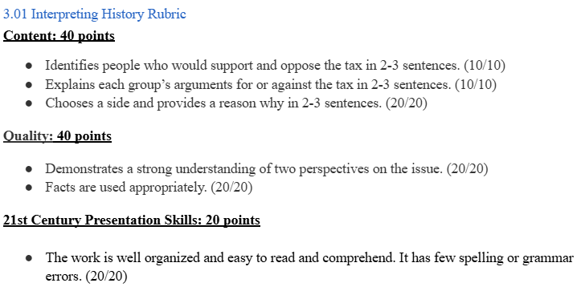

Unless Otherwise Noted All Content © 2022 Florida Virtual School. FlexPoint Education Cloud™ is a trademark of Florida Virtual School.