**🛑You do not need permission to download this file🛑  
Google Doc: To make a copy of this document: Go to File and select- “Make a copy”.   
Word Doc: To download a copy of this document- Go to File and select “Download as” choose .doc or .rtf. Save it on your computer and you can then complete your work. You may need to click “enable editing”.**

**2.06 Contributions of Supporters Template**

[Click here for an Assignment Explanation Video](https://drive.google.com/file/d/1kY1DjMSzW6kTU21KYiSLRfIdUDWISgFW/view?usp=sharing)

For this assignment you will describe how each group contributed and explain how each of these contributions impacted the American Revolutionary war effort. Please be sure that all work is written in complete sentences using your own words. Each response should be two-to-three sentences in length. Then, respond to the reflection question below the chart.

| **Supporters** | **Name a contribution this group made to the American Revolutionary war effort.**  (one sentence) | **How did this group’s contributions impact the outcome of the American Revolutionary war?**  (two-to-three sentences) |
| --- | --- | --- |
| African Americans |  |  |
| Native Americans |  |  |
| Women |  |  |

**Reflection**

Refer to George Washington’s report to the Continental Congress on page four of the lesson. Summarize General Washington’s message in your own words in at least three sentences.

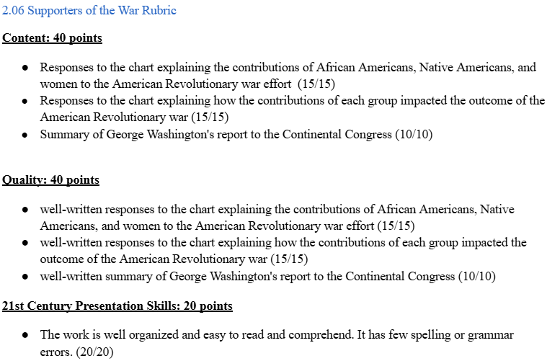

Unless Otherwise Noted All Content © 2022 Florida Virtual School. FlexPoint Education Cloud™ is a trademark of Florida Virtual School.