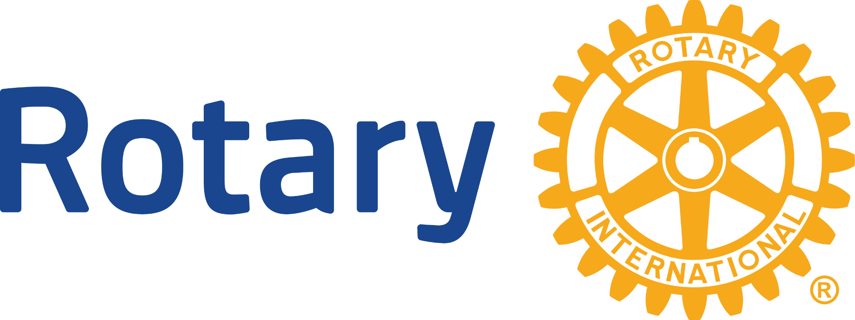What is Probus?

An introduction for Rotarians, adapted from Probus & Rotary District 9620

# 

# Why your Rotary club may start or support a Probus club

**Initiated by Rotary**, Probus is a not-for-profit organization with clubs in Canada, Australia, New Zealand and 20 other countries. It provides retirees and semi-retirees the opportunity to connect socially, explore new interests, and maintain an active role in their communities.

**The core goal** of Probus clubs is to provide meaningful support to encourage active and enjoyable social participation. The problems associated with social isolation can be reduced. Older people living in safe communities, having satisfying relationships, and experiencing meaningful roles in society are likely to be the most socially engaged and to remain contributing members.

**Significant benefits** can flow to communities by Rotary clubs supporting or assisting in the formation of new Probus clubs to enjoy the fellowship of new friends and participation in society. It is an opportunity for retired Rotarians and their partners in addition to their membership of their Rotary club, to enjoy a local Probus club’s program of speakers and events.

**Rotary Clubs who sponsor** or have sponsored Probus clubs in the past, stay connected with creating or maintaining a relationship and awareness of Rotary and may provide opportunities for volunteers for Rotary projects and attracting Rotarians from families of Probus members. Take the challenge – explore sponsorship or support the formation of a new club because:

* Membership in a Probus club is not a threat to membership in a Rotary club.
* People join Rotary to take part in Service.
* People join Probus to have fun and fellowship -- it's for active retirees and semi-retired.
* People can join both Probus and Rotary -- and many do.
* Probus is a major community service of Rotary clubs and Rotary has sponsored Probus.
* Probus is recognized by Rotary International as a worthy community service.

# How a Rotary club can start a Probus club [www.probuscanada.ca]

1. Advance the opportunity to create a club in your community.
2. Contact the District Probus Director.
3. The Probus Director will assist in setting up initial meetings and begin a simple approval process of forming a new club.
4. Rotary may act as a sponsor and assist by helping spread the news by word of mouth and contacts of club members.
5. There is no cost to a Rotary club unless a small gift as a start-up contribution.
6. Stimulate interest and hold an initial potential member meeting.
7. Assist members create the initial Executive and introduce standard constitution and bylaws, and budget in preparation for a Formation Meeting.
8. At the Foundation meeting, the President of the Rotary club provides transition greetings and support for the new club.

That’s all there is to it – what a great way to enrich the quality of life of the senior members of your community! “**Get Connected, Stay Connected**”