NOTICE OF LEAD SERVICE LINE MATERIAL
Water System Name:
Public Water System ID:
Site Address:
Este informe contiene información muy importante sobre su agua potable. Tradúzcalo o hable con alguien que lo entienda bien.
New state and federal laws require us to inventory all water service lines in our service area. A service line is the underground pipe that carries water from the water main, likely in the street, into your home or building. We are required to notify consumers annually if their service line is made of lead.
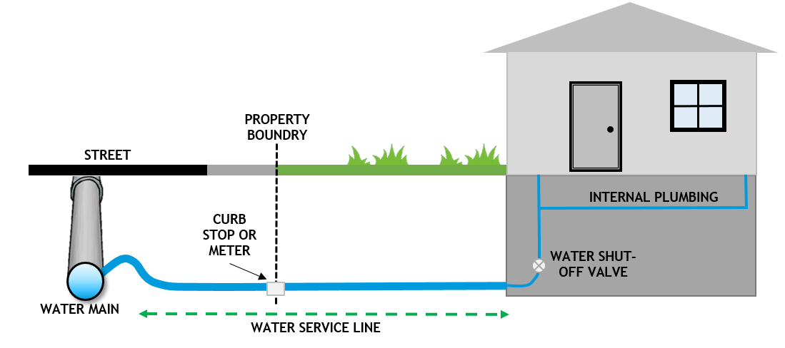
Figure 1. Typical water service line configuration of a water service line connecting the water main in the street to the interior plumbing of a home.
Our records indicate that your water service line is made of lead. [Describe service line ownership and material of both portions of the service line, if applicable]. If you believe your service line material is incorrectly categorized, please contact us to assist with material verification.

What does this mean? What is being done?
- Lead exposure can result in adverse health effects to humans. Replacement of lead service lines can help reduce lead exposure in drinking water.
- Water systems are required to replace all system-owned lead service lines. Property owners are encouraged to replace their portion of the service line if it is made of lead. We are required to replace our portion of lead service line when the property owner notifies us they are replacing their portion of lead service line. If you are planning to replace your lead service line, contact us at [Phone] prior to replacement so that we can coordinate our efforts.
- [Discuss opportunities for lead service line replacement and financing solutions to assist with replacement of the customer’s portion of lead service line, if applicable].

Health Effects of Lead:
- Exposure to lead in drinking water can cause serious health effects in all age groups. Infants and children can have decreases in IQ and attention span. Lead exposure can lead to new learning and behavior problems or exacerbate existing learning and behavior problems. The children of women who are exposed to lead before or during pregnancy can have increased risk of these adverse health effects. Adults can have increased risks of heart disease, high blood pressure, kidney or nervous system problems.

What can I do to reduce exposure to lead in drinking water?
In addition to replacing your lead service line, see below for a list of steps you can take to minimize lead in your water:
- Run your water to flush out lead. If it hasn’t been used for several hours, run the cold water tap until the temperature is noticeably colder. This flushes lead-containing water from the pipes. To conserve water, remember to catch the flushed tap water for plants or some other household use (e.g. cleaning).
- Always use cold water for drinking, cooking, and preparing baby formula. Never cook with or drink water from the hot water tap. Never use water from the hot water tap to make formula.
- Do not boil water to remove lead. Boiling water will not reduce lead.
- You may consider investing in a home water treatment device or alternative water source. When purchasing a water treatment device, make sure it is certified under Standard 53 by NSF International to remove lead. Contact NSF at 1-800-NSF-8010 or visit the NSF website. You may also visit the Water Quality Association's website.
- Get your child's blood tested. Contact your local health department or healthcare provider to find out how you can get your child tested for lead if you are concerned about exposure.
- For more information on reducing lead exposure around your home/building and the health effects of lead, visit EPA's website or contact your health care provider.

For more information about this notice, contact us at:
- Phone:
- Email:

