3.3 - Adjectives Used with Food

This is not really so much a grammar lesson as just some more detailed notes on some of the adjectives presented in this chapter. You are responsible for knowing this information, so please read through the descriptions below to learn more about how these are used:

Czech Word | Meaning | Examples and Explanation
hovězí | made out of beef | This adjective is frequently used either to refer directly to the type of meat and is often combined with the word maso ‘meat’.  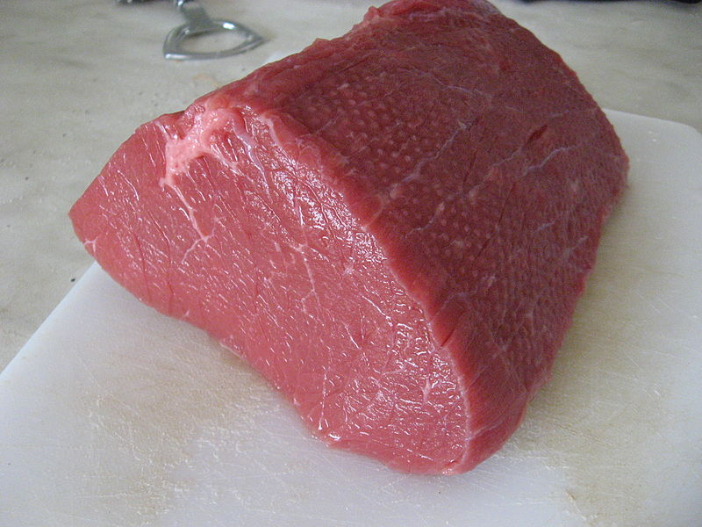  hovězí maso  Or it can describe the type of meat used in certain dishes, such as guláš:  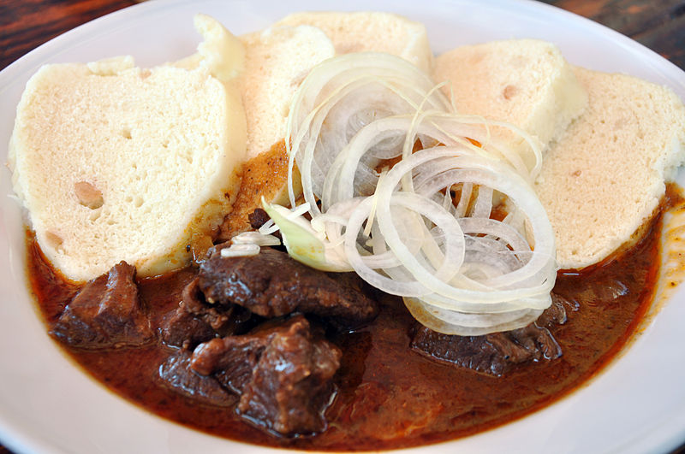  hovězí guláš
kuřecí | made out of chicken | Like above, this adjective is frequently used either to refer directly to the type of meat and is often combined with the word maso ‘meat’.  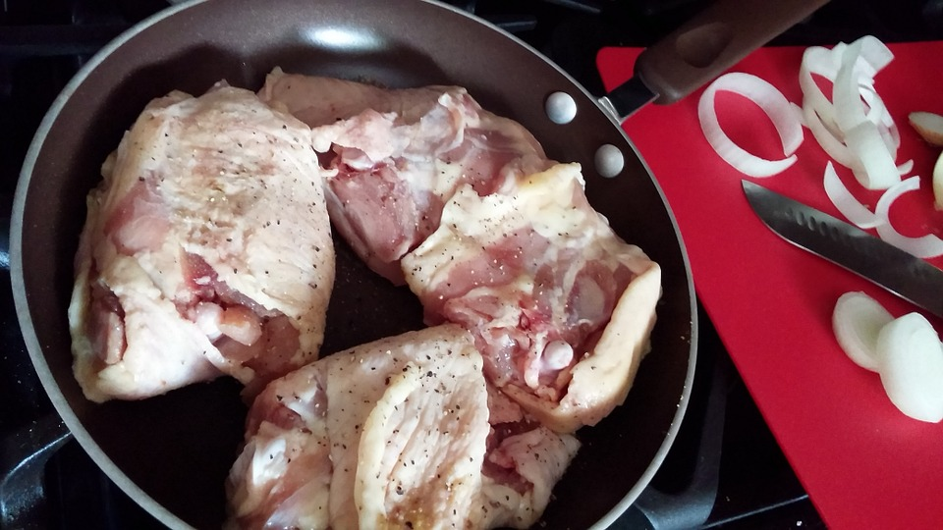  kuřecí maso  Or it can describe the type of meat used in certain dishes, such as řízek - schnitzel:  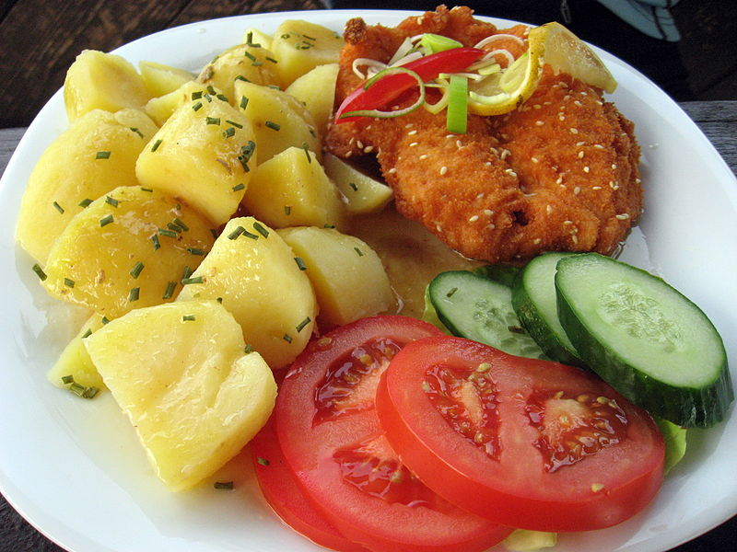  kuřecí řízek
vepřový | made out of pork | Like above, this adjective is frequently used either to refer directly to the type of meat and is often combined with the word maso ‘meat’.  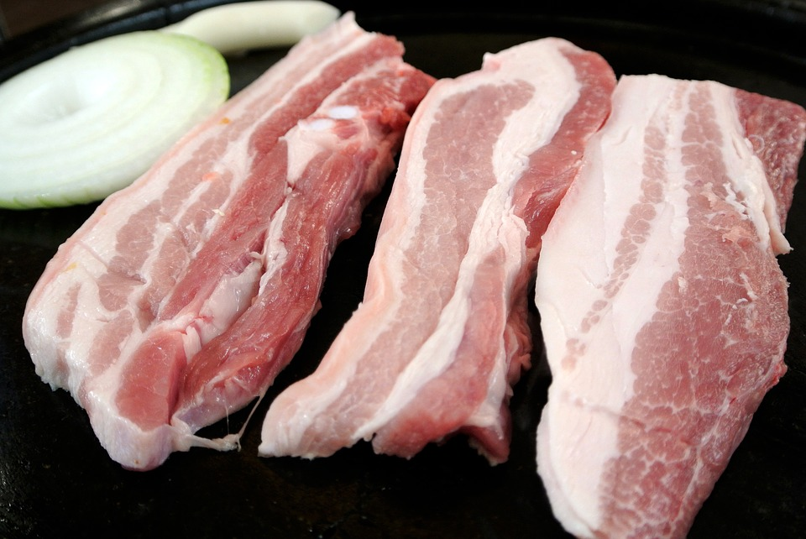  vepřové maso  Or it can describe the type of meat used in certain dishes, such as řízek - schnitzel:  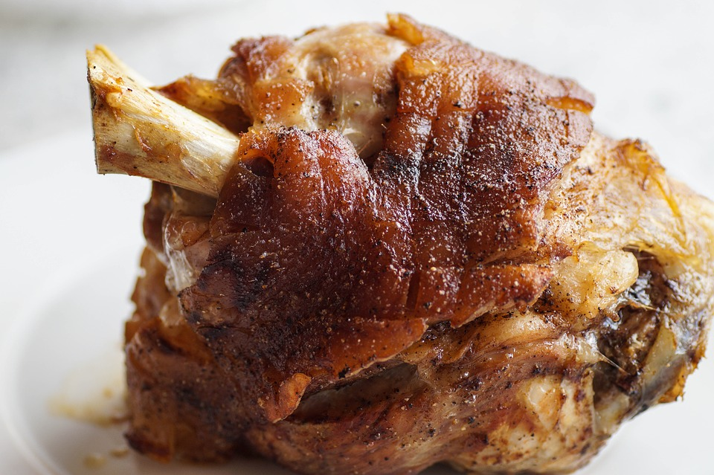  vepřové koleno  (pork knee – really a pork shank)
nakládaný | pickled, marinated | 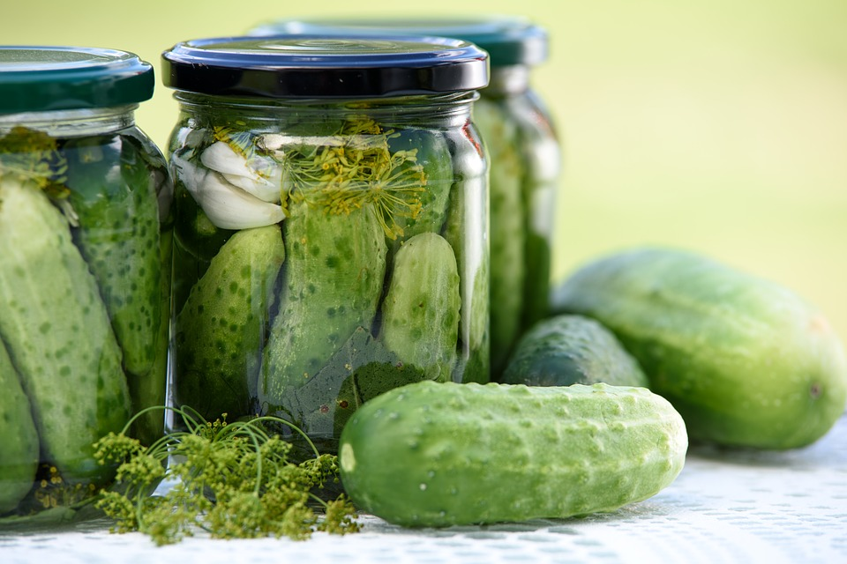  nakládané okurky (cucumbers cooked briefly in hot vinegar and spices, i.e. pickles)  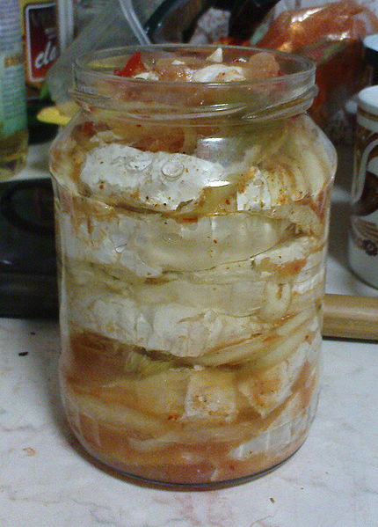  nakládaný hermelín  (cheese marinated in oil with onions and other spices)
ovocný | fruit | 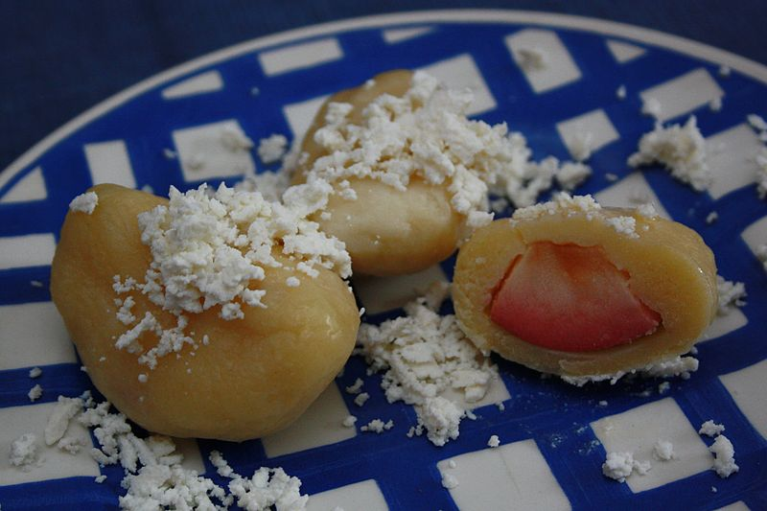  ovocné knedlíky (dumplings stuffed with various types of fruit)
čerstvý | fresh | 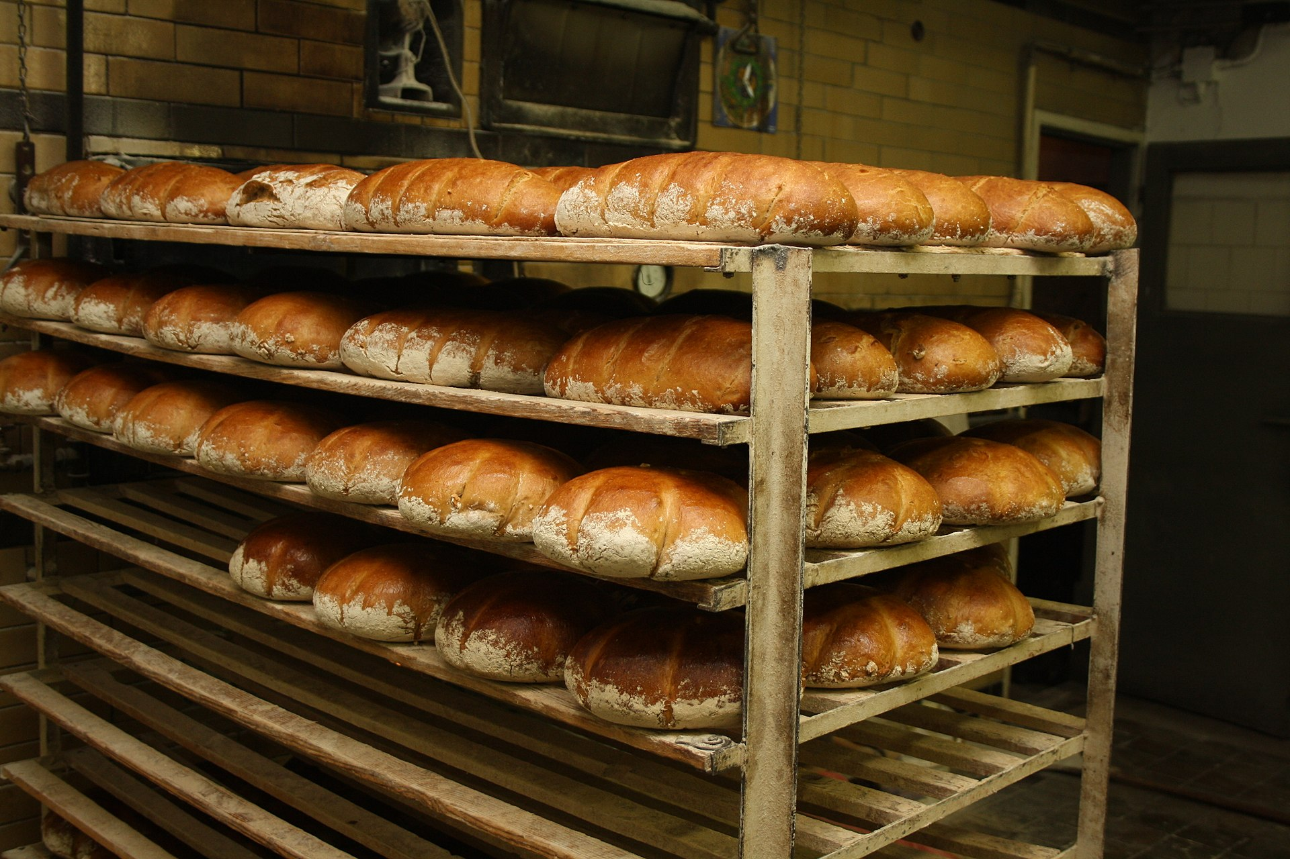  čerstvý chléb (chleba)
mražený | frozen | 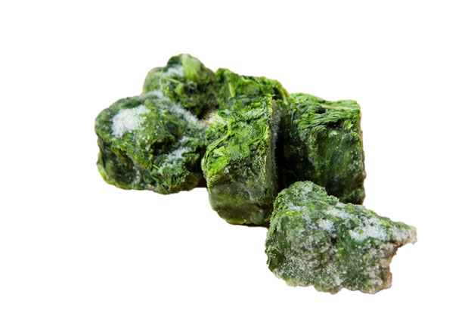  mražený špenát (a convenient food in many places)
pečený | baked | 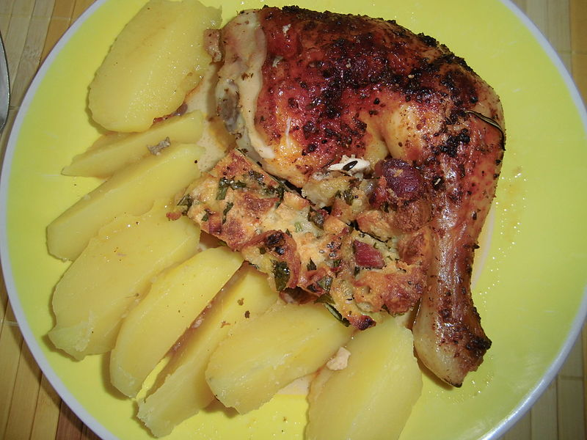  pečené kuře
smažený | fried | 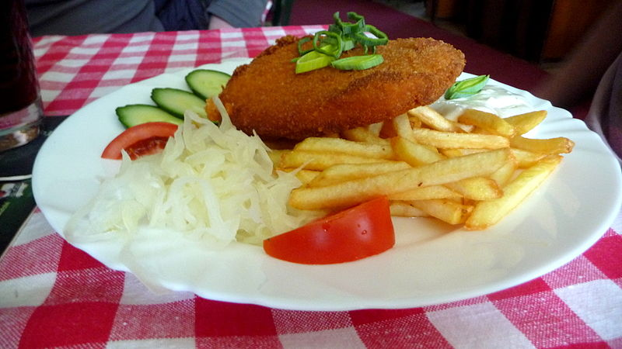  smažený sýr (the answer to everything]
dušený | braised/stewed | 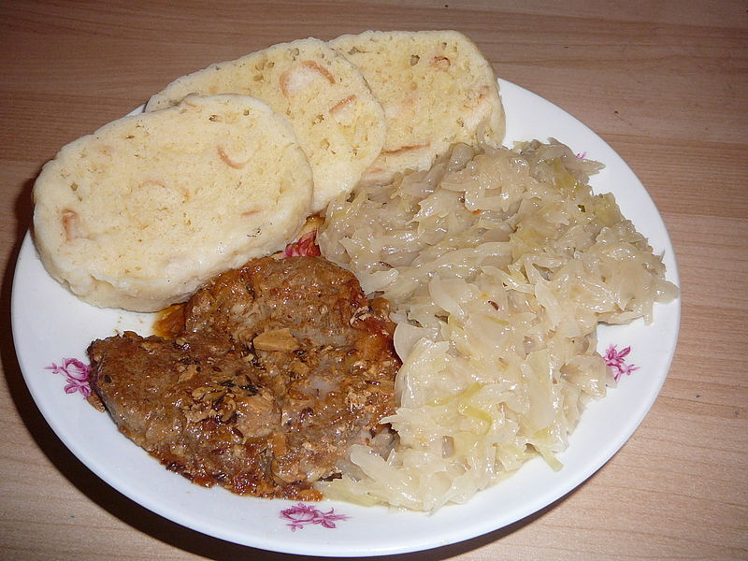  dušené zelí (stewed cabbage is a frequent side for Czech dishes) here served with vepřové maso a houskové knedlíky  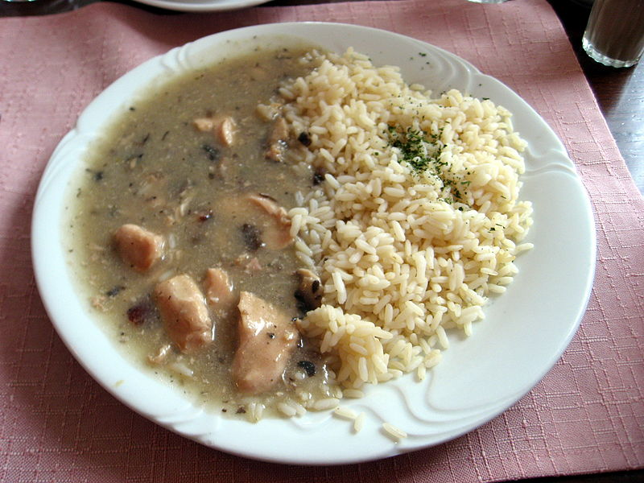  dušená rýže (since it’s cooked in a pot with water, the rice is considered stewed; note in English we say steamed rice)
vařený | boiled | 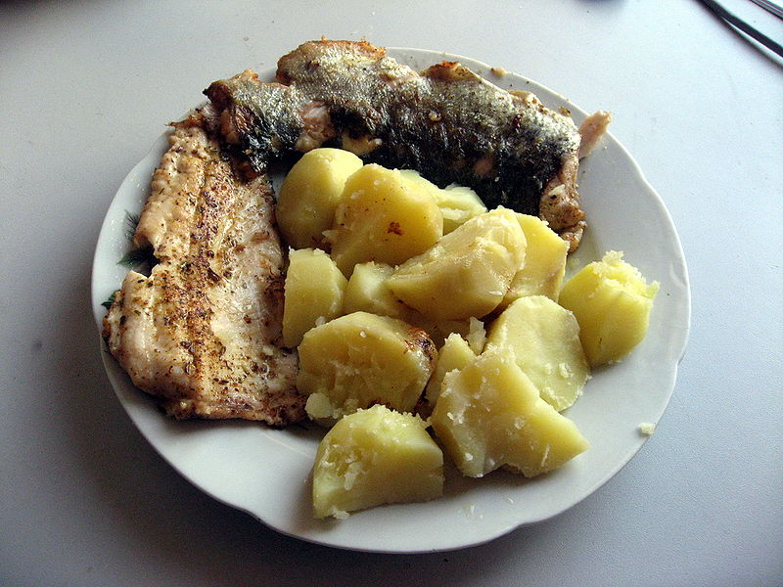  Pstruh a vařené brambory (these are frequent side on Czech plates)
grilovaný | grilled | 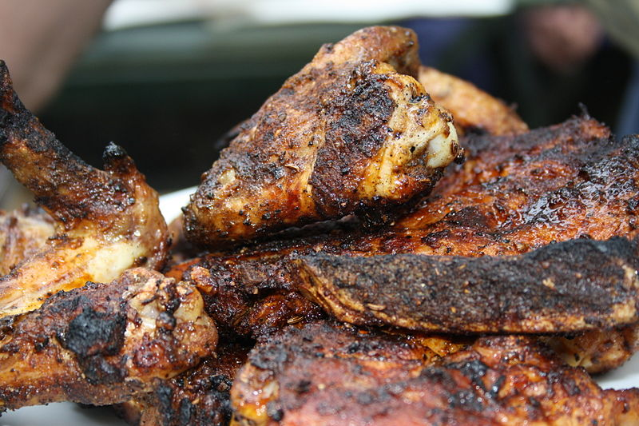  grilované kuře
horký | hot | 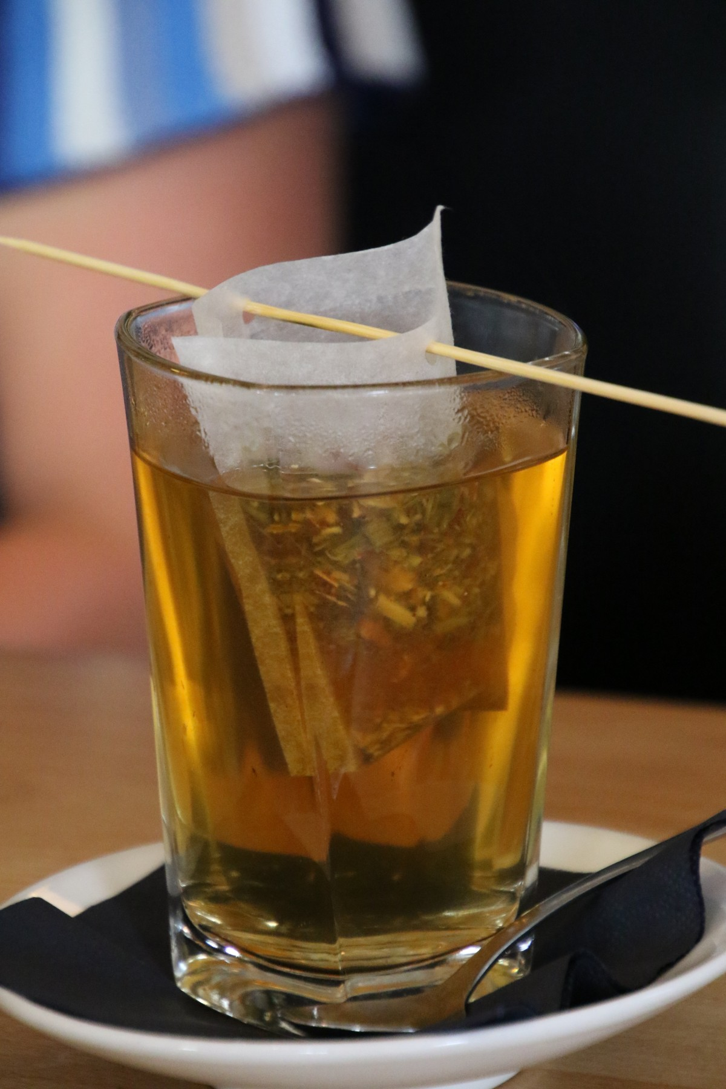  horký čaj
studený | cold | 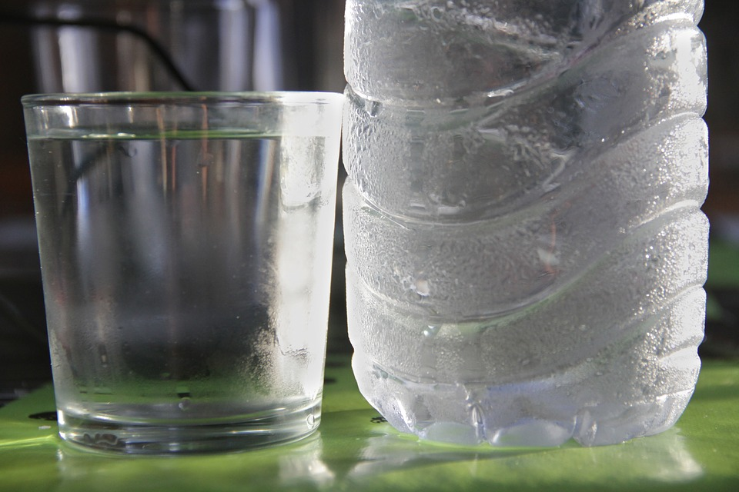  studená voda
teplý | warm | 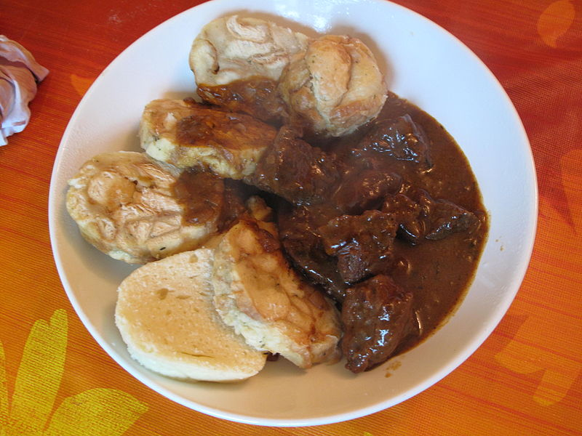  teplé jídlo (we talk about getting a hot meal, they talk about getting warm food)
světlý | pale (color) e.g. světlé pivo | 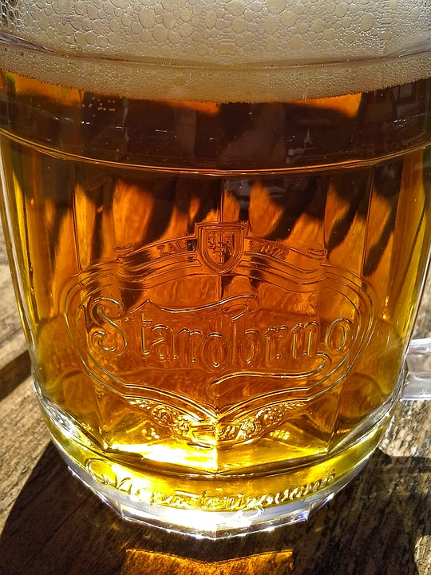  světlé pivo (the most traditional Czech beers are pale lagers – světlé ležáky)
tmavý | dark (color) e.g. tmavé pivo | 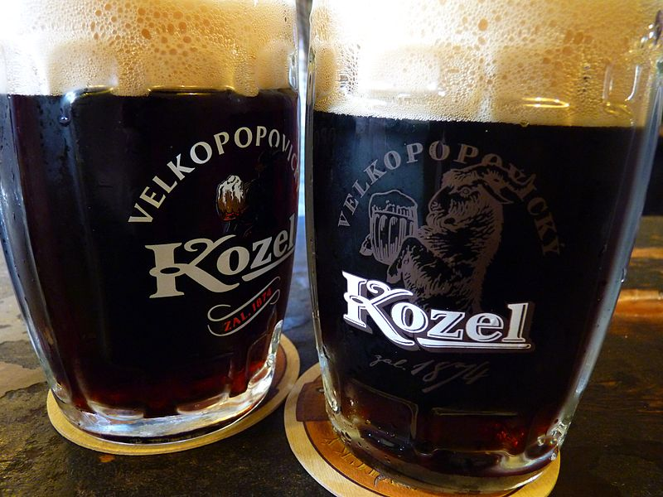  tmavé pivo (also černé pivo - these are also common and slightly sweeter than dark beers elsewhere.)
lehký | light | 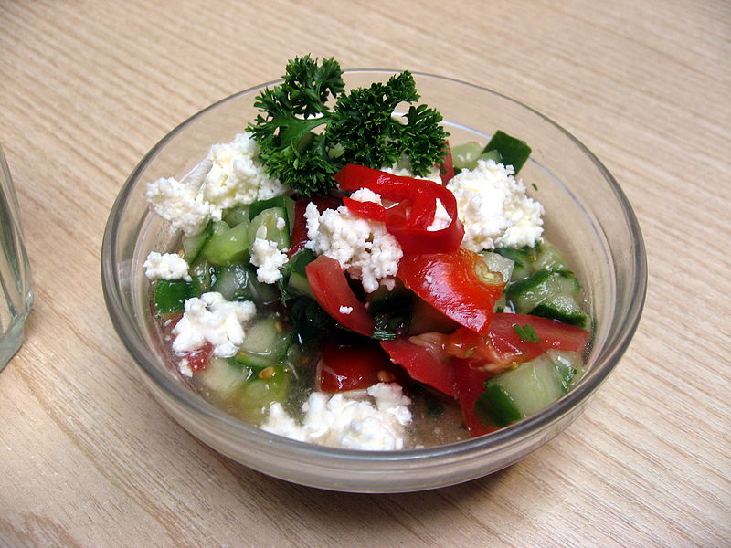  lehké jídlo (šopský salát - salads find a place on most menus, though Czech food is hardly light fare)
těžký | heavy (also means difficult) | 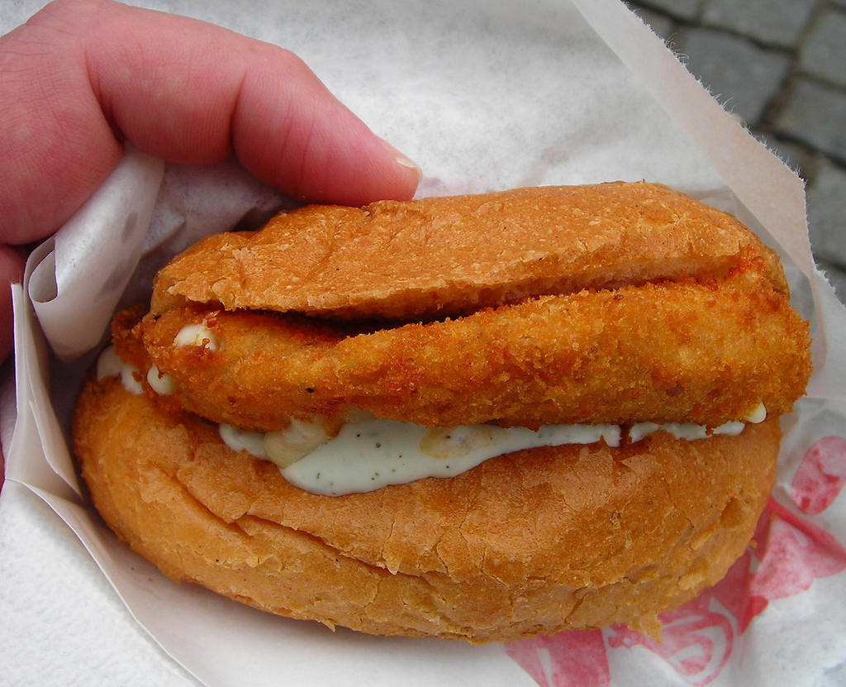  těžké jídlo (smažený sýr – Czech is known for heavy dishes. This is a popular street food – fried cheese and tartar sauce in a bun)
hořký | bitter | 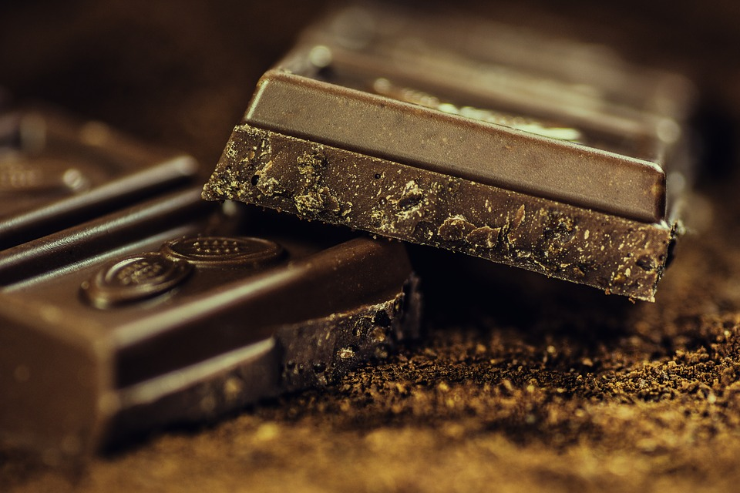  hořké jídlo - hořká čokoláda; káva is also a good example of a bitter thing we frequently consume
kyselý | sour | 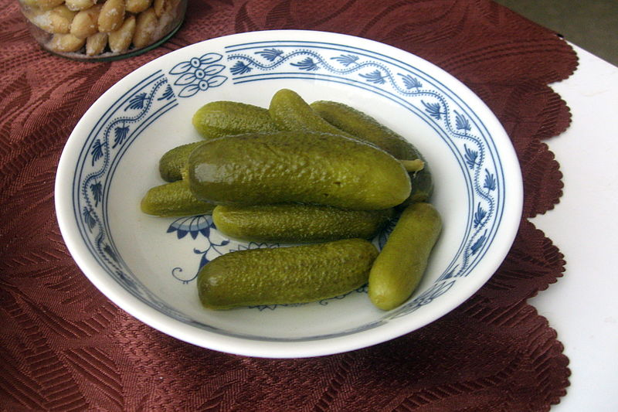  nakládané okurky jsou kyselé  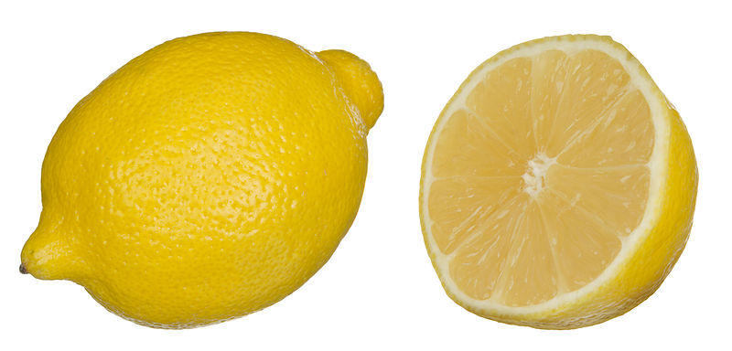  citrón je taky kyselý
sladký | sweet | 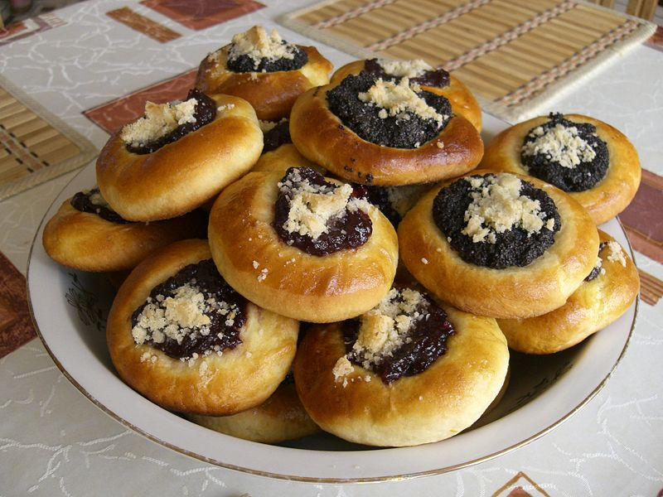  koláče jsou sladké
slaný | salty | 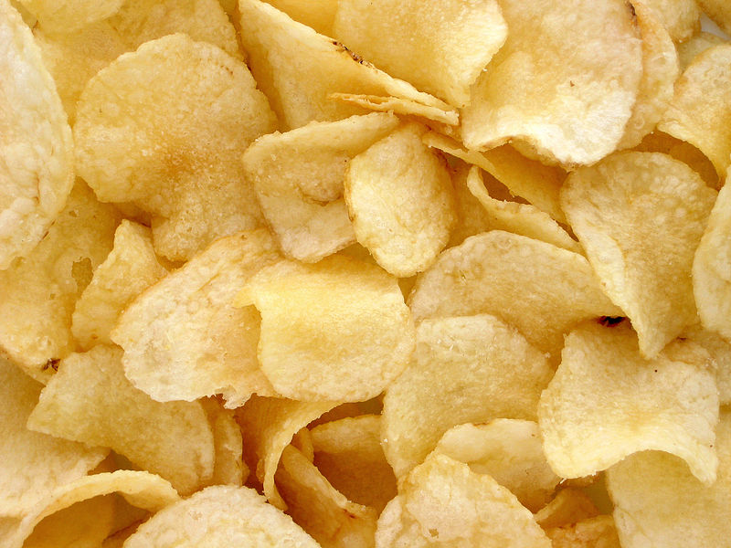  brambůrky jsou slané
ostrý/pálivý/pikantní | spicy (also means sharp) | 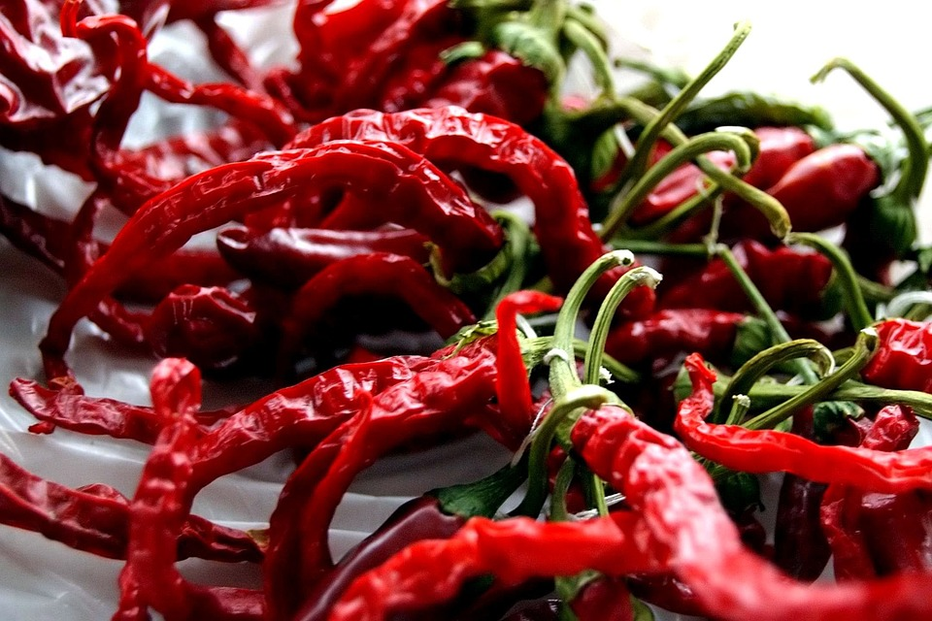  chilli papriky jsou ostré / pálivé / pikantní (Czech food is rather mild and most foods are not spicy)
drahý | expensive | 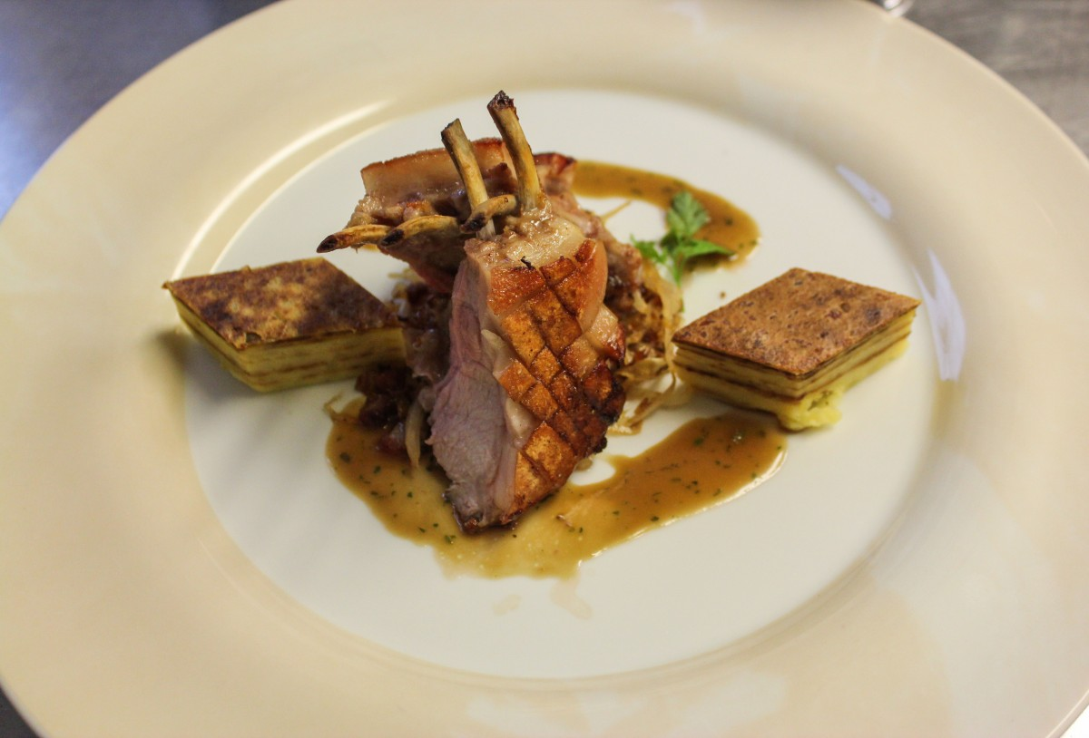  to je drahé jídlo a drahá restaurace
levný | cheap | 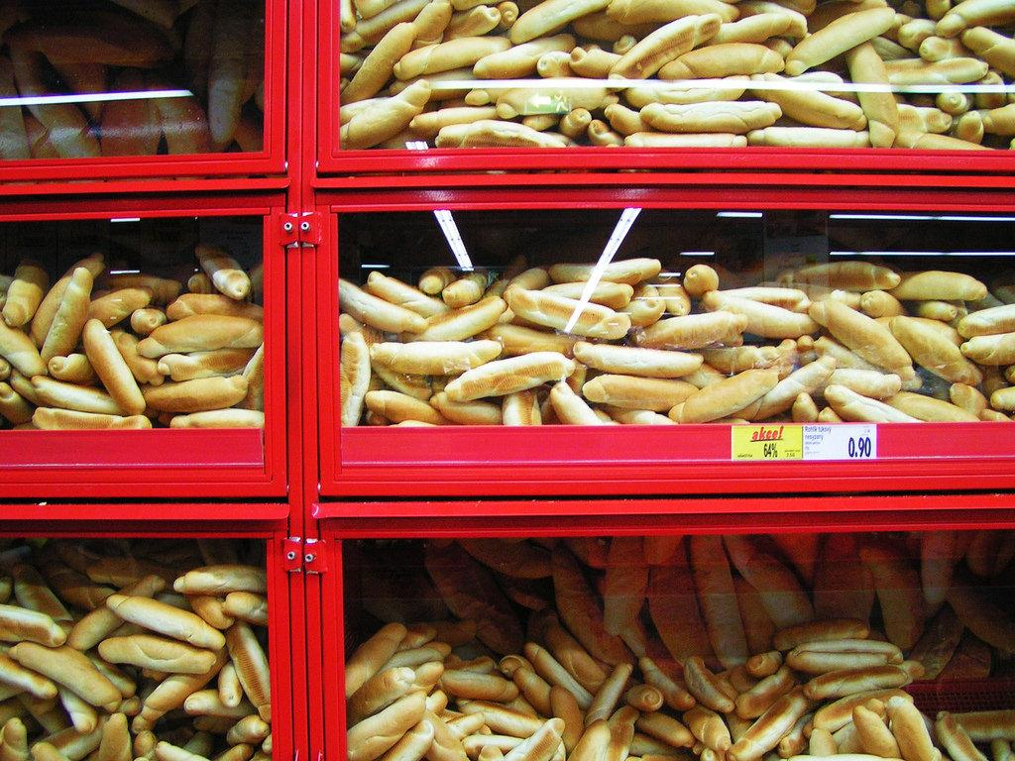  rohlíky jsou velmi levné jídlo

Images used in this document come from these sources.

