1.5 - Color Adjectives

[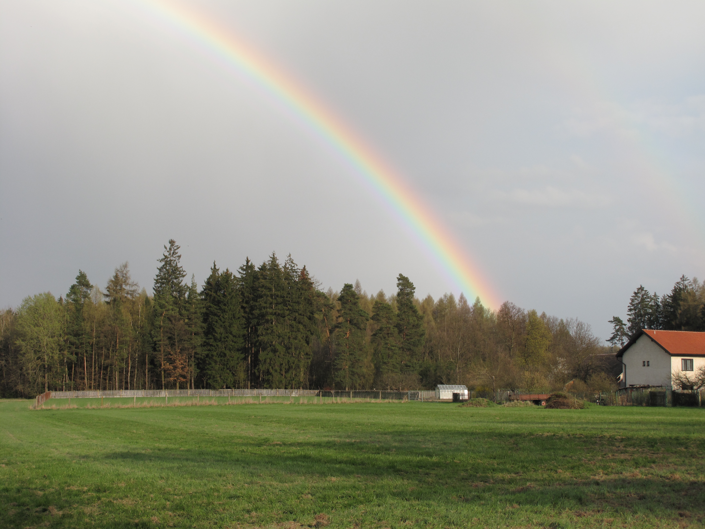](https://commons.wikimedia.org/wiki/File:Struha%C5%99ov_(okres_Praha-v%C3%BDchod),_duha.jpg)

The following adjectives in Czech are used to describe colors:

|  |  |  |  |  |  |
| --- | --- | --- | --- | --- | --- |
| *červená* | *modrá* | *zelená* | *žlutá* | *bílá* | *béžová* |

|  |  |  |  |  |  |
| --- | --- | --- | --- | --- | --- |
| *černá* | *oranžová* | *fialová* | *šedá* | *hnědá* | *růžová* |

**Note** - when colors are listed in Czech, they are listed with the feminine ending -á. Why? It’s because of the word *barva* ‘color’...what gender is it?? It’s feminine, right? So all of these assume the word *barva* after them (i.e. *zelená barva*, *červená barva*, etc.).

As with adjectives we have already learned, you will need to pay attention to the gender of the noun and put on the correct adjective ending:

| **masculine** | **feminine** | **neuter** |
| --- | --- | --- |
| *-ý* | *-á* | *-é* |

| *To je červené auto.* | *To je modrá kniha.* | *To je hnědý pes.* | *To je žlutý klíč.* |
| --- | --- | --- | --- |
| *To je zelený batoh.* | *To je černá kočka.* | *To je oranžové auto.* | *To je bílý mobil.* |

Images used in this document come from [these sources](https://docs.google.com/document/d/1zSVvQ1Po3k4-Sw8GvM3yMtkm03U0BWQ_nCFanxEs1Es/edit#heading=h.m9lkp6h3r0lk).