4.10 - moc velký, moc malý, akorát...

  Tyhle džíny mi jsou moc velké. | 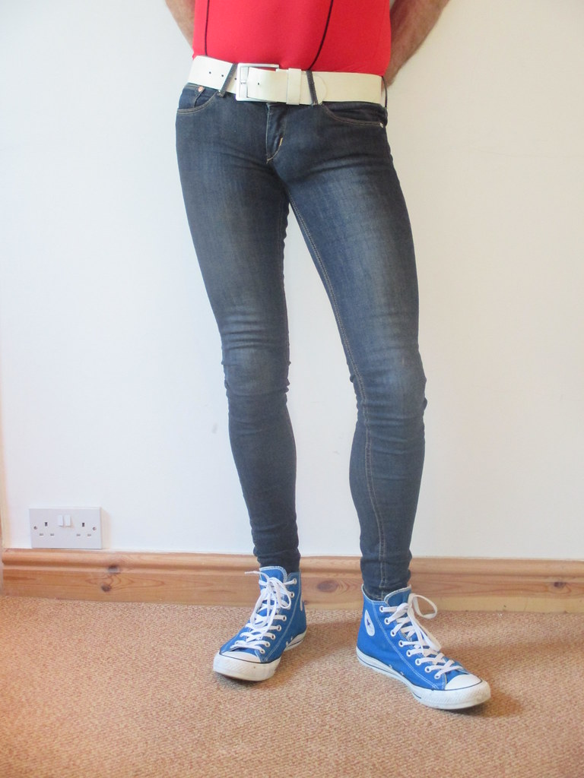  Tyhle džíny mi jsou moc malé. Jsou moc těsné. |   Tyhle džíny mi jsou akorát. Sedí mi a cítím se v nich dobře.  cítit se - to feel

In this unit we’ll learn how to say that something fits well (or poorly). Here is some vocabulary:

sedí mi - it/they fit me
akorát - just right

volný - loose-fitting, baggy
těsný - tight

We use the word moc - ‘very, too’ to say that things are ‘too big’ – moc velký and ‘too small’ – moc malý. You can also use moc to describe other qualities of a clothing item, such as krátký - short, or dlouhý - long.

Notice how in the examples below they use the word mi ‘to me’, which is the same form we have seen with líbit se and constructions like je mi teplo, je mi zima.

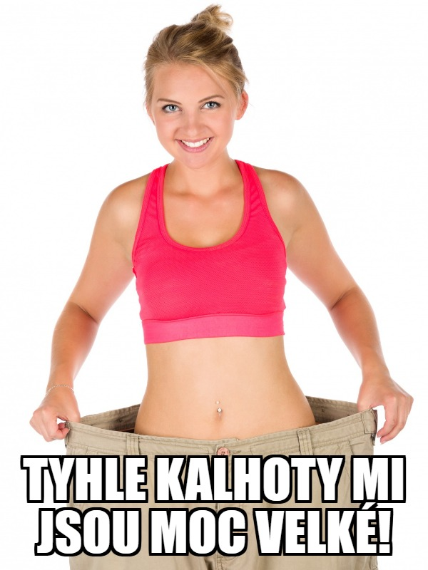 | 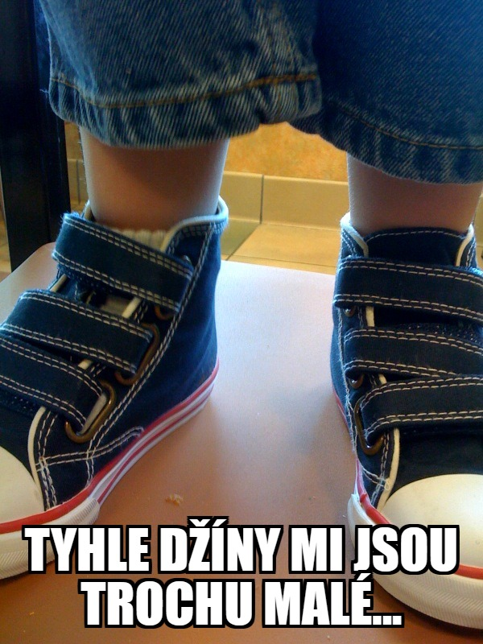

Also, along with moc you can use words like trochu, i.e. trochu volný ‘a bit baggy’, trochu krátký ‘a bit short’, etc.

Images used in this document come from these sources.

