2 | 3 | Lekcija 5: Moji interesi

| Aktivnosti
Kamo ideš?
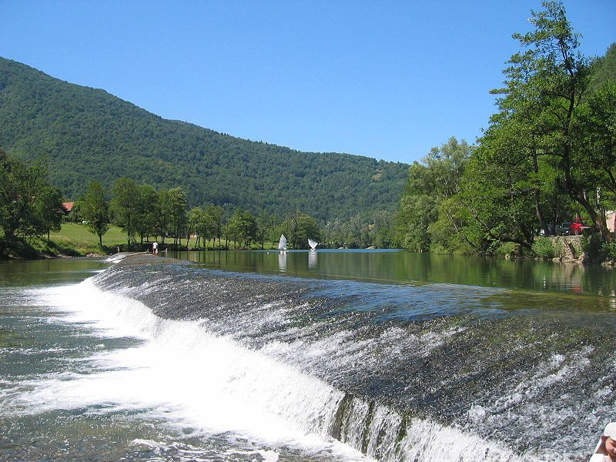 |  | 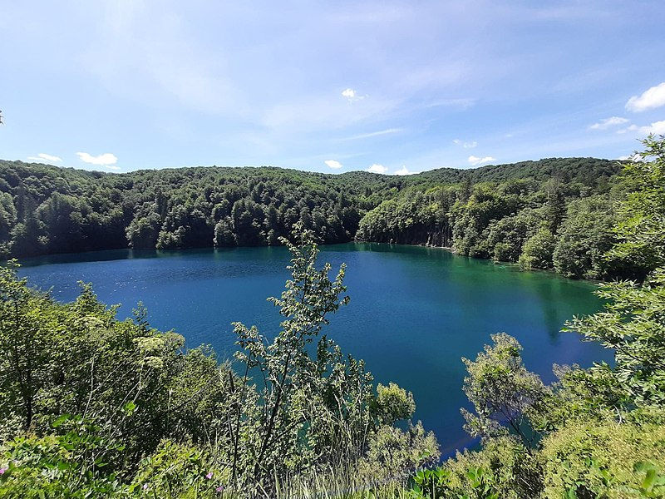
rijeka | more | jezero
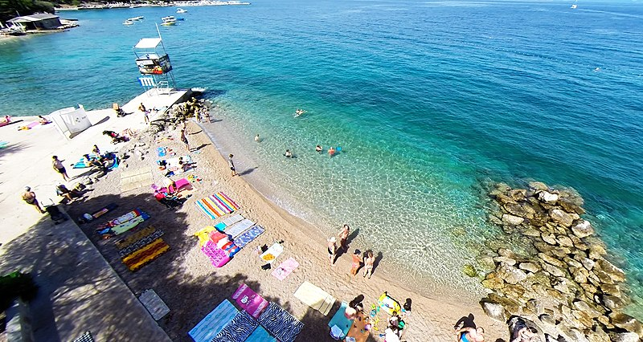 |  | 
plaža | šuma | trg

Pay attention!
Locations such as: rijeka, more, jezero can go with both prepositions - u and na. Look at the differences between the following sets of sentences.
Idem plivati u more. | Idem plivati u rijeku. | Idem plivati u jezero.
When using the verb ići + preposition u, these three sentences indicate the meaning that you will enter the water - you are indicating your action of swimming.
Idem na more. | Idem na rijeku. | Idem na jezero.
When using the verb ići + proposition na, as shown in the above sentence, you are sending a message that you are planning to take a trip, drive, bike, or walk towards the sea/river/lake.

Što radiš?
 |  | 
Organiziram zabavu. | Planiram izlet. | Plivam u moru.

Kakvo je more?
 | 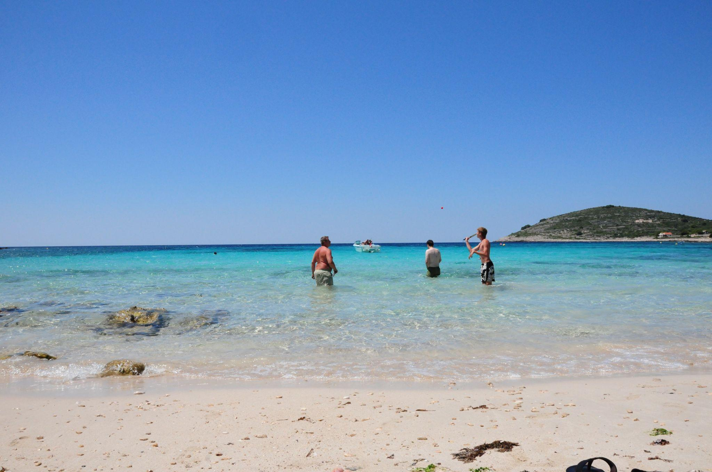
More je hladno. | More je toplo.

| Informal communication

Read the following communication one more time.
[h5p id="608"]
As you can see, to initiate an informal communication, you will most likely start with a general greeting. These might be:
Hej, hej (or simply “hej”) | Pozz | Bok / Bog
Translated to English, these would simply mean “hi” or “hey.” However, you can also see that our characters used:
→ Pozz iz Šibenika.
→ Pozdrav iz Sarajeva.
These are more than just “hey/hi.” These phrases can be translated in English as “Greetings from […].” To finish your conversation, you will most likely encounter:
Pozz
Čujemo se (kasnije). || English: Talk (later).
Vidimo se (kasnije). || English: See you (later).
As you can see, “pozz” [pozdrav] can be used to indicate: (1) hey/hi, but also (2) bye. To wish someone a good time, you can use:

Uživaj (to a single person)
Uživajte (to a group of people).
Both forms in English can be translated as “Have a great time.”

| The question ŠTO (“what”)
Difference between što and šta
In the above communication, Mario asked Laura “Šta radiš” (What are you doing?). You learned that in Croatian a question form of what is što. However, in everyday speech it is most likely that you will hear people saying šta. This is a very common way of saying it. It is perfectly normal to say šta in an informal setting. However, if you are in a more formal setting and you need to use the standardized language form, it is preferable to use što.

Images used in this document are from these sources.

