5 | 2 | Lekcija 4: Advent u Zagrebu

| The Verb KLIZATI (SE)
The verb we are focusing on in this lesson is the verb klizati (se) - as part of winter activities that we are talking about in the lesson.
SINGULAR |  |  | PLURAL
(audio) | ja | kli-ž-em | (audio) | mi | kli-ž-emo
(audio) | ti | kli-ž-eš | (audio) | vi | kli-ž-ete
(audio) | on/-a/-o | kli-ž-e | (audio) | oni/-e/-a | kli-ž-u
The verb klizati (se) belongs to a group of verbs that have -d-, -t-, -k-, -g-, -s-, -z-, -c-, -h- in front of the – ati ending. After removing the final -ati part, these verbs merge the final sounds with -j producing a completely new sound and then we add the – em endings to form the present tense.
to dry, to wipe | brisati | bris + j - em | brišem
to write | pisati | pis + j - em | pišem
to shout | vikati | vik + j - em | vičem
to cry | plakati | plak + j - em | plačem
to crawl | puzati | puz + j - em | pužem
to wave | mahati | mah + j - em | mašem

| The Verbal Noun
We already talked about verbal nouns in Croatian. Usually, a verbal noun derives from a transitive verb (a verb that is followed by the Accusative case). There are several endings that we can use to create a verbal noun. However, for now we will look only at the most common ending for creating a verbal noun: the ending –nje for talking about sports.

Look at the following sentence from this Lesson: Ivica Kostelić voli skijanje. In this sentence we see the verbal noun skijanje which originates from the verb skijati (to ski). Usually, verbal nouns indicate a certain action is involved (skiing, swimming, playing, running, etc.). In this lesson we encountered some winter activities that will very often be expressed in the form of a verbal noun.
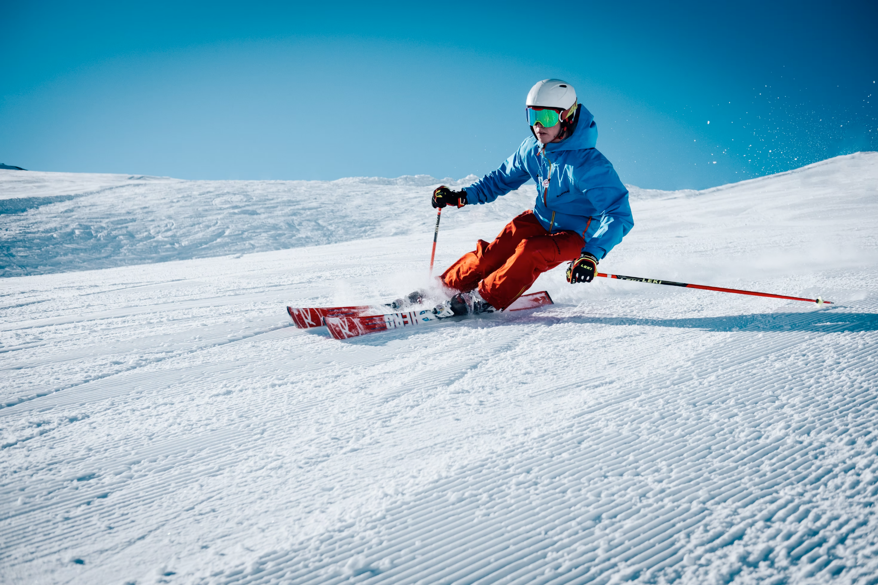 | 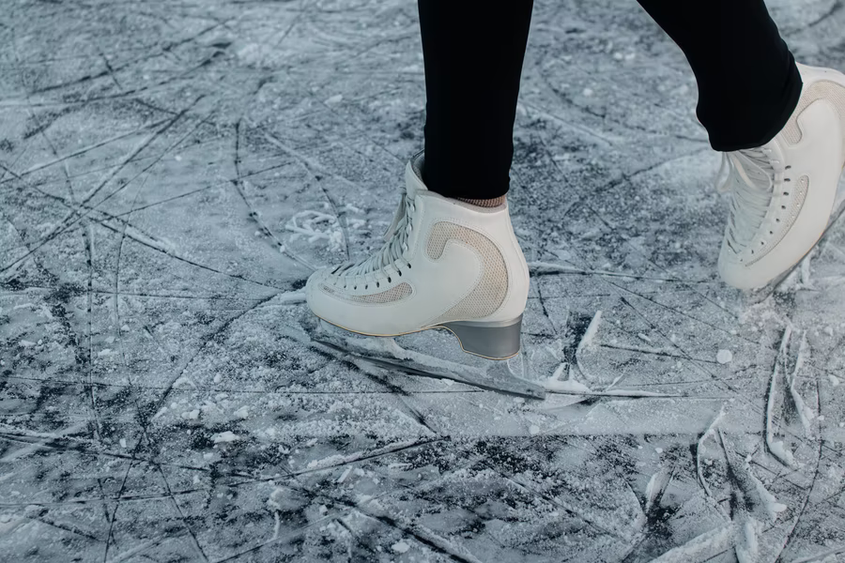
skijati – skijanje | klizati – klizanje
 | 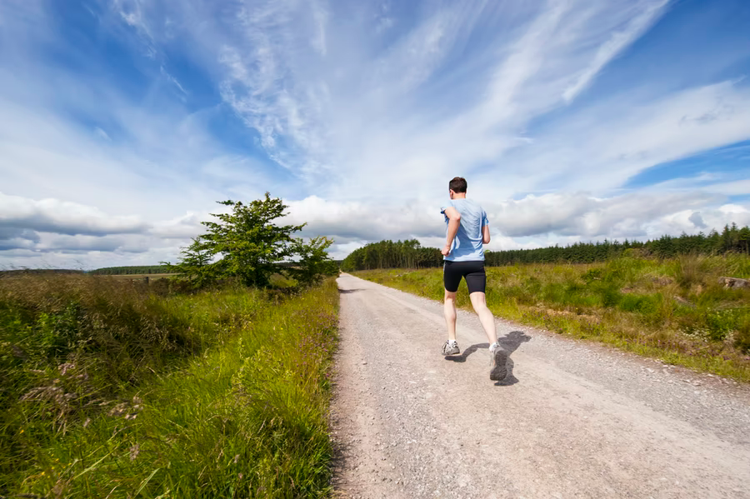
trenirati – treniranje | trčati – trčanje
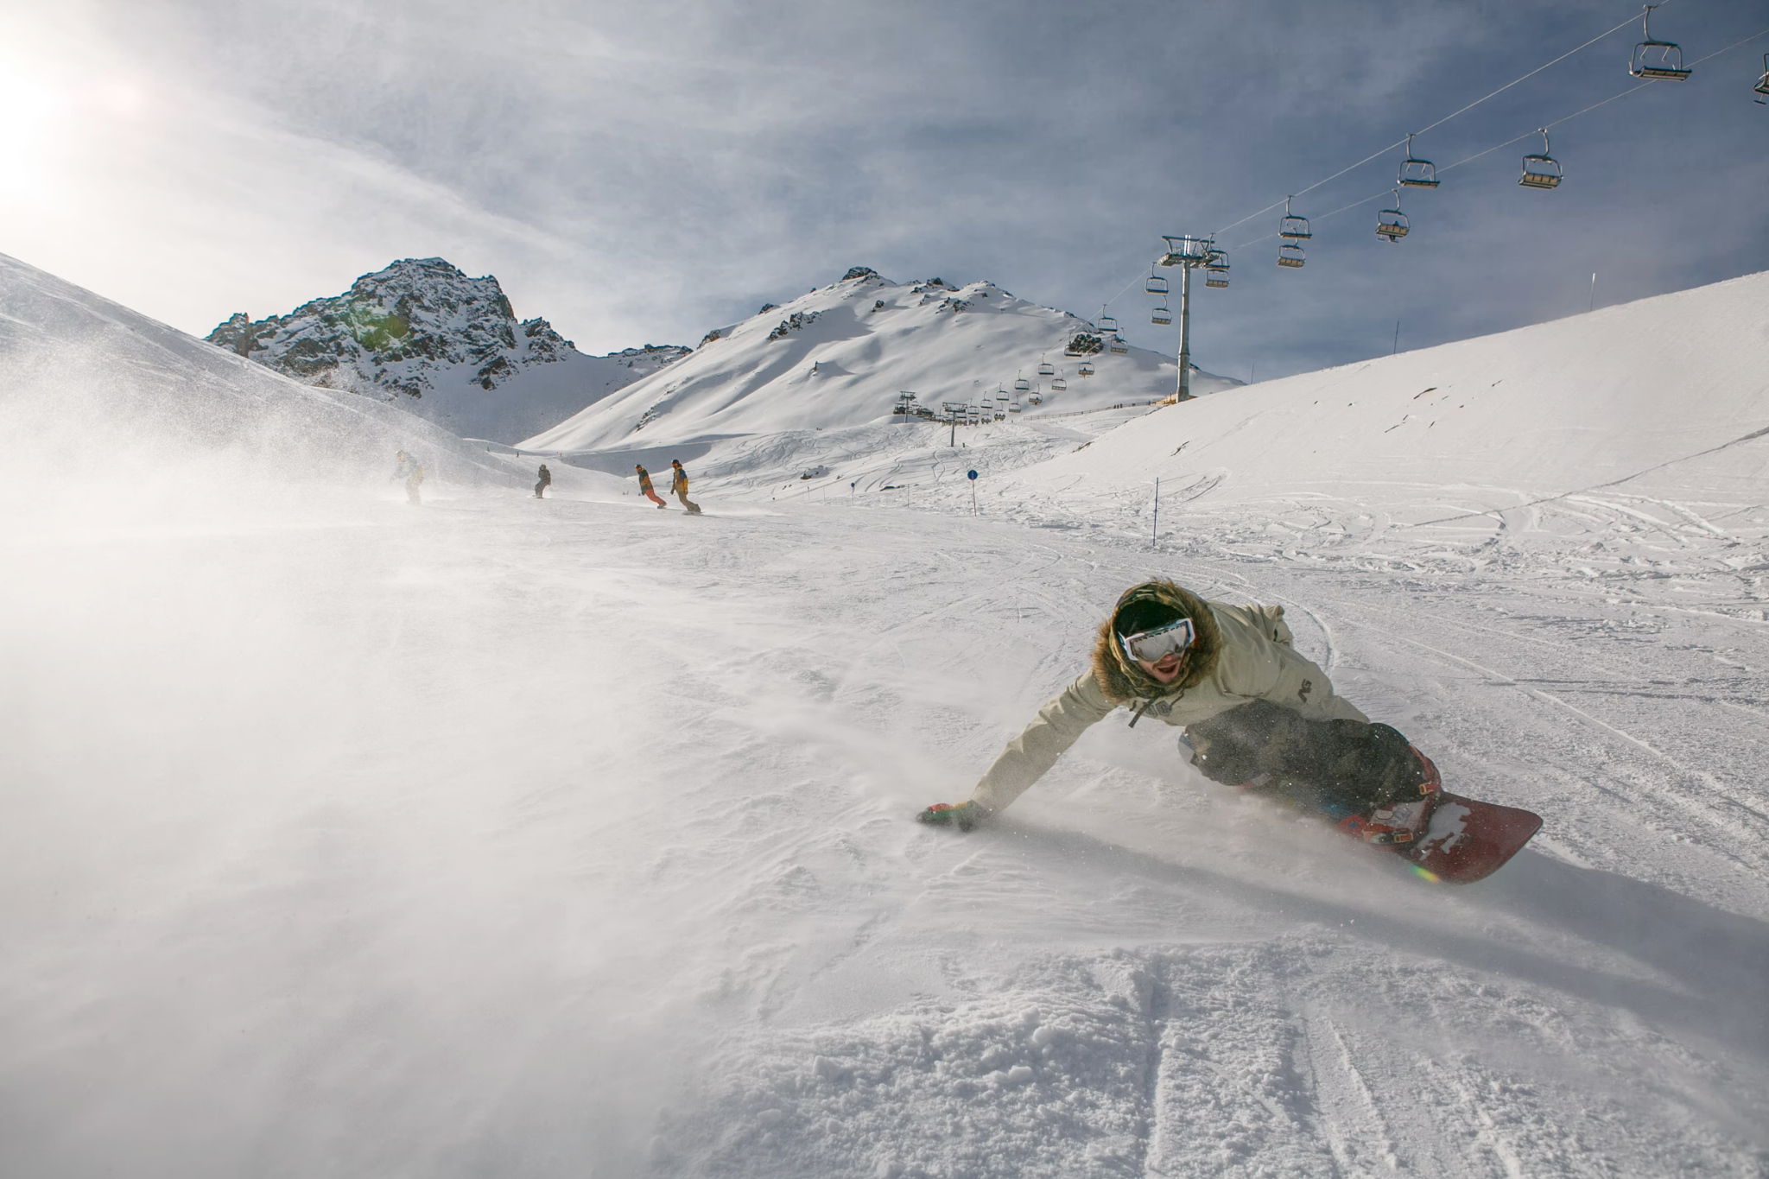 | 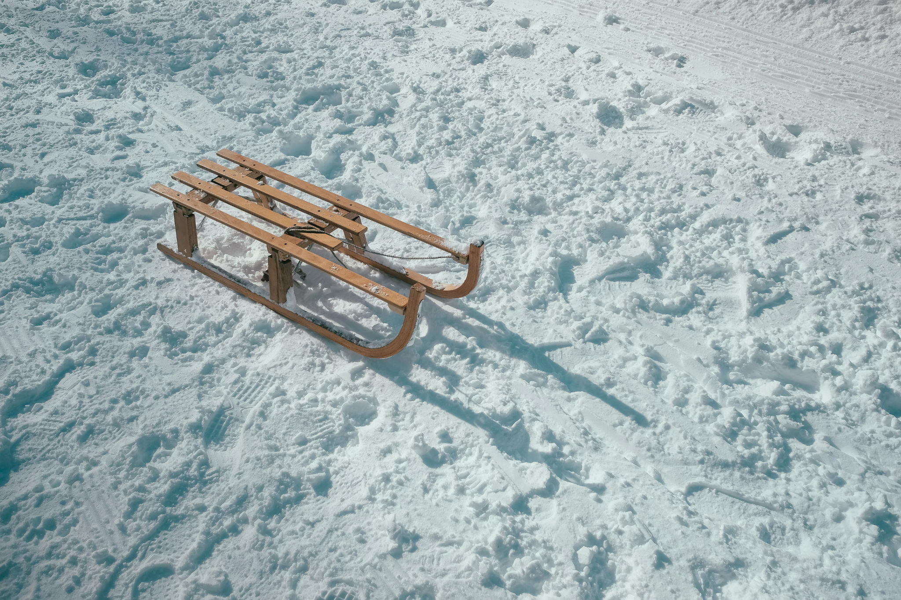
bordati – bordanje | sanjkati – sanjkanje

5.2 Zadatak 8. Što vole?
Below you will find a list of verbs (in no specific order). Think of how you would create a verbal noun out of these verbs. Finally, match each verb with the corresponding person below before you move on to finishing the sentences at the very end of the task.

Na primjer: Michael Phelps – njega zanima plivanje.
 | 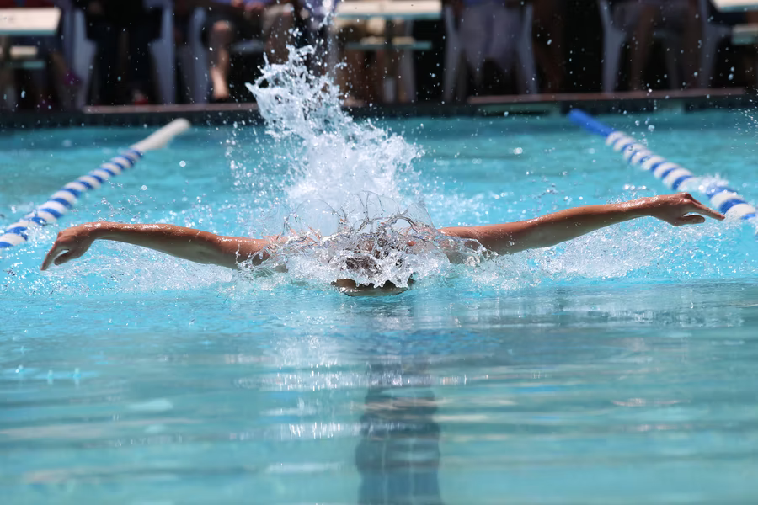
Michael Phelps | plivati

| Aktivnosti
 |  |  |  | 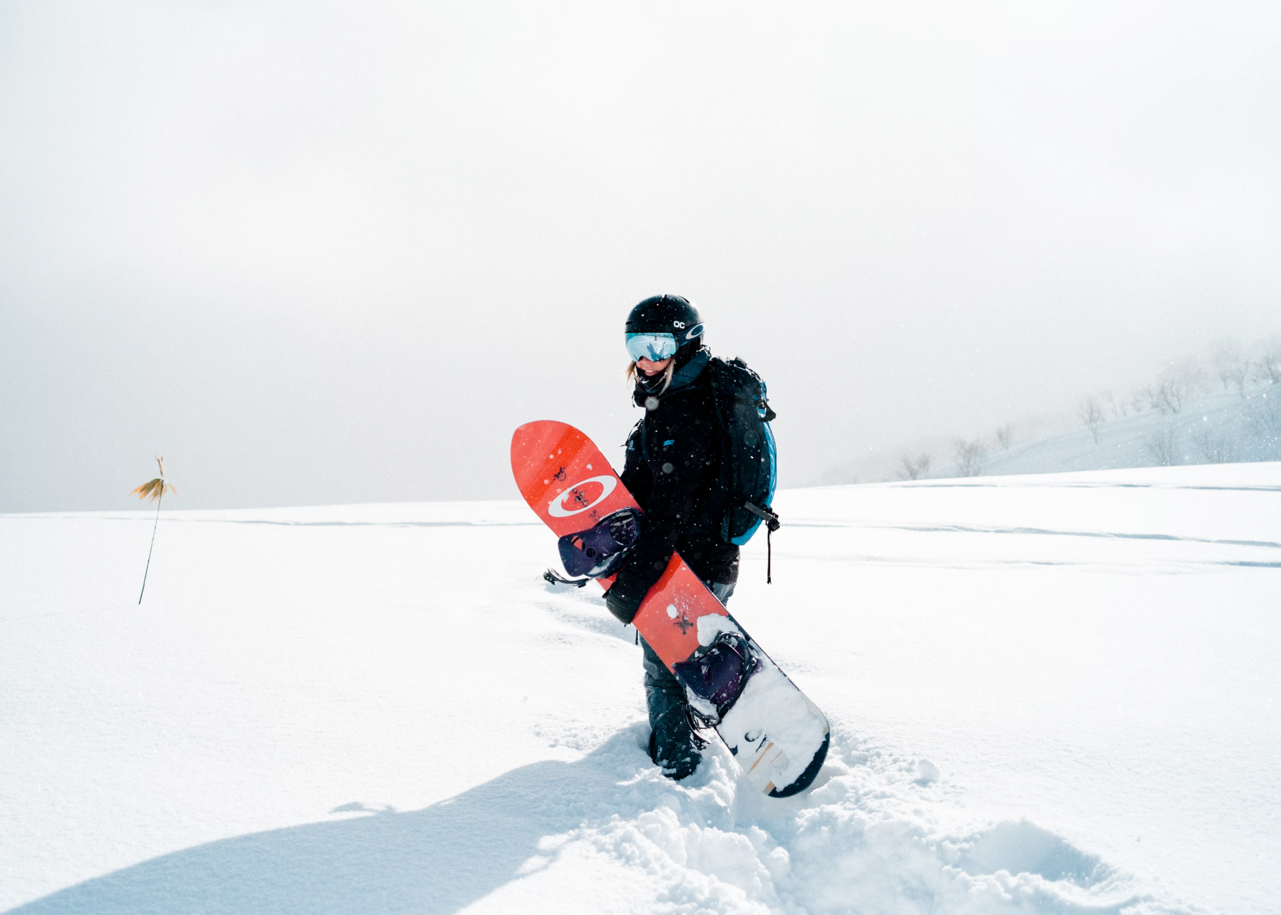
klizati (se) | trčati | vježbati | pjevati | bordati (se)
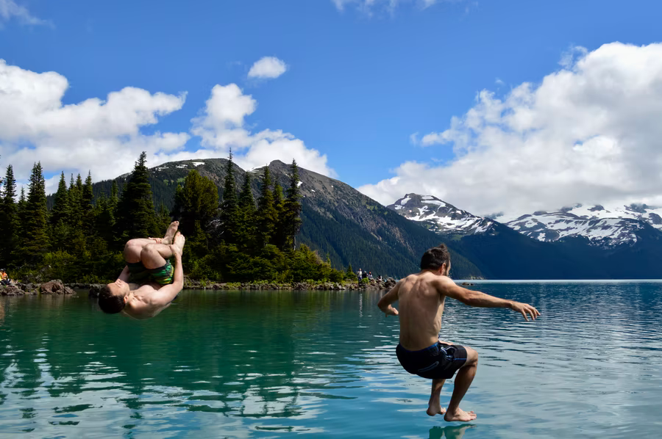 | 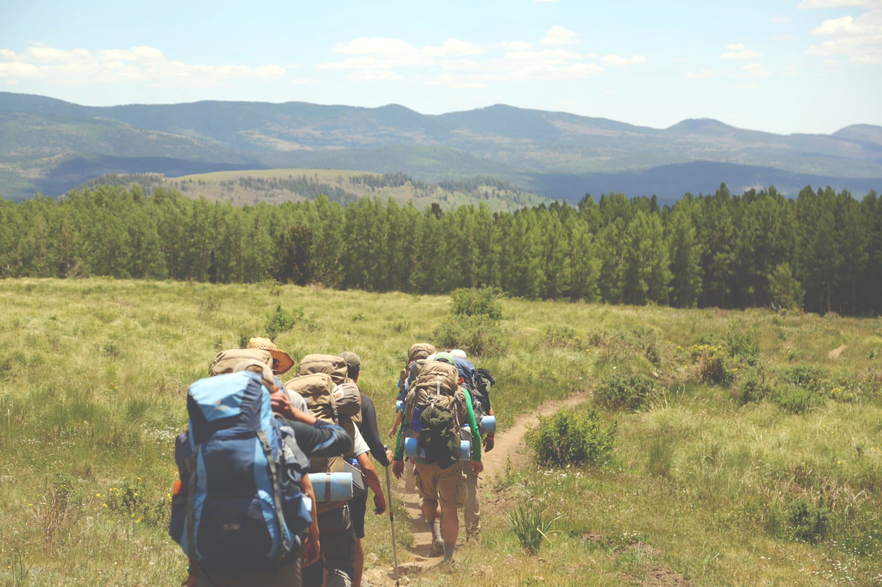 | 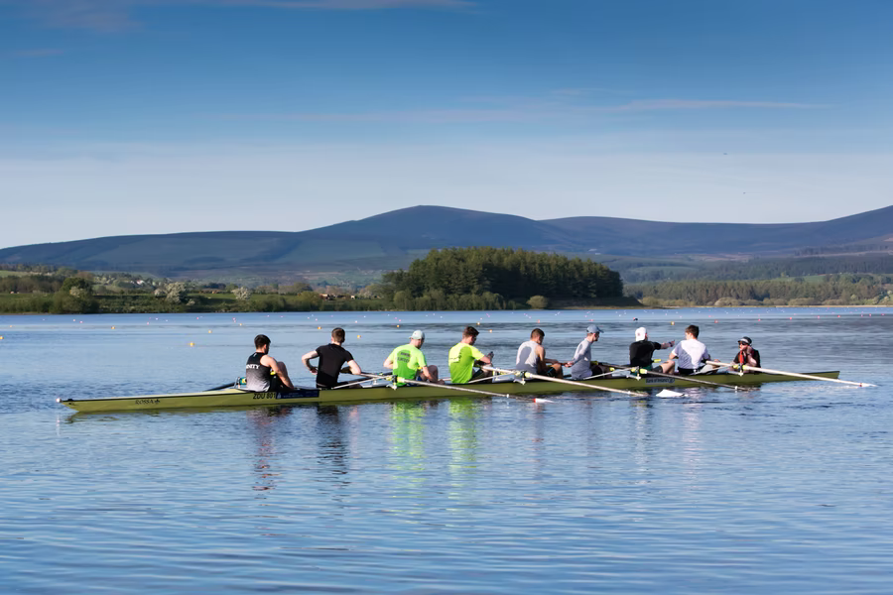 | 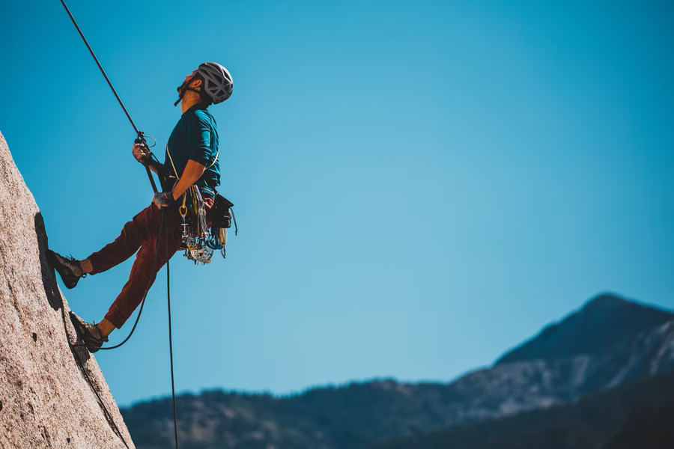
skakati | planinariti | veslati | penjati (se) | skijati (se)

| Poznate osobe
 | 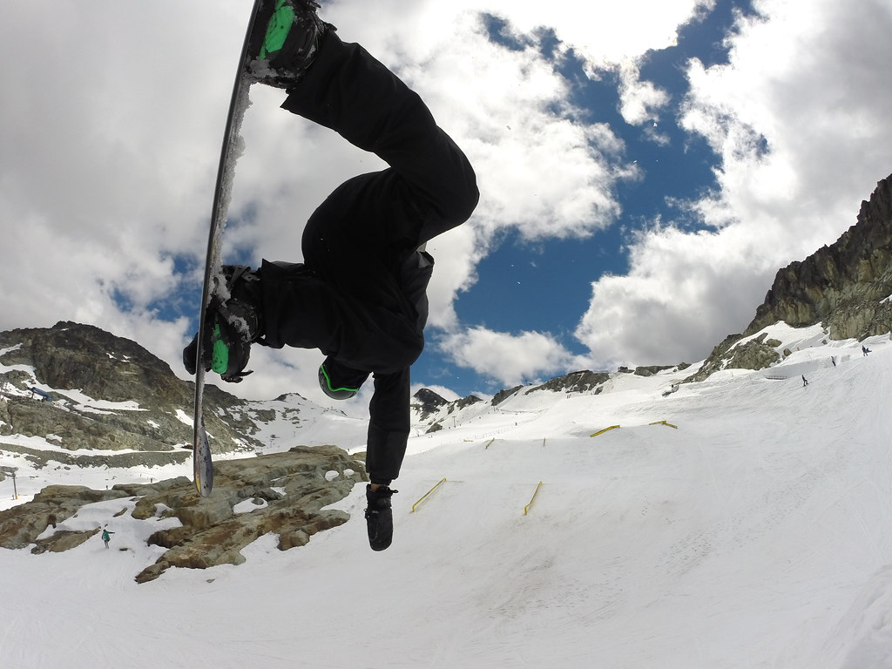 | 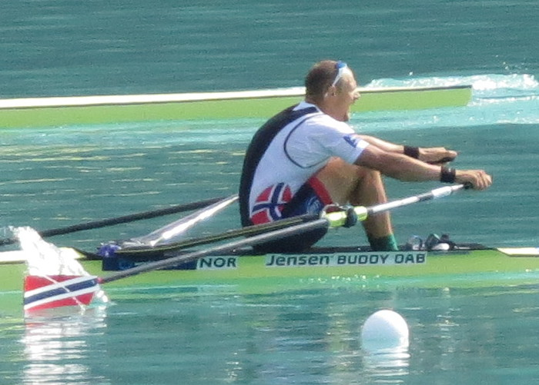 | 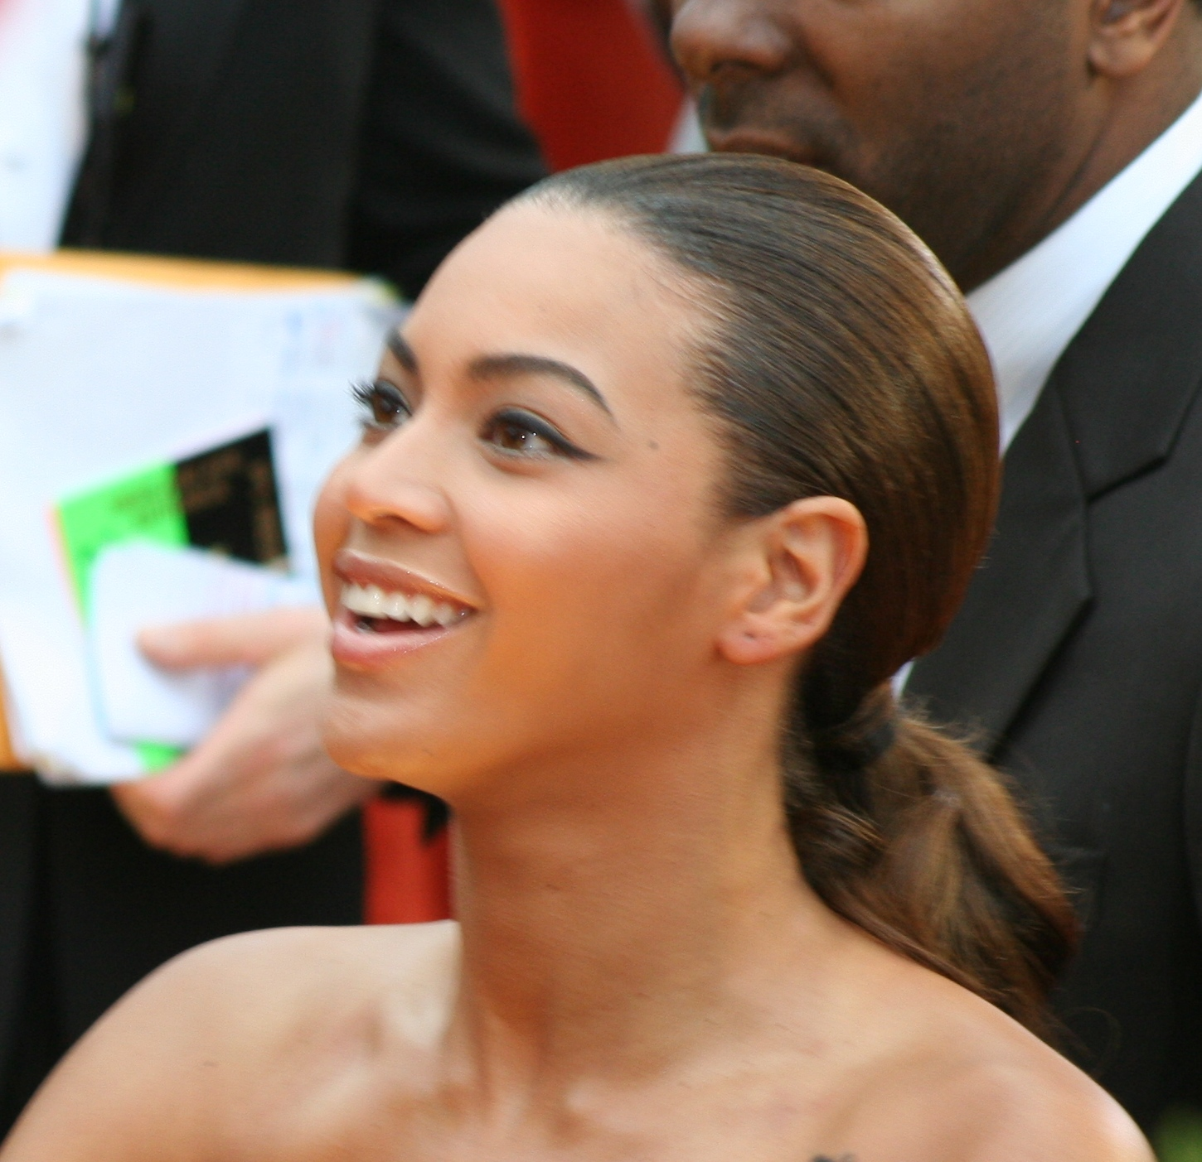 | 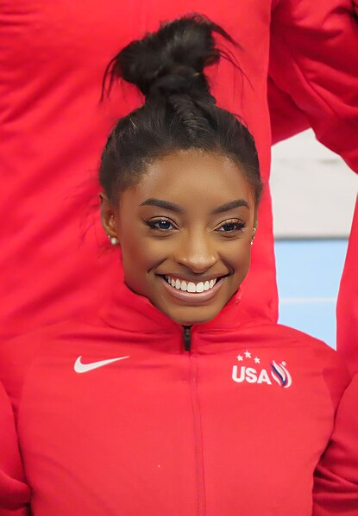
Usain Bolt | Mark McMorris | Olaf Tufte | Beyoncé | Simone Biles
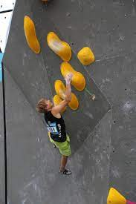 | 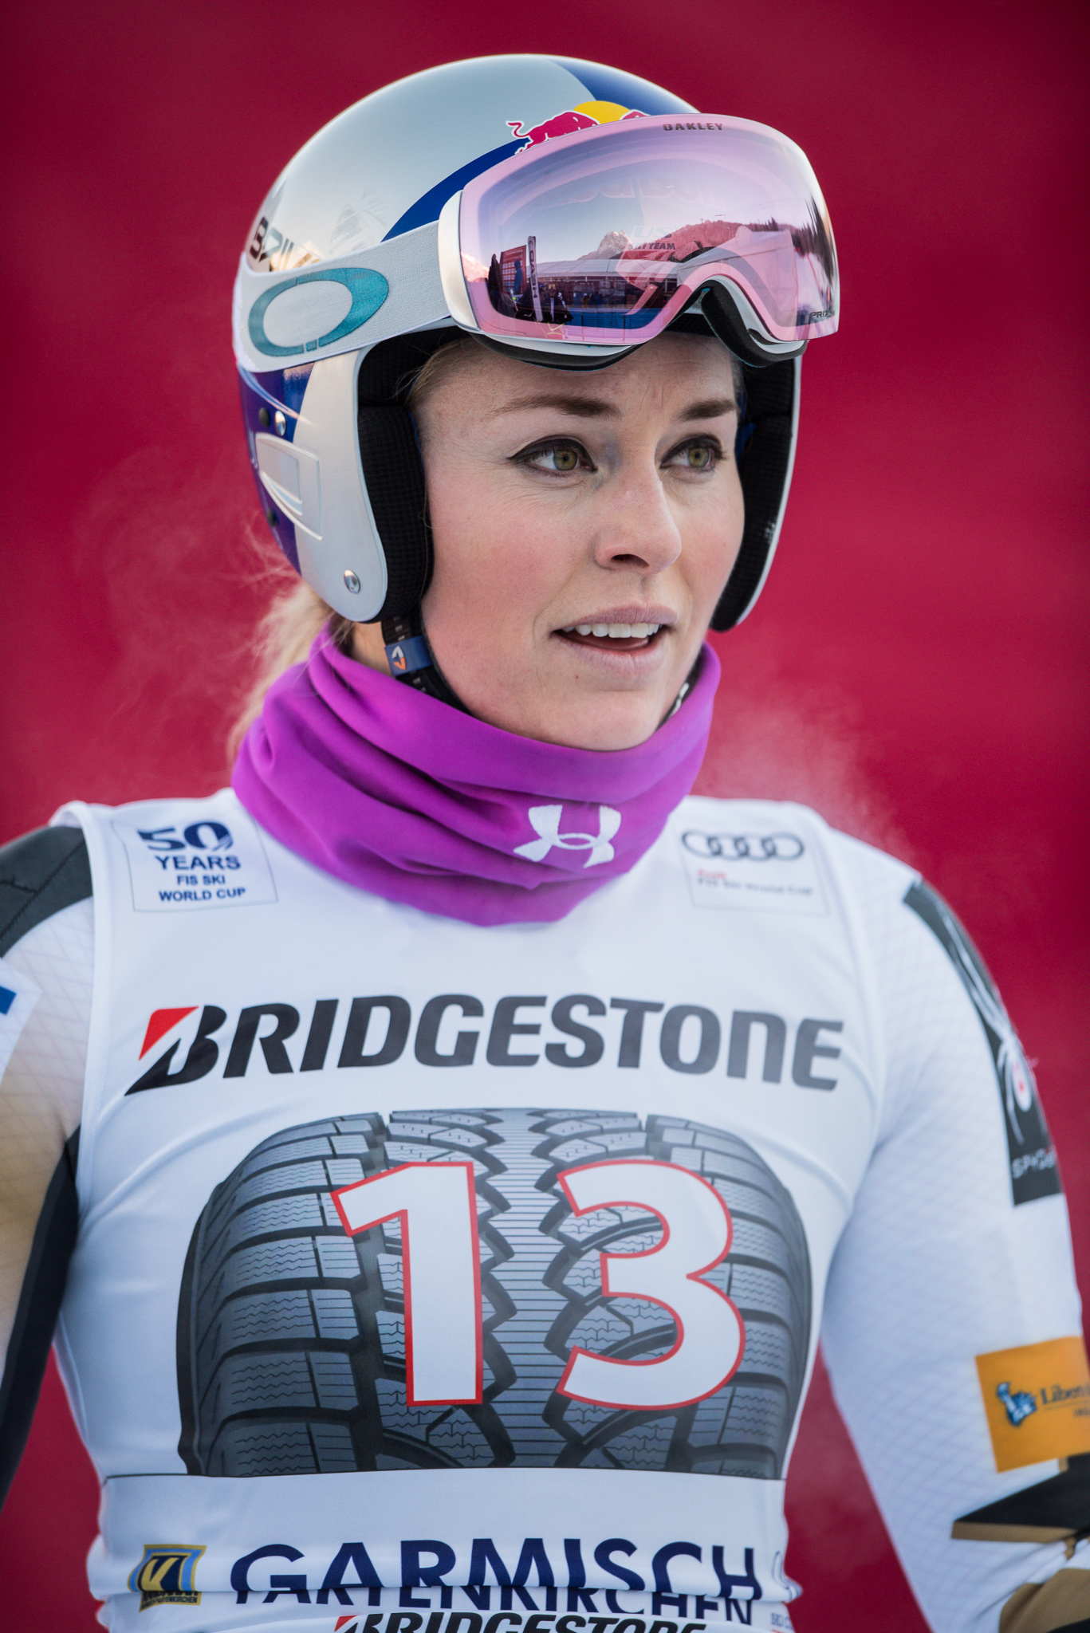 |  |  | 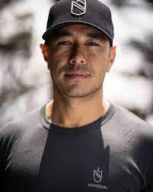
Alex Megos | Lindsey Vonn | Johnny Weir | David Boudia | Nirmal Purja
Complete the task by using the correct verbal noun of the following verbs:

verslati | penjati se | skakati | planinariti | bordati
skijati | trčati | pjevati | vježbati | klizati
[h5p id="450"]

Images used in this document are from these sources.

