8.7 - poprvé, podruhé... - for the first time, the second time...

University life is a time of firsts: oftentimes living alone, being in a new city, meeting new friends, learning new subjects, etc. Here are a few useful ones:

poprvé | for the first time
podruhé | for the second time
potřetí | for the third time
počtvrté | for the fourth time
popáté | for the fifth time

As you can see, these are formed by combining po + the ordinal number (which is incidentally in the neuter singular form, though you don’t need to worry about that beyond learning the terms above).

Finally, if you ever want to say “Every time I…”, use pokaždé, když...

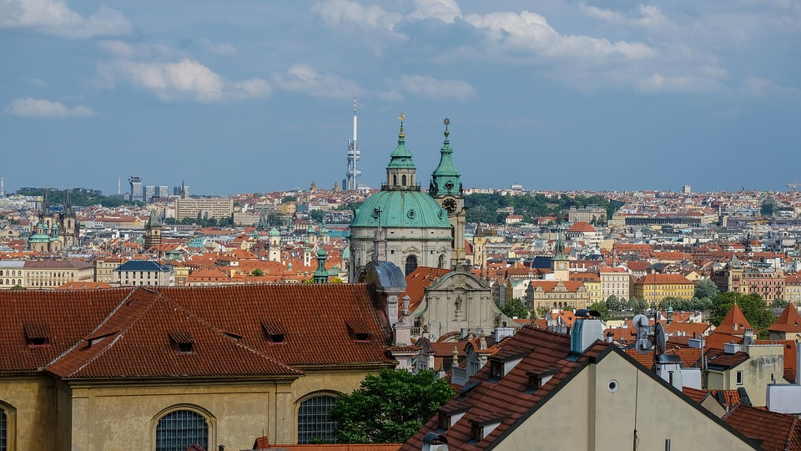  Adam poprvé žije ve velkém městě. |   Učím se tahle nová slova už podruhé. Nemůžu se je naučit. | 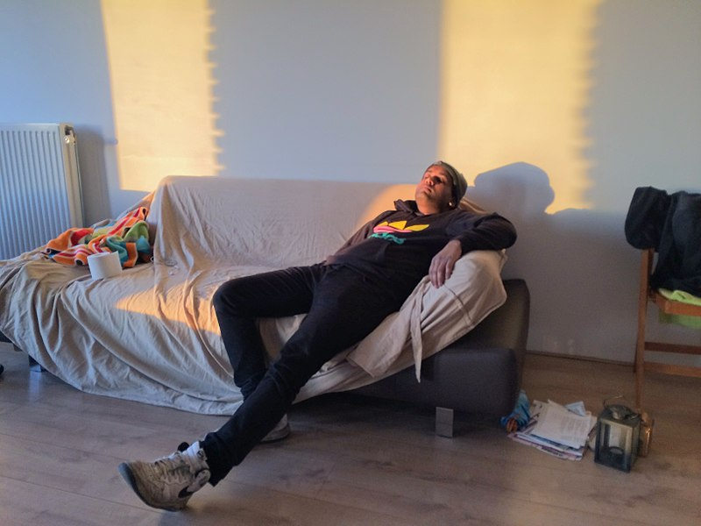  Pokaždé, když má Karel do školy nějaký projekt, strašně moc prokrastinuje.

Images used in this document come from these sources.

