6 | 5 | Lekcija 1: Ponavljanje

6.5 Zadatak 1. Hoćeš li, želiš li…
 | 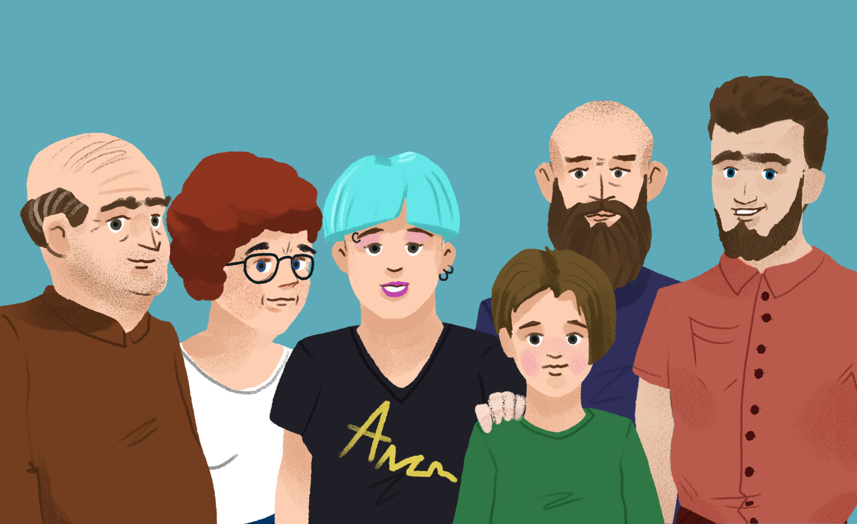
Complete the sentence by using the correct form of the verb htjeti or željeti (depending on the context).
[h5p id="754"]

6.5 Zadatak 2. Što je James kupio?
 | 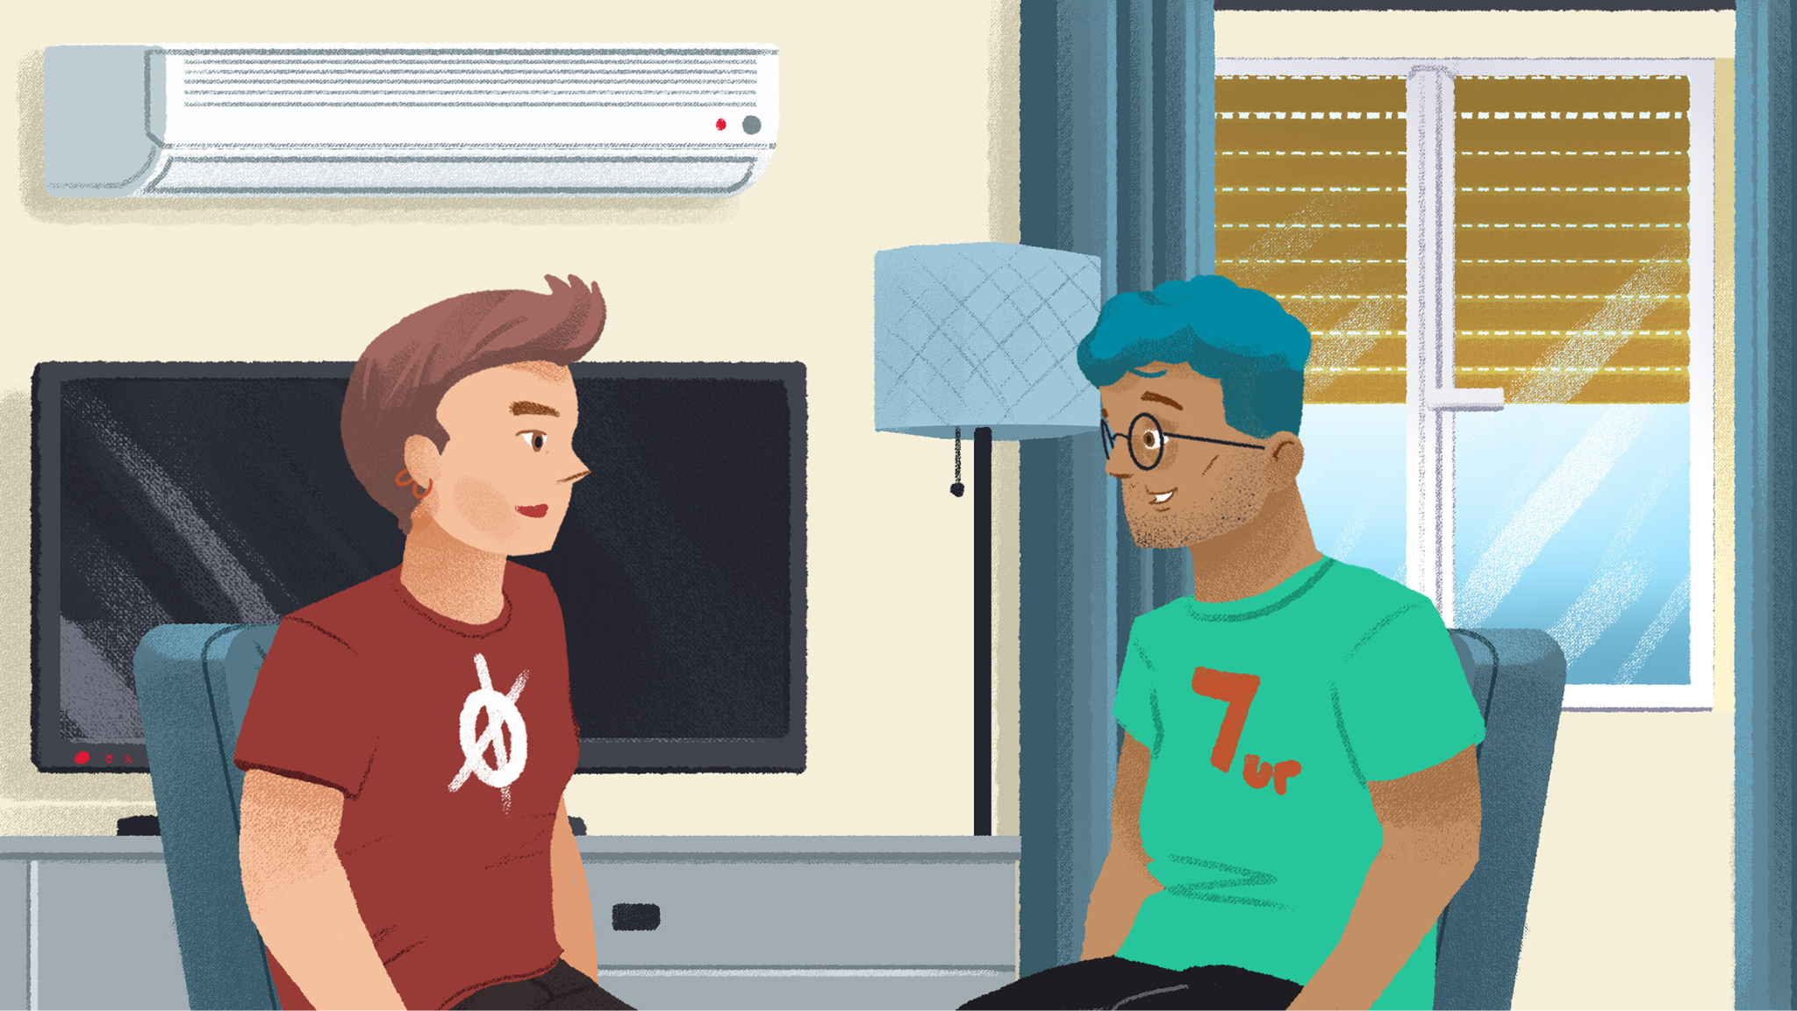
Complete the sentence by using the correct form of personal pronouns in the Dative case.
[h5p id="755"]

6.5 Zadatak 3. Tko se kome sviđa?
Complete the sentences based on what you see. You need to use the Dative or nominative case with personal names.
 |  |  | 
Josipa / Luka | Darko / Sandra | Filip / Ines | Mario / Marija
[h5p id="756"]
Complete the sentences based on what you see. To complete the question, you need to use the Dative with personal names. In the response to a question, you need to use the correct form of a personal pronoun in the Dative case (stressed or unstressed form, based on the sentence structure).
 |  |  |  |  |  | 
Josipa | Luka | Filip | Ines | Darko | Sandra | Mario | Marija
[h5p id="757"]

6.5 Zadatak 4. Koji glagol?
Finish the sentences by using the appropriate verb. There are several options at time to complete the sentence. Pay attention to the subject in a sentence. Use the appropriate verb -- choose between: nositi, obući, odjenuti, obuti.
[h5p id="758"]

6.5 Zadatak 5. Što je ljepše?
Complete the sentence in a logical way. Use the correct form of the verb biti.
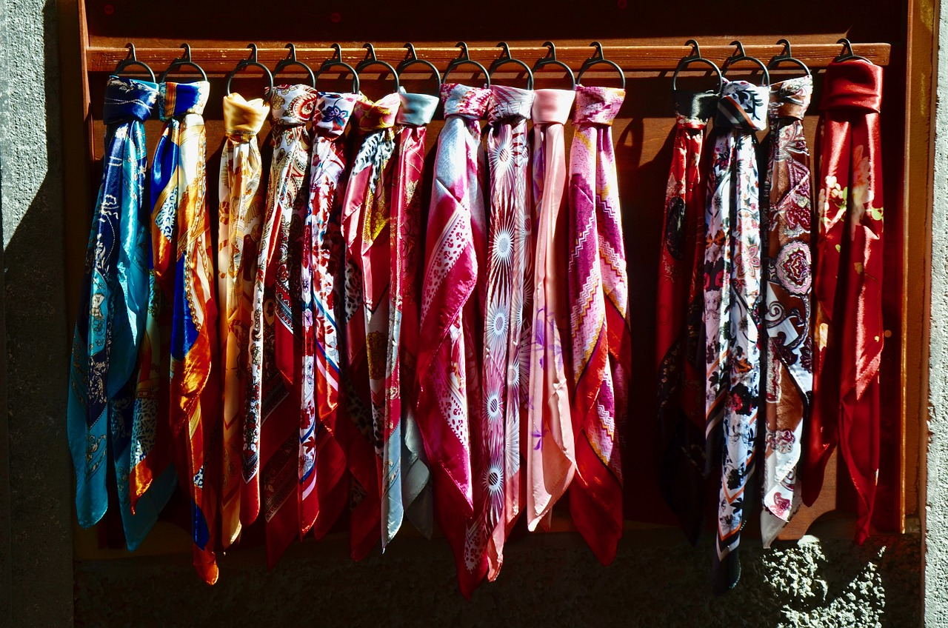 |  | 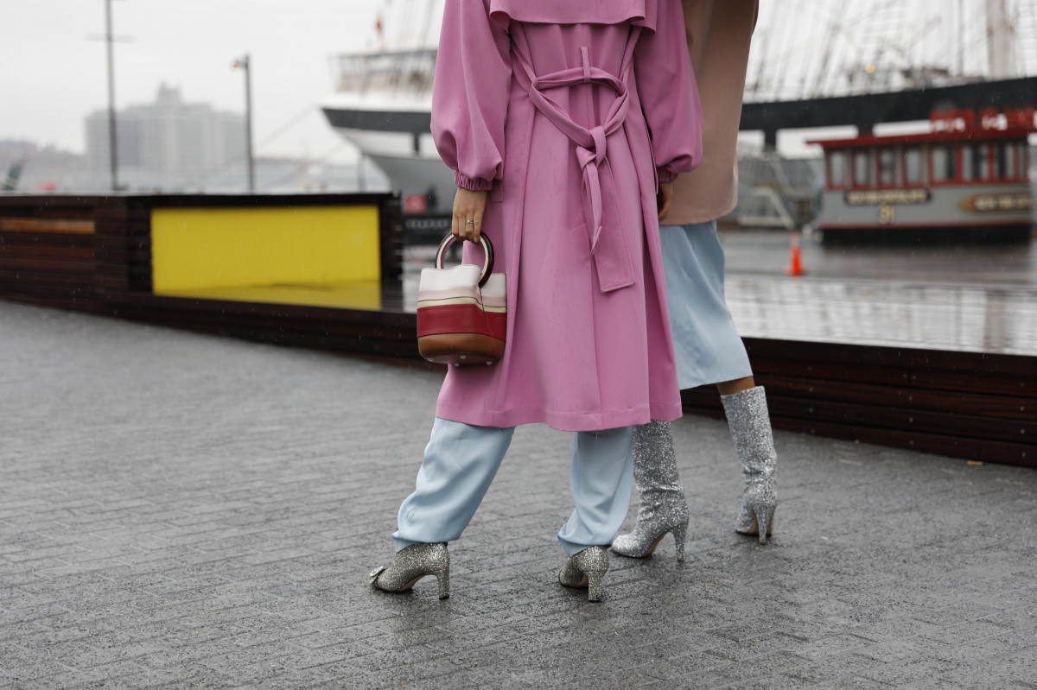 | 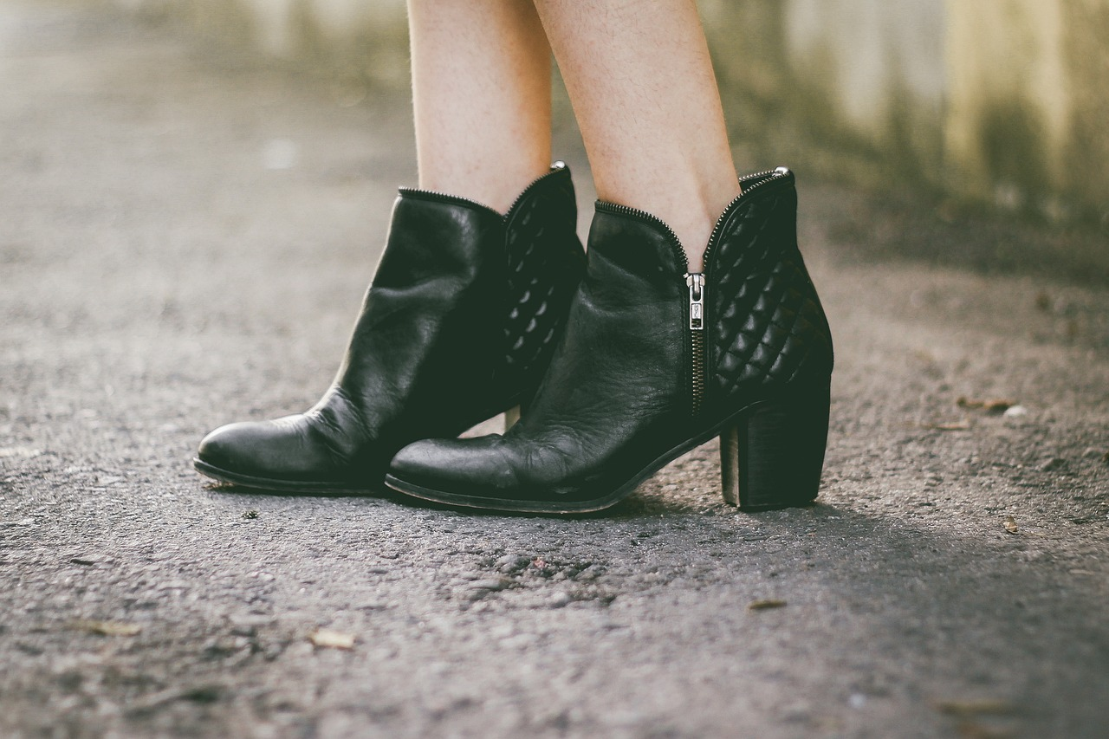
[h5p id="759"]
Finish the sentences by using the correct form of ljepši.
[h5p id="760"]

Images used in this document are from these sources.

