8 | 2 | Lekcija 2: Pripreme za put

| Mjerne jedinice
Measurement units are different in Croatia from those used in the US. When it comes to food and drinks, these are the ones that you will most likely encounter.
JELO | PIĆE
kilogram (kg) | litra (l)
dekagram (dag) | decilitar (dl)
gram (g) | mililitar (ml)

In recipes some measurements are used that are like the ones used in the US – namely a tablespoon, a teaspoon, a pinch of something.
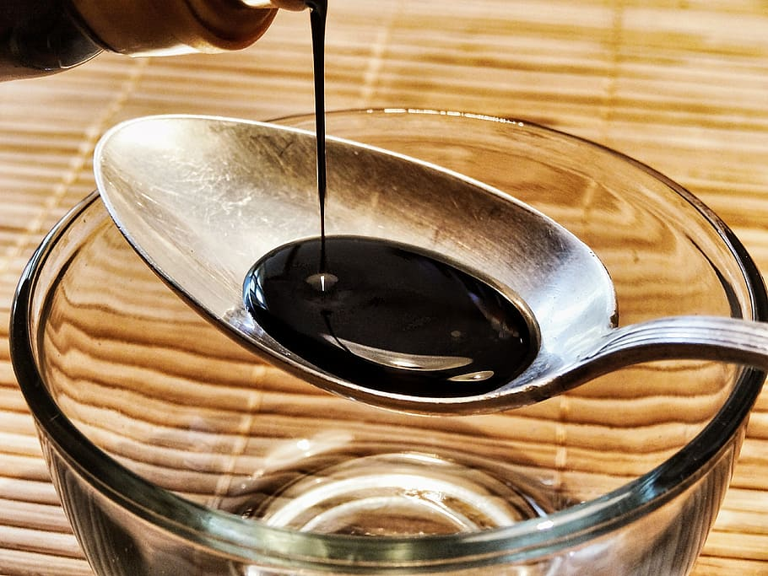 | 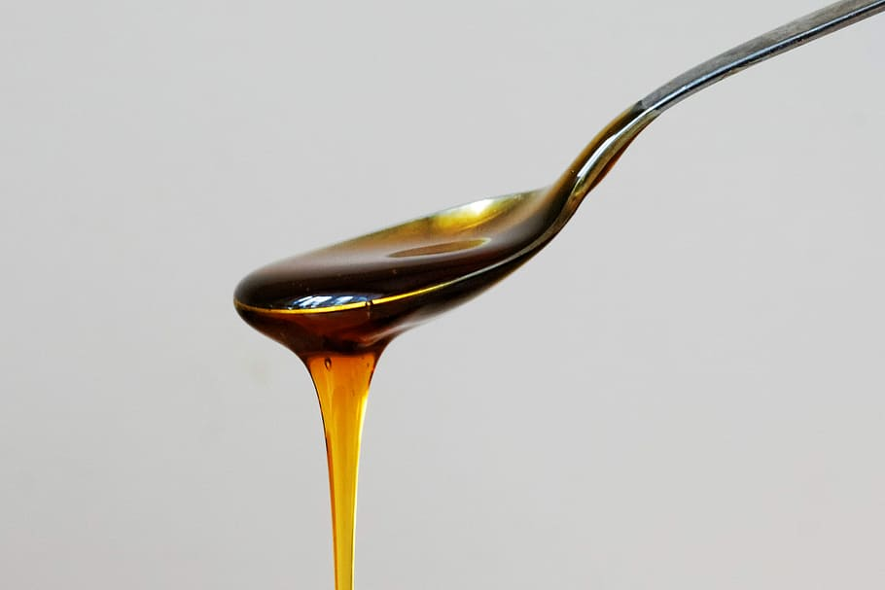 | 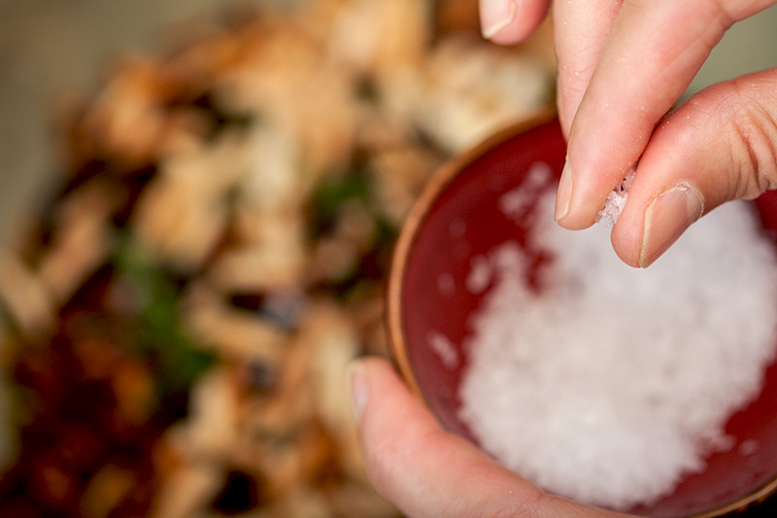
žlica | (čajna) žličica | prstohvat

Images used in this document are from these sources.

