6.5 - On your own - sám, sama

You certainly may do things with certain people, but there are also times we do things alone, by ourselves. To express this in Czech, we’ll need the words sám, sama… as illustrated in the chart below:

singular |  |  | plural
MA, MI | F | N | MA pl | MI and F | N
sám | sama | samo | sami | samy | sama

Each of the forms above correspond to what the subject of the sentences is. In other words, if the subject is masculine, use sám, if the subject is feminine, use sama. If a group of men or a mixed group, use sami, otherwise there is MI and F plural form samy and neuter plural sama.

  Nikola ráda chodí na procházky sama. | 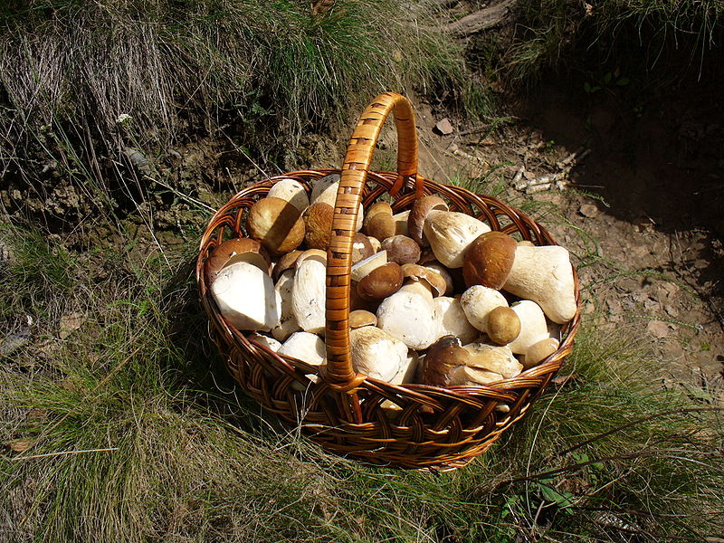  Karel nejradši sbírá houby sám.
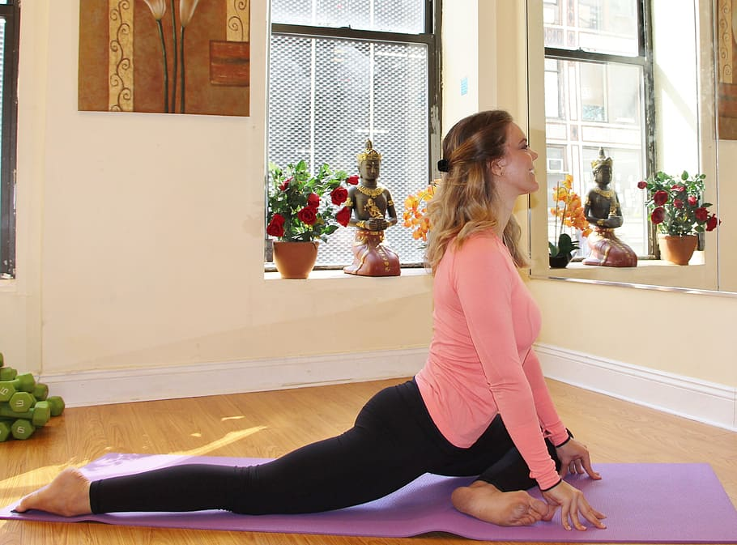  Katka radši cvičí jógu sama doma než ve studiu. | 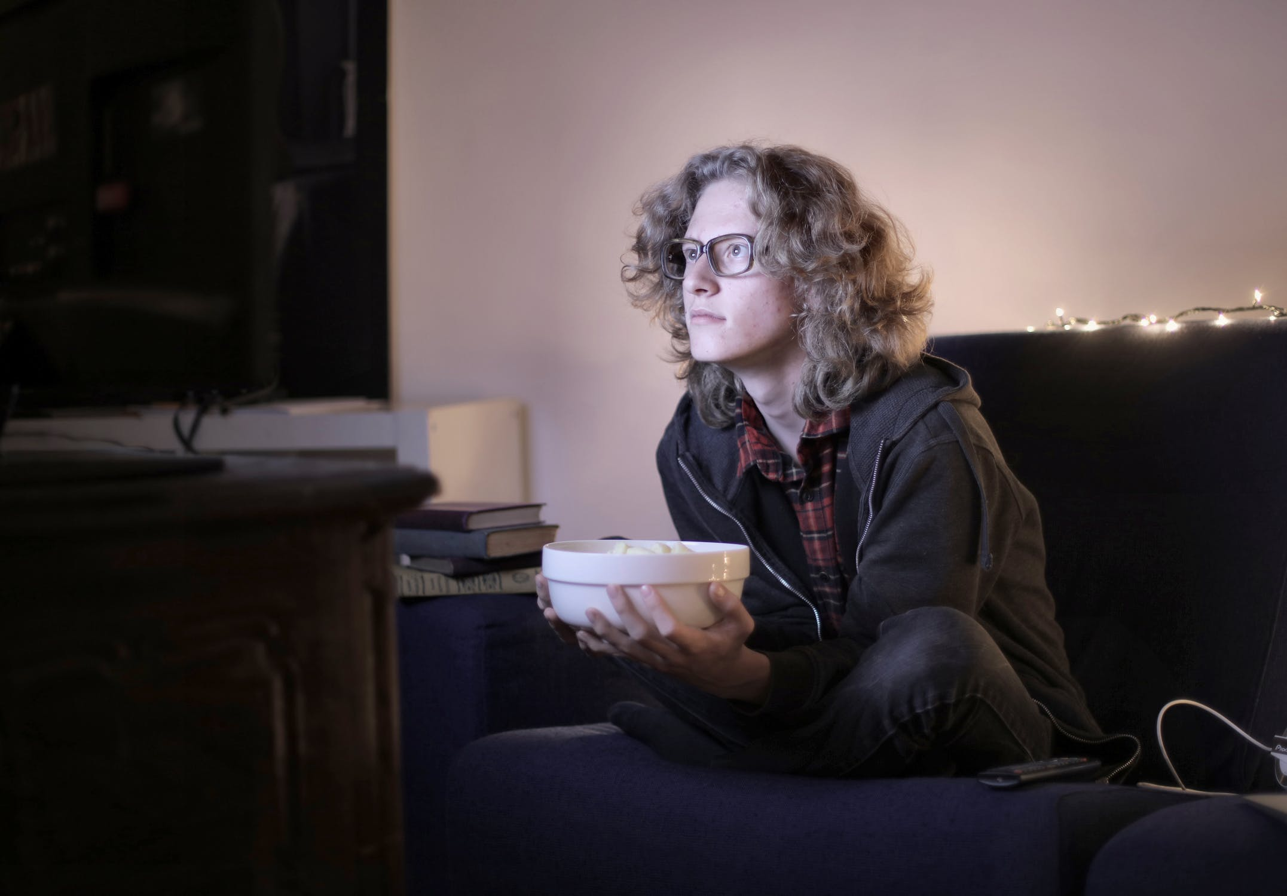  Pavel se velmi rád dívá na filmy sám.

Images used in this document come from these sources.

