3 | 2 | Lekcija 1: Tradicija

3.2 Zadatak 1. Čije je?
Look at the following list and pictures. It contains: (1) names of cities/countries around the world, and (2) cultural landmarks/products from those places. Try to match each item with a certain country/city and express that this place ''possesses'' something. You might need to search online for certain items. One example is done for you. Na primjer:
 | FRANCUSKA:  Eiffelov toranj 🇫🇷 🗼  To je francuski Eiffelov toranj.

Sarajevo | Split | Pag | Srbija | Dubrovnik
Mostar | Drniš | Pula | Crna gora | Zagreb

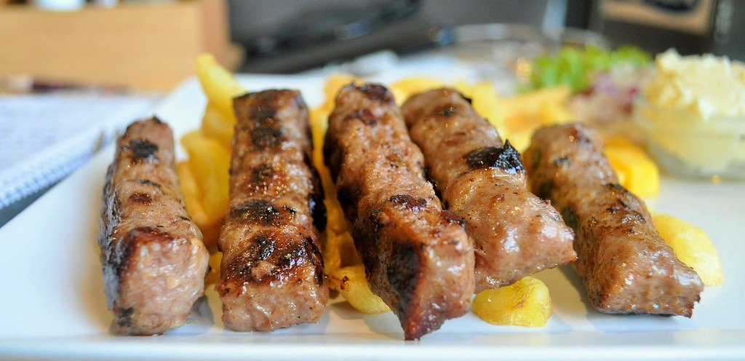 | 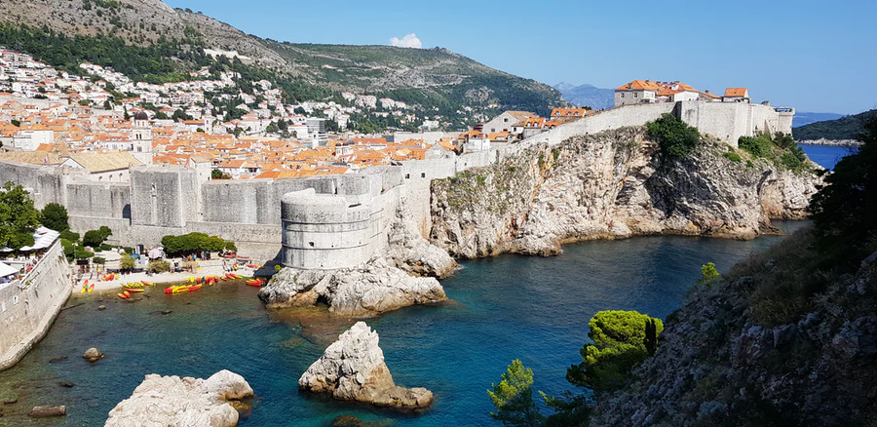 | 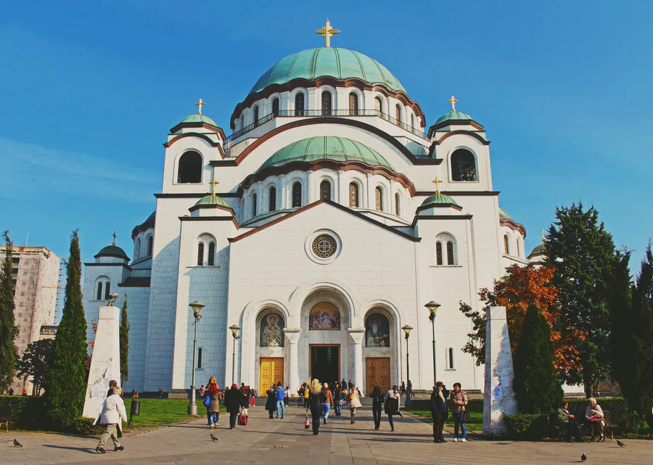
*sarajevski* ćevapi | *dubrovačke* zidine | *srpski* hram sv. Save
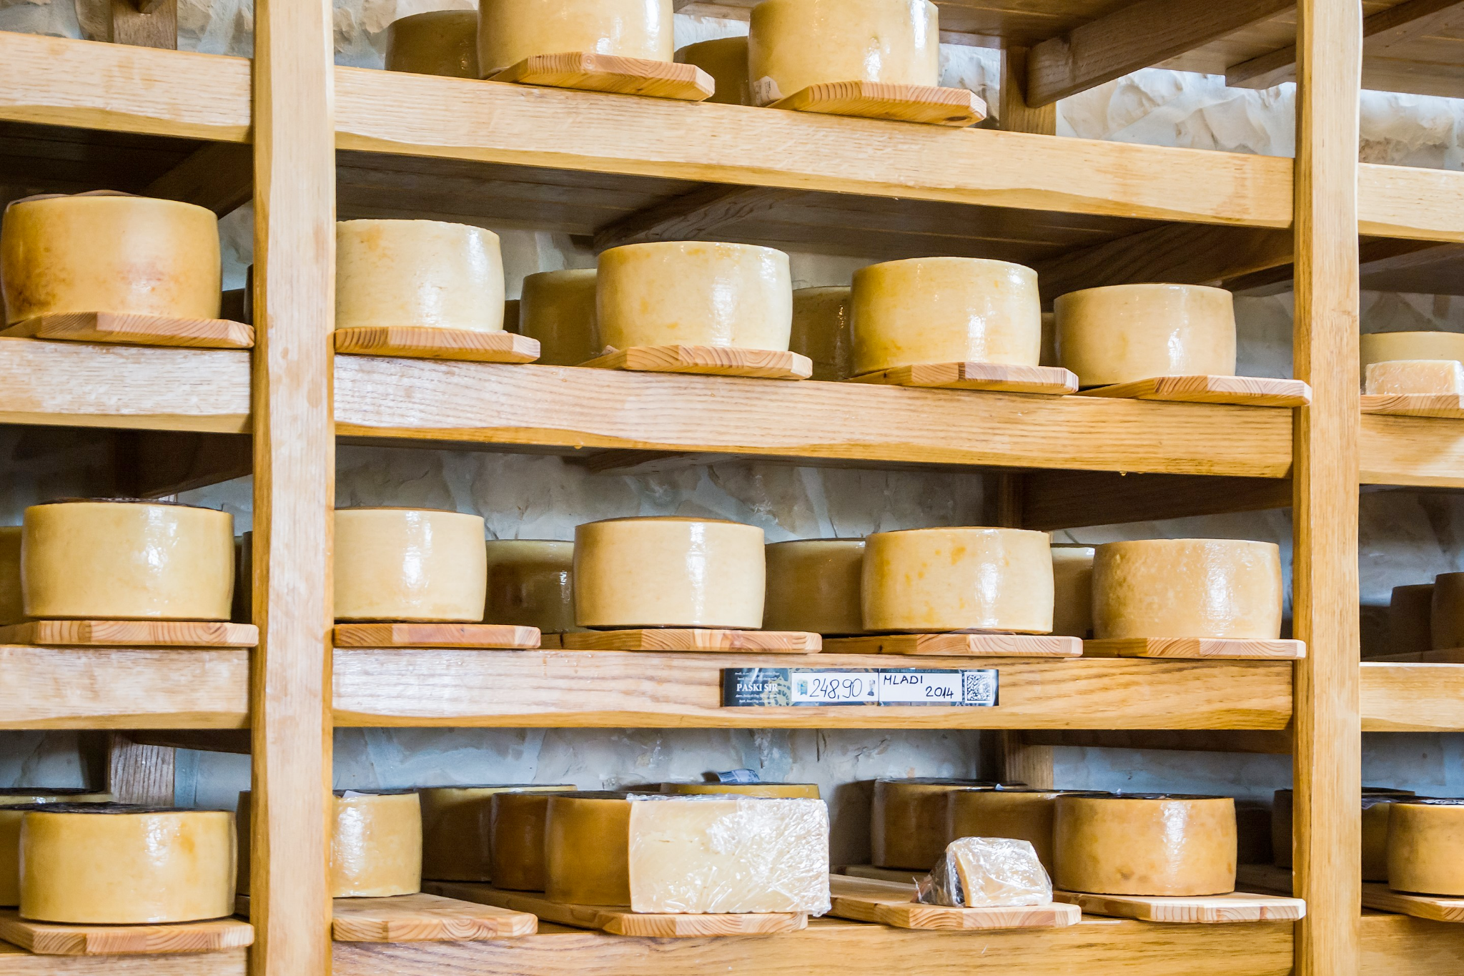 | 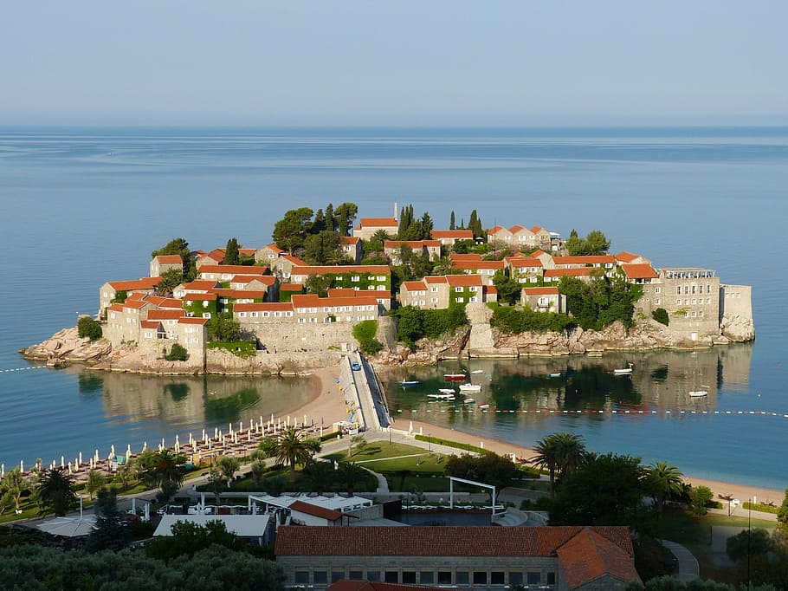 | 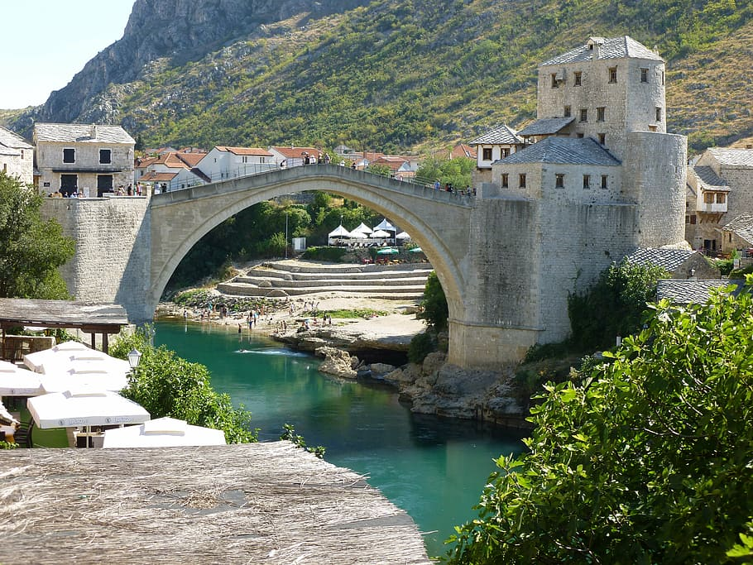
*paški* sir | *crnogorski* otok sv. Stefan | *mostarski* most
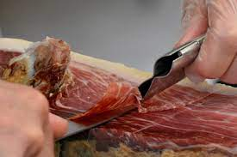 | 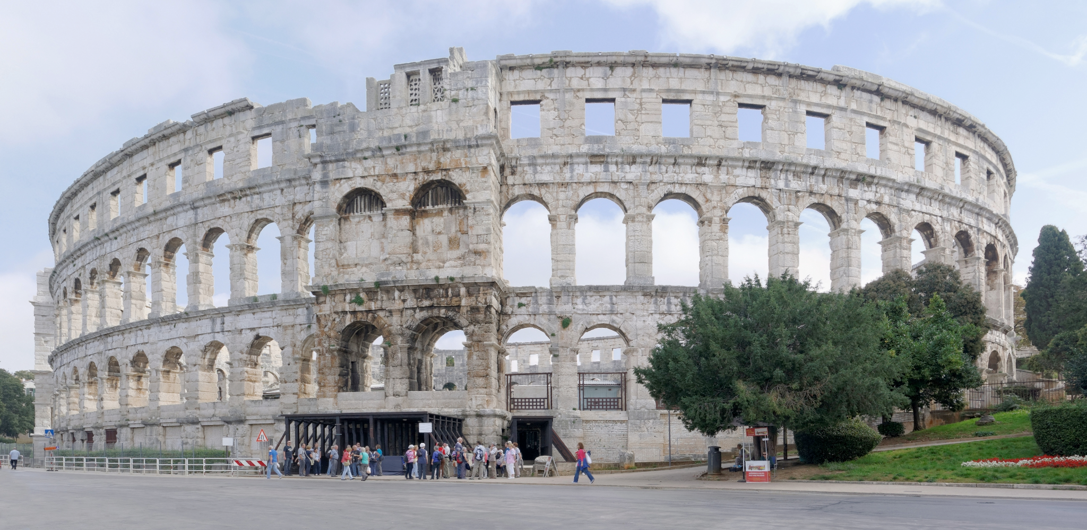 | 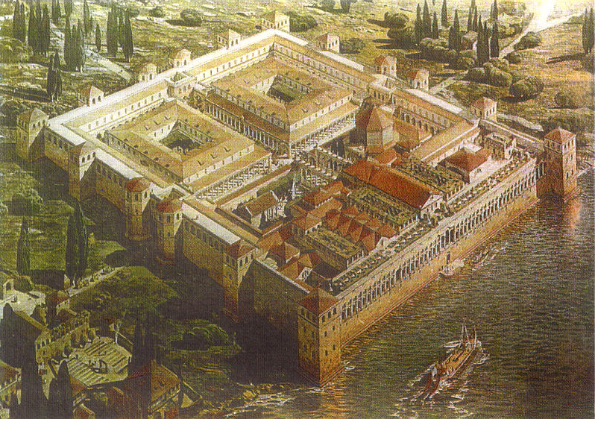
drniški pršut | *pulska* arena | *splitska* palača

Look at the following food items and tell us where they come from.
 | 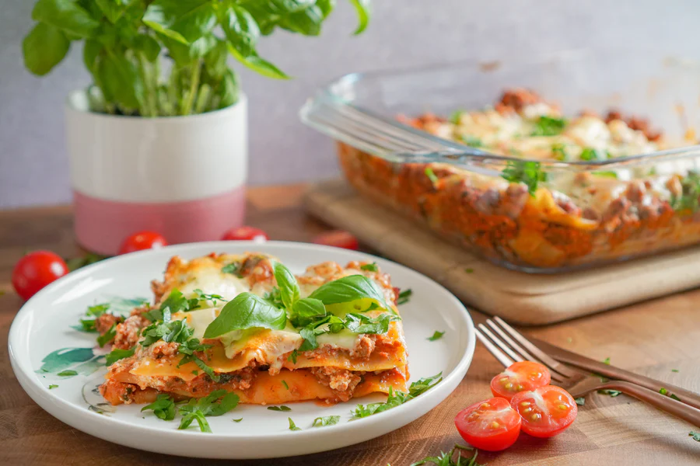 | 
suši | lazanje | hamburger
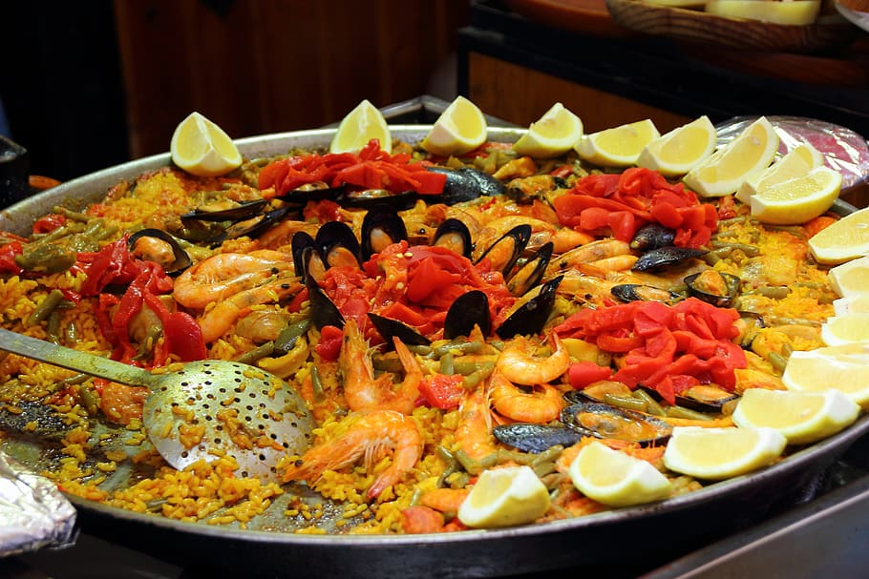 | 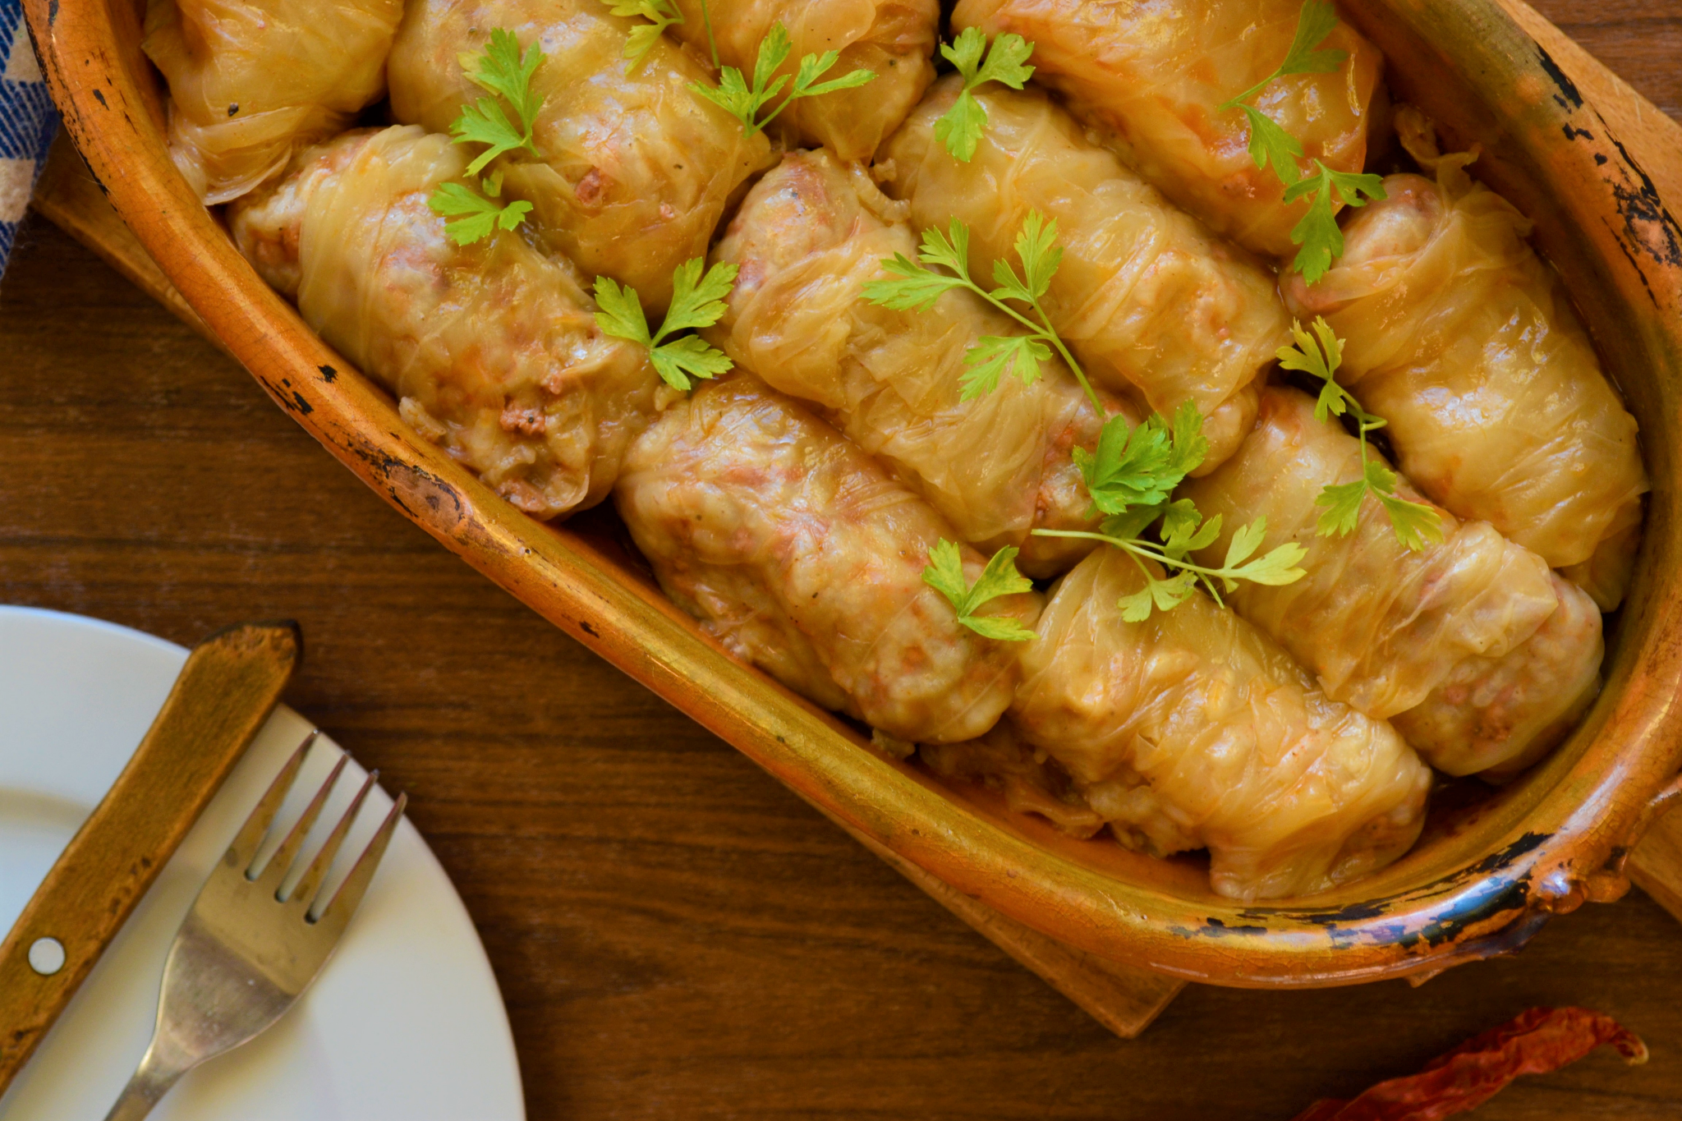 | 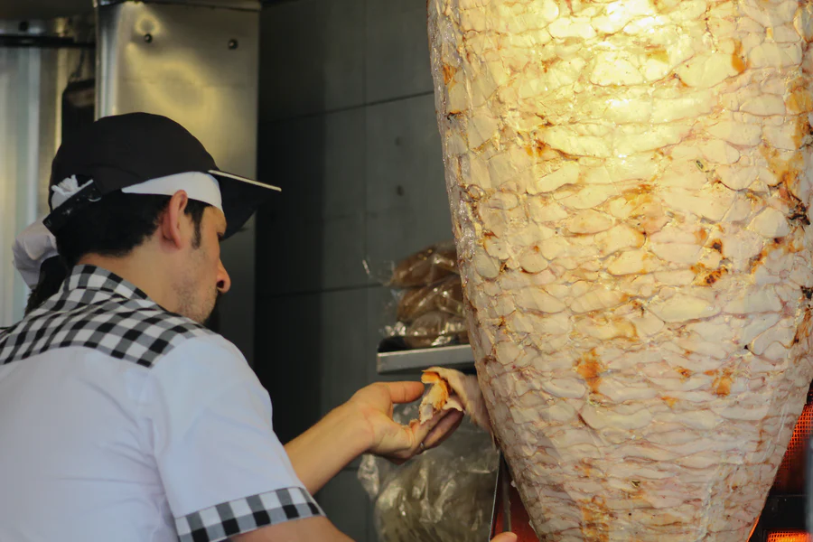
paella | sarma | gyros
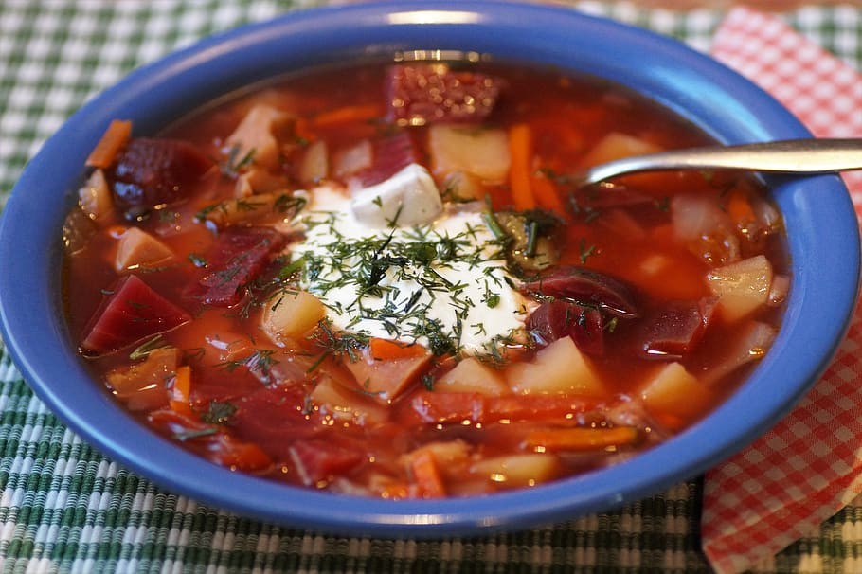 | 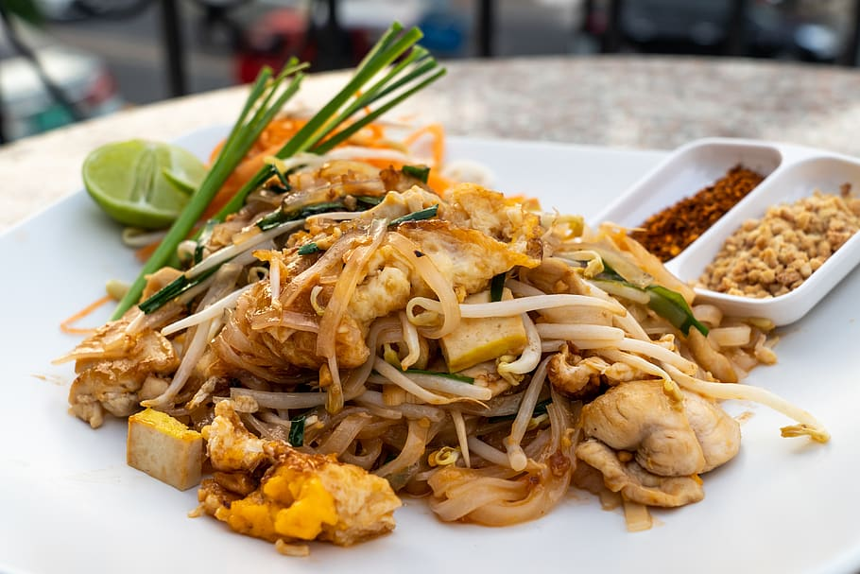 | 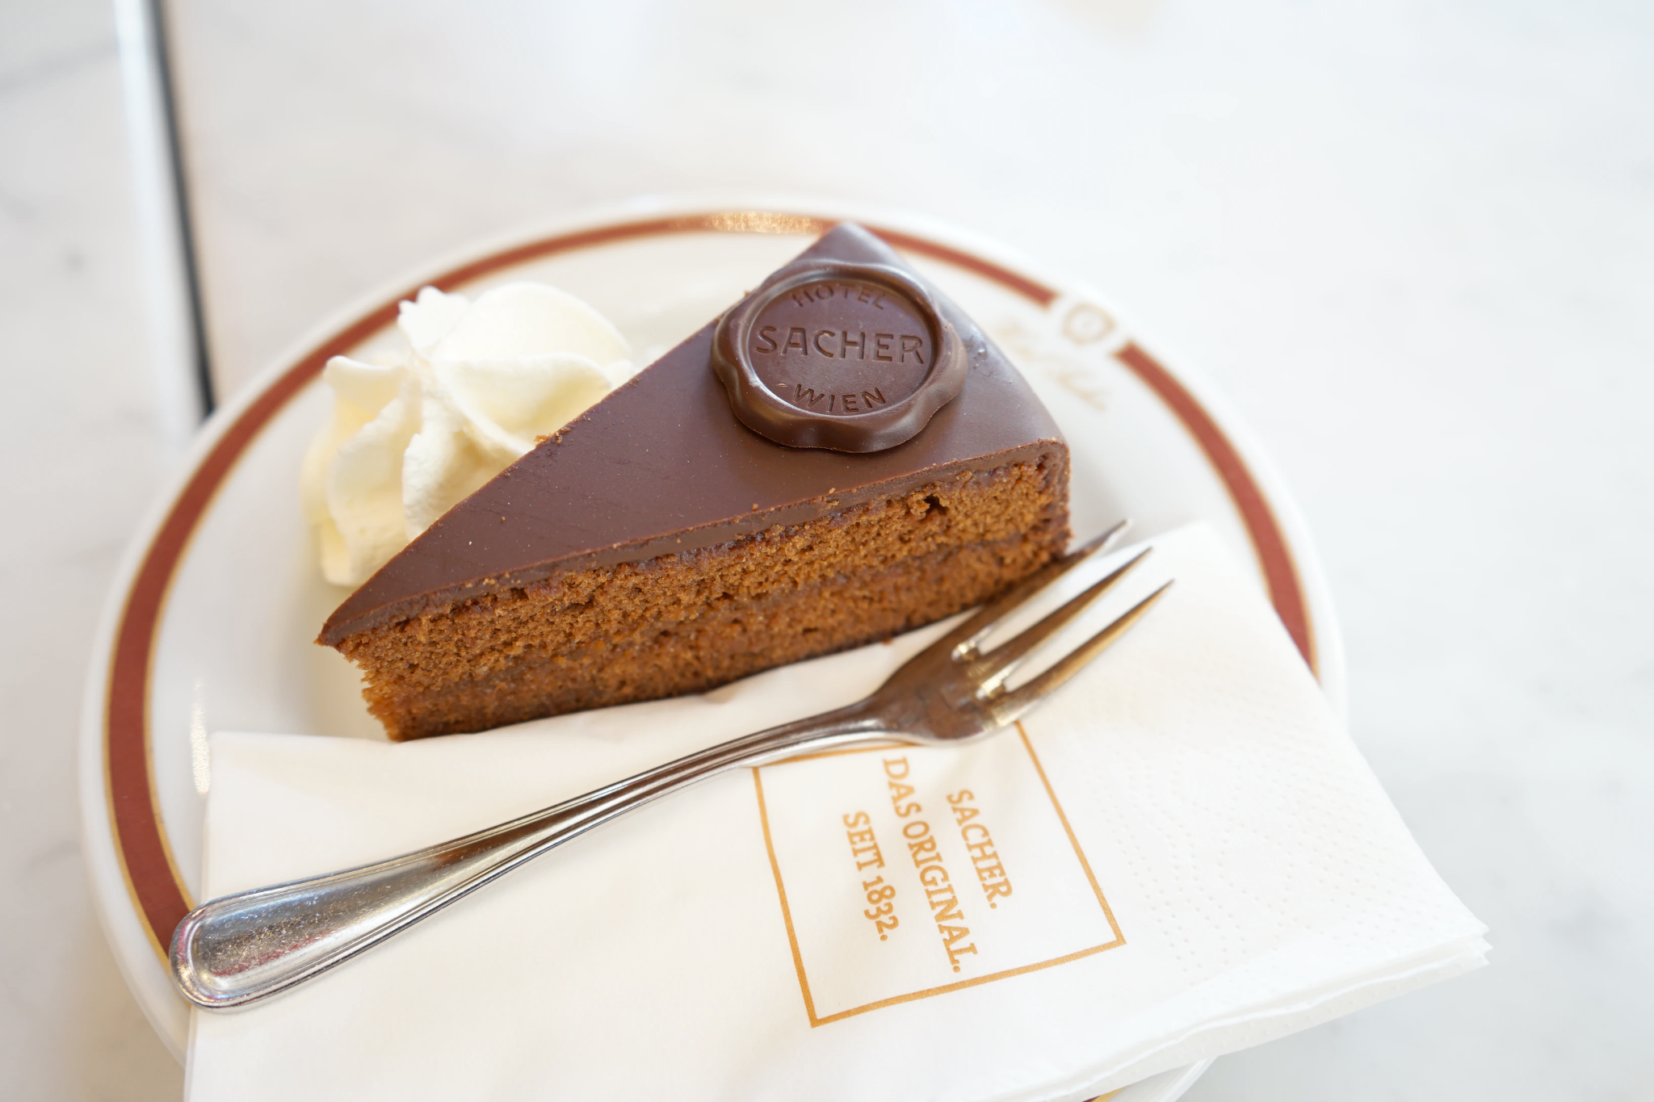
boršč | pad thai | zaher torta (Sachertorte)
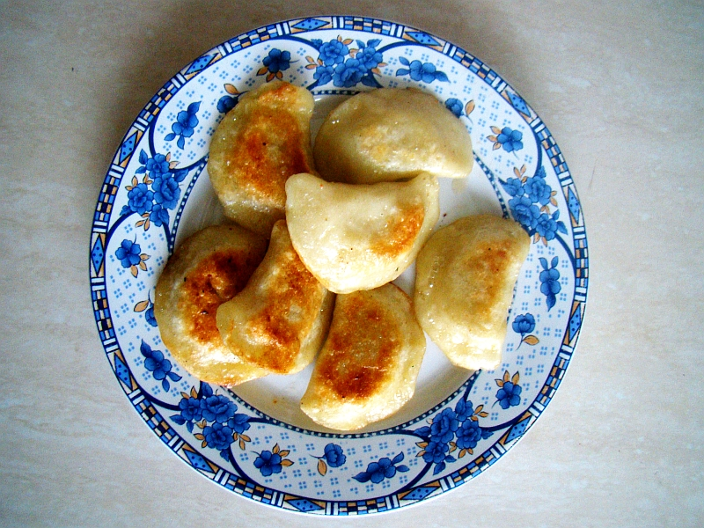 | 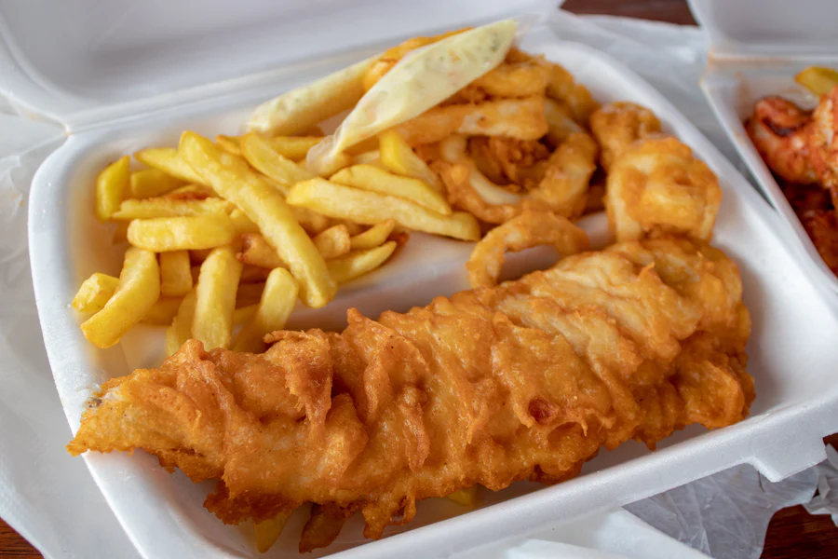 | 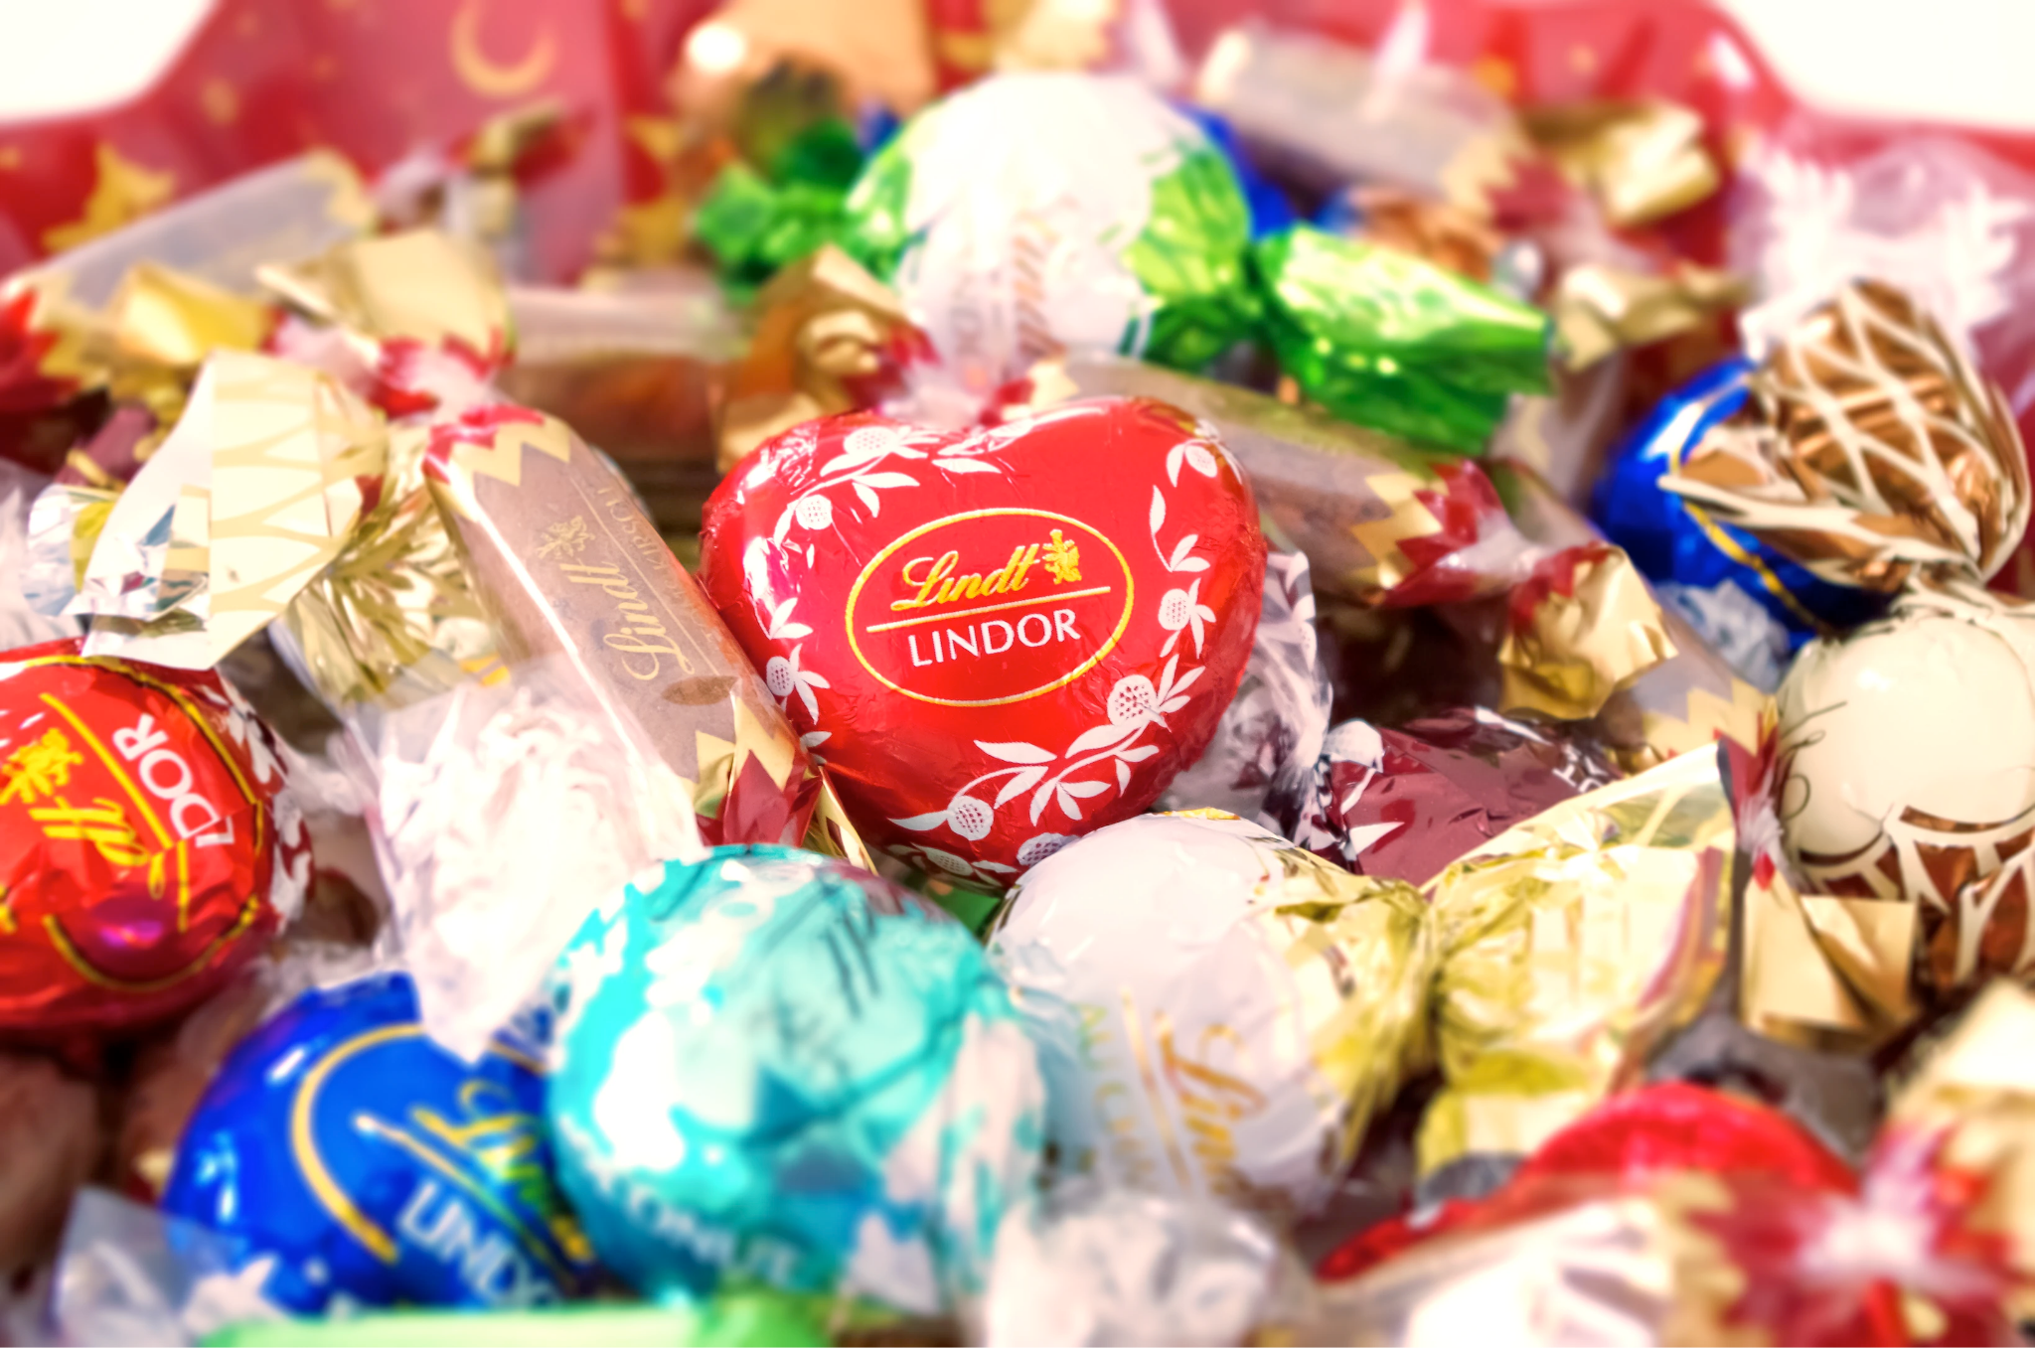
pirogi | fish and chips | čokolada

3.2 Zadatak 2. Moja obitelj
🔊 Listen to the text below and answer the questions in English. As you do so, take notes on the vocabulary/phrases/sentences because you will need them for the task below. You will find some useful vocabulary in this recording.
(audio)

| In English
1 | What do they like / like to do?
 | -
2 | What type of food do they like to eat?
 | -
3 | What is “balkanska hrana”?
 | -
4 | What do they like to drink?
 | -
5 | What type of coffee is popular in Croatia? Can you provide more information about the coffee they drink? Do an online search for more information if needed.
 | -
6 | What is “mediteranska hrana”?
 | -

| In Croatian
Answer to the two questions that you heard in the audio recording.

1 | Pitanje 1.
 | -
2 | Pitanje 2.
 | -

3.2 Zadatak 3. Moja obitelj i interesi
Following the example from the previous task, write about your family. Indicate what your mutual interests are and give a specific interest (or interests) for each member of your nuclear family. Elaborate on specific elements for each interest. For example, if someone has an interest in music, you may say that he/she likes to listen to American/French music.

3.2 Zadatak 4. Moji interesi
💻 Video and written discussion. Think of your interests. What type of food do you like to eat (for example, American food) and what activities do you like? Post your video in the discussion section online. Your classmates will watch your video and provide you with their personal comments, saying whether they do or don’t like to eat and do the same things as you.

No matter what your answer is, post a link related to your interest. For example, if you like to listen to music, post a link of a singer that you know from the area. The link has to be in the target language (i.e., Croatian).

Images used in this document are from these sources.

