1 | 1 | Lekcija 4: Kako ste?

1.1. Zadatak 15. Kako si?
🔊The following dialogues are happening in the hallway at the university.

Part 1
Listen to the first three dialogues between students and mark what each student says about how they feel. Write it down in Croatian.
Kako je [...]: |  |  | 
James? On je...
Laura? Ona je...
Davor? On je…
Sandra? Ona je...
Luka? On je…

Now ask other classmates the same question. Provide an answer that is true for you.
1 | A kako si ti?
 | -

Part 2
🔊 Listen to the dialogues 4 and 5, between students and their professors.
Kako se kaže? [How do you say?]. Look back at both sections (Part 1 and Part 2) and answer the following questions.

1. What do both professors say in response to hearing how their students feel?

1 | Profesor Danijel
 | -
2 | Profesorica Jasna
 | -

2. What do these individuals say to their conversation partners right after greeting them?
1 | Luka asked James:
 | -
2 | Laura asked Sandra:
 | -
3 | Laura asked Prof Jasna:
 | -
4 | James asked Danijel:
 | -

3. What is the follow-up question to the situations in question 2?
1 | James asked Luka:
 | -
2 | Laura asked Sandra:
 | -
3 | Prof Jasna asked Laura:
 | -
4 | Prof Danijel asked James:
 | -

4. Place all the above phrases that you collected in the previous set of questions by the appropriate rubric. Some elements might go in more than one rubric.
Question | Your classmate | Your instructor
Questions for: | → | →
Comments for: | → | →

5. Create a cohesive dialogue with one of your classmates by using the information we covered so far. Things to potentially include:
full name | greetings | feelings
where you’re from | profession | farewell / goodbye phrase

1.1 Zadatak 16. Vidimo se!
🔊 Part 1
Listen to the dialogues 6 and 7. The first one is between two friends (Luka and James), and the second one is between two colleagues (Jasna and Marko). Both dialogues happen at the university when their paths cross in the hallway as they are on their way to their classes. 🤔

Write down the key phrases from each dialogue - something that you can reuse later in your own conversation (something that would be appropriate for a situation in which you might find yourself).

Dijalog 6 (audio)
 | 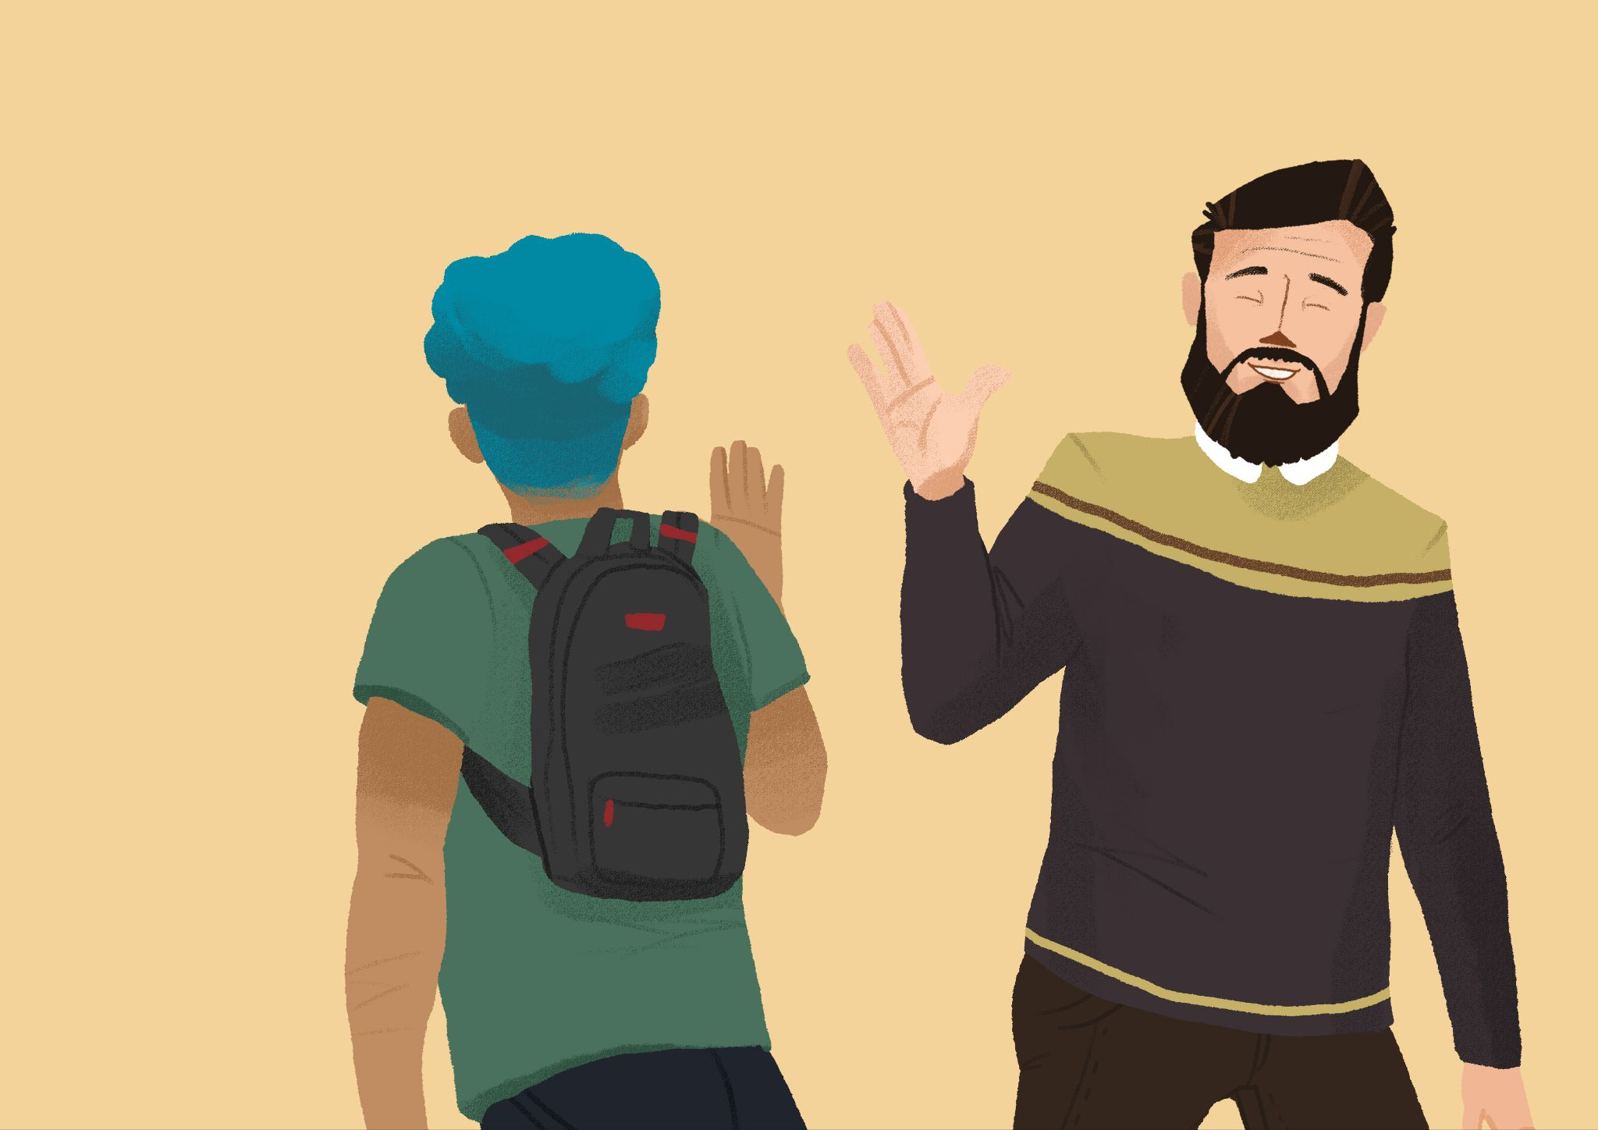

Korisne fraze: →

Dijalog 7 (audio)
 | 

Korisne fraze: →

Part 2
Talk with a classmate in order to complete the task. Choose one of the two possible scenarios.
 | 
Scenario 1: You meet your close friend in the city. Create a dialogue where you greet your friend, ask how he/she is doing, and say you’ll see each other later. | Scenario 2: You are at the university and you see your professor in the hallway. Greet each other and make small talk. One of you needs to be the professor.

