2 | 3 | Lekcija 2: Vikend putovanje

2.3 Zadatak 4. Slobodno vrijeme
Talk to your classmates and find out what they like to do in their free time. When you collect information from all of your classmates, see who you have the most in common with.
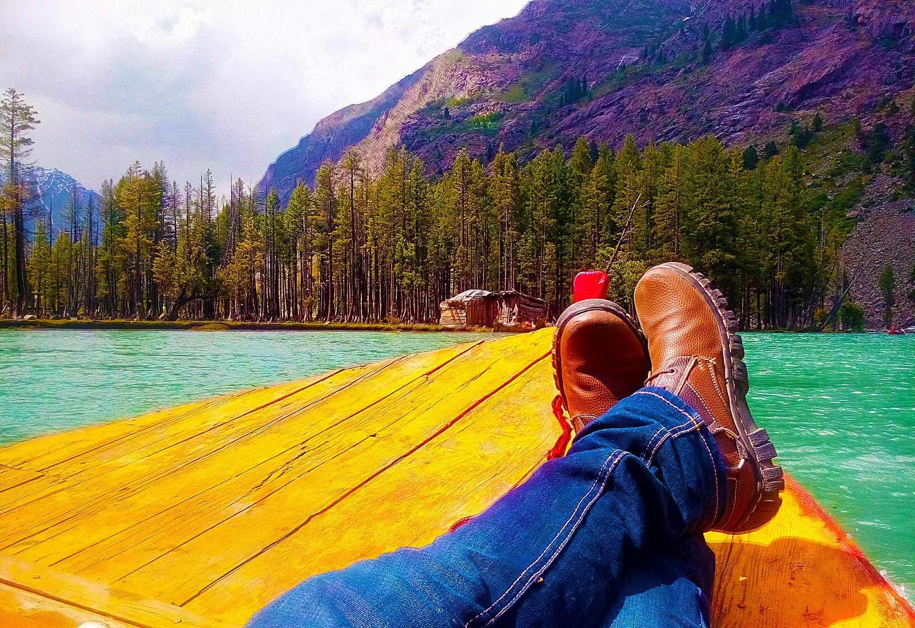 | 

Tko? | U slobodno vrijeme on/ona…
↦ | ↦
↦ | ↦
↦ | ↦
↦ | ↦
↦ | ↦
↦ | ↦
Now you will present your findings to your instructor. You should use the following structure: [James] i ja smo dobra kombinacija! Mi volimo [slušati muziku], [čitati knjige] i volimo ići [u muzej].

2.3 Zadatak 5. Što za vikend?

Part 1
 | 
Work with the classmate you had the most in common with from the previous task. Ask each other about what you want to do for the weekend. Name at least 5 things you want to do. Write his/her answers. Example:

Što ti želiš raditi za vikend?
Ja želim ići [u muzej]

When writing the answers that your classmate tells you, you should start the sentence with: [James] želi...
[odgovor] →
[odgovor] →
[odgovor] →
[odgovor] →
[odgovor] →

Part 2
Based on the answers that you have collected, list appropriate places in your city where you can take your friend. Provide at least two options for each day. Follow the example: U četvrtak mi idemo u muzej gledati izložbu. Muzej se zove Muzej iluzija.
Ovo je moj plan!
Kada? | Tko? | Kamo?
u petak | mi idemo | →
u subotu | mi idemo | →
u nedjelju | mi idemo | →

Part 3
3️⃣ Present your ideas to your classmate. See if they agree with your choice. Follow the example:

Što kažeš da ovaj vikend idem u kazalište pogledati izložbu?
Da, dobra ideja! Želim ići u muzej. —or— Ne, ne želim ići u muzej.

If your classmate does not agree, ask where he/she wants to go. – Kamo želiš ići? Write the final weekend schedule based on what you both agreed on.

Planovi za vikend:
Kada? | Tko? | Kamo?
u petak | mi idemo | →
u subotu | mi idemo | →
u nedjelju | mi idemo | →

2.3 Zadatak 6. Idemo u BiH
🔊 Listen to the conversation between Laura and Mario.
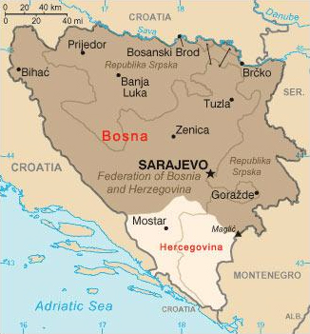 | 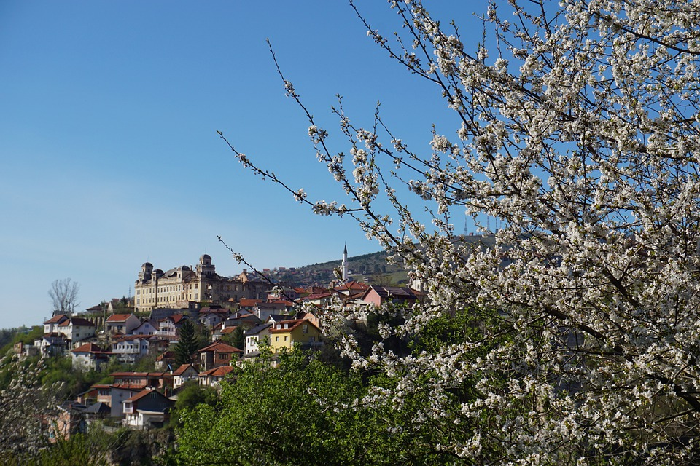 | 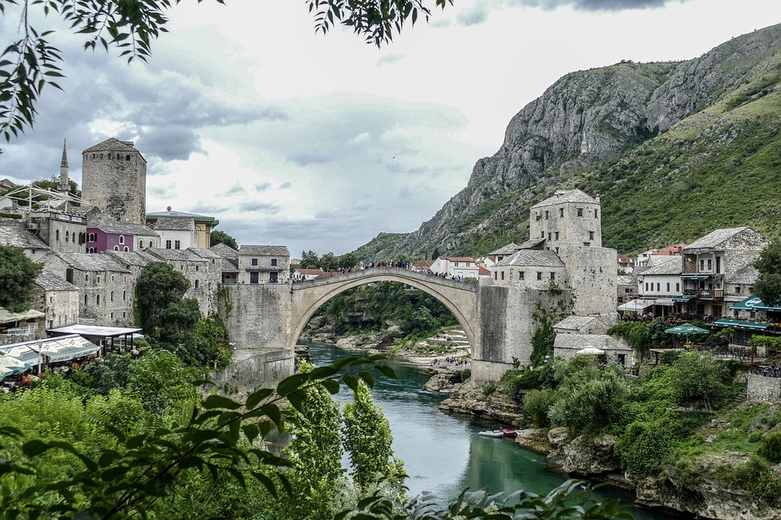
Talk with a classmate. Ask the following questions in order to check you both understand the text.
1 | Kamo Laura želi ići?
 | -
2 | Zašto Laura želi ići tamo?
 | -
3 | Koji grad ona želi posjetiti?
 | -
4 | Što Laura želi posjetiti u gradu?
 | -
5 | Što Laura mora posjetiti ako ide u Sarajevo?
 | -
6 | U koliko sati otvara muzej?
 | -
7 | U koliko sati zatvara muzej?
 | -

2.3 Zadatak 7. Moj prijedlog za BiH
 | 
Search online for potential places that could fit Laura’s interest. Choose Sarajevo or Mostar. For each of her points of interest (listed below), find at least two locations. Fill in the chart with appropriate information.
pitanje / lokacija | Kako se zove?  Koja je adresa? | U koliko sati otvara? | U koliko sati zatvara?
muzej
trg
restoran

2.3 Zadatak 8. E-mail
 | 
Reply to Laura and give her your suggestions. Below are some phrases that can help you in your writing:
hrvatski | engleski
Trebaš ići... | [You need to go]
Trebaš vidjeti... | [You need to see]
Moraš vidjeti… | [You must see]
Mislim da… | [I think that]

Draga Laura,
nadam se da si dobro. Znam da planiraš ići u Bosnu i Hercegovinu. Ovo je moj savjet što trebaš POSJETITI.

Puno pozdrava,
Mario _________
Images used in this document are from these sources.

