# 8.6 - Future Tense of Imperfective Verbs

[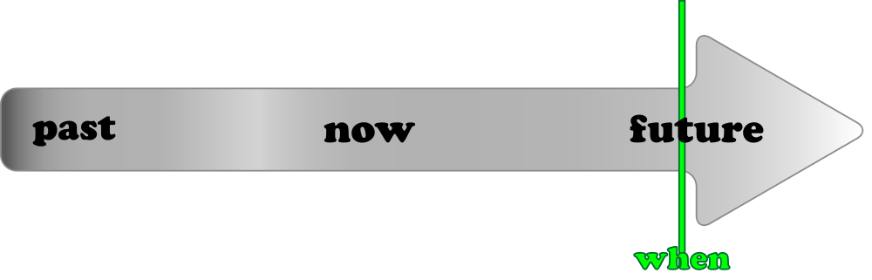](https://commons.wikimedia.org/wiki/File:EGG_Future_simple.svg)

In this lesson we will learn how to conjugate **imperfective** verbs in the future tense. We will ultimately learn to put perfective verbs in the future as well (they form their future tenses differently) and we will focus on the differences between them.

So, what will it mean to put an imperfective verb in the future tense?

| Remember – the imperfective focuses on the activity itself, and not the act as a completed whole. We can think of imperfective verbs as a sort of unbounded activity like this line on the right: |  |
| --- | --- |

So if you talking about something in the future that is just going to be a general activity or something that you will frequently/regularly do, then the imperfective future will come in handy.

In general, this is pretty simple provided you know the forms of the verb *být* in the future tense:

| (já) | **budu** | (my) | **budeme** |
| --- | --- | --- | --- |
| (ty) | **budeš** | (vy) | **budete** |
| (on/ona/ono) | **bude** | (oni/ony/ona) | **budou** |

| Imperfective Future: | *budu, budeš…* + **infinitive** |
| --- | --- |

The future tense of imperfective verbs is formed by simply taking the conjugated forms *budu, budeš…* and combining them with the infinitive of an imperfective verb, e.g. -

***Budu zpívat****.*

‘I will sing.’

***Budeme tančit****.*

‘We will dance.’

In many instances, the forms *budu, budeš…* can be separated from the infinitive. Czech word order is rather free in this regard:

*V sobotu* ***budu spát*** *celý den.*

‘On Saturday I’m going to sleep all day.’

*Zítra Sára a Bedřich* ***budou uklízet*** *byt.*

‘Sára and Bedřich will clean their apartment.’

(i.e. work on cleaning -- since it is imperfective, this sentence does not specify whether it will be completed)

*Příští týden Lenka* ***bude vstávat*** *každý den v sedm hodin.*

Next week Lenka is going to get up every day at 7 o’clock.

Also note how the infinitive will frequently not be right next to the forms of *budu, budeš...*

*Kde* ***bude*** *Tomáš* ***bydlet****?*

Where will Tomáš live?

**Budu** trochu **pracovat**.

I will work a little.

Negating the Future Tense

To say you will not do something, simply negate *budu, budeš…* and follow with the infinitive:

Dnes večer **nebudu pracovat**.

‘This evening I am not going to work.’

*Bolí mě noha, a tak* ***nebudu běhat****.*

‘My leg hurts and so I’m not going to run.’

One More Note on Negation – Comparison with Past Tense

| **Negation in Past Tense is on l-form**  (i.e. *nepracoval*, *nevařila*, *neuklízeli*) | **Negation in Future is on *budu***  (i.e. *nebudu, nebudeš…*) |
| --- | --- |
| *Nepracoval jsem.*  I didn’t work.  *Proč jsi nevařila?*  Why weren’t cooking?  *Neuklízeli jsme.*  We weren’t cleaning. | *Nebudu pracovat.*  I didn’t work.  *Proč nebudeš vařit?*  Why won’t you be cooking?  *Nebudeme uklízet.*  We won’t be cleaning. |

Images used in this document come from [these sources](https://docs.google.com/document/d/1HQqSIqnOQo0_cjj3ZbBSyDe-fgq1AEZhIxgZ_W4CIUA/edit#heading=h.wf5yloy6c9jy).