4 | 1 | Lekcija 4: Gdje živiš?

# | Ordinal Numbers

So far in Croatian you have learned to count using the cardinal numbers. In the table below you will find the associated ordinal numbers.

| **prvi** | **drugi** | **treći** | **četvrti** | **peti** |
| --- | --- | --- | --- | --- |
| *first* | *second* | *third* | *fourth* | *fifth* |
| **šesti** | **sedmi** | **osmi** | **deveti** | **deseti** |
| *sixth* | *seventh* | *eighth* | *ninth* | *tenth* |

The ordinal numbers in Croatian are adjectives and agree with the noun they modify. With the exception of *treći*, they all have regular adjective endings. *Treći* has the following forms that occur because of the final -ć (i.e., in masculine and neuter gender it takes the ending -em instead of -om).

|  | **Masculine** | **Feminine** | **Neuter** |
| --- | --- | --- | --- |
| Nominative singular | prvi kat | prva kuća | prvo selo |
| Locative singular | na prvom katu | u prvoj kući | u prvom selu |

|  | **Masculine** | **Feminine** | **Neuter** |
| --- | --- | --- | --- |
| Nominative singular | treći kat | treća kuća | treće selo |
| Locative singular | na trećem katu | u trećoj kući | u trećem selu |

# 4.1 Zadatak 13. U redu u banci

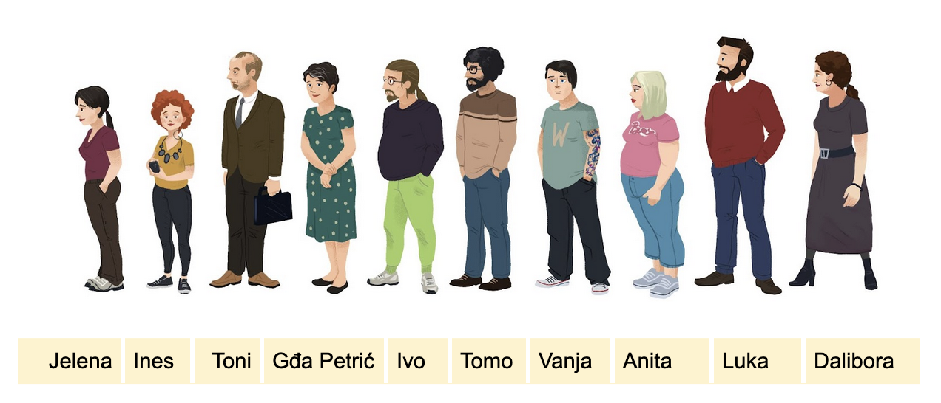[h5p id="562"]

# 4.1 Zadatak 14. Na kojem mjestu?



[h5p id="564"]

# 4.1 Zadatak 15. Sunčev sustav

[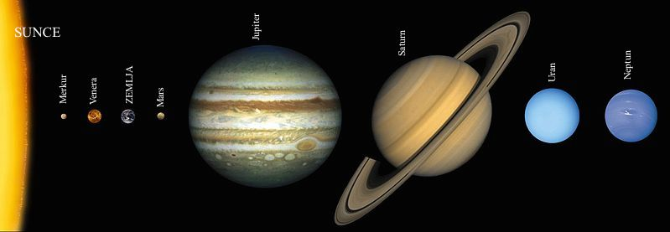](https://hr.wikipedia.org/wiki/Sun%C4%8Dev_sustav#/media/Datoteka:Suncev_sustav_01.jpg)

[h5p id="565"]

Images used in this document are from [these sources](https://docs.google.com/document/d/1pj8BvPoU0O1H8zqCrpgvm5wtIiy2hWpBdmIeX2VTawQ/edit#heading=h.byyff2tb0eez).