6 | 1 | Lekcija 2: Izlet za vikend

# | Vremenske (ne)prilike

Read the statement and choose the corresponding picture.

[h5p id="660"]

# | The noun vrijeme

The Croatian word for weather is ***vrijeme***. To ask about the weather, you can say: ***Kakvo će biti vrijeme?***

| [Danas] će biti lijepo vrijeme. | Bit će lijepo vrijeme. |
| --- | --- |
| [Danas] će biti ružno vrijeme. | Bit će ružno vrijeme. |

[h5p id="460"]

To be more specific about the weather forecast, we can say: ***Bit će…***

|  |  |  |  |
| --- | --- | --- | --- |
| vruće | toplo | hladno | sunčano |
|  |  |  |  |
| kišovito | snježno | vjetrovito | maglovito |

# | Temperatura

In Croatia the temperature is expressed in Celsius. Look at the chart to get a sense of how Fahrenheit and Celsius temperatures compare.

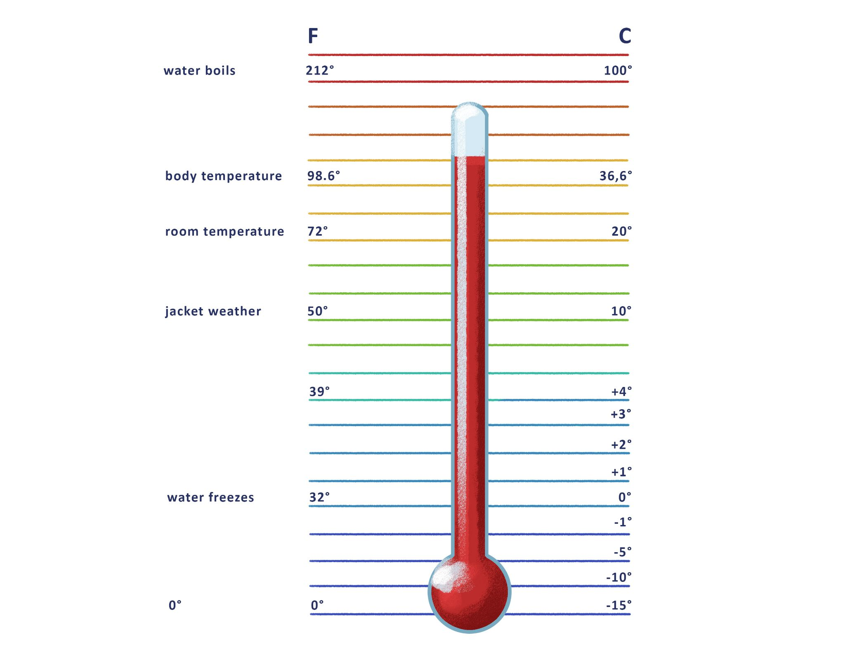

# 6.1 Zadatak 5. Temperatura

Read the following sentences and decide what the weather is like.

[h5p id="714"]

# 6.1 Zadatak 6. Vremenska prognoza

|  |  |
| --- | --- |

Let’s learn some basic vocabulary about the compass and geography. Look at the list of Croatian terminology and choose the English equivalent. The pictures above will help you choose the correct term.

[h5p id="752"]

Drag and drop. Place each term in the correct position.

[h5p id="753"]

Now that you have covered the basic terminology, check your knowledge of Croatian geography. Choose the image that corresponds to each statement.

[h5p id="751"]

# | Vremenska prognoza

|  |  |
| --- | --- |

Watch the following [**video**](https://www.youtube.com/watch?v=8H84L9lqe3s&t=1s) and indicate the correct answer(s) about the weather forecast in Croatia.

[h5p id="749"]

Images used above are from [these sources](https://docs.google.com/document/d/1NWPoZHtjl7iotNRUzt5j3rlsJlB7YnghpZX0_0Wqm9k/edit#heading=h.sunyral40mto).