# 8.2 - učebnice matematiky, hodina biologie

If you want to describe your textbook or your class (Czech class, math textbook, etc.) in Czech, you will literally say *class of biology*, *textbook of math*. The crucial bit of information here is that you say *of*. What case do you need here then?

[](https://commons.wikimedia.org/wiki/File:Gorilla_Scratching_Head_(18047130741).jpg)

[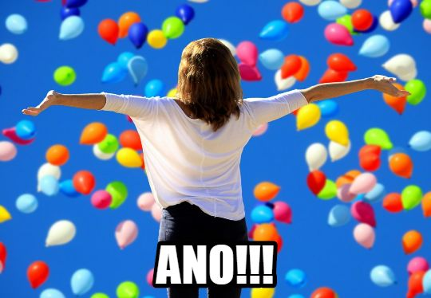](https://pxhere.com/en/photo/1380074)

Here’s a reminder of your endings:

**Genitive (koho, čeho)**

|  | **MA** | **MI** | **F** | **N** |
| --- | --- | --- | --- | --- |
| **Hard stem nouns** | *pána* | *hradu (-a)* | *ženy* | *města* |
| **Soft stem nouns** | *muže* | *počítače* | *růže / koleje / věci* | *moře / náměstí* |
| **Adjectives** | *-ého / -ího* | *-ého / -ího* | *-é / -í* | *-ého / -ího* |

The main words we’ll need to keep in mind are our subjects and the following words:

*učebnice* - textbook

*kurz* - course

*hodina* - class (lit. hour, since that’s how long most classes last).

*učebnice matematiky* - a math textbook

*kurz biologie* - a biology course

*hodina geologie* - geology class

Images used in this document come from [these sources](https://docs.google.com/document/d/1HQqSIqnOQo0_cjj3ZbBSyDe-fgq1AEZhIxgZ_W4CIUA/edit#heading=h.7oov9bpcge89).