1 | 3 | Lekcija 2: Moji prijatelji

1.3 Zadatak 3. Matija i Antonio
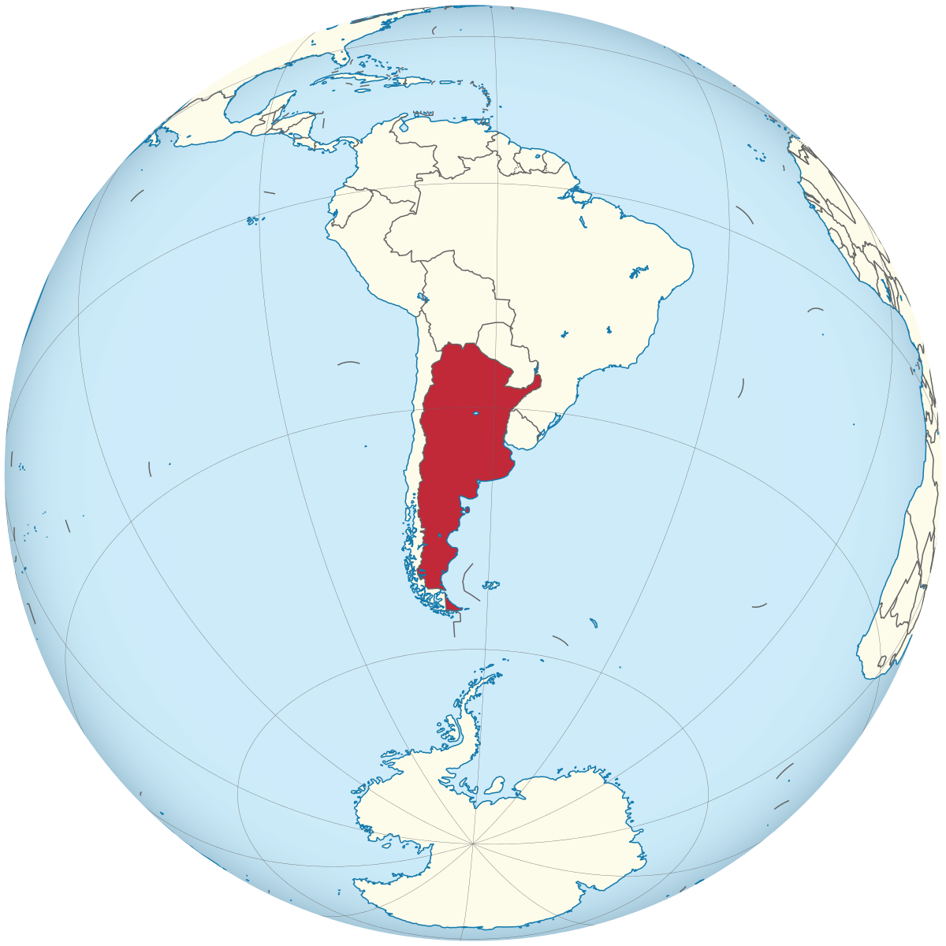 | 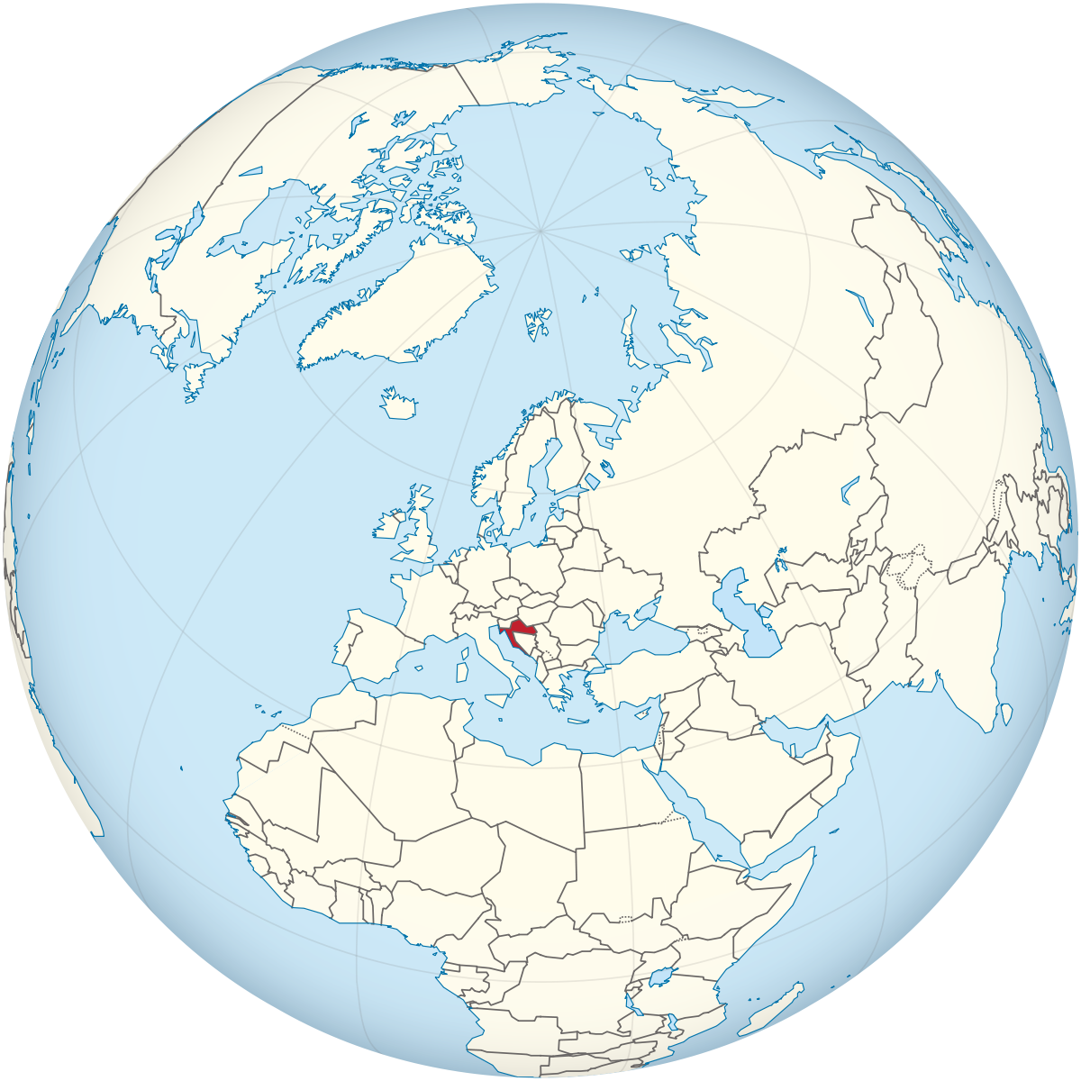 | 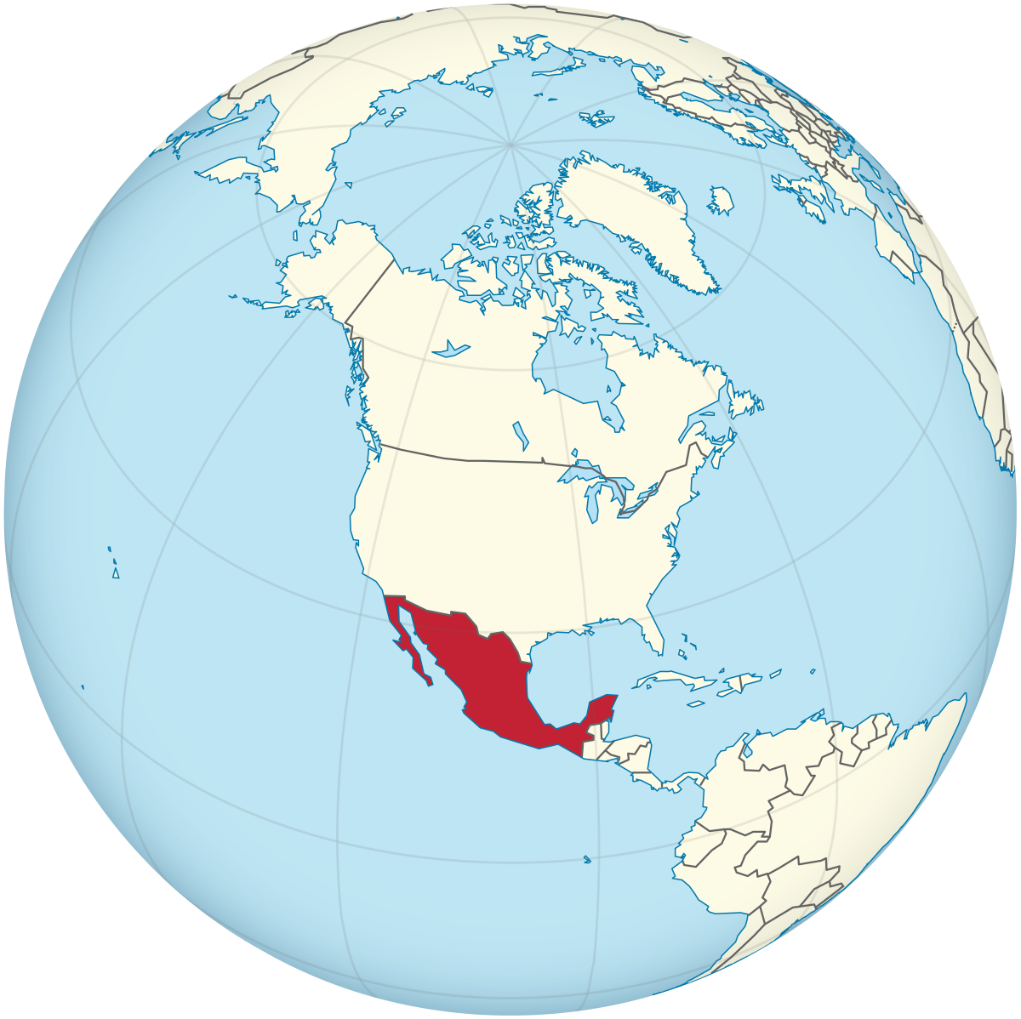
🔊 Listen to the dialogue and answer the questions.
(audio)

| Razumijevanje
1 | Odakle je Matija?
 | -
2 | Što Matija studira?
 | -
3 | Je li studij zanimljiv?
 | -
4 | Je li Antonio ekonomist?
 | -
5 | Odakle je Antonio?
 | -
6 | Odakle su njegovi roditelji?
 | -
7 | Kakav je grad Split?
 | -

1.3 Zadatak 4. Prijatelji
🔊 Listen to the story that Sandra tells about her friends and provide the following information about each character. Not all the elements are present for each character. Fill in the blanks in English.

(audio)
 | 

Name
Favorite place and the address
Nationality
Profession
Description

1.3 Zadatak 5. Moj grad
 | 
💻 Video recording. For this assignment you need to prepare Google slides about yourself and your city. Follow the example in the listening section from class and the homework session. Tell us about yourself and your city (what it looks like) and include at least 5 locations that someone should see/visit when there. Provide your opinion about each location.

You will need to take notes about your classmates and their presentations. The next day, you will be paired with someone in your class to discuss what you learned about other classmates.

Images used in this document are from these sources.

