1 | 1 | Lekcija 6: Roditelji

1.1 Zadatak 24. Kako se zovu?
Answer the following questions so that they are true for you. Give the names of your parents and friends.
Pitanje: | Odgovor:
Kako se zove tvoj tata? | Moj tata se zove:
Kako se zove tvoj prijatelj? | Moj prijatelj se zove:
Kako se zove tvoja mama? | Moja mama se zove:
Kako se zove tvoja prijateljica? | Moja prijateljica se zove:

1.1 Zadatak 25. Kakvi su oni?
Now, give a bit more information about the people in your life. How are they? Are they good/nice, likable, dear to you, tall, or short? Choose one of the options below. You can add more than one characteristic for each person.
Pitanje: | Odgovor:
Kakav je tvoj tata? | Moj tata je:
Kakav je tvoj prijatelj? | Moj prijatelj je:
Kakva je tvoja mama? | Moja mama je:
Kakva je tvoja prijateljica? | Moja prijateljica je:

Tata/prijatelj je…
dobar | simpatičan | drag | visok | nizak
Mama/prijateljica je…
dobra | simpatična | draga | visoka | niska

1.1 Zadatak 26. Što su oni?
Provide even more information about the people in your life by giving their profession. Choose one of the options below. You can add more than one profession for each person.
Pitanje: | Odgovor:
Što je tvoj tata? | Moj tata je:
Što je tvoj prijatelj? | Moj prijatelj je:
Što je tvoja mama? | Moja mama je:
Što je tvoja prijateljica? | Moja prijateljica je:

Tata/prijatelj je…
 |  |  |  | 
profesor | ekonomist | liječnik | odvjetnik | menadžer
 |  | 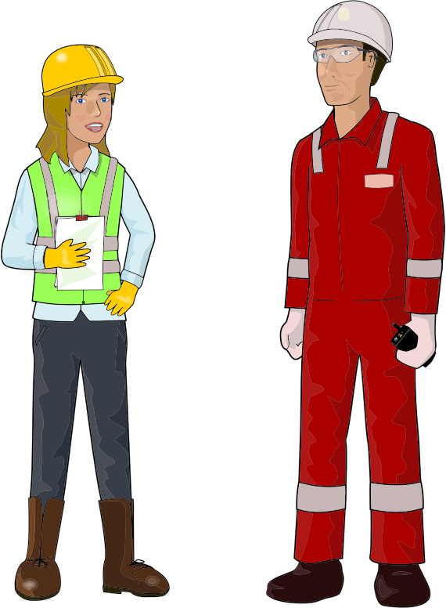 |  | 
glumac | policajac | inženjer | arhitekt | boksač
 | 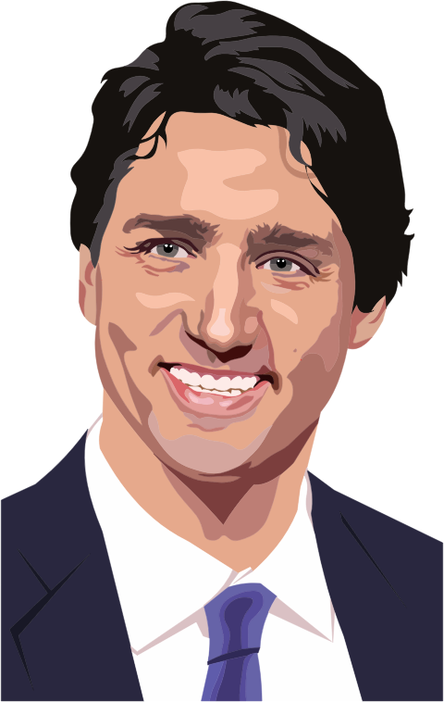 |  |  | 
pjevač | političar | dizajner | novinar | programer
 |  | 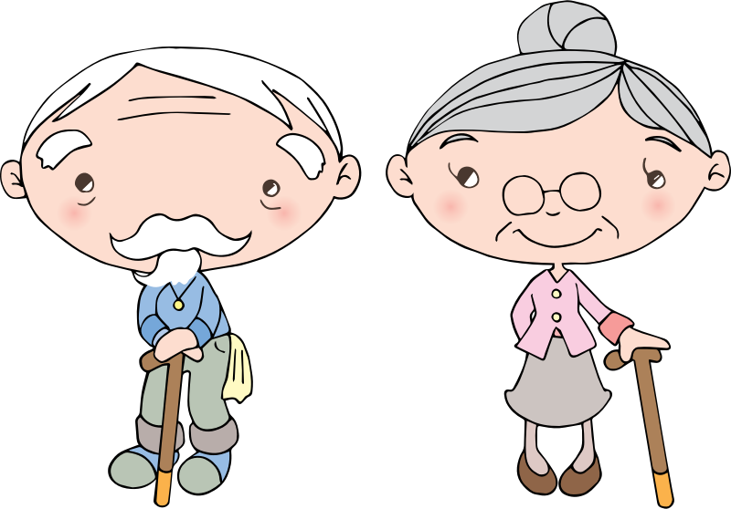 | 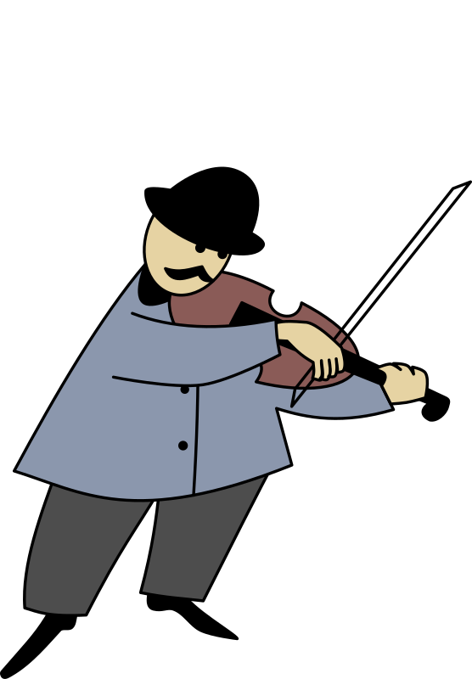 | 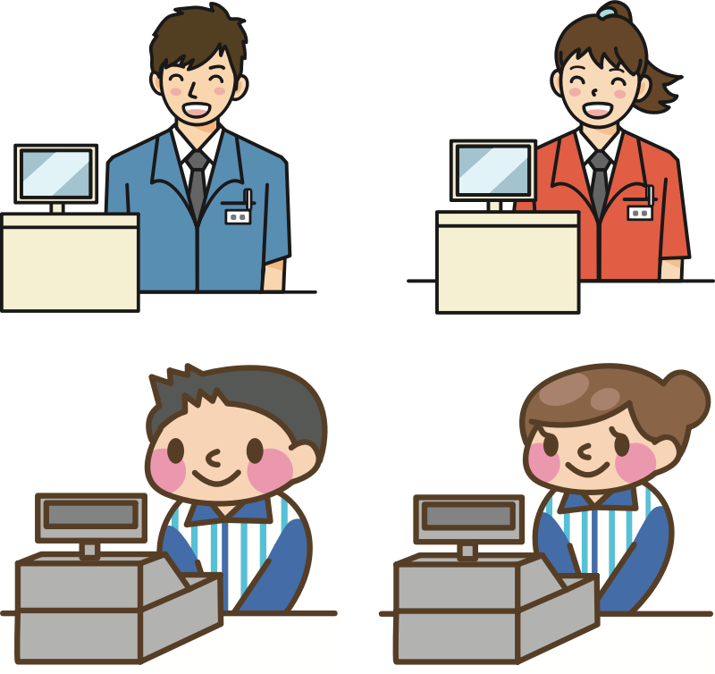
umjetnik | kuhar | umirovljenik (penzioner) | glazbenik | prodavač

Mama/prijateljica je…
 |  |  |  | 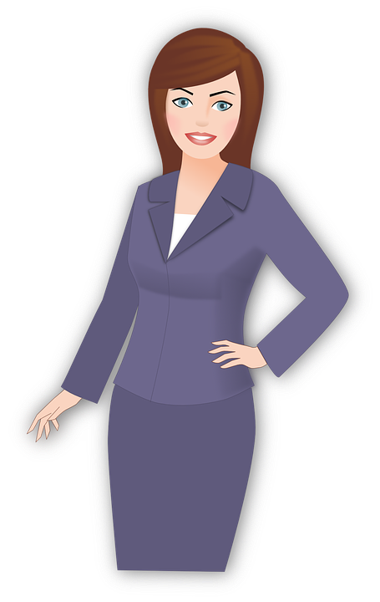
profesorica | ekonomistica | liječnica | odvjetnica | menadžerica
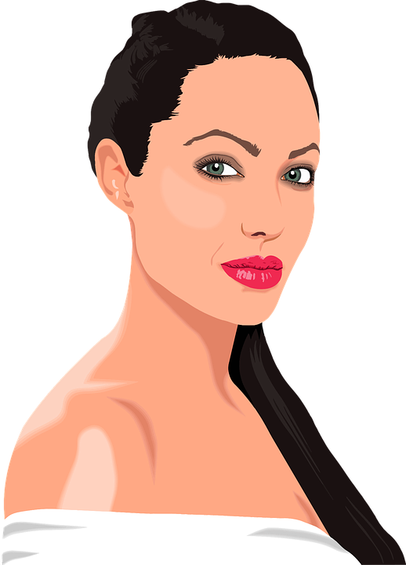 |  |  |  | 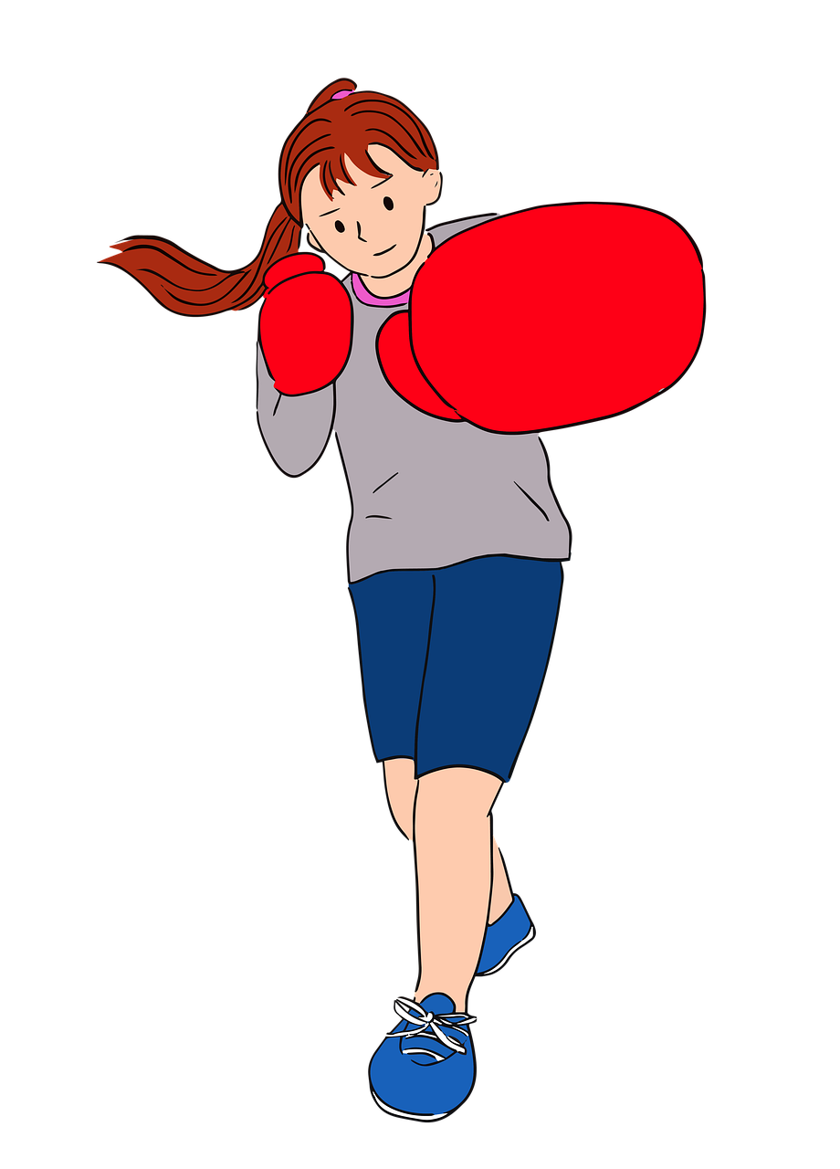
glumica | policajka | inženjerka | arhitektica | boksačica
 | 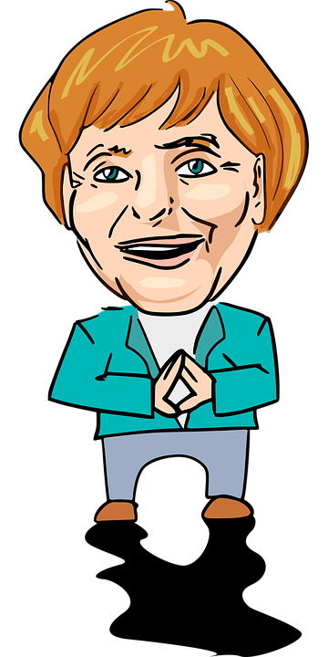 | 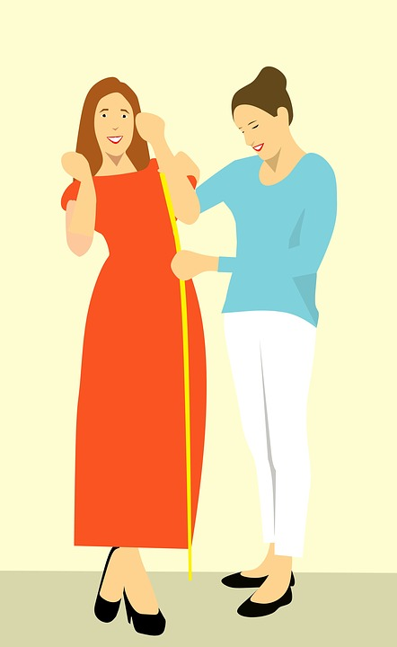 | 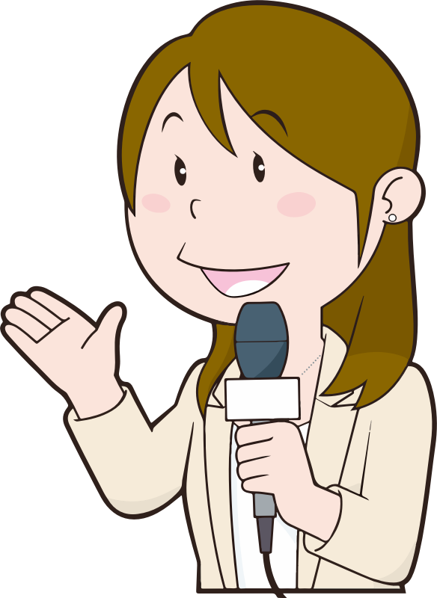 | 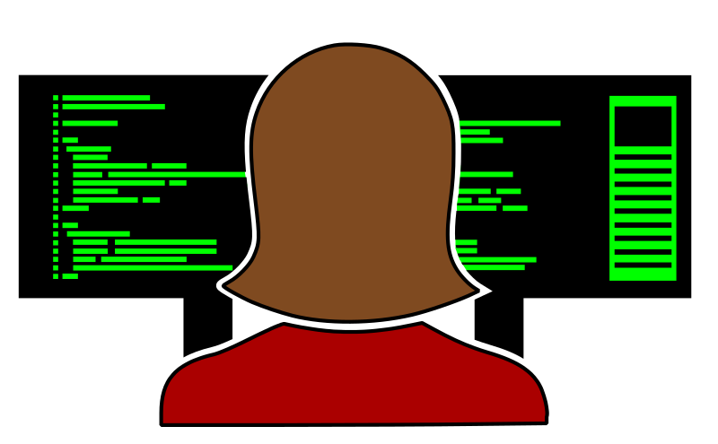
pjevačica | političarka | dizajnerica | novinarka | programerka
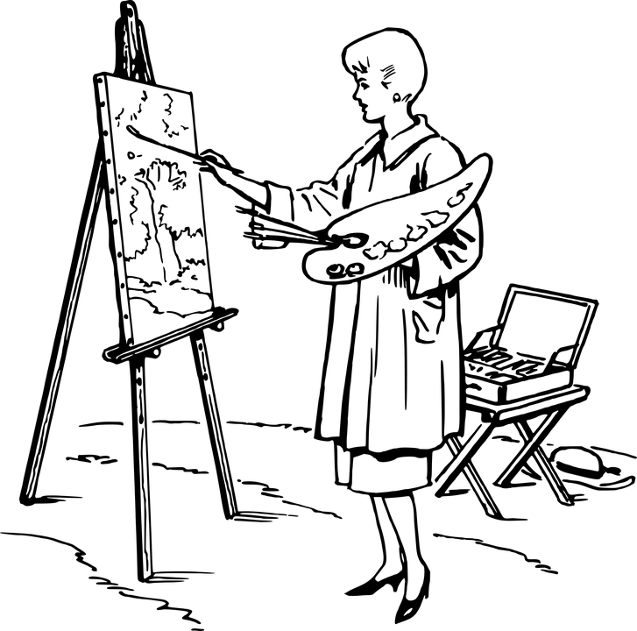 | 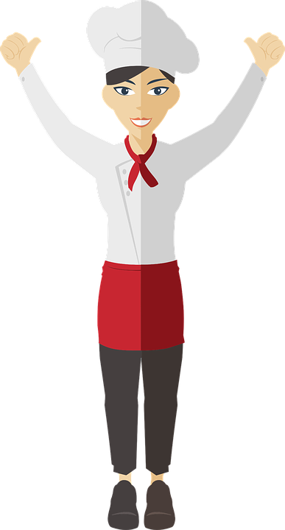 |  | 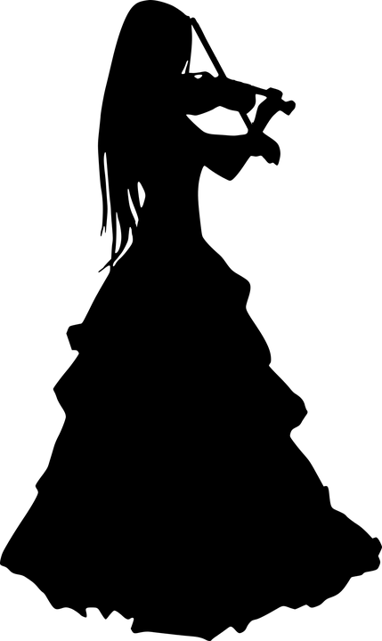
umjetnica | kuharica | umirovljenica (penzionerka) | glazbenica | prodavačica

When you are done, talk with two of your classmates and find out more about the people in their life. Share the information above about your family and friends. Take notes on what your classmates tell you about their family. You will report on what they say later, so you will need to note their responses here.
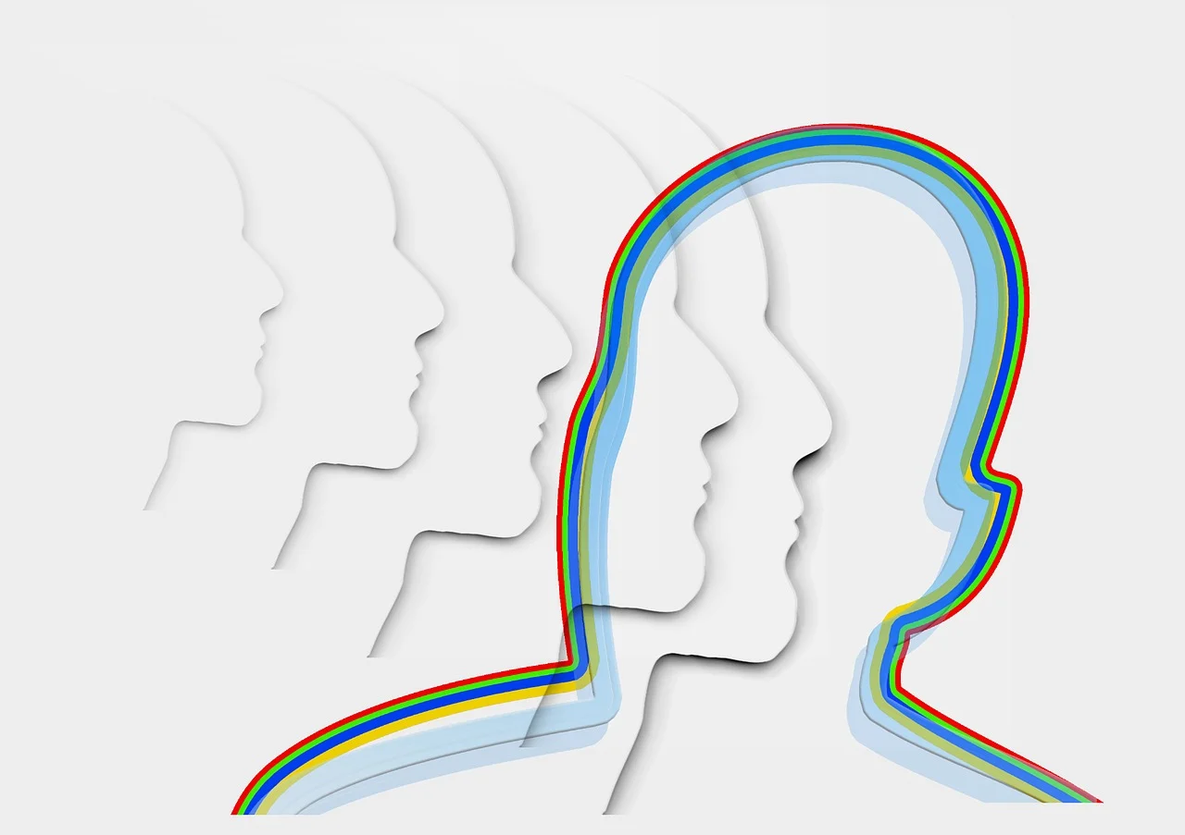 | 
Student 1 | Student 2
- | -

1.1 Zadatak 27. Moj novi prijatelj
🔊 Luka is talking with Matija about his new friend. Listen to dialogue one and complete the task below.

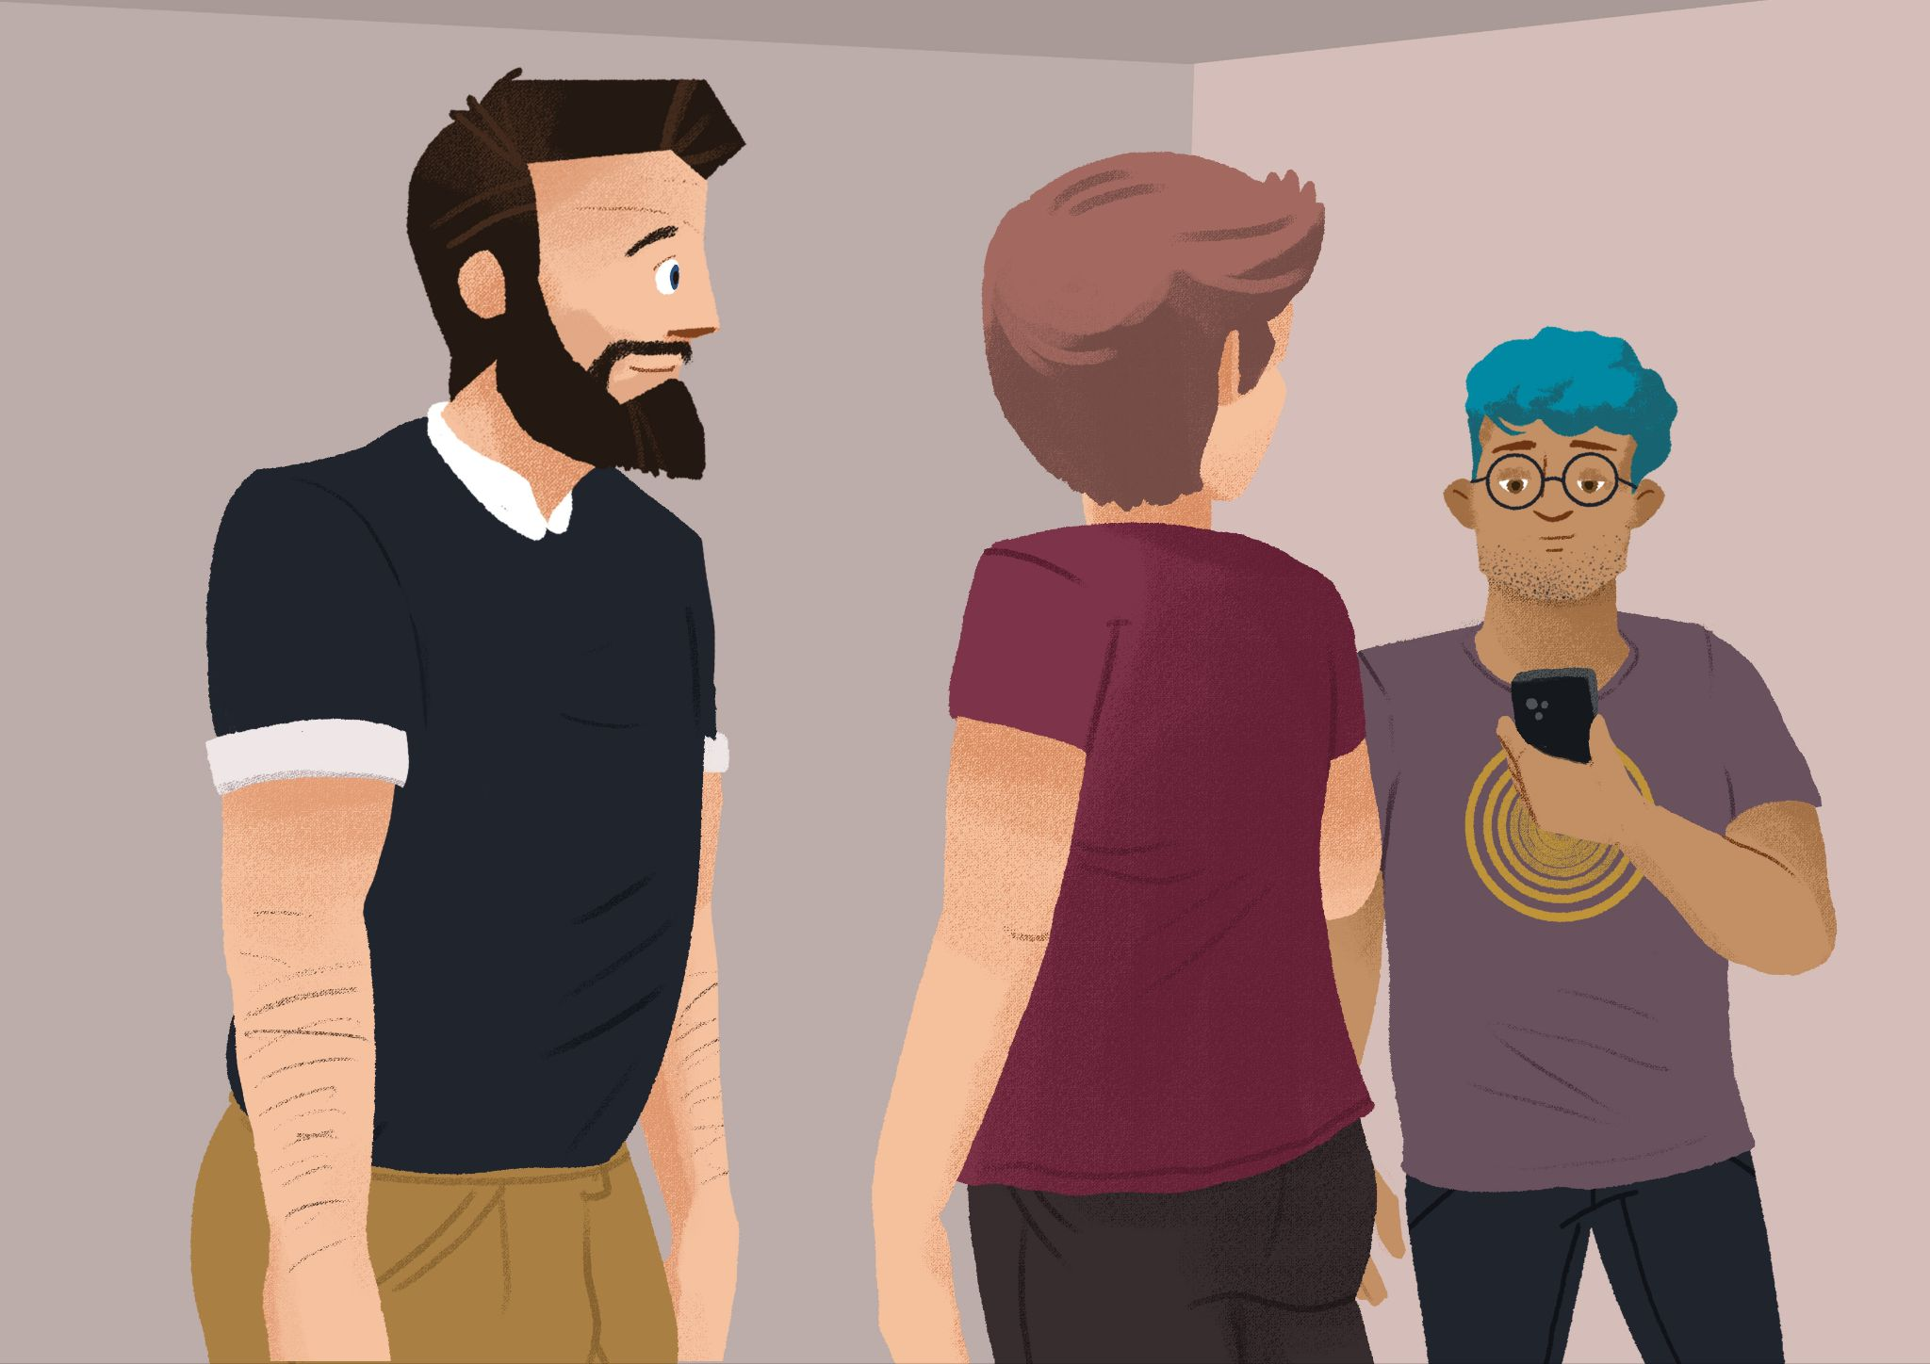 | 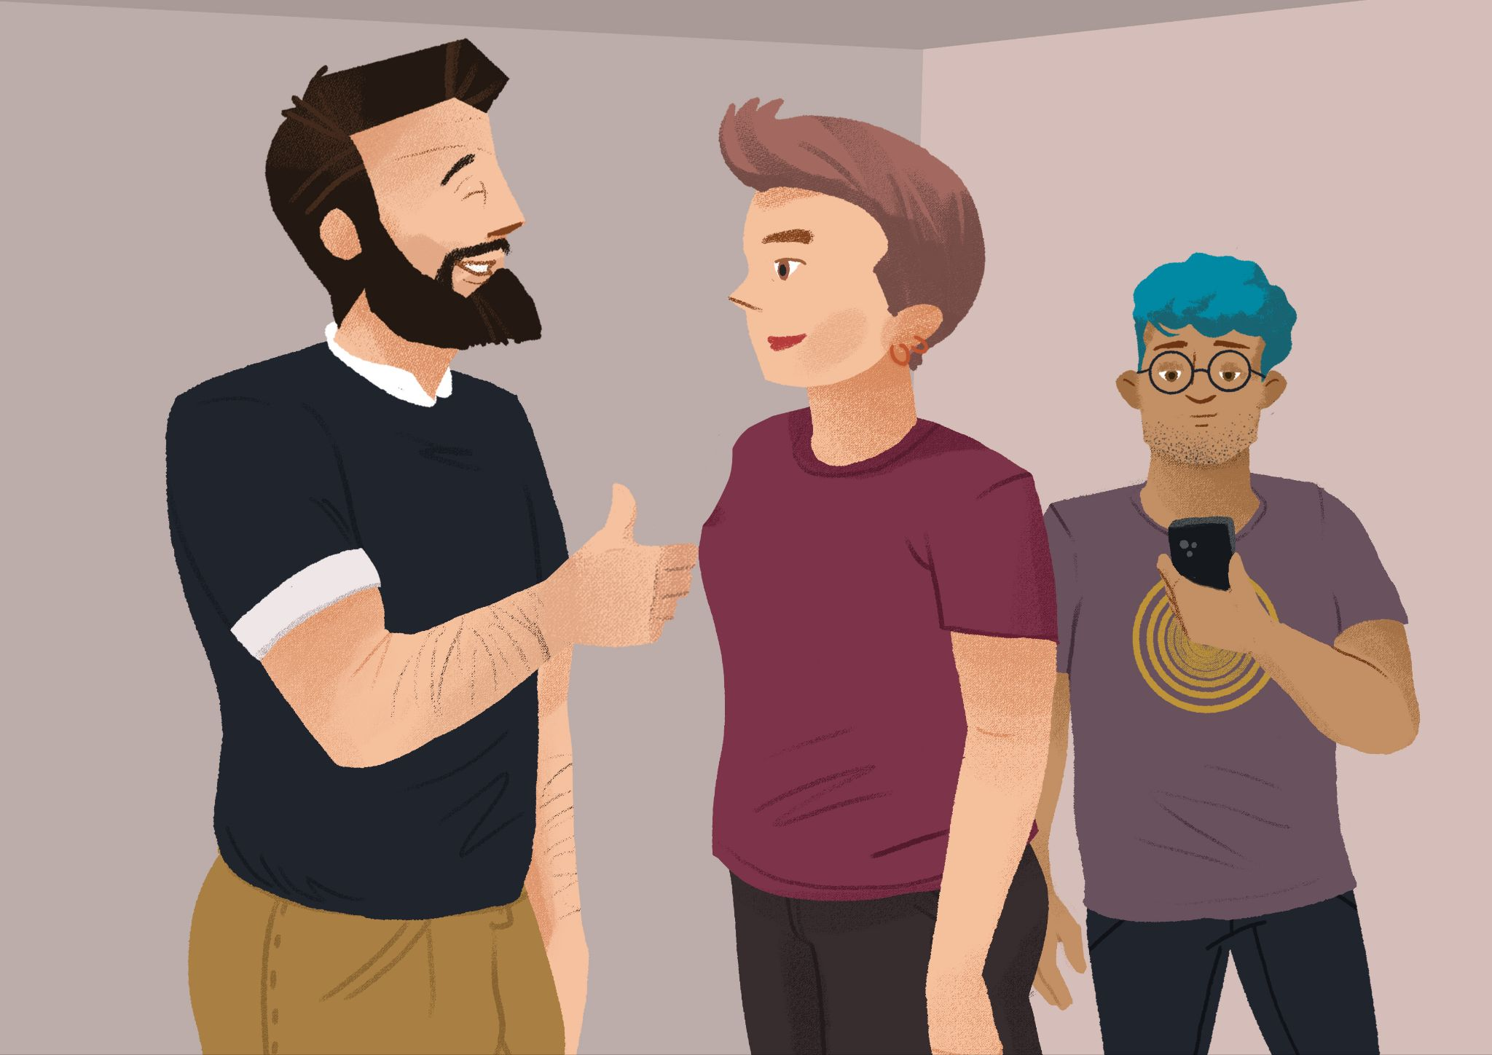

1 | Kako se zove novi student?
 | -
2 | Odakle je on?
 | -
3 | Kakav je on?
 | -

1.1 Zadatak 28. Upoznajmo se
🔊 Listen to dialogue two between James and Luka. They are getting to know each other better. While you listen to their conversation, make notes on what information Luka gives to James.
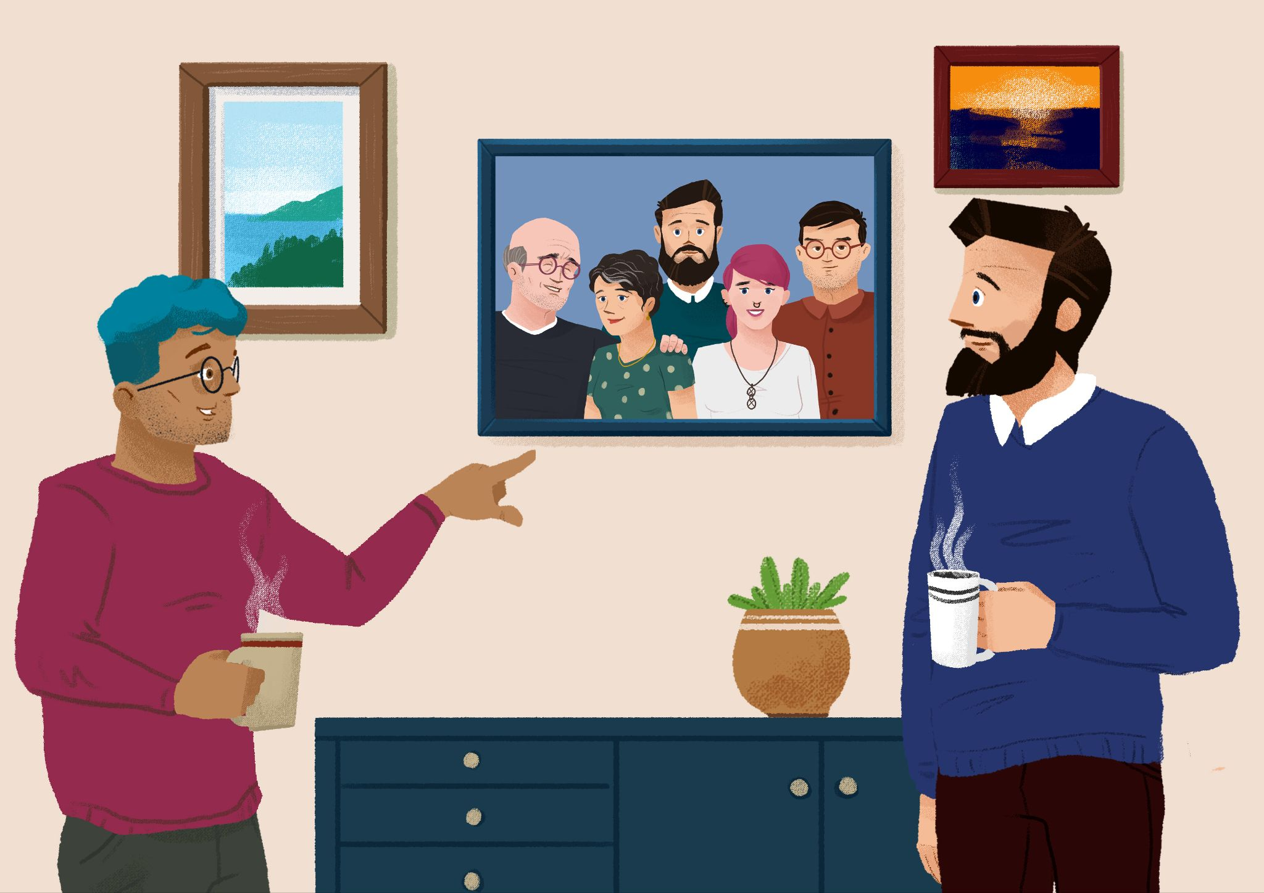 | 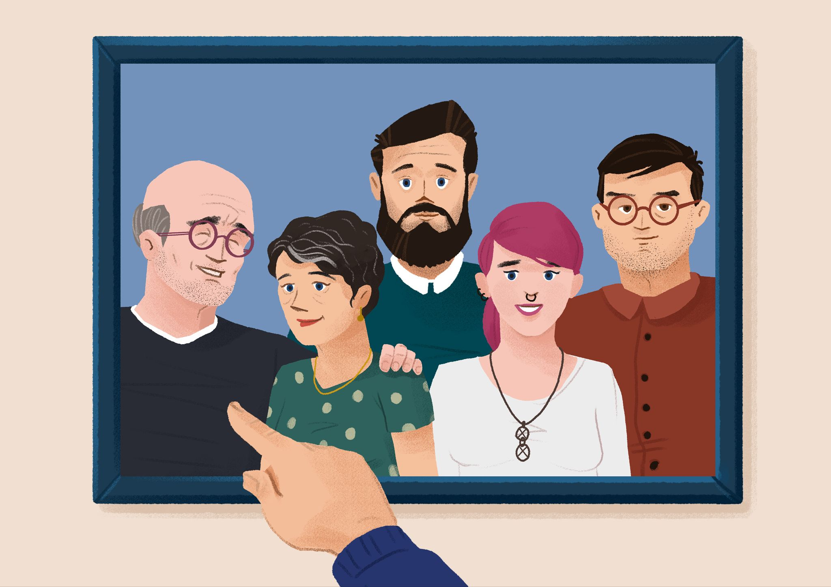

TATA | →
BRAT | →
MAMA | →
SESTRA | →

Now look at the information that James wrote down about Luka, and what he found out about his parents and friends. Did James get everything right? Would you change and/or add any information? Read through the text carefully and mark all the words that are wrong (if any).

Ovo je moj prijatelj Luka. Njegov tata se zove *Igor*. Njegov tata je arhitekt. Njegov tata je *simpatičan*. Njegova mama se zove Tamara. Njegova mama je *doktorica*. Njegova mama je dobra i draga. Njegov brat se zove *Tomislav*. Njegov brat je *student*. Njegov brat je *simpatičan*. Njegova *prijateljica* se zove Emanuela. Njegova sestra je također *arhitektica*.

1 | What do you know about Luka? Tell us your version about Luka.
 | -
2 | Finally, do you remember what James said when he learned the name of Luka’s mother?
 | -

1.1 Zadatak 29. Njezina mama i njezin tata
While Luka was talking with James, Laura (a new student from the USA) was talking with two other students at her University in Zagreb.
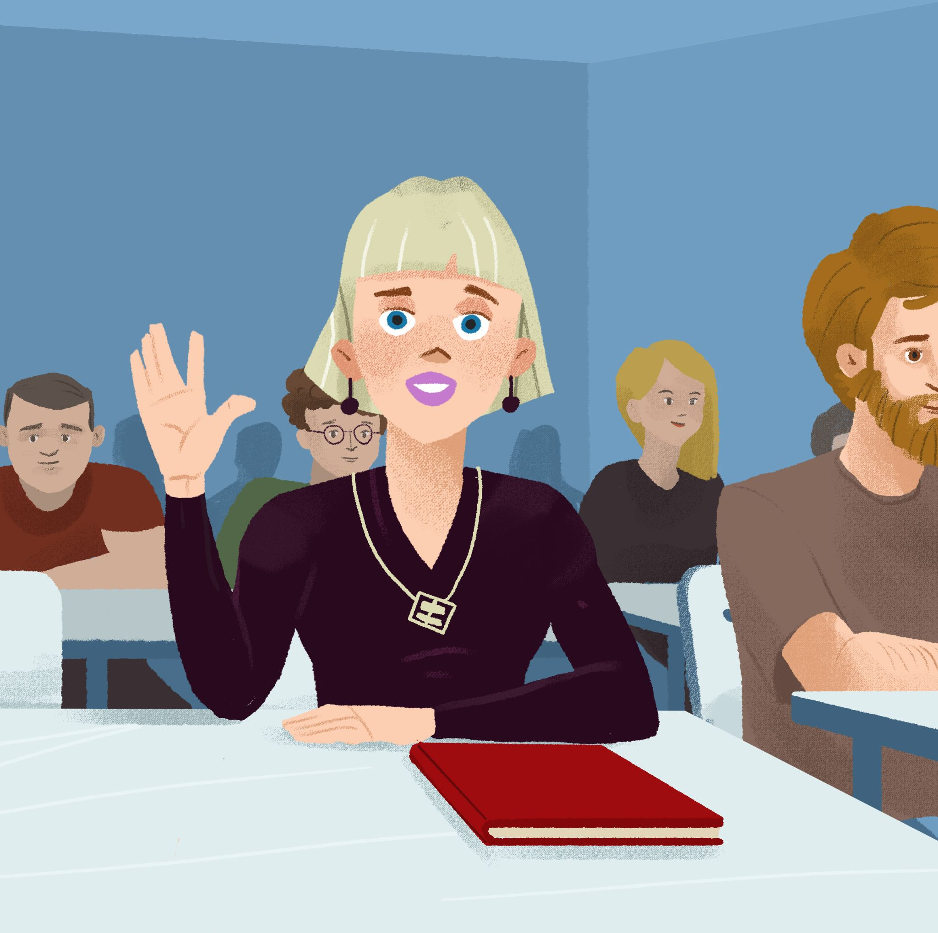 | 
📄 Handout. Each of you will receive information about one person (Laura, Sandra, or Ivana). Pretend that you are that character. All together you should create a similar dialogue to the one between James and Luka – one with similar information about the other two students. When you are done with your dialogue, complete the table below with information you gathered.
Tko? | njezin tata | njezin prijatelj | njezina mama | njezina prijateljica
Laura | ↦
Sandra
Ivana

1.1 Zadatak 30. Moj prijatelj / Moja prijateljica
Use the information that you collected at the very beginning of this class about your classmates and tell us more about the people in their lives. Follow the pattern you have learned for possessive pronouns based on their gender:
on | ona
njegov tata/prijatelj | njezin tata/prijatelj
njegova mama/prijateljica | njezina mama/prijateljica

Images used in this document are from these sources.

