6.1 - Volný čas/volno

volný čas - ‘free time’, or colloquially just the single word volno is something we all like to have. This unit is largely going to be about how we spend our free time (though we will talk about obligations such as house work as well). If you want to talk about how you spend your time, use the verb trávit čas - ‘to spend time’.

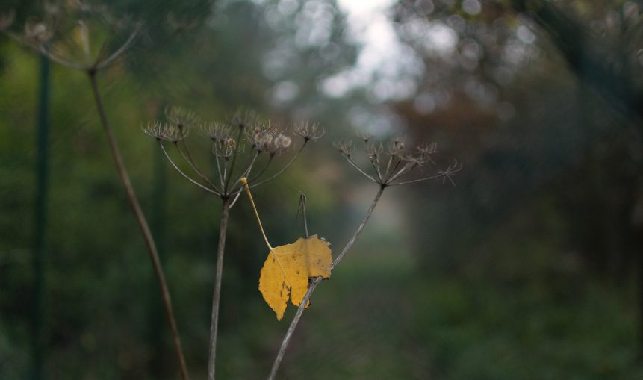  Ráda trávím volný čas v přírodě. |   Když naše děti mají volno, rády tráví čas spolu venku.

Images used in this document come from these sources.

