8.9 - Locative Plural of Nouns

Ok, now we’re going to learn the locative plural of nouns. The good thing? All the endings are similar. This means that it will be easy to recognize these forms in writing and speech.
The bad thing? All the endings are similar.
Nouns
The following chart gives the endings for the locative plural in Czech:
 | MA | MI | F | N
Hard stem | -ech  o studentech  o bratrech  o stolech |  | -ách  v kavárnách  o knihách  o holkách | -ech  o oknech  o pivech
 | -ích  (after k, h, g, ch -- see chart)  o klucích  v parcích  o jazycích |  |  | -ách  (after k, h, g, ch)  o jablkách  o pivkách
Soft stem | -ích  o sportovcích | -ích  o počítačích | -ích  o učebnicích  o kolejích | -ích  o mořích  letištích  o náměstích
-ech
o věcech

So you probably can tell that all the endings end in the letter ch. All you have to do is figure out what vowel is going to go before. That can get a little annoying, considering that they all seem a pretty idiosyncratic. The best bet going forward is to try to drill these forms using notecards or similar tools.  If you are speaking and can’t remember, pretty much any of these endings will do. Even if it’s not totally correct, you will still be understood. | 

Here are some examples. Reminder that so far we have learned the locative after the following prepositions in Czech:

v/ve ‘in, at’
na ‘on, at’

o ‘about’
po ‘after’

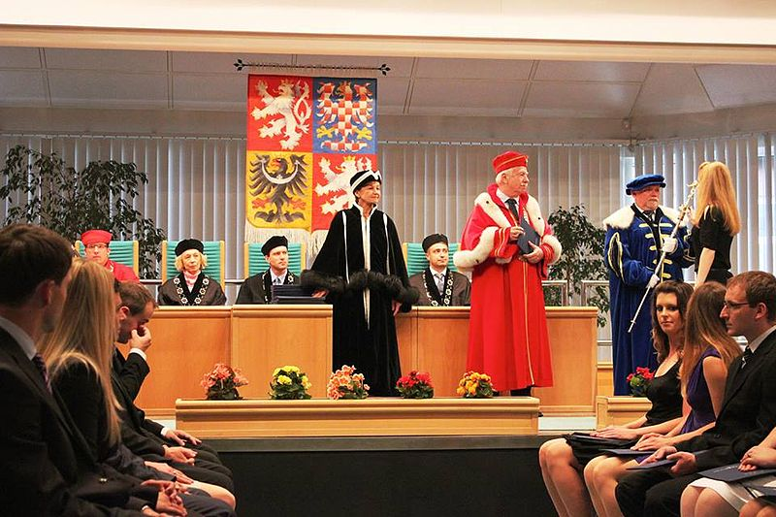 |  | 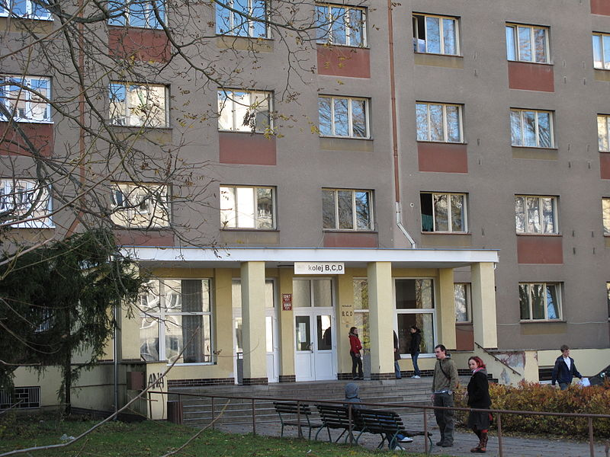
Mluvili jsme o profesorech na promoci.  We were talking about the professors at graduation. | Tvoje brýle jsou na knihách na stole.  Your glasses are on the books on the table. | Studenti často bydlí na kolejích.  Students often live in dorms.

Images used in this document come from these sources.

