4 | 3 | Lekcija 1: Ponavljanje

# 4.3 Zadatak 1. E-mail

Here is an example on how to apply for the apartment. Read the text and complete the tasks.

| Poštovani,  Pročitala sam oglas u novinama i jako sam zainteresirana za Vaš stan. Studiram na Medicinskom fakultetu. Na petoj sam godini. Jako sam marljiva, uredna, puno učim i tražim miran kvart. Vidim da se Vaš stan nalazi u centru. U zimskom semestru dolazim u Zagreb i želim naći jednosoban stan. Je li stan slobodan u rujnu? Možete li mi reći što još ima stan? Ima li radnu sobu i blagovaonicu? Vidim da se stan se nalazi na četvrtom katu. Ima li u zgradi lift? Koliki je mjesečni najam i kolike su mjesečne režije?    Unaprijed zahvaljujem.    Srdačan pozdrav,  Marija Klović |
| --- |

[h5p id="422"]

### Say how you would do the following in Croatian:.

| 1 | How to introduce yourself. |
| --- | --- |
| - |
| 2 | How to express your interest. |
| - |
| 3 | How to ask for additional information. |
| - |
| 4 | How to ask when the apartment is available. |
| - |
| 5 | How to say why you are interested, providing some reasons. |
| - |
| 6 | How to ask for the price or how much it costs. |
| - |

# 4.3 Zadatak 2. U Zagrebu

*A Croatian student is meeting her new roommate at the airport for the first time. On their way from the airport to the apartment they are getting to know each other and they talk about the region*.



### Read the dialogue and answer the questions.

| Ivana: | Bok! Dobro došao u Zagreb! Ja sam Ivana, tvoja nova cimerica. |
| --- | --- |
| Tom | Bok! Ja sam Tom. Drago mi je. |
| Ivana | Kakav je bio let?? |
| Tom | Let je bio dobar. Dug, ali ugodan. Baš se veselim što sam napokon u Zagrebu! |
| Ivana | Je li ovo tvoj prvi dolazak u Zagreb? |
| Tom | Da, nikada nisam bio u Hrvatskoj niti na Balkanu općenito. |
| Ivana | Ti izvrsno govoriš hrvatski! |
| Tom | Hvala. Trudim se. Često čitam o hrvatskoj kulturi, povijesti i glazbi. Često slušam i domaće pjesme. |
| Ivana | A zašto studiraš na Croaticumu? Što želiš raditi u budućnosti? |
| Tom | Želim studirati hrvatsku kulturu. Želim raditi istraživanje o hrvatskoj kulturi. Zanima me povijest i književnost. |
| Ivana | To je jako zanimljivo! Ako trebaš pomoć, slobodno me možeš pitati. Ja studiram na Filozofskom fakultetu. Ja sam studentica na trećoj godini. Studiram antropologiju i komparativnu književnost. Znam mnogo o književnosti i kulturi. |
| Tom | Izvrsno! Imam pitanja o Hrvatskoj, ali i o Crnoj Gori, Srbiji i Bosni i Hercegovini... Dok sam u Hrvatskoj, želim posjetiti razna mjesta i u Crnoj Gori, Bosni i Hercegovini te Srbiji. |
| Ivana | Da, to je dobra ideja. Dok si ovdje, možeš putovati po regiji. A što te zanima? Što želiš vidjeti? |
| Tom | Znam da je Hrvatska poznata po Istri i Dalmaciji. Znam da u Istri trebam posjetiti Pulu. Pula je poznata po Areni. U Dalmaciji trebam posjetiti Split, Dubrovnik i Zadar. Split je poznat po Dioklecijanovoj palači. Dubrovnik je poznat po zidinama, a Zadar je poznat po katedrali. |
| Ivana | Ti zaista poznaješ hrvatsku povijest. Ti znaš po čemu su poznati Split, Dubrovnik i Zadar... A znaš li po kome su poznati? |
| Tom | Hm.. pa i ne baš. Ne znam po kome su poznati Split, Dubrovnik i Zadar. |
| Ivana | Split je poznat po Marku Maruliću. On je hrvatski pisac. On je otac hrvatske književnosti. Zadar je poznat po Petru Zoraniću. On je također pisac. On je napisao prvi hrvatski roman. Roman se zove Planine. Dubrovnik je poznat po Ruđeru Boškoviću i Marinu Držiću. Ruđer Bošković je znanstvenik, a Marin Držić je pisac. |
| Tom | Oh, pa to je izvrsno! Stvarno želim ići u Split, Dubrovnik i Zadar. Je li bolje ići prvo u Crnu Goru ili u Bosnu i Hercegovinu? |
| Ivana | Bolje je ići prvo u Crnu Goru. Kada si u Dubrovniku možeš ići u Crnu Goru. To je blizu. |
| Tom | Izvrsno! A po čemu je poznata Crna Gora? |
| Ivana | Crna Gora je poznata po Kotoru, Budvi, Lovćenu, ali i po Njegošu. |
| Tom | A tko je Njegoš? Ne znam ništa o Njegošu. |
| Ivana | Petar II Petrović Njegoš je crnogorski pisac. |
| Tom | Zanimljivo... Moram pronaći na internetu nešto o Njegošu. |
| Ivana | Evo, stigli smo... ovo je naša zgrada. |

## | Razumijevanje

| 1 | Gdje živi Ivana, u kojem gradu? |
| --- | --- |
| - |
| 2 | O čemu Tom često čita? |
| - |
| 3 | Ivana je studentica. Na kojoj godini je ona? |
| - |
| 4 | Po čemu je poznata Istra? |
| - |
| 5 | Po čemu je poznat Split? |
| - |
| 6 | Po čemu je poznat Dubrovnik? |
| - |
| 7 | Po čemu je poznat Zadar? |
| - |
| 8 | Po kome je poznat Split? |
| - |
| 9 | Po kome je poznat Zadar? |
| - |
| 10 | Po kome je poznata Crna Gora? |
| - |

# 4.3 Zadatak 3. Tvoj novi stan

🔊 Listen to the text from today’s lesson and answer the questions. Check your answers with another classmate.

[h5p id="423"]

[h5p id="424"]

# 4.3 Zadatak 4. Kako se kaže?

Answer the following questions that are based on the dialogue from the previous task:

|  |  |
| --- | --- |

| 1 | How would you express that you hope someone likes something? |
| --- | --- |
| - |
| 2 | How would you express that each room has something? |
| - |
| 3 | How would you express that you like to read in bed? |
| - |
| 4 | How would you express that there is a king bed in each room? |
| - |
| 5 | How would you express that there is a desk in your bedroom? |
| - |
| 6 | How would you formulate your sentence in which you will point out something obvious? |
| - |
| 7 | How would you say that you like flowers? |
| - |
| 8 | How would you say that a certain room is a shared space? |
| - |

# 4.3 Zadatak 5. Privremeni posjet

**Video recording.** Your friend is staying with you for a week. Guide your friend through your apartment. Show him/her all the rooms in your apartment. Say more about your building/house – is it new, old, renovated, etc? Express that you hope he/she will enjoy it while there. While describing each room to your friend, include information about what he/she can do in each room. Point out the things you will share together. While your friend shows you around, ask intelligent questions/clarifications about the apartment/house. Express your opinion about the apartment/building.

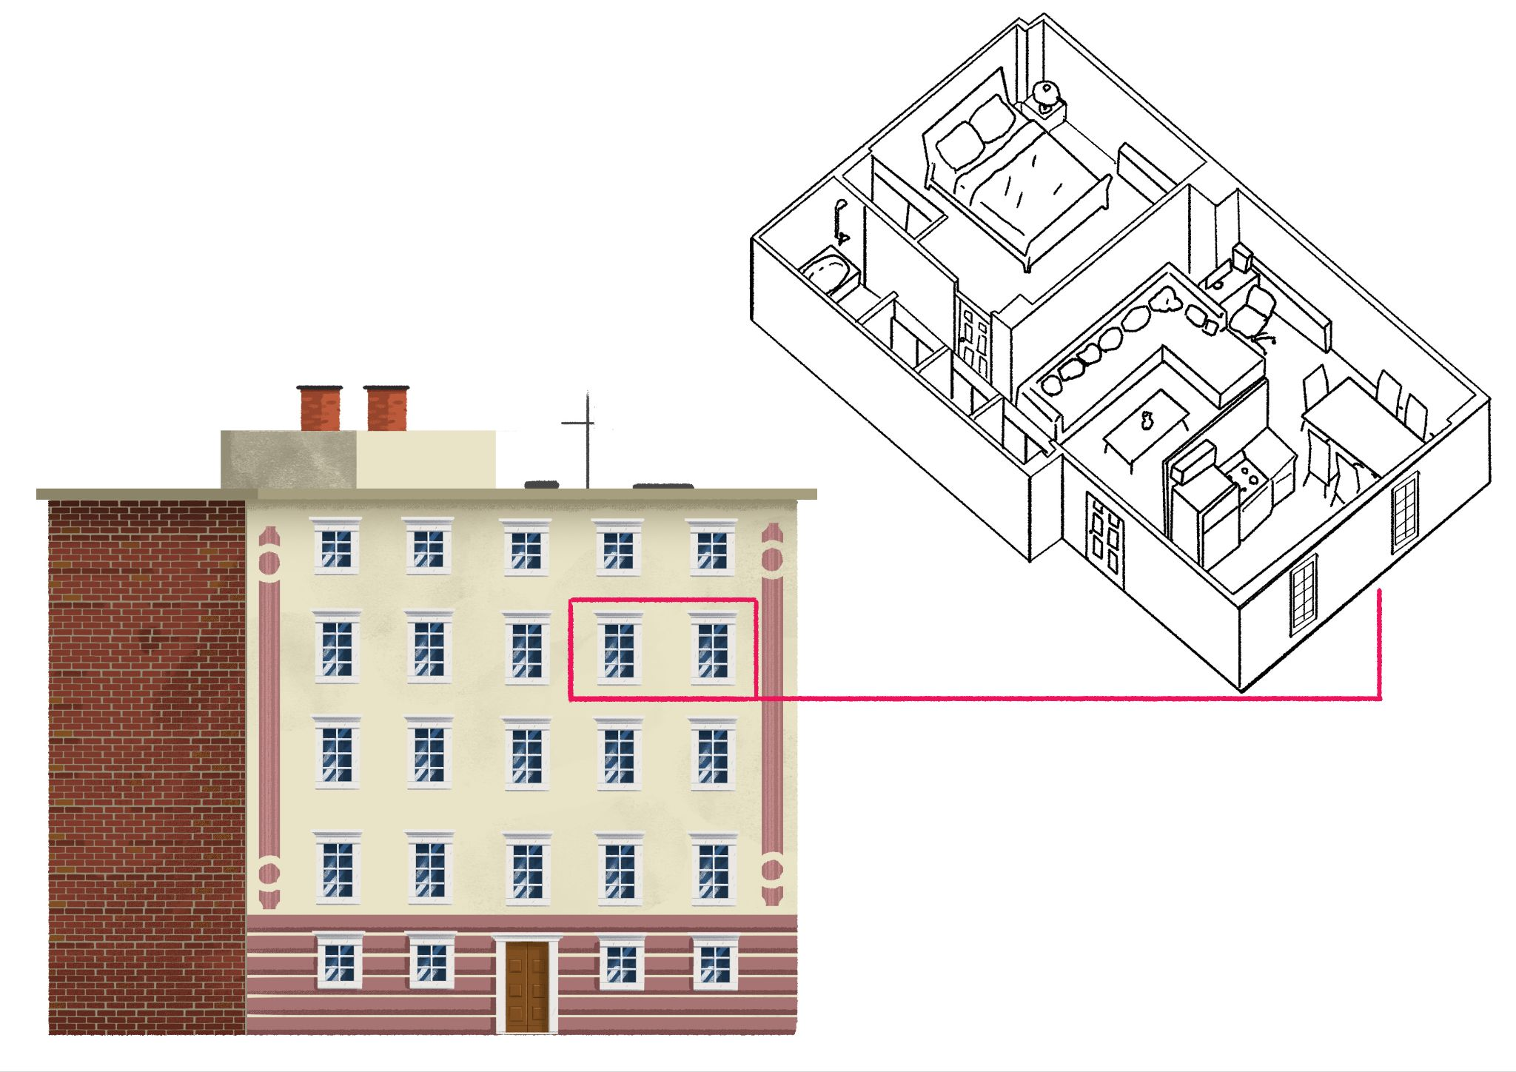

# 4.3 Zadatak 6. Kako se kaže?

Based on the dialogues that we covered in class during this unit, here are some very frequent phrases that you might hear when talking with native speakers. You should try and find phrases for the following situations (we covered them in our dialogues). Try not to translate them verbatim.

| 1 | How would you say that everything is well organized? |
| --- | --- |
| - |
| 2 | How would you say that a place is a mess? |
| - |
| 3 | How would you suggest doing something some other day/time? |
| - |
| 4 | How would you say that there is a lot happening at the same time? |
| - |
| 5 | How would you say that a place looks very bright and well put together? |
| - |
| 6 | How would you say to your friend that you haven’t seen each other for a very long time? |
| - |
| 7 | How would you say that you haven’t spoken for a while? |
| - |
| 8 | How would you say you are extremely busy? (There is a phrase for this.) |
| - |
| 9 | How would you express that you were disappointed and upset? |
| - |
| 10 | How would you say to someone that someone has a style? |
| - |

Images used in this document are from [these sources](https://docs.google.com/document/d/1GOEX7YUeF_GXC1z_qtrExptIXQpwD0zpyG9MyOW_N_I/edit#heading=h.tpym7r30qlpg).