1 | 3 | Lekcija 1: Odakle si?

1.3 Zadatak 1. Što voliš?

Part 1
Individual work. Answer the following questions about yourself.
1 | Što studiraš? ✍️
 | -
2 | Što voliš?
 | -
3 | Koje je tvoje omiljeno mjesto?
 | -
4 | Koja je adresa?
 | -
5 | Koji je broj telefona?
 | -

Part 2
💻Video recording. Now talk with one of your classmates in order to compare your answers from Part 1. Further, think of our new students in Croatia and remind yourself of what their field of study is and what they like. Discuss the following questions with your classmates and provide the answers. Compare yourself and/or your classmate with our students in Croatia. Are there any similarities between all of you?
 | Što studira Laura?
 | Što Laura voli? (include all 3 things she mentioned)
 | Što James studira?
 | Što James voli? (include all 3 things he mentioned)

Part 3
Individual work. Based on the information you have about Laura and James, find at least 3 places in the city where they are currently living (Zagreb or Split) that would fit their interests. Include the picture, name of the place, address/telephone number (if applicable).
Laura
slika | lokacija | adresa i broj

Laura
slika | lokacija | adresa i broj

Laura
slika | lokacija | adresa i broj

James
slika | lokacija | adresa i broj

James
slika | lokacija | adresa i broj

James
slika | lokacija | adresa i broj

1.3 Zadatak 2. Kultura – razgovor

| Kultura
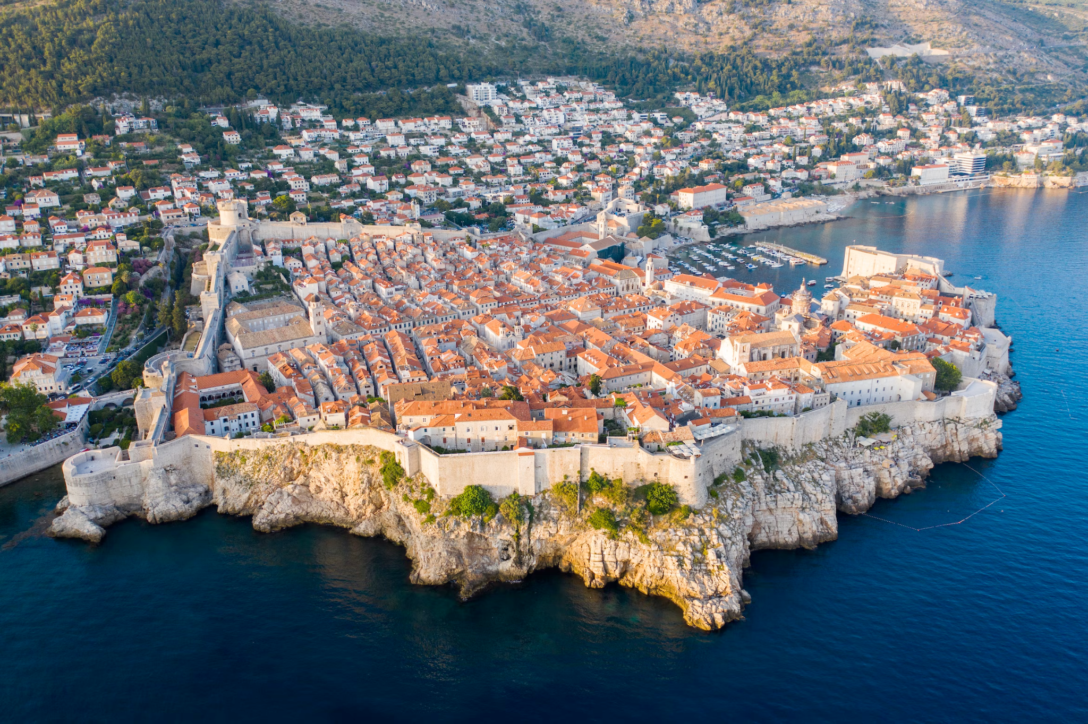 | 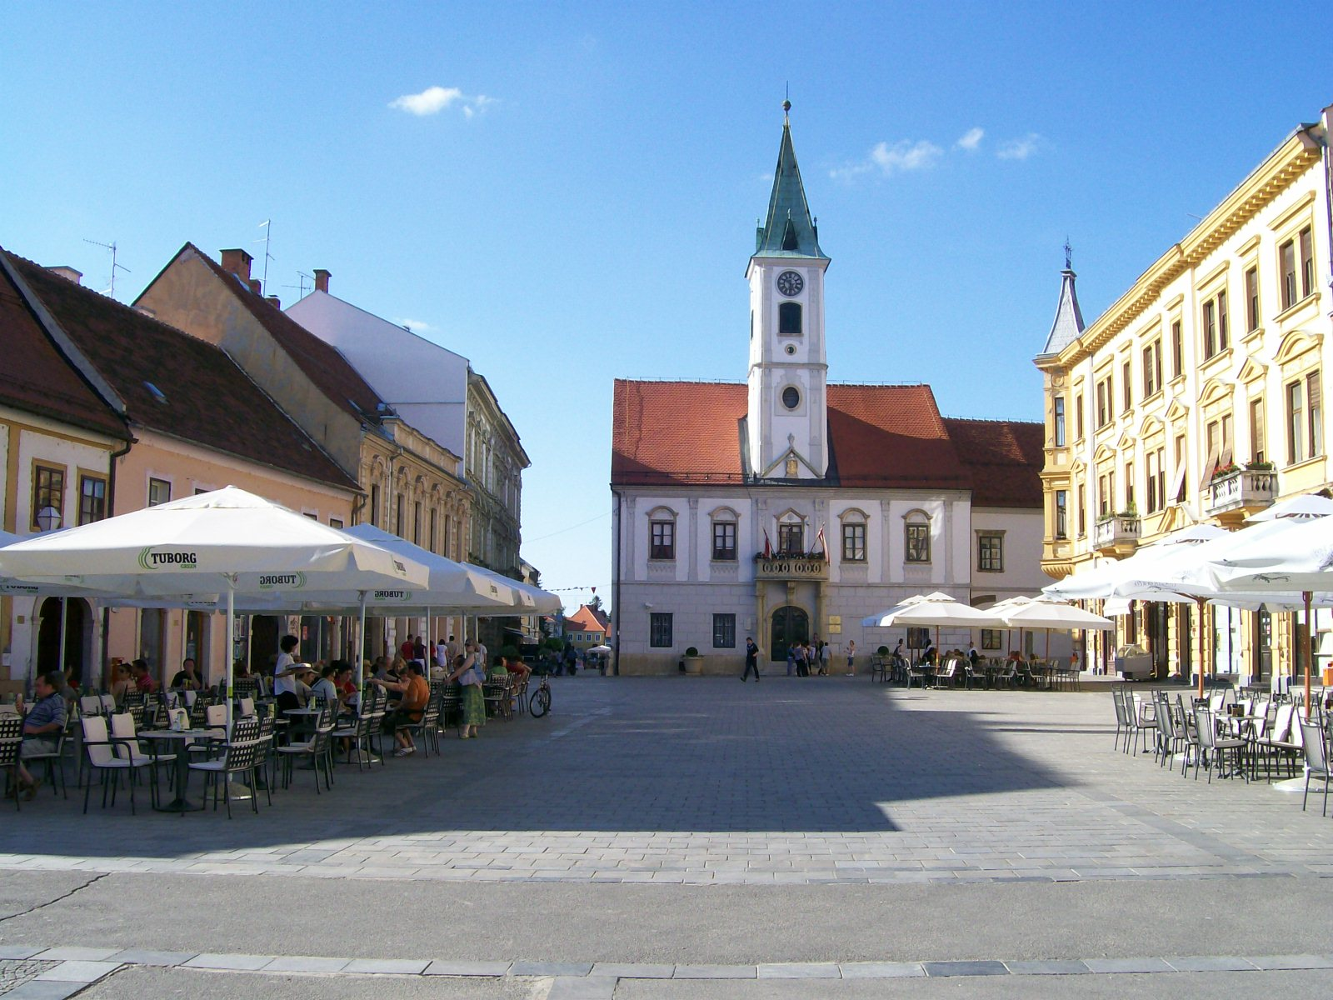
Dubrovnik - renesansi grad | Varaždin - barokni grad
Answer the following questions in English. Be sure to do an online search about both cities before you answer the questions. Search for some images and information online.
1 | Why do we call Dubrovnik renesansi grad? What is/was the importance of Dubrovnik for Croatia?
 | -
2 | Why do we call Varaždin barokni grad? What is/was the importance of Varaždin for Croatia?
 | -
3 | Which city would you like to visit? Why? What would you visit there? Why (beside the fact you have personal interest/curiosity for those places)?
 | -
4 | Among the places you said you want to visit – what is their cultural significance in Croatia?
 | -

| Zagreb
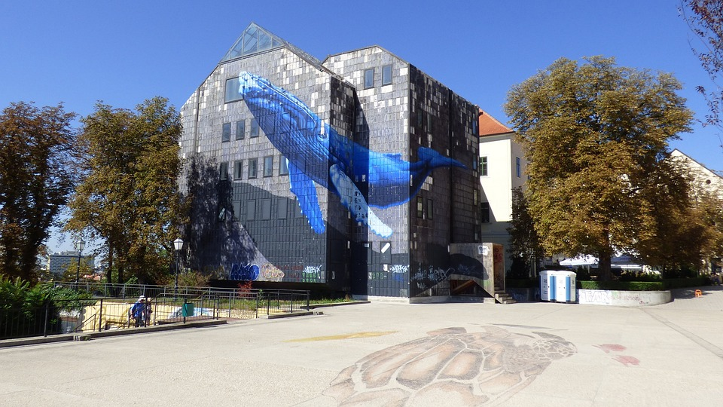 | 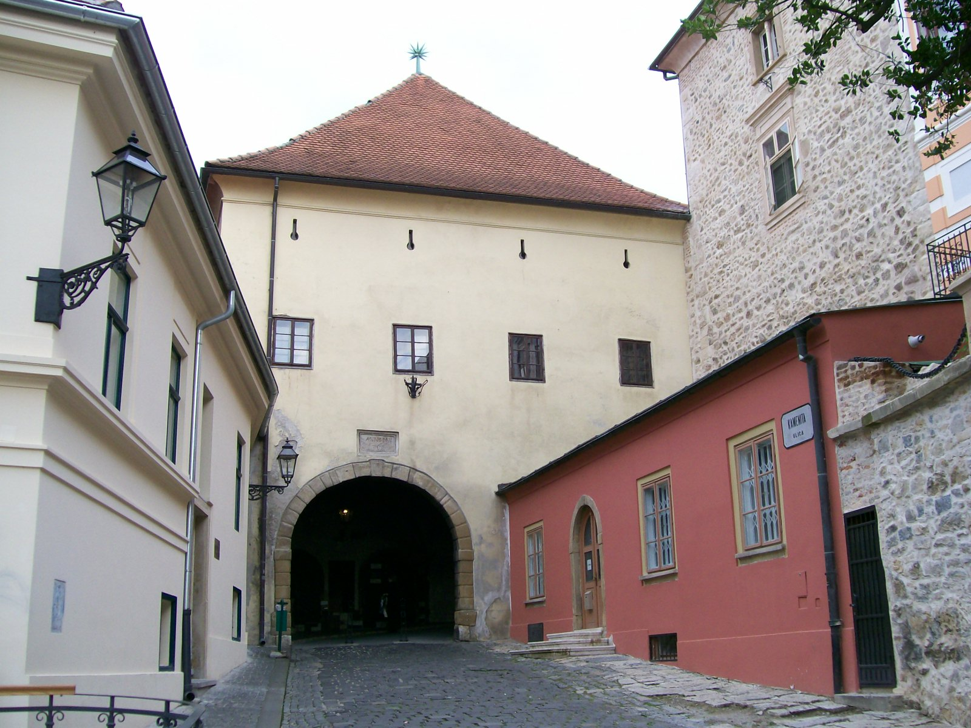 | 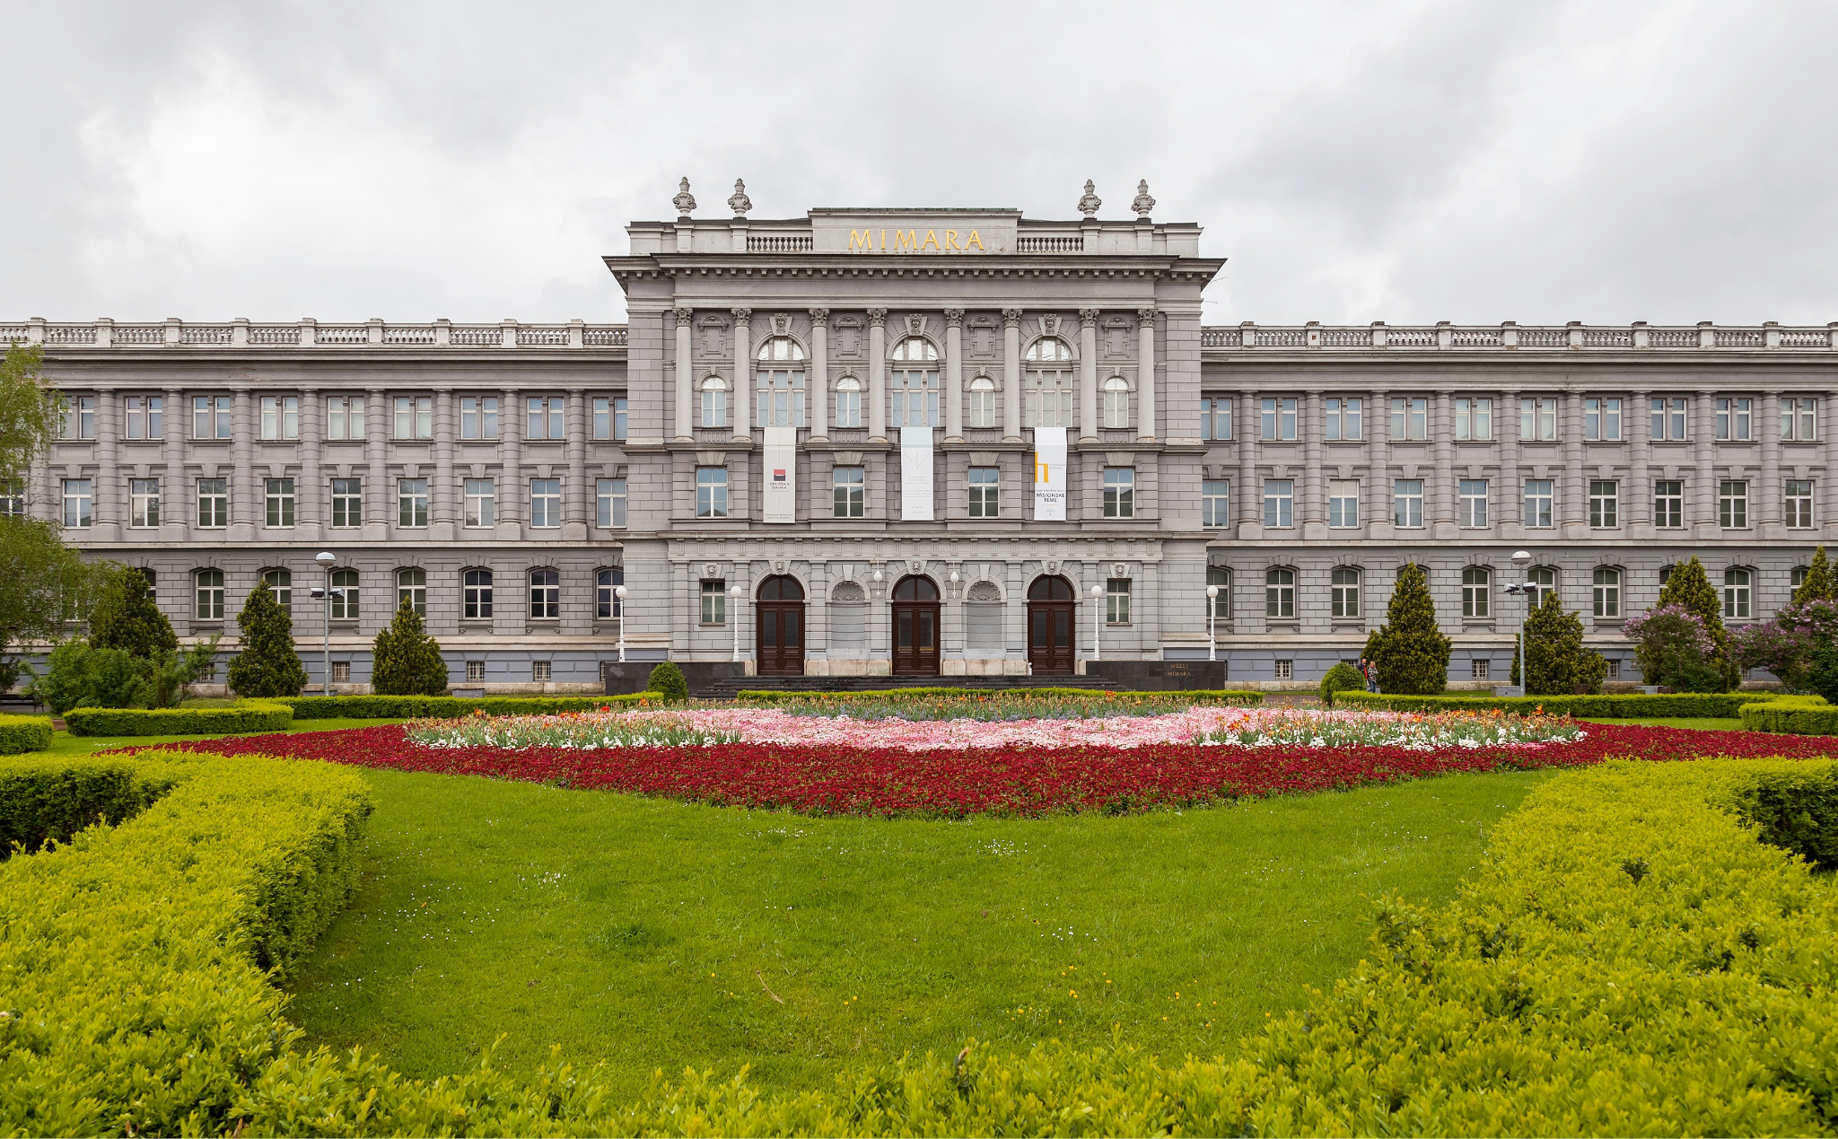
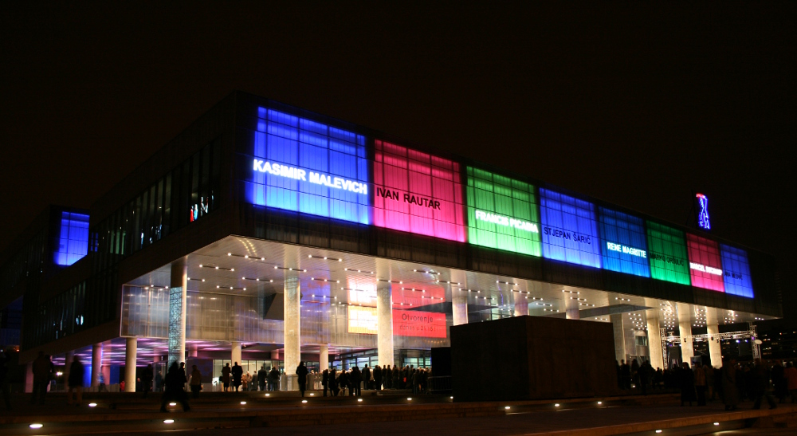 | 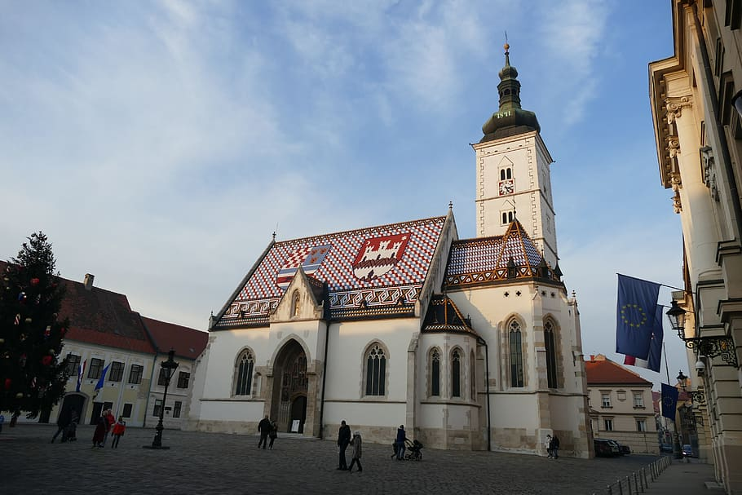 | 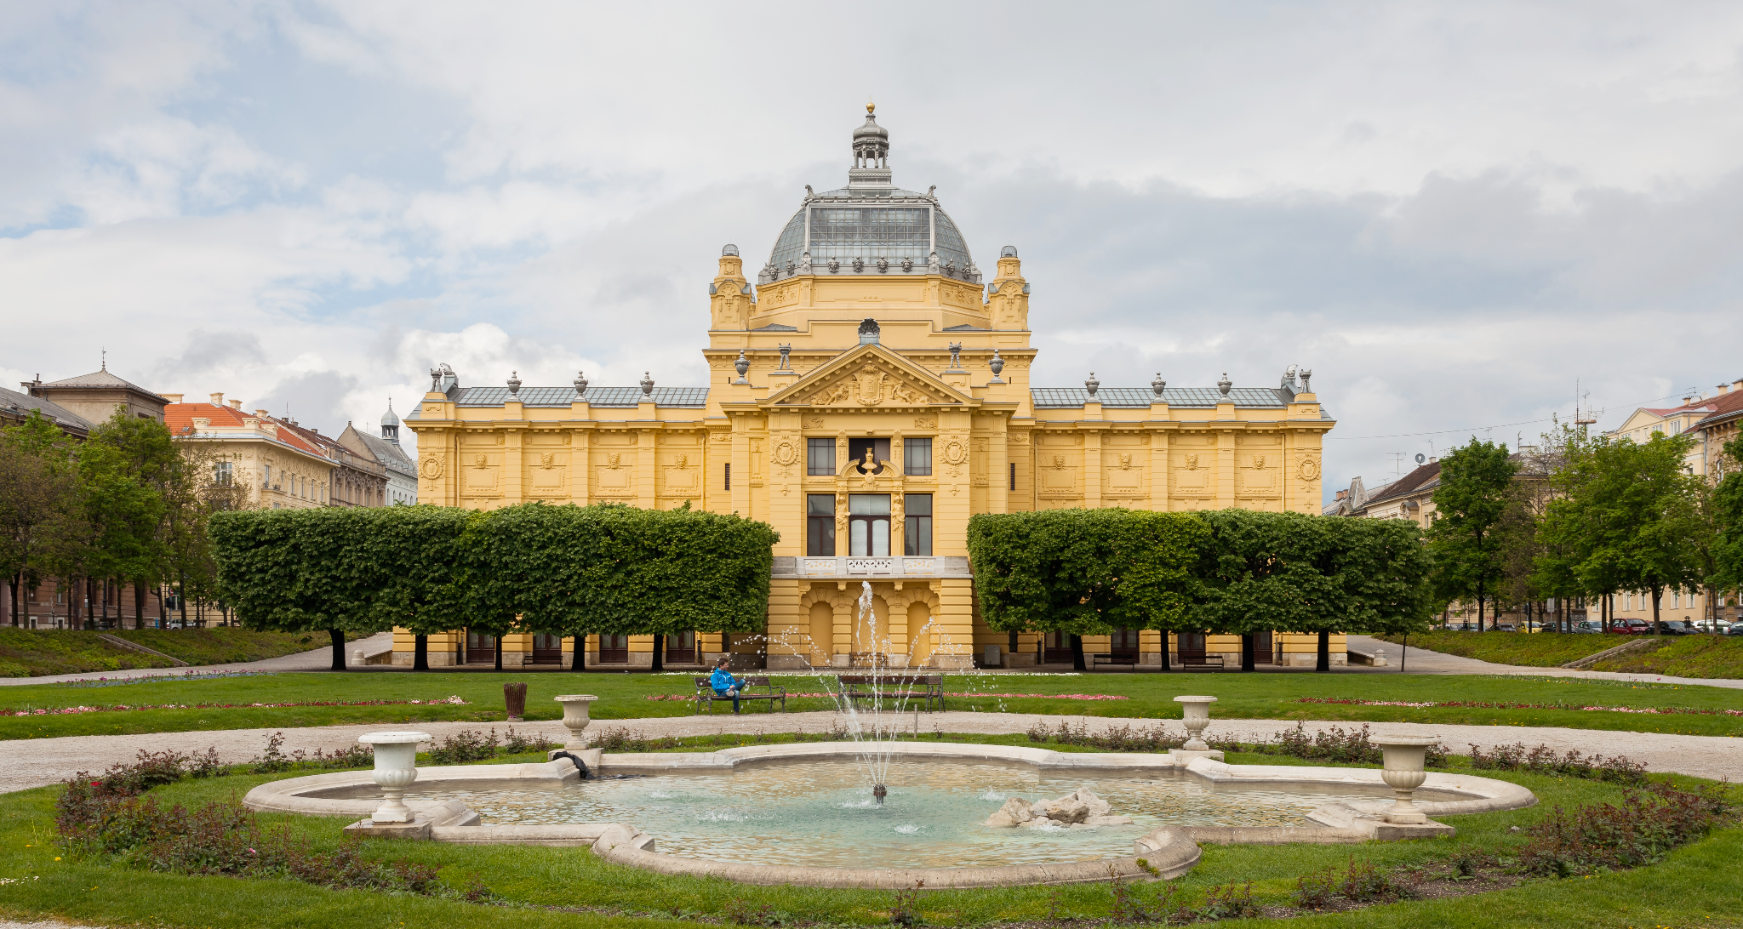

1 | What do you think of Zagreb? Is this a modern city, an old city? Explain your answers.
 | -
2 | What architectural design is present in Zagreb? Why?
 | -
3 | When was Zagreb built? What do you know of its history?
 | -
4 | Tell us something about your city and its history?
 | -
5 | Any similarities with any of the Croatian cities that you encountered so far?
 | -
6 | Can you compare Croatian cities in this lesson with US cities? What cultural significance (and values) cities hold? What about your city?
 | -

Images used in this document are from these sources.

