8.4 - Locative Singular of Adjectives

In this lesson we will cover the endings for adjectives, demonstrative pronouns, and possessive pronouns. As with previous cases, these words will change their form depending on the case of the noun it modifies.

Adjective Endings:

 | Masculine Animate | Masculine Inanimate | Feminine | Neuter
Hard Stem Adjective | -ém  novém | -ém  novém | -é  nové | -ém  novém
Soft Stem Adjective | -ím  moderním | -ím  moderním | -í  moderní | -ím  moderním

 | 
Marek pracuje v novém obchodě.  Mark works in a new store. | Byli jsme v dobré restauraci.  We were at a good restaurant.
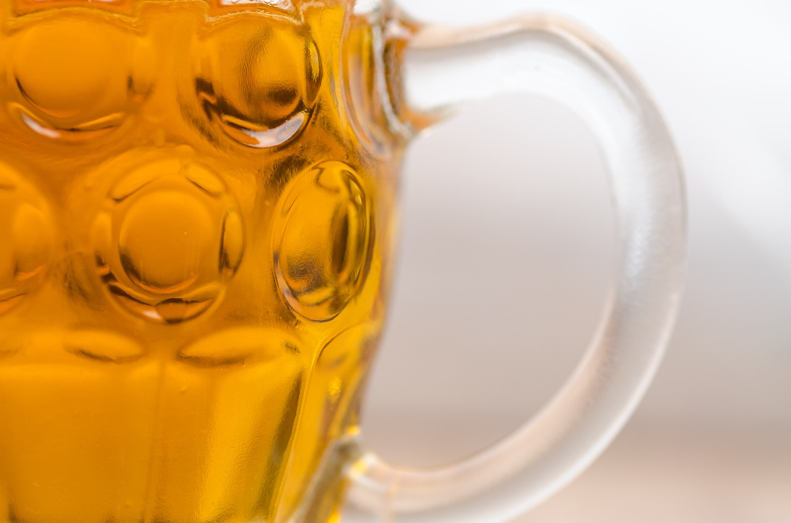
Pavel rád mluví o českém pivu.
Pavel likes to speak about Czech beer.

Images used in this document come from these sources.

