4.3 - Things to do when it’s raining…

[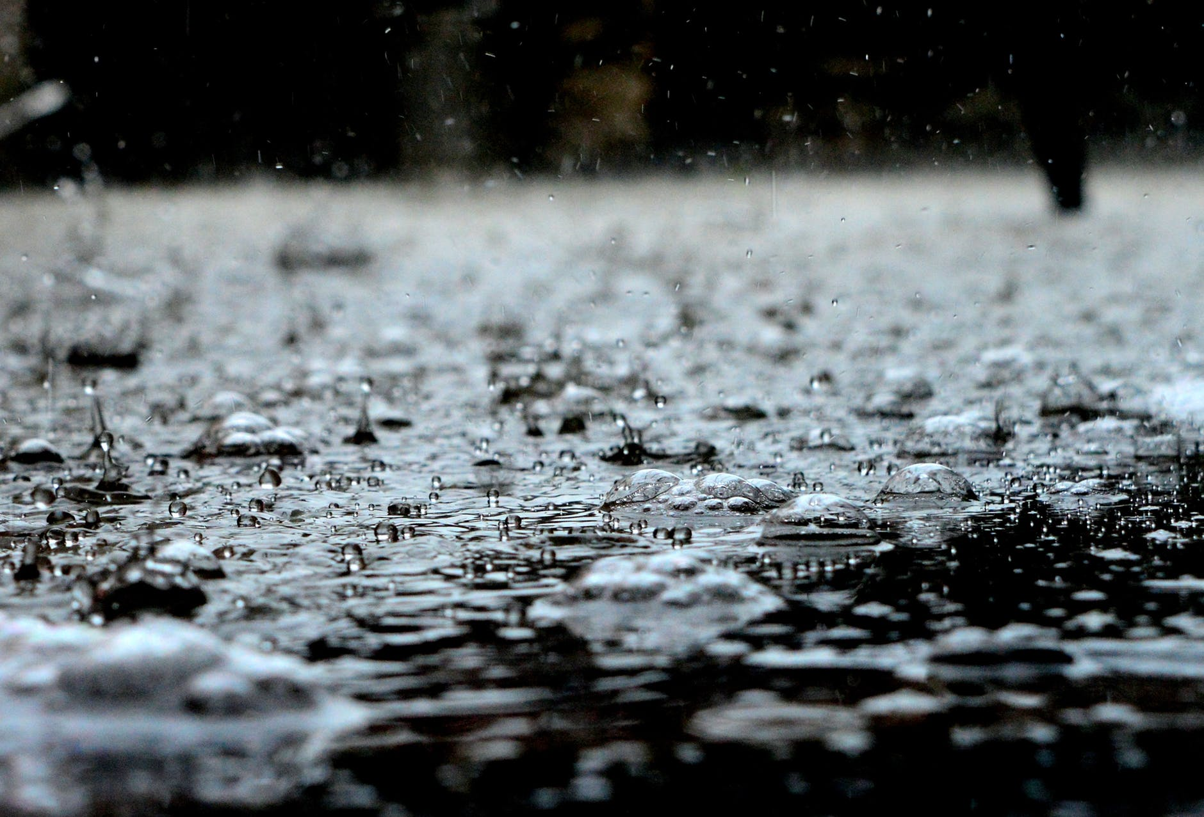](https://www.pexels.com/photo/black-and-white-clear-cool-dew-459451/)

In this unit you will learn some verbs to talk about things that you might do when it’s raining outside. Here they have been divided into *-á-*, *-í-*, and *-e-* verbs in order to help you with conjugation.

-**á- verbs** (see [2.2 - Conjugation of -á- verbs](https://realityczech.org/conjugation-of-a-verbs))

| *zůstávat vevnitř* - to stay inside | *dívat se na televizi* - to watch tv |
| --- | --- |
| *koukat na televizi* - to watch tv (more colloquial) |  |

**-í- verbs** (see [2.2 - Conjugation of -í- verbs](https://realityczech.org/conjugation-of-i-verbs))

| *chodit do muzea* - to go (regularly) to a museum | *chodit do hospody* - to go (regularly) to the pub |
| --- | --- |
| *chodit do kina* - to go (regularly) to the movies | *vařit* - to cook |
| *uklízet* - to clean | *nudit se* - to be bored |

**-e- verbs** (see [2.4 - Conjugation of -e- verbs](https://realityczech.org/conjugation-of-e-verbs))

| *číst (čt-) si* - to read, pleasure read | *hrát (hraj-) počítačové hry* - to play computer games |
| --- | --- |
| *hrát (hraj-) deskové hry* - to play board games | *pracovat* - to work |
| *péct (peč-)* - to bake |  |

Images used in this document come from [these sources](https://docs.google.com/document/d/1Xo646gq_-RYxFseXVAapjPBPXowVA9NjxukSlYo8has/edit#heading=h.1cx6gv55cygn).