6 | 1 | Lekcija 2: Izlet za vikend

6.1 Zadatak 6. Kamo ćete ići? Što ćete raditi?
Look at the following events and write sentences saying where you will go/what you will do in the future. Na primjer: Za Božić ću ići na skijanje i odmarat ću.
| za rođendan
→
| za blagdane
→
| za proljetne praznike
→

6.1 Zadatak 7. Što ćemo raditi?
Look at the following list of verbs. Finish the sentences by using the appropriate verb in the future tense.
plivati | planinariti | slušati | kupiti | vidjeti
zvati | raditi | ići | platiti | gledati

| Rečenice
U nedjelju Marko __________________ film Na putu.
Za vikend Ivana i Darko __________________ glazbu.
Sljedeći mjesec ti __________________ prijatelje.
U ponedjeljak studenti __________________ na fakultet.
Moji prijatelji i ja __________________ na planini.
Za Božić ja __________________ jelku.
Moja mama __________________ prijateljicu na telefon.
Kad idem na odmor ja __________________ u moru.
U budućnosti ti __________________ zanimljiv posao.
Ona __________________ večeru.

6.1 Zadatak 8. Vremenska prognoza
🔊 Listen to the weather reports and fill in the first three columns of the chart below. Then evaluate the information you have gathered, mark the answer in the last column that seems most appropriate. Remember that all of the temperatures are in Celsius.
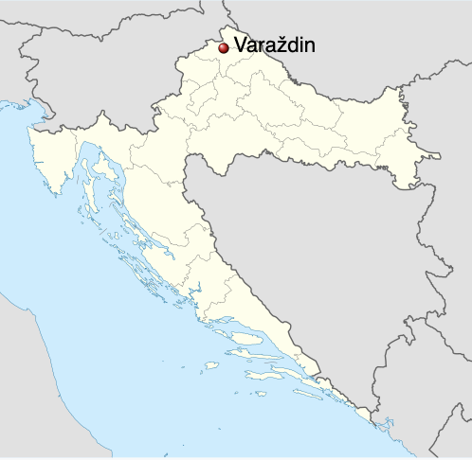 | 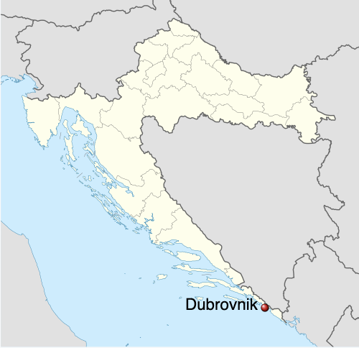
(audio) | (audio)
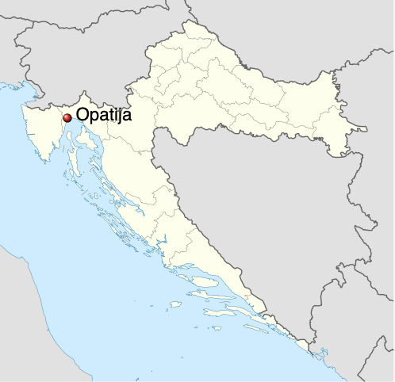 | 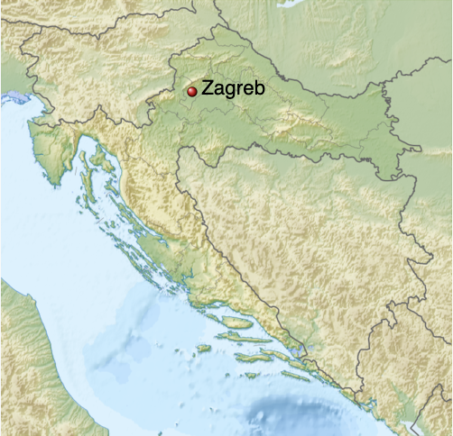
(audio) | (audio)

Gdje? | Kada? | Kakvo će biti vrijeme? | Temperatura? | Ja mislim da će biti…
a. hladno
b. prohladno
c. toplo
d. vruće
a. hladno
b. prohladno
c. toplo
d. vruće
a. hladno
b. prohladno
c. toplo
d. vruće
a. hladno
b. prohladno
c. toplo
d. vruće

6.1 Zadatak 9. Kamo će ići Davor?
Look at Davor’s weekly schedule.
PONEDJELJAK | UTORAK | SRIJEDA | ČETVRTAK | PETAK | SUBOTA | NEDJELJA
08:00-10:00  predavanja | 08:00  predavanja | 09:00-11:00  ispit | 07:00  teretana | 09:00  doručak | 08:00  doručak | slobodan dan
12:00  ručak | 09:00-12:00  sastanak | 11:30-12:30  konzultacije | 08:00  doručak | 10:00  kupovina | 09:00  odlazak u prirodu
13:00  knjižnica | 12:00  odgovoriti na  e-mailove | 14:00-17:00  predavanja | 9:30-14:00  predavanja | 13:00  ručak
17:00  šoping centar | 16:00  druženje | 17:30-19:00  knjižnica | 15:00:16:00  konzultacije na fakultetu | 15:00 sportska aktivnost
19:30  predstava | 18:00-19:00  klizanje | 20:00  večera | 19:00  obiteljska večera | 18:00  kino | 19:00  rođendan

Listen to the set of sentences. Based on his schedule, write down when Davor will do a certain thing (according to his schedule). For example: Davor će ići u kazalište u ponedjeljak navečer.
(audio) Aktivnost 1 | (audio) Aktivnost 2 | (audio) Aktivnost 3
(audio) Aktivnost 4 | (audio) Aktivnost 5 | (audio) Aktivnost 6
(audio) Aktivnost 7 | (audio) Aktivnost 8 | (audio) Aktivnost 9
(audio) Aktivnost 10 | (audio) Aktivnost 11 | (audio) Aktivnost 12

* The sentences you will hear are not in the order that activities are presented in the weekly schedule. Not all fields from his schedule are present.
Aktivnost 1
Aktivnost 2
Aktivnost 3
Aktivnost 4
Aktivnost 5
Aktivnost 6
Aktivnost 7
Aktivnost 8
Aktivnost 9
Aktivnost 10
Aktivnost 11
Aktivnost 12

6.1 Zadatak 10. Kako se kaže?
 | 
Look at the two dialogues from the class session and write the equivalent forms in Croatian.
1 | How would you ask someone where he/she wants to go?
 | -
2 | How would you ask someone where he/she will go?
 | -
3 | How would you ask someone what he/she will visit?
 | -
4 | How would you ask someone what he/she will do for the weekend?
 | -
5 | How would you say that you will go to the museum?
 | -
6 | How would you say that you will not see the castle?
 | -
7 | How would you say that you will be at the university at a certain time?
 | -

6.1 Zadatak 11. Kultura - razgovor

| In English
You will need to do a search online to answer the following two questions. You will share your answers with others so we can learn together more about Varaždin.

In this lesson you learned that Varaždin is also known as hrvatski barokni grad. Why do you think that is? Find several examples online that support your argument.

What is Špancirfest? When does it happen? What do you think about this event? What is the cultural significance of the costumes that appear during the event? Does anything similar exist in your city/country?
| Answer the Questions
→

6.1 Zadatak 12. Kamo ćemo za vikend?
💻 Based on the assignments from today’s class session, make a video presentation about your plans for the weekend. Include visual elements if possible (pictures, maps, specific locations, etc.). Submit your work online.

Images used in this document are from these sources.

