2 | 3 | Lekcija 6: Idemo na kavu

| Odjeća
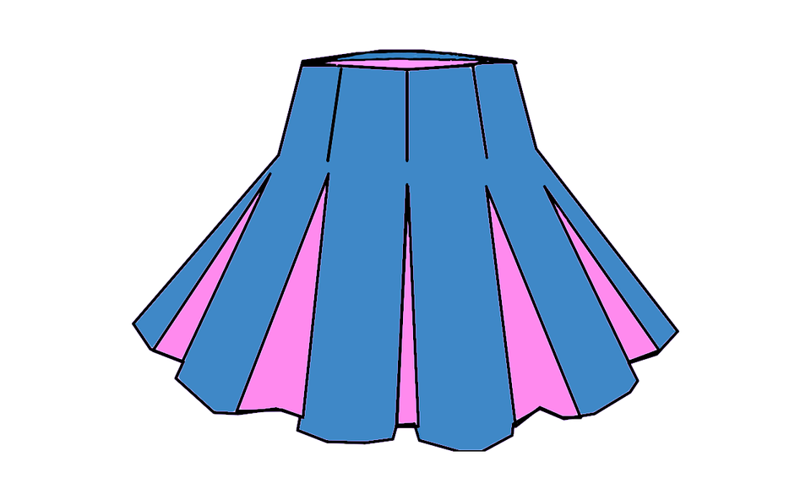 | 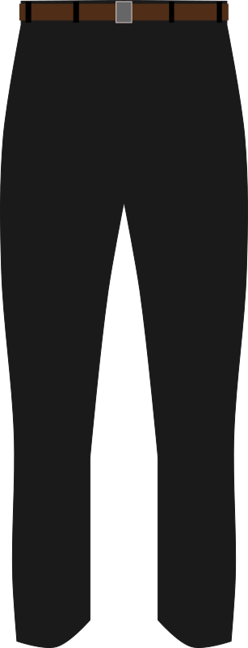 | 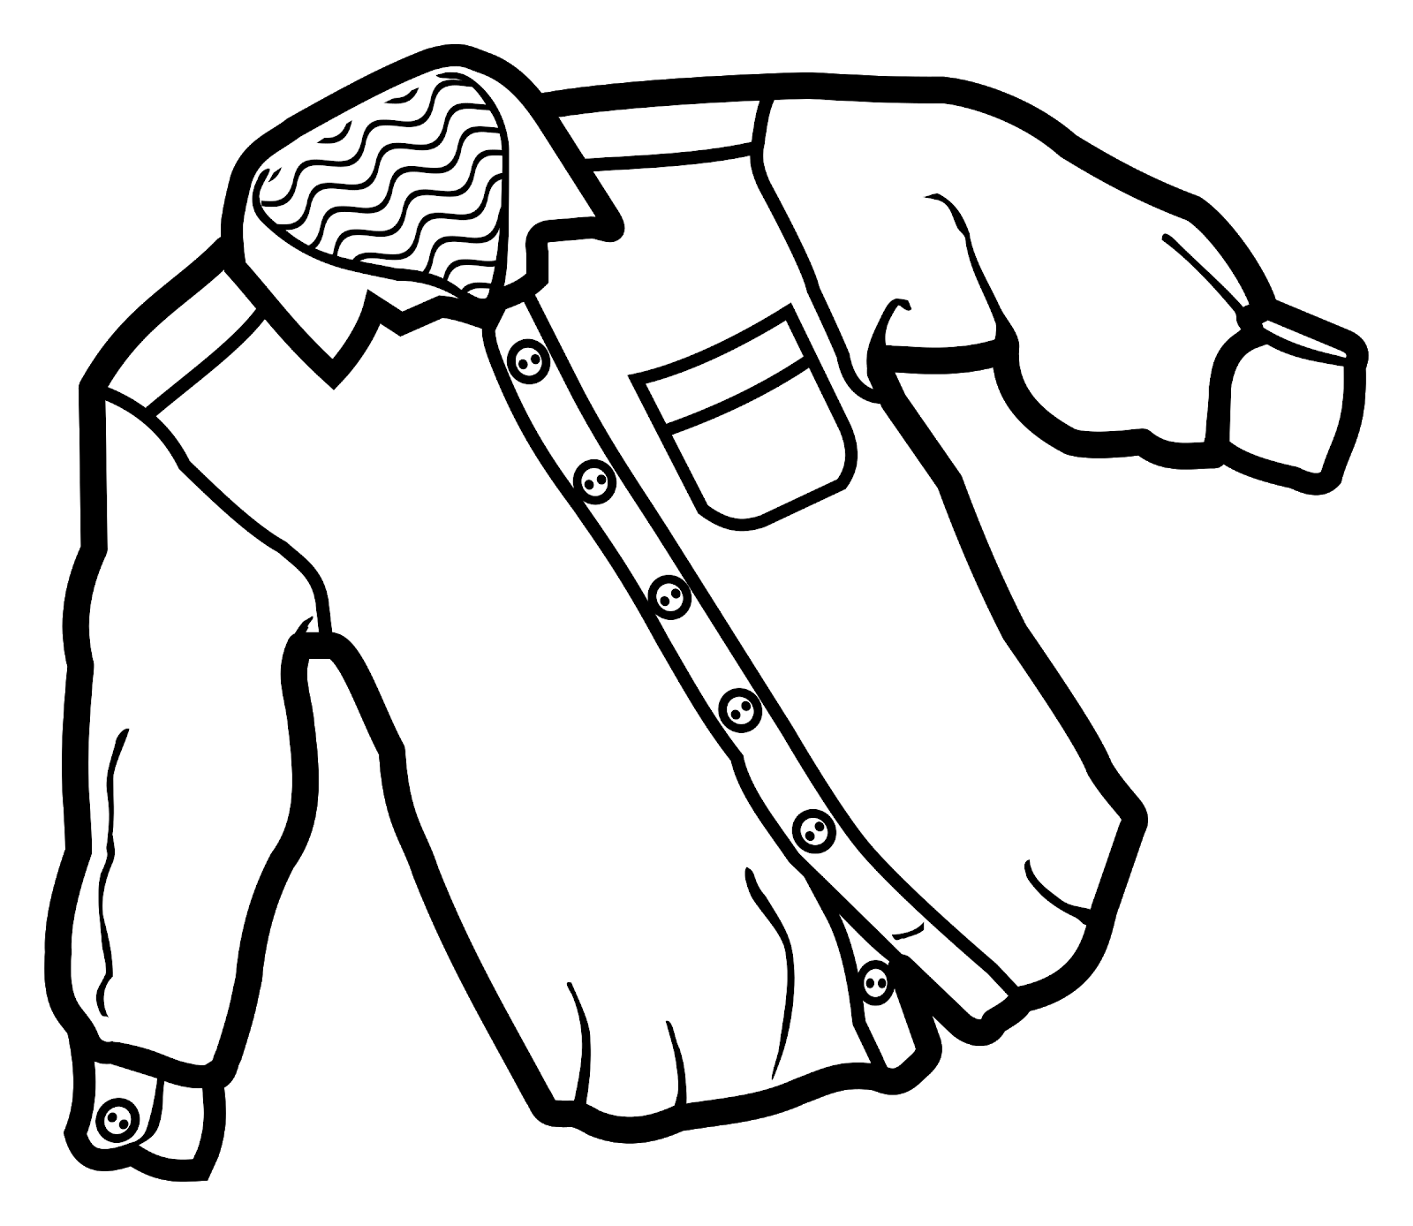
suknja | hlače | košulja
(audio) | (audio) | (audio)
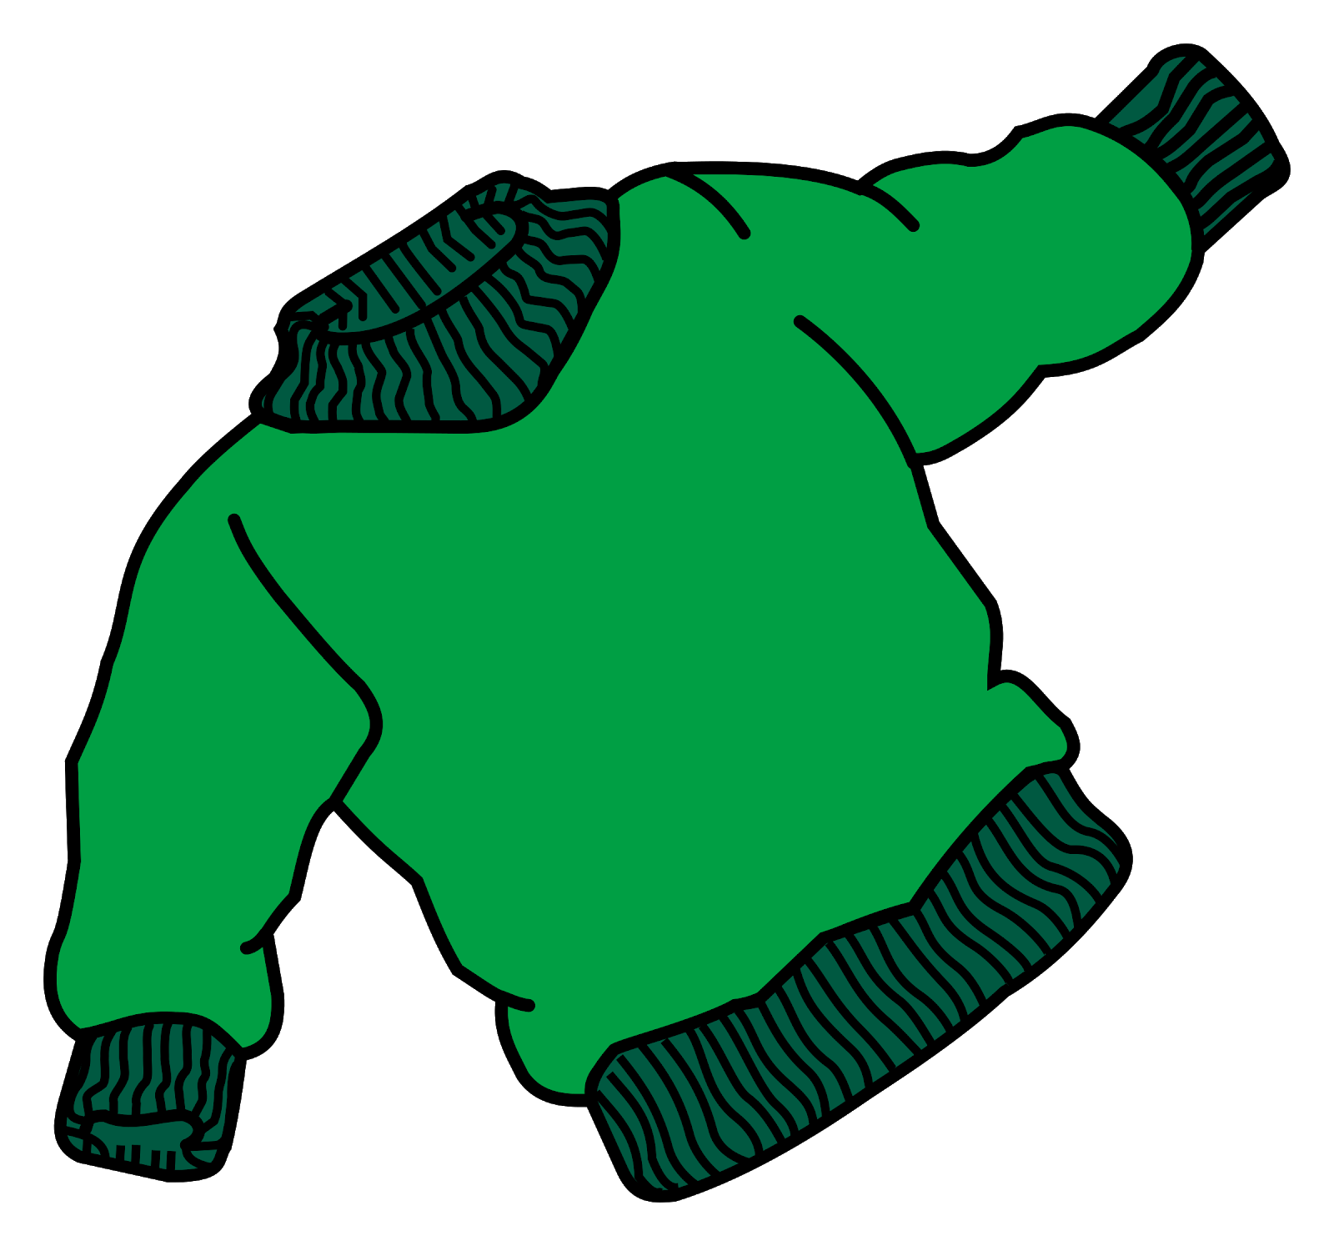 | 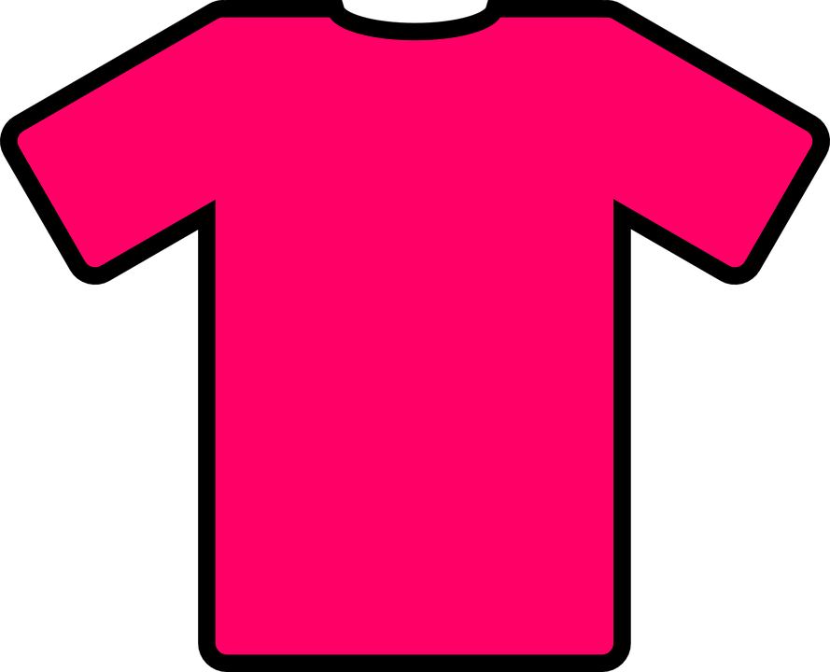 | 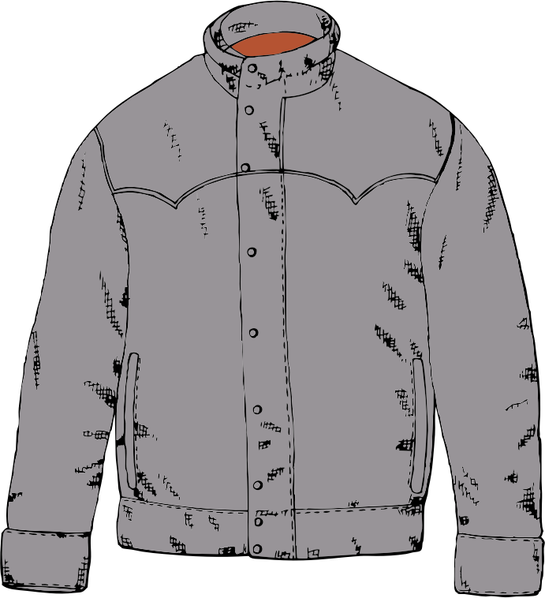
džemper | majica | jakna
(audio) | (audio) | (audio)
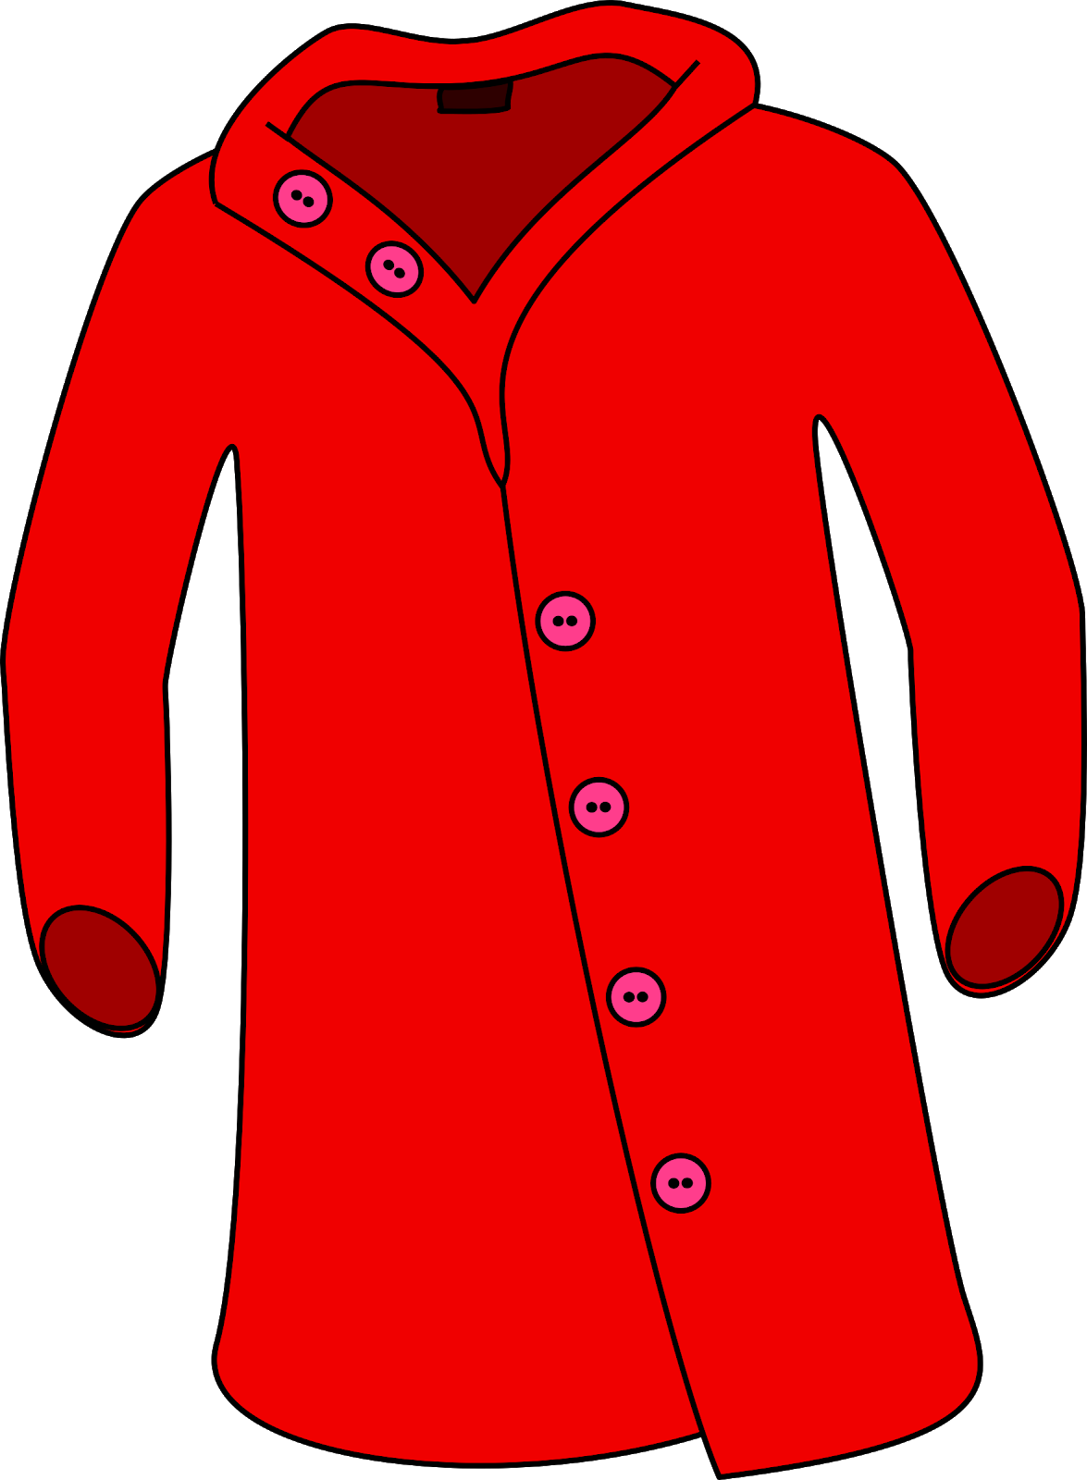 | 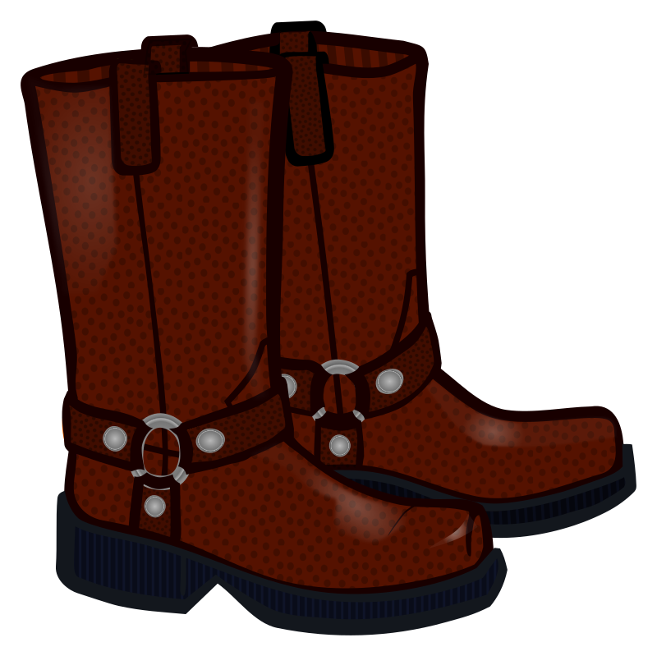 | 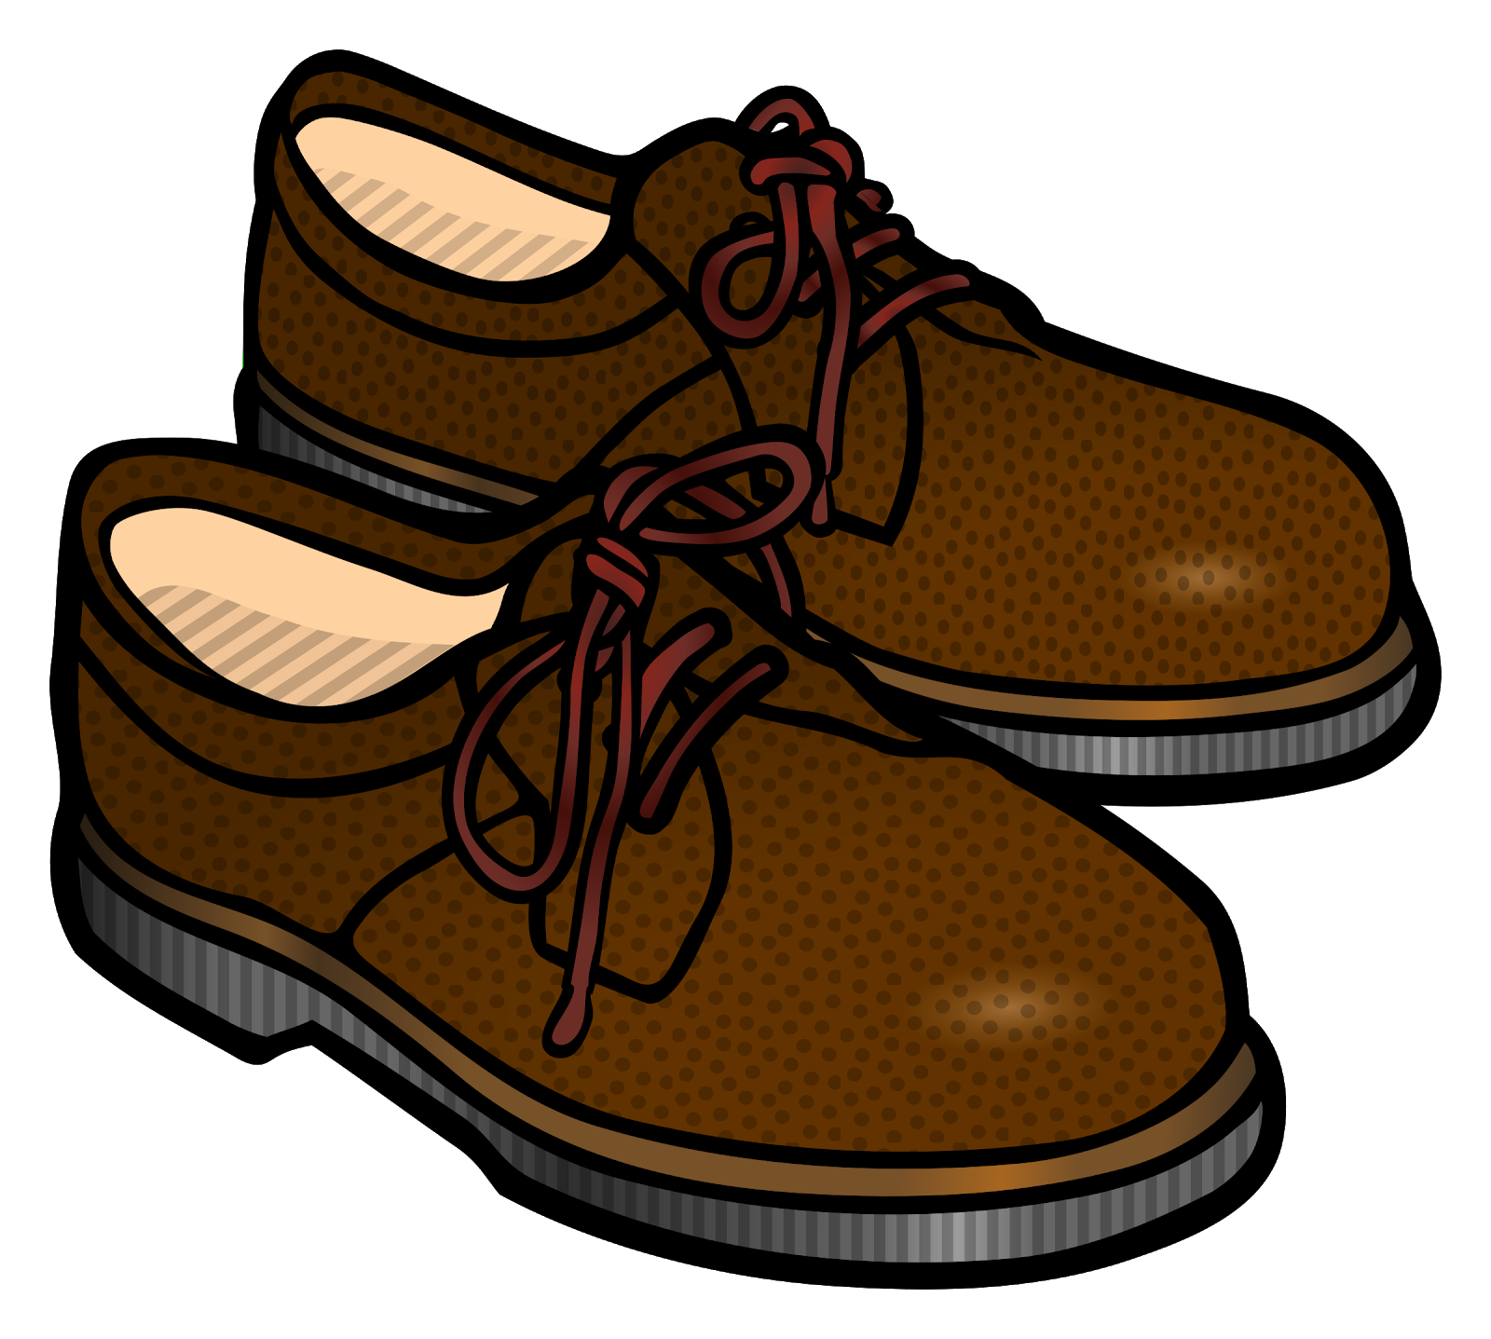
kaput | čizme | cipele
(audio) | (audio) | (audio)
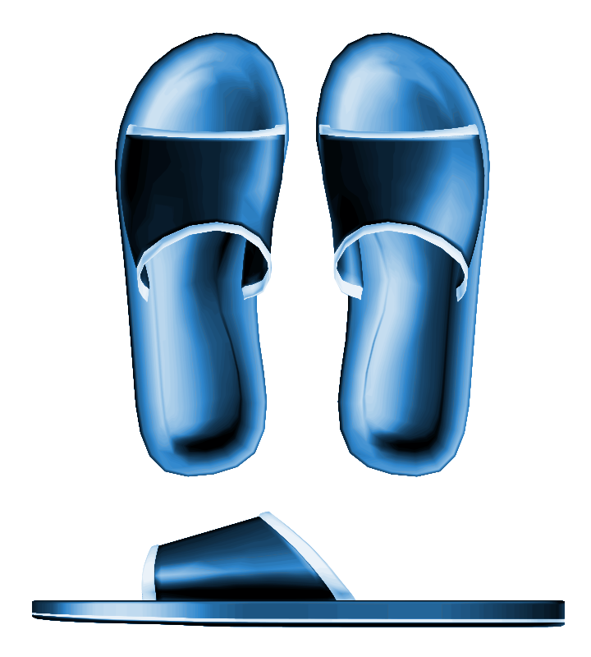 | 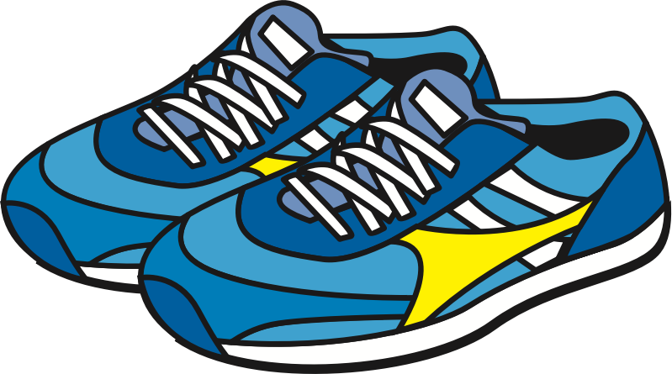 | 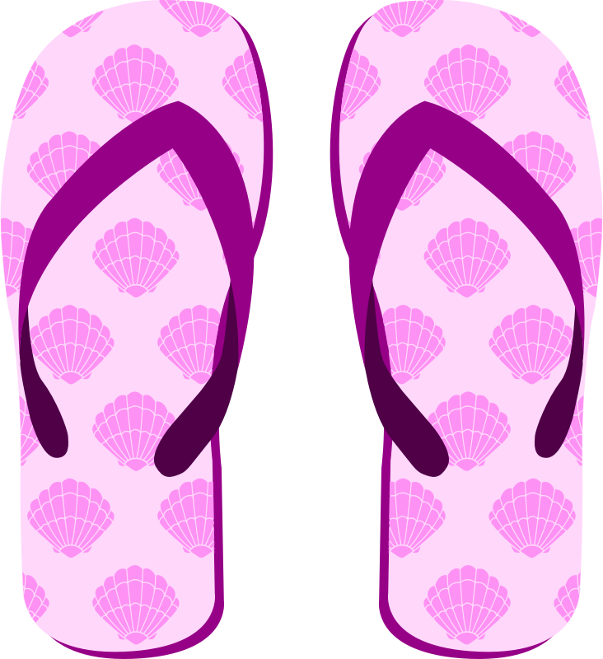
šlape | tenisice | japanke
(audio) | (audio) | (audio)
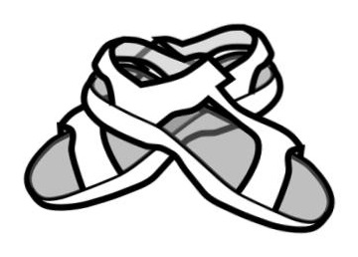 |  | 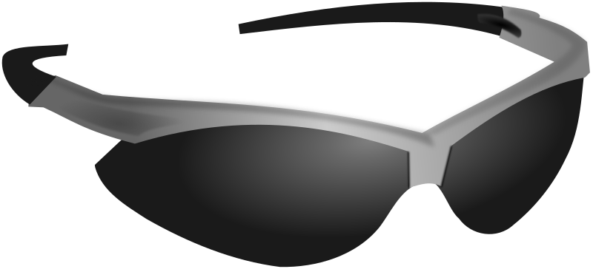
sandale | kapa | sunčane naočale
(audio) | (audio) | (audio)
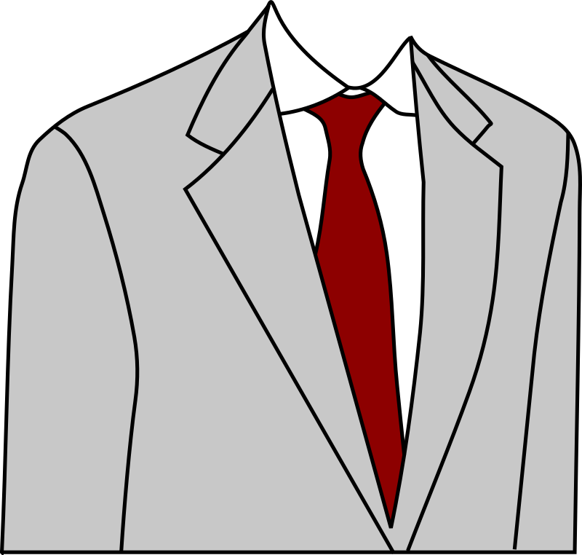 |  | 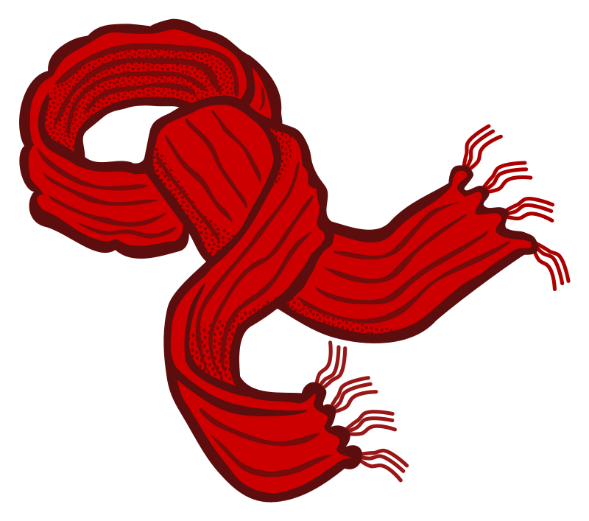
odijelo | šešir | šal
(audio) | (audio) | (audio)
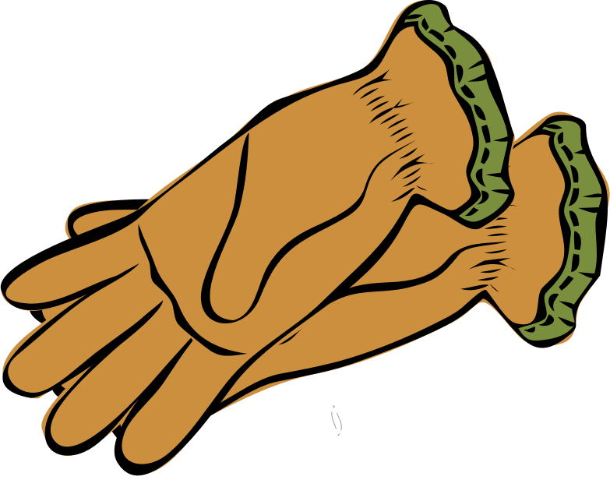 | 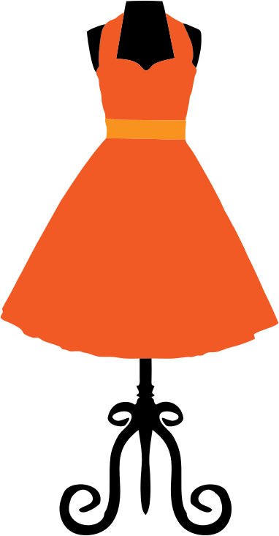 | 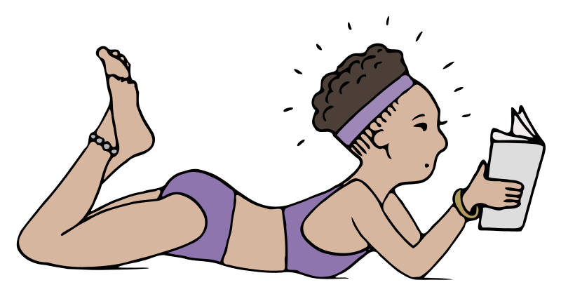
rukavice | haljina | kupaći kostim
(audio) | (audio) | (audio)
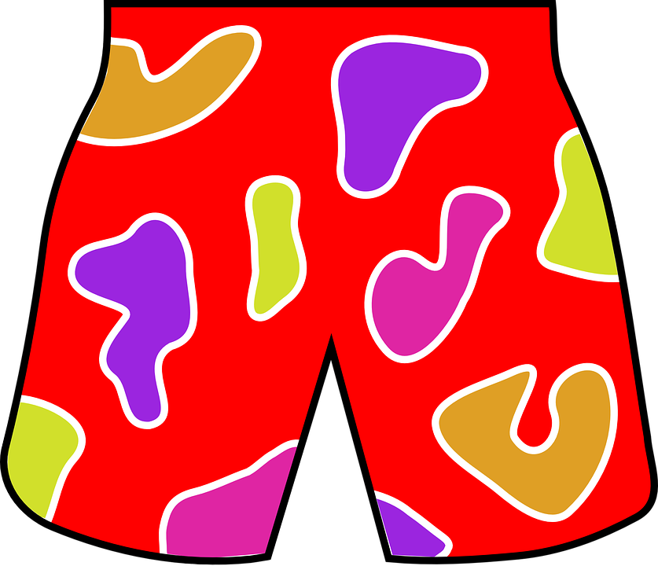
kratke hlače
(audio)

2.3 Zadatak 8. Kako se kaže?

Match an image with a given word.

[h5p id="609"]
[h5p id="116"]

2.3 Zadatak 9. Što nositi?
Look at the following pictures and mark all the items that a person can wear in each situation.
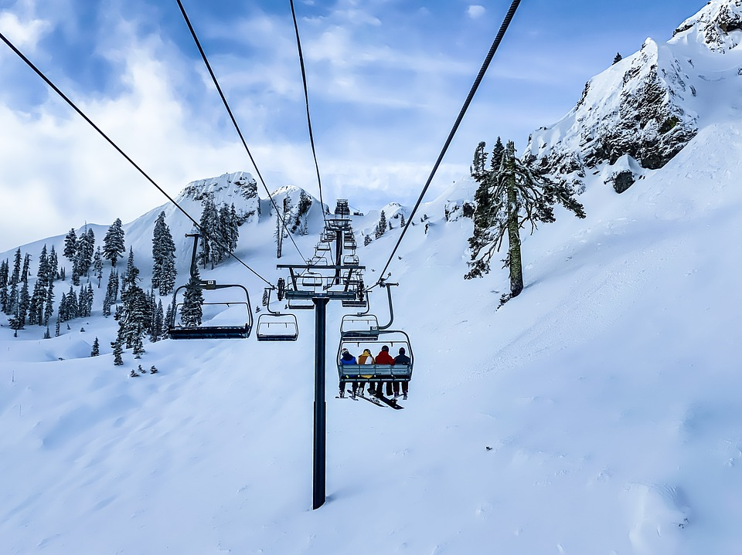 | 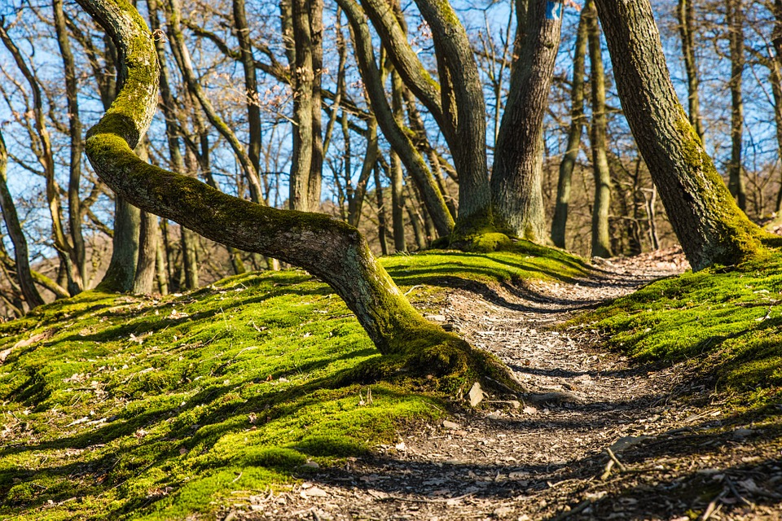 | 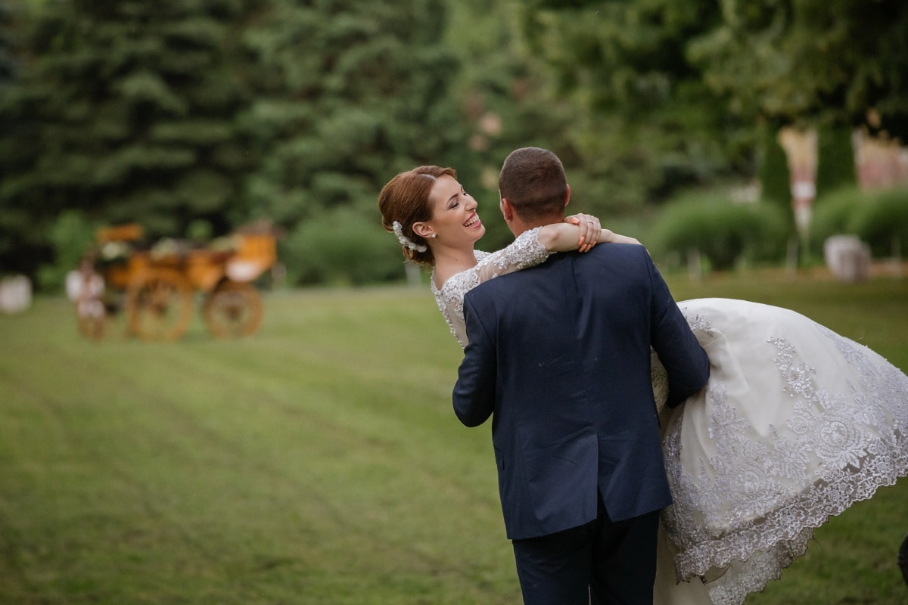 | 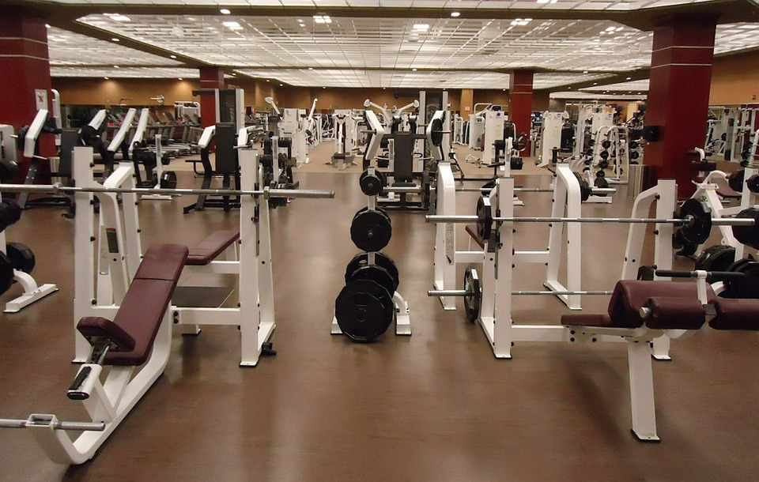
skijanje | planinarenje | vjenčanje | teretana
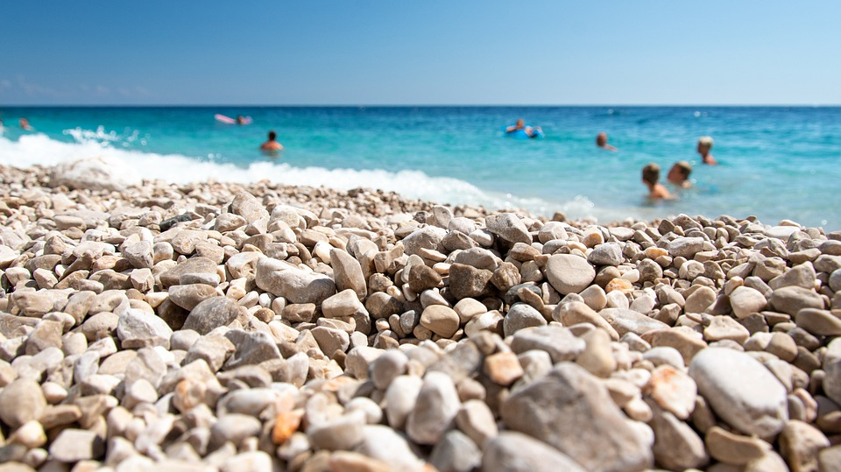 | 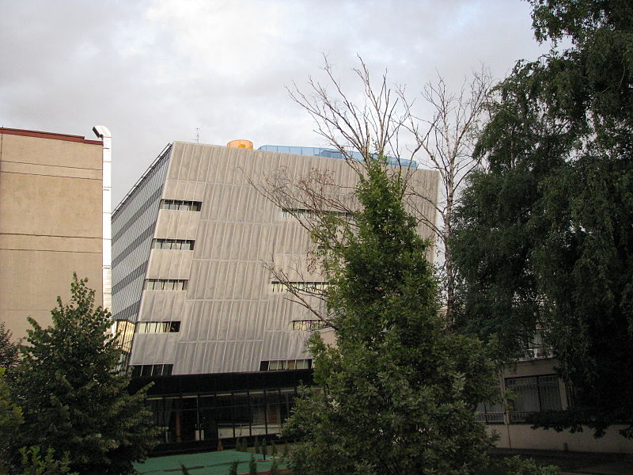 | 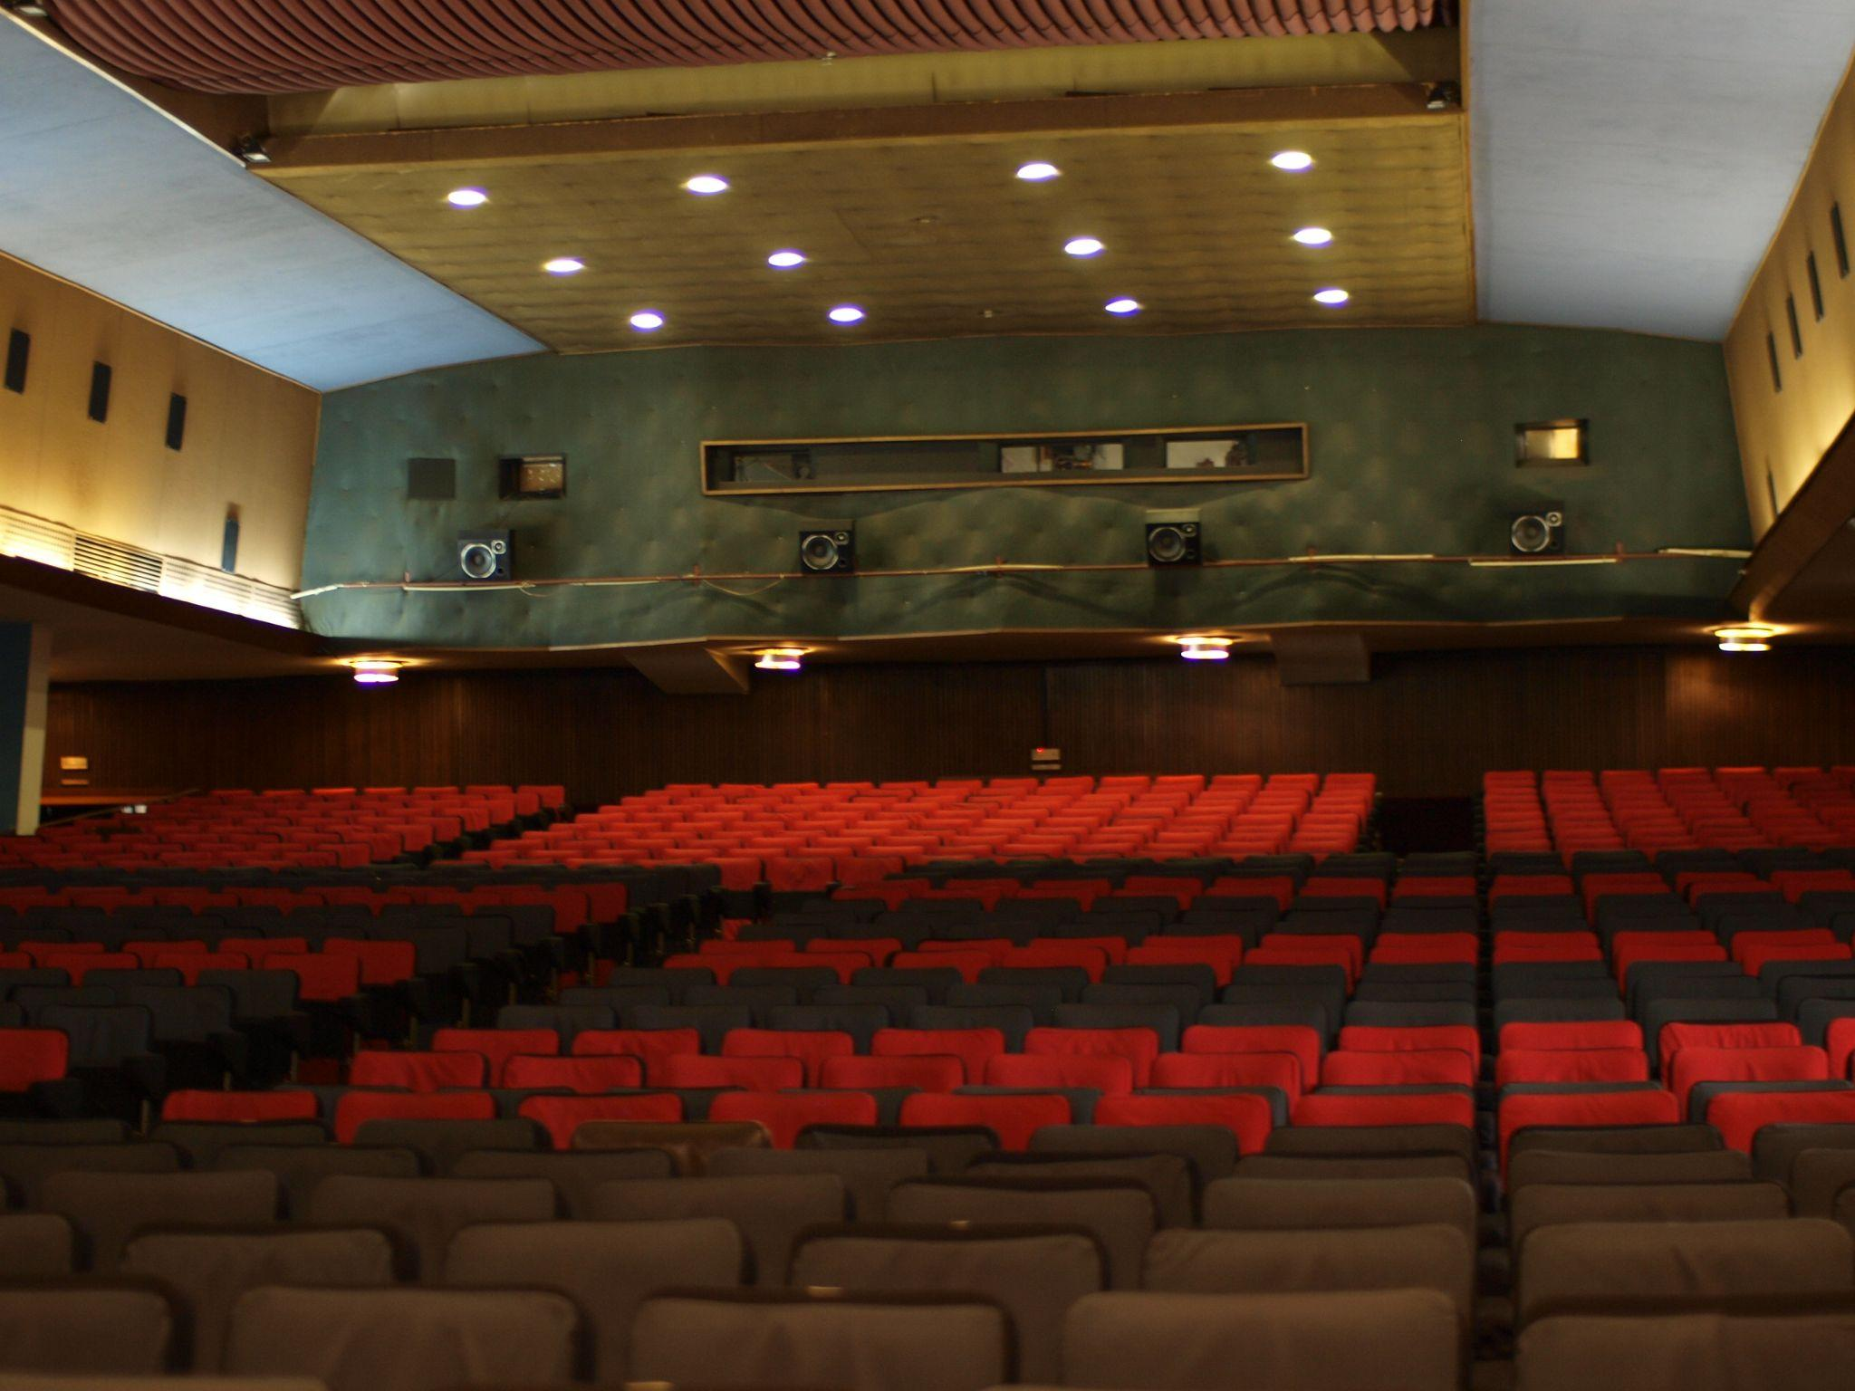 | 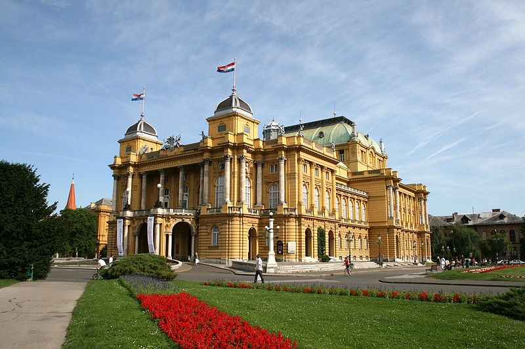
plaža | fakultet | kino | kazalište
[h5p id="255"]

2.3 Zadatak 10. Što ljudi nose?
Look at the following pictures and write what the people in them are wearing.
[h5p id="699"]

2.3 Zadatak 11. Što nosimo?
Look at the following pictures and answer the questions. Only one item in each group is correct.
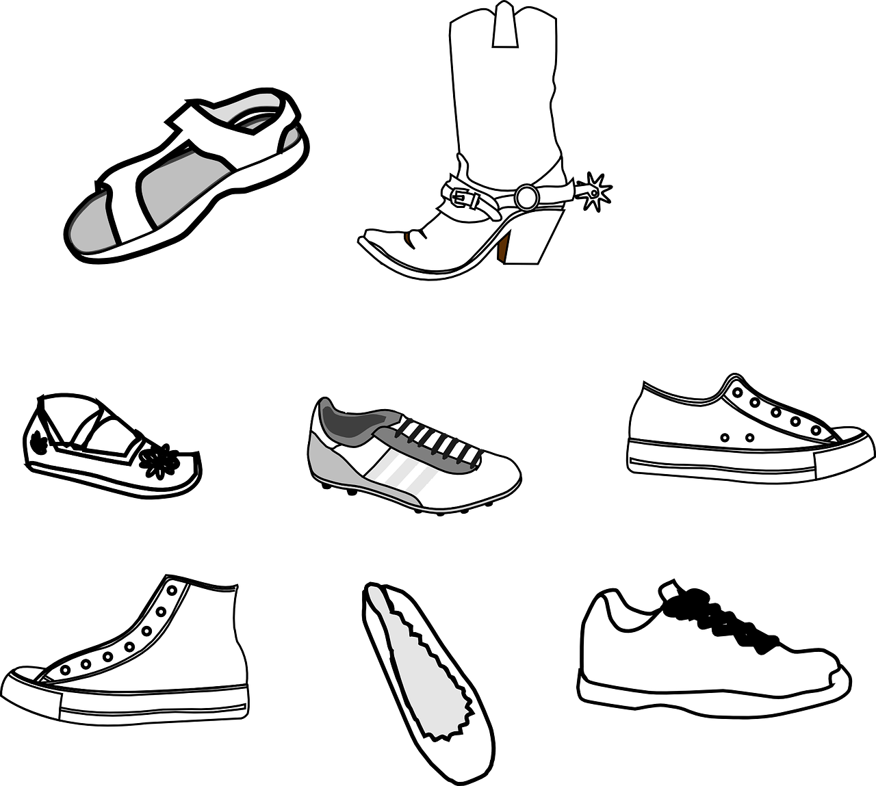
[h5p id="303"]
[h5p id="304"]
[h5p id="305"]
[h5p id="306"]

[h5p id="307"]
[h5p id="308"]

| Godišnja doba [Seasons]
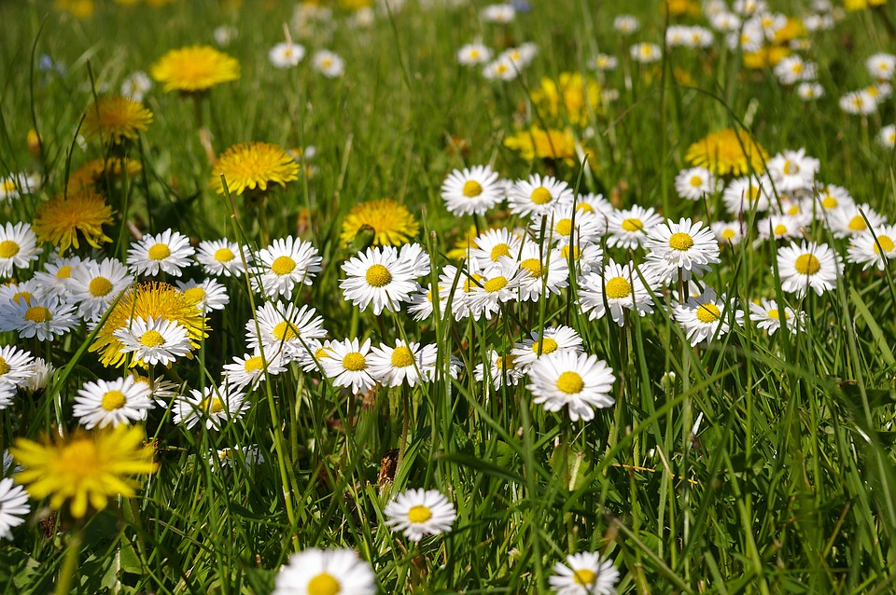 | 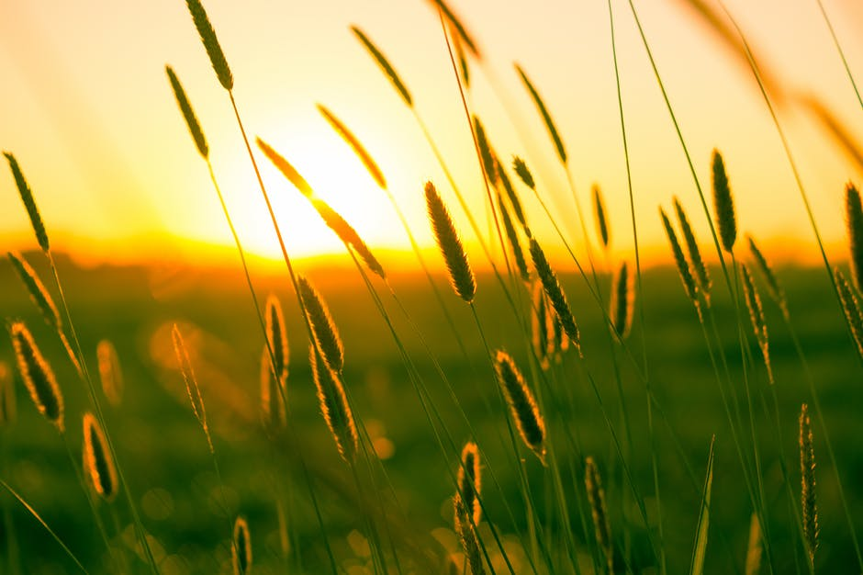
proljeće | ljeto
(audio) | (audio)
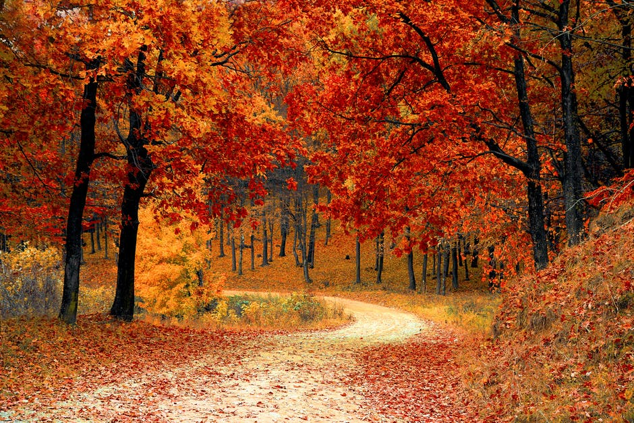 | 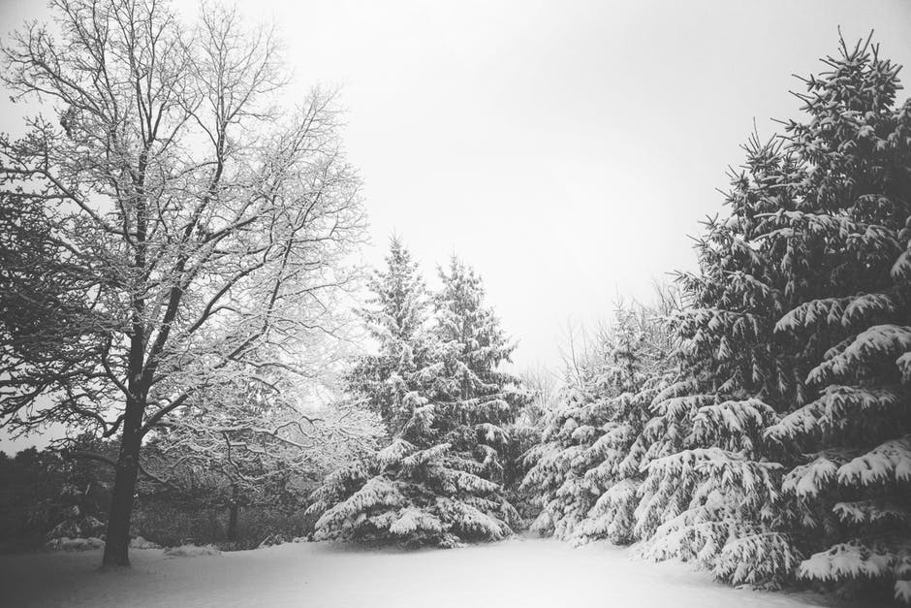
jesen | zima
(audio) | (audio)

Images used in this document are from these sources.

