10 | 1 | Lekcija 2: Poklon za rođendan

# 10.1 Zadatak 8. Gdje se nalazi?

Use the map of Europe to compose 8 sentences in which you will say where certain countries are located in comparison to other countries. You need to write two sentences for each of the following:

| sjeverno od | južno od | istočno od | zapadno od |
| --- | --- | --- | --- |

Here are two examples when we want to express that a country is located south of another country. (1) *Hrvatska se nalazi južno od Mađarske*. (2) *Mađarska se nalazi južno od Slovačke*.

[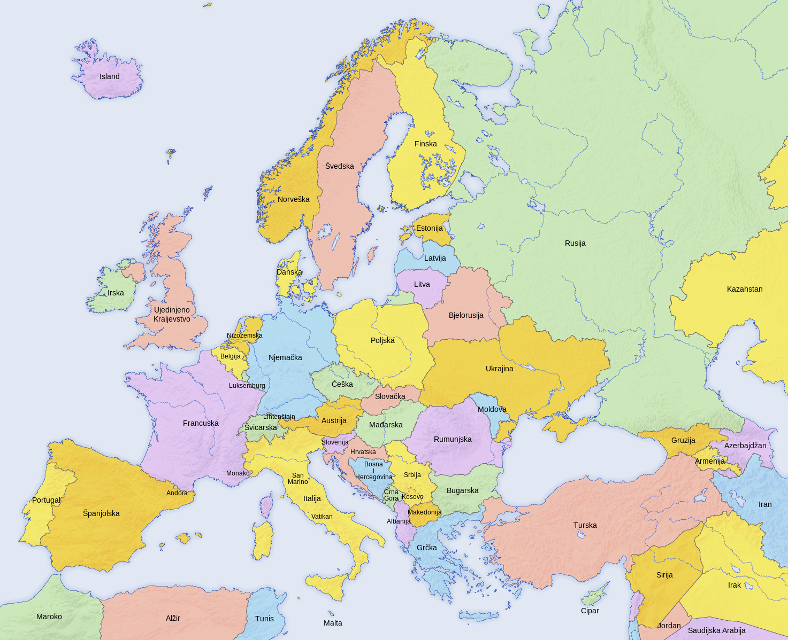](https://commons.wikimedia.org/wiki/File:Europe_countries_map_2_hr.svg)

## | Gdje se nalazi?

| 1. |
| --- |
| 2. |
| 3. |
| 4. |
| 5. |
| 6. |
| 7. |
| 8. |

Now that you have your sentences ready, meet with a classmate and ask them if they know where your countries are located. Keep in mind, your classmate might provide a different answer. Listen carefully to see if you agree and provide your alternative. Submit your video recording of this portion online.

# 10.1 Zadatak 9. Savezne države

👥 Before you meet with a classmate, prepare questions to test your classmate’s knowledge on the geographical location of the states in the U.S. Your goal is to test your classmate's knowledge on ten different states. In their answers, your classmate needs to use one of the following:

| blizu | pokraj | daleko od | nedaleko od |
| --- | --- | --- | --- |

| **| Na primjer:** |
| --- |
| Gdje se nalazi Teksas? |
| → Teksas se nalazi pokraj Novog Meksika. |

### | Gdje se nalazi?

| 1. |
| --- |
| 2. |
| 3. |
| 4. |
| 5. |
| 6. |
| 7. |
| 8. |
| 9. |
| 10. |

# 10.1 Zadatak 10. Je li daleko?

Look at the following list of destinations that go from one city to another city. Your task is to find out how far away they are from one another in kilometers and miles. When you have the answers ready, write down if they are: *blizu, daleko, nedaleko od, daleko od*.

| Destinacija: | udaljenost | | Je li daleko? |
| --- | --- | --- | --- |
| km | mi |
| Orlando, FL → Tampa, FL | 151 | 94 | nedaleko |
| Austin, TX → Santa Fe, NM |  |  |  |
| Los Angeles, CA → San Francisco, CA |  |  |  |
| Pittsburgh, PA → Philadelphia, PA |  |  |  |
| Austin, TX → San Antonio, TX |  |  |  |
| Portland, OR → Seattle, WA |  |  |  |
| St. Louis, MO → Washington, DC |  |  |  |

Submit your recording. Other classmates will listen to your answers and will say if they agree or not (based on their perception of distances). Use the example on how to read your answers: *Orlando je nedaleko od Tampe. Oni su udaljeni 151 kilometar, tj. 94 milje*.

Be careful how you read the distances between cities. Here is a reminder/handout about numbers and nouns.

| **kilometar** | **jedan** | **dva, tri, četiri** | **pet, šest, sedam…** |
| --- | --- | --- | --- |
| *kilometar* | *kilometra* | *kilometara* |
| **milja** | **jedna** | **dvije, tri, četiri** | **pet, šest, sedam…** |
| *milja* | *milje* | *milja* |

# 10.1 Zadatak 11. Idemo do Dubrovnika

So far we know that our students from Split are planning to go to Dubrovnik over the weekend. Let's investigate some options for Dubrovnik and learn more about the location, activities, etc. To answer the following questions you will need to use Google search for general information and Google maps for locations.

| 1 | Gdje se nalazi Dubrovnik u Hrvatskoj? |
| --- | --- |
| - |
| 2 | Koliko treba voziti od Splita do Dubrovnika? |
| - |
| 3 | Kolika je udaljenost od Splita do Dubrovnika? |
| - |
| 4 | Što treba posjetiti u Dubrovniku? |
| - |
| 5 | Koliko dana je dovoljno otići u Dubrovnik? (dovoljno = enough) |
| - |
| 6 | Koji grad ti se više sviđa, Split ili Dubrovnik? Zašto? |
| - |
| 7 | Koje lokacije blizu Dubrovnika treba posjetiti? Zašto? |
| - |
| 8 | Gdje se nalazi Lokrum? |
| - |

Images used in this document are from [these sources](https://docs.google.com/document/d/1DNffz3niTFcUzQxKiWFhQeXhVGRhjnkoJFj_AfveuWM/edit#heading=h.shfvwvk0v5f7).