7 | 2 | Lekcija 2: Plan putovanja

# 7.2 Zadatak 5. Kakav je?

Search online for four different images of any type of local Croatian transportation and copy-paste them in the table below.

| copy-paste image #1 | copy-paste image #2 |
| --- | --- |
| copy-paste image #3 | copy-paste image #4 |

Now, compare them according to your opinion by using the comparatives listed below. One example is given to you.

| skuplji | povoljniji | jeftiniji |
| --- | --- | --- |
| brži | sporiji | noviji |
| → Avion je udobniji nego brod. | | |
| → | | |
| → | | |
| → | | |
| → | | |
| → | | |
| → | | |

# 7.2 Zadatak 6. Kakav je?

👥 Look at **Zadatak 13** from today’s class session again. Meet with one of your classmates and share your plans for the upcoming weekend trip. You cannot work with the same person as you did during class. The goal is to share your plans with different people. Be sure to comment on your classmate’s ideas and ask for more information.

## | Pitanja

| Kamo ideš? |
| --- |
| S kim putuješ? Zašto? |
| Čime putuješ? |
| U koliko sati je polazak? |
| U koliko sati je dolazak? |
| Što ćeš raditi/posjetiti na destinaciji? |

# 7.2 Zadatak 7. Kamo i čime putuješ?

Continuation of Zadatak 10 from our class session. Let’s say you are currently in Zagreb and in class you have already picked where you want to go. You also researched one option on how to get to your destination. You researched a train, bus, or plane itinerary to get to your destination. Now it’s time to investigate the second preferred way to get to your destination.

|  |  |  |
| --- | --- | --- |
| [Željeznički kolodvor](https://prodaja.hzpp.hr/) | [Autobusni kolodvor](https://www.flixbus.hr/) | [Zračna luka](https://www.croatiaairlines.com/hr) |

Find two possible time slots to leave to your destination and when you will come back. You will need to present both options later on to your classmate and discuss which option is better for you. You will also need to compare these options with the one you did in class. What is the best way to travel to your destination?

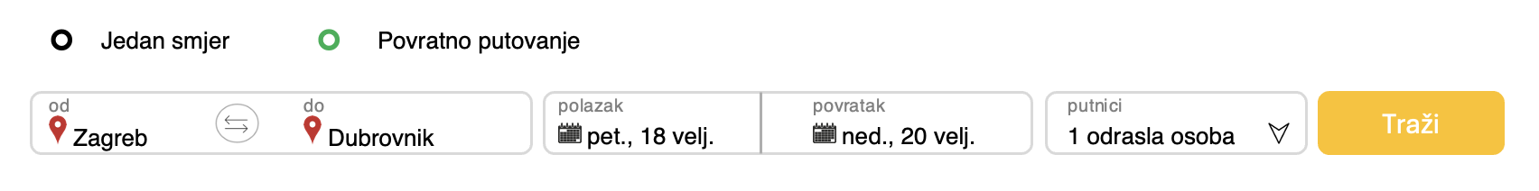

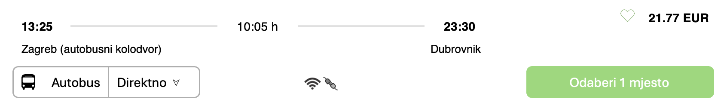

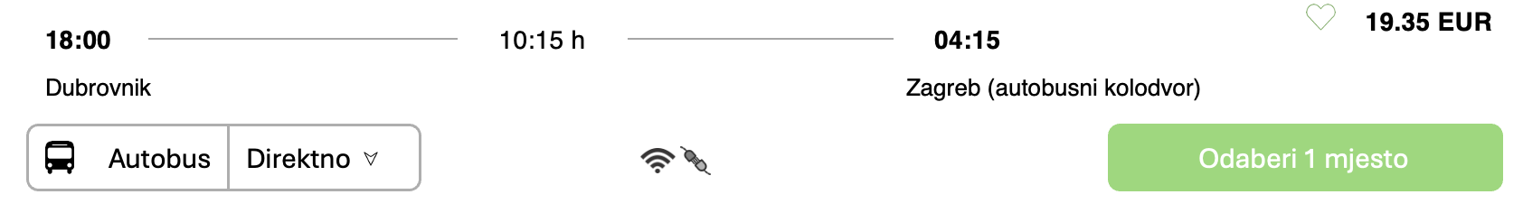

| Opcija br. 1 | |
| --- | --- |
| Polazak: |  |
| Povratak: |  |
| Koliko traje put? |  |
| Koliko košta povratna karta? |  |
| Opcija br. 2 | |
| Polazak: |  |
| Povratak: |  |
| Koliko traje put? |  |
| Koliko košta povratna karta? |  |

👥 Meet with your classmate and discuss your options. Present both of the options from this assignment, together with the findings that you did in class. Ask your classmate for suggestions and what you should do. Provide some additional comments on your classmate’s plans. Submit your video recording online.

# 7.2 Zadatak 8. S dragim prijateljima

You want to go for a weekend trip with your classmates (Friday-Sunday) in the city where you study. Do some online research on where you would like to go, what you would like to do there, and how to get there. Use an actual web source for the chosen transportation. Find at least two possible time slots for when to leave and come back. Present your ideas in a video recording and post it for others to watch. Everyone should reply to all videos with their comments, saying if they want to go there or not. Include specific reasons for your choices in your video.

|  |  |
| --- | --- |

Before you start your video recording and you invite your friends to join you, answer the questions below as they will help you formulate your invitation/presentation.

| Opcija br. 1 | |
| --- | --- |
| Destinacija (zašto): |  |
| Čime želiš putovati? |  |
| Polazak: |  |
| Povratak: |  |
| Koliko traje put? |  |
| Koliko košta povratna karta? |  |
| Što želiš raditi/vidjeti? |  |
| Opcija br. 2 | |
| Destinacija (zašto): |  |
| Čime želiš putovati? |  |
| Polazak: |  |
| Povratak: |  |
| Koliko traje put? |  |
| Koliko košta povratna karta? |  |
| Što želiš raditi/vidjeti? |  |

Images used in this document are from [these sources](https://docs.google.com/document/d/1jvxnrKgmli-yNt2XrFTjyWxffnum2UXOTK30AeHcmBo/edit#heading=h.shfvwvk0v5f7).