8 | 3 | Lekcija 1: Ne jedi rukama!

# 8.3 Zadatak 1. Što pripremaš?

👥 Talk to your classmates to see if you all have anything in common.

## | Pitanja

| Pripremaš li (često) večeru? |
| --- |
| Za koga pripremaš večeru? |
| Što obično pripremaš/kupiš za večeru s prijateljima? |
| Koju hranu voliš? |

# 8.3 Zadatak 2. Koju hranu voliš?

Do you know where these foods originate from? You have a list of flags that you need to match with the pictures. To present your answers, be sure to change the name of the country to its possessive adjective form. For example: Hrvatska → hrvatski puding, hrvatska torta, or hrvatsko vino.

|  |  |  |  |
| --- | --- | --- | --- |
| a. boršć | b. giros | c. bečki odrezak | d. gulaš |
|  |  |  |  |
| e. pizza | f. kranjska kobasica | g. hamburger | h. jorkširski puding |
|  |  |  |  |
| i. haringa | j. suši | k. paella | l. burek |
|  | | | |
|  |  |  |  |
|  |  |  |  |
|  |  |  |  |

| | Tradicionalna hrana | |
| --- | --- |
| → nizozemska haringa | → |
| → | → |
| → | → |
| → | → |
| → | → |
| → | → |

Now collect answers from your classmates about their past experiences and food they have tried and want to try. Do they like the food? What would they like to try?

| Što si jeo / jela? | Što želiš probati? |
| --- | --- |
|  |  |
|  |  |
|  |  |
|  |  |
|  |  |

# 8.3 Zadatak 3. Poziv na druženje i večeru

James decided to invite his friend for dinner before the semester starts all over again. However, his fridge is completely empty and he needs to do some shopping. Help James organize his dinner plans. The following questions reflect your personal choices. Be creative.

|  |  |  |
| --- | --- | --- |
| savijača od jabuka | soparnik | piće |

Ines će donijeti savijaču od višnje. Njezina mama je napravila 4 komada i rekla je da Ines mora ponijeti jedan komad na večeru. Lukina mama je napravila [soparnik](https://www.croatiaweek.com/croatian-recipes-soparnik/). Matija će kupiti piće, ona neće donijeti ništa za jelo. A James, što on može pripremiti?

| 1 | Što James može pripremiti za večeru? |
| --- | --- |
| - |
| 2 | Hoće li on pripremiti predjelo, prilog, glavno jelo ili desert? Zašto? |
| - |
| 3 | Što James može pripremiti za glavno jelo? |
| - |
| 4 | Što James mora kupiti? |
| - |

Read the text communication between James and his friends. Then, answer the questions.

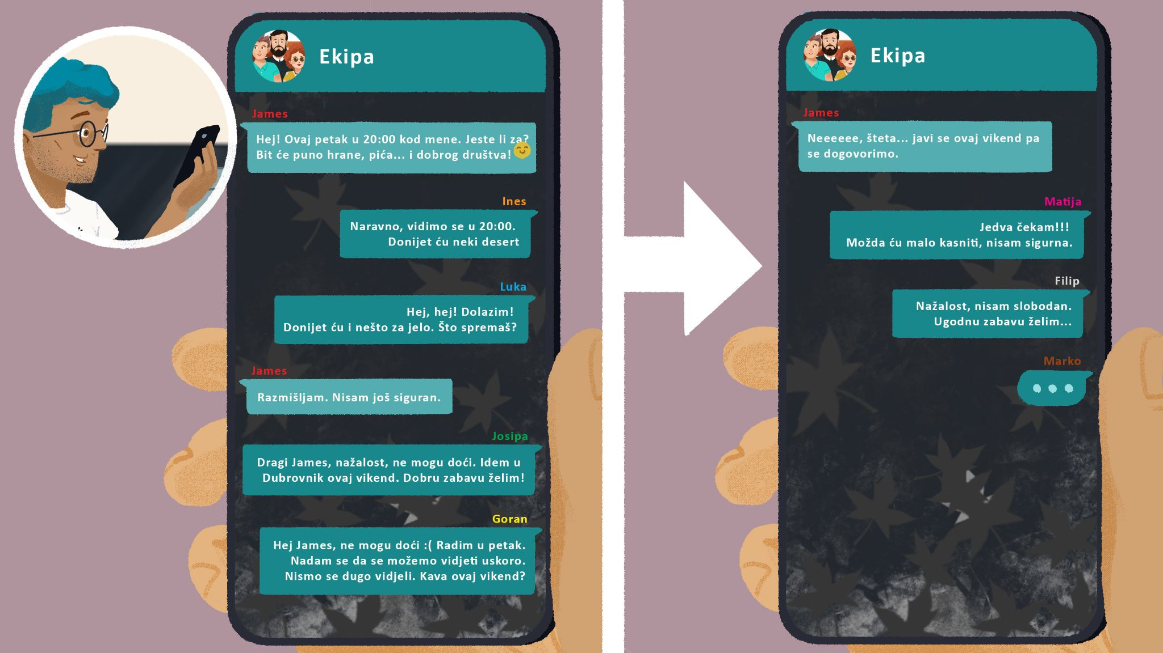

## | Razumijevanje

| 1 | Tko dolazi na večeru? |
| --- | --- |
| - |
| 2 | Hoće li Jamesov cimer Marko također biti na večeri? |
| - |
| 3 | Tko će kasniti na večeru? |
| - |
| 4 | Tko radi i ne može doći? |
| - |
| 5 | Tko još neće doći na večeru? Zašto? |
| - |
| 6 | U koliko sati je večera? |
| - |

# 8.3 Zadatak 4. Što jedeš?

Look at the following food items and talk with your classmates. Collect their answers in order to see what you all like/want to try.

|  |  |  |
| --- | --- | --- |
| tjestenina s tartufima | soparnik | kremšnita |
|  |  |  |
| juha od povrća | torta od čokolade | pita od sira |
|  |  |  |
| crni rižoto od sipe | pizza s ananasom | tjestenina s gorgonzolom |
|  |  |  |
| meso na žaru | meso ispod peke | riba na žaru |

| Tko? | Što voliš jesti? | Što želiš probati? |
| --- | --- | --- |
|  |  |  |
|  |  |  |
|  |  |  |
|  |  |  |
|  |  |  |

Now, look again at the food items below. How do we eat them? What cutlery do we use or not use?

| Čime jedemo […]? | | |
| --- | --- | --- |
|  |  |  |
| nožem | vilicom | žlicom |
|  |  |  |
| malom žlicom | štapićima | rukama |

🔊 Listen to the **dialogue** and answer the questions.



## | Razumijevanje

| 1 | Što je James pripremio? |
| --- | --- |
| - |
| 2 | Čime Ines jede pizzu i/ili soparnik? Zašto? |
| - |
| 3 | Čime Luka jede pizzu? |
| - |
| 4 | Čime ti jedeš pizzu? |
| - |
| 5 | Čime Luka jede tortu? |
| - |
| 6 | Čime Matija jede tortu? |
| - |
| 7 | Čime ti jedeš tortu? |
| - |
| 8 | Što Luka misli o Ines? |
| - |

## | Razgovor

| → | Što ti želiš pripremiti za prijatelje? |
| --- | --- |
| → | Što moraš kupiti? |
| → | Tko dolazi na tvoju večeru? (dolaziti = to come) |

[](https://commons.wikimedia.org/wiki/File:Youtube.png)

If there is time left, let’s watch a short [YouTube video](https://www.youtube.com/watch?v=wp7KHUiuTfk) about **komiška pogača**.

### Pitanje: Želiš li probati komišku pogaču? Zašto?

Images used in this document are from [these sources](https://docs.google.com/document/d/1uNkHz1koLNHrFho8AsFaOCA2hwzfRV1PHuNxsMFmh50/edit#heading=h.ktkus0ccq3de).