8.10 - pracovat jako __________

In Czech if you want to say what you do, you say pracuju jako + your profession

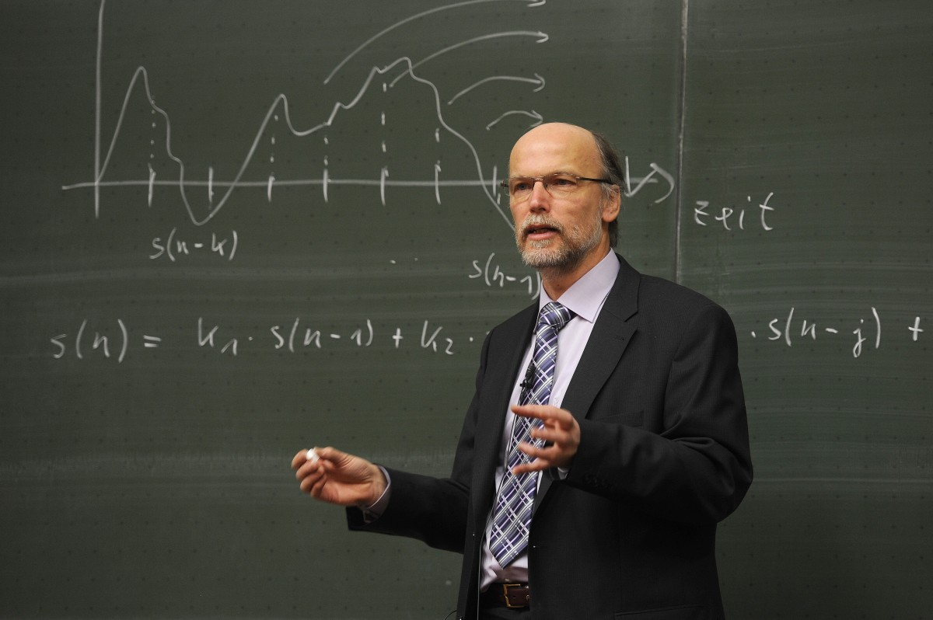 | 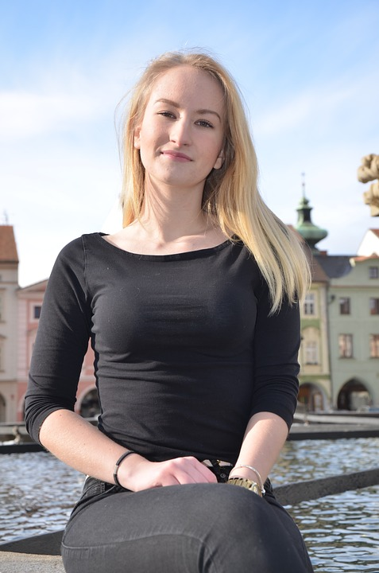 | 
Martin pracuje jako profesor.  Martin works as a professor. | Aneta pracuje jako číšnice v restauraci.  Aneta works as a waitress in a restaurant. | Milena pracuje jako fotografka.  Milena works as a photographer.

If you want to ask someone what they do, ask them Co děláte za práci? which literally translates as ‘what do you do for work?’

Images used in this document come from these sources.

