3 | 1 | Lekcija 5: Stambeno pitanje

# | The verb ŽIVJETI

The verb *živjeti* follows the rules of -jeti verbs that you already encountered. Most likely you will use the verb živjeti in the context of a specific location (I live in Austin, or I live in a house). Remember, when you want to express where you are located, you need to use the Locative case. Endings are listed for you again here.

| **SINGULAR** | | | **PLURAL** | | |
| --- | --- | --- | --- | --- | --- |
| [(audio)](https://croatian.takolako.org/wp-content/uploads/ZIVIM.mp3) | ja | živ-im | [(audio)](https://croatian.takolako.org/wp-content/uploads/ZIVIMO.mp3) | mi | živ-imo |
| [(audio)](https://croatian.takolako.org/wp-content/uploads/ZIVIS.mp3) | ti | živ-iš | [(audio)](https://croatian.takolako.org/wp-content/uploads/ZIVITE.mp3) | vi | živ-ite |
| [(audio)](https://croatian.takolako.org/wp-content/uploads/ZIVI.mp3) | on/-a/-o | živ-i | [(audio)](https://croatian.takolako.org/wp-content/uploads/ZIVE.mp3) | oni/-e/-a | živ-e |

## Gdje živiš?

| Ja živim… | u grad**u** | u kuć**i** | na sel**u** |
| --- | --- | --- | --- |
| masculine  locative singular | feminine  locative singular | neuter  locative singular |

# 3.1 Zadatak 11. Gdje živite?

[h5p id="357"]

# 3.1 Zadatak 12. Lokacije

🔊 Listen to the dialogue that you encountered in Unit 2. It is a dialogue between Laura and her local friends (Sandra, Davor, and Mario). In the dialogue she asked them where they originally came from. Your task is to use this information in order to answer the set of questions below. Be careful, this time you need to use the Locative case in your answer, together with the appropriate preposition) in order to provide the answer to where they live.

| Nominative | stan | kuće | polje |
| --- | --- | --- | --- |
| Locative | -u | -i | -u |

[(audio)](https://croatian.takolako.org/wp-content/uploads/U2_M1_L1_zadatak_1_1.mp3)

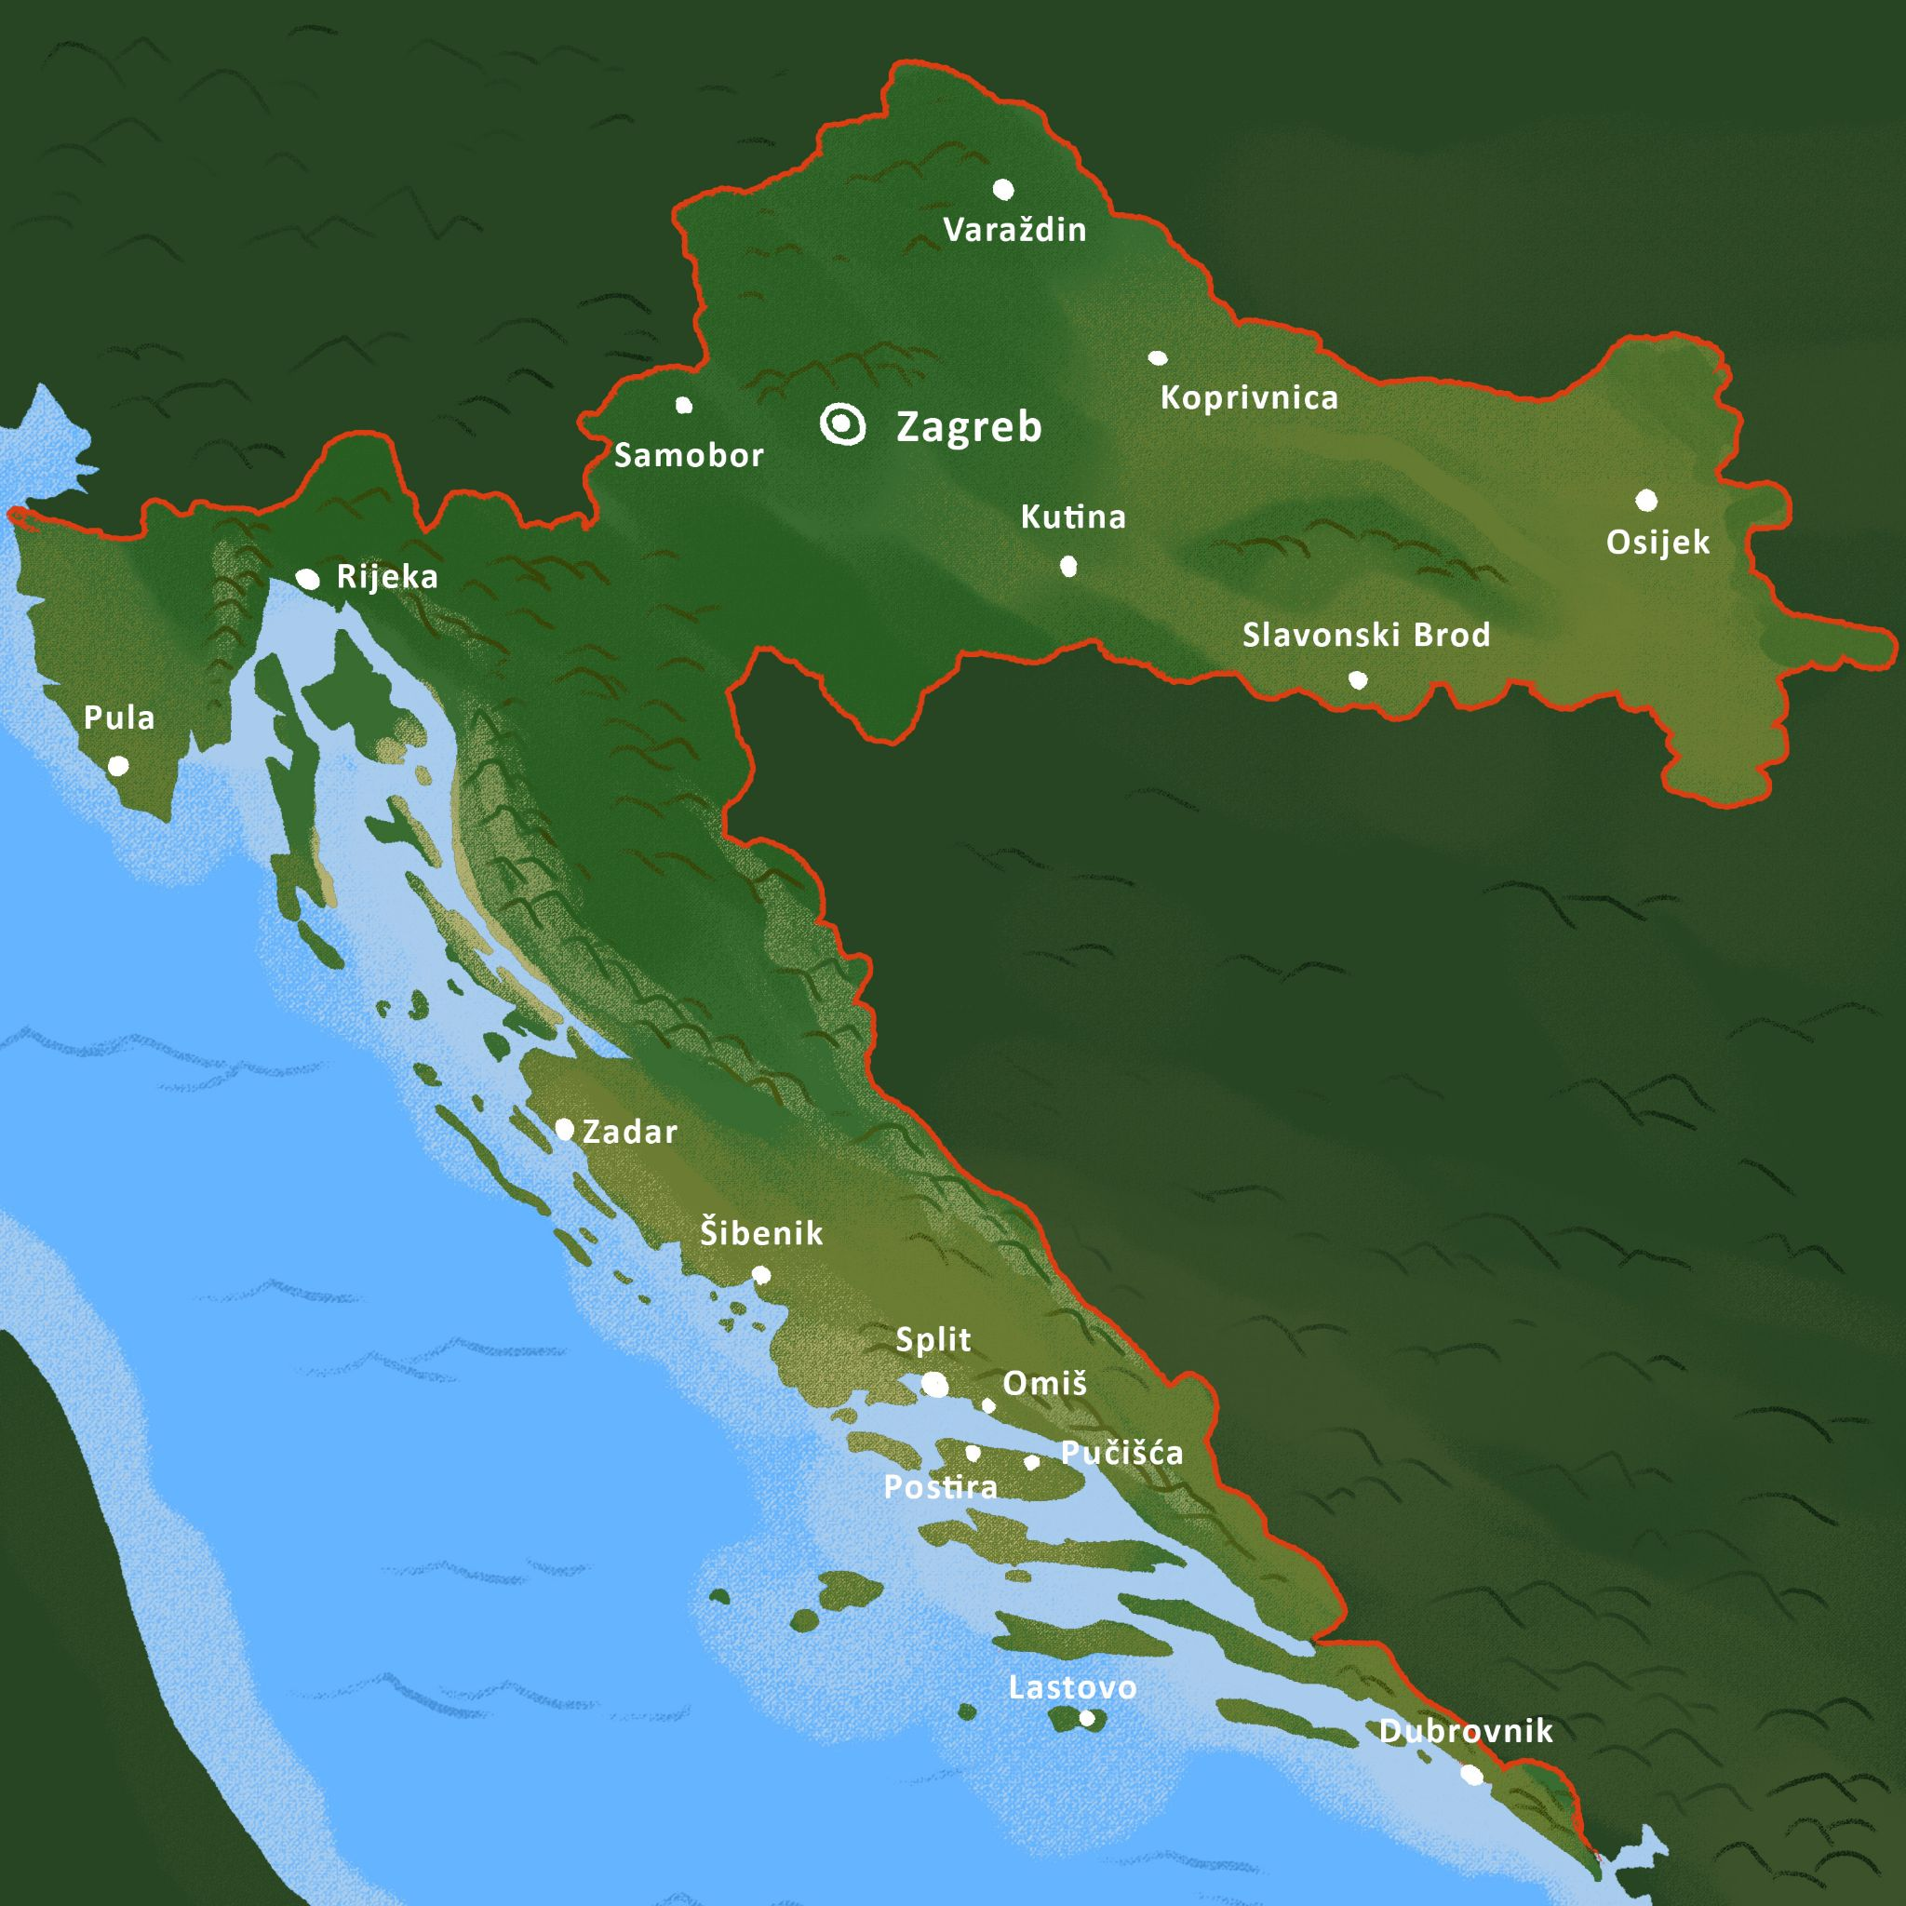

[h5p id="358"]

# | Possessive adjectives – Animate nouns

Possessive adjectives are formed from personal names of people and animals or common nouns denoting people to express that something or someone belongs to them. They have different forms for all three genders, both in singular and plural, depending on the noun following the adjective. These kinds of possessive adjectives (if they come from personal names) are always written with a capital letter (Ivan – Ivanov, Marta – Martin).

| Masculine nouns add the following endings: |
| --- |
| The most common ending for masculine personal names is –ov. (first name) Ivan: Ivanov |
| If a masculine name ends in: ć, č, đ, dž, j, lj, nj, š, ž, r |
| Personal names will use the ending –ev. (last name) Perić: Perićev |
| Feminine nouns lose the –a ending and add –in. |
| Feminine nouns will remove the final -a and will add the ending –in.  Ivana – Ivanin; Jelena – Jelenin; Branka – Brankin |

Remember – masculine nouns ending in –a (Ante, Nikola, tata) also use the feminine ending – in for the possessive adjective form (Antin/-a/-o, Nikolin/-a/-o, Andrijin/-a/-o, tatin/-a/-o).

So how does one make the singular and plural forms for both genders? Look at the following chart. Remember, the possessive adjective form of a personal name (Ivan’s bag, Ivan’s table, etc.) depends on the gender of the noun that they are referring to. For example, if Ivan ‘’possesses’’ a table (stol) – the correct form is to say: Ivanov stol. However, if Ivan ‘’possesses’’ a book (knjiga) – the correct form is: *Ivanova knjig*a.

| Gender | Jednina (singular) | Množina (plural) |
| --- | --- | --- |
| masculine | Ivanov stol. | Ivanovi stolovi. |
| feminine | Ivanova knjiga. | Ivanove knjige. |
| neuter | Ivanovo dijete. | Ivanova djeca. |

| Gender | Jednina (singular) | Množina (plural) |
| --- | --- | --- |
| masculine | Anin stol. | Anini stolovi. |
| feminine | Anina knjiga. | Anine knjige. |
| neuter | Anino dijete. | Anina djeca. |

Some common nouns denoting people (mostly family words and professions) form possessive adjectives in the same way.

| **brat** | **prijatelj** |
| --- | --- |
| *bratov automobil* | *prijateljev automobil* |
| **mama** | **sestra** |
| *mamin automobil* | *sestrin automobil* |

# 3.1 Zadatak 12. Tko je to?

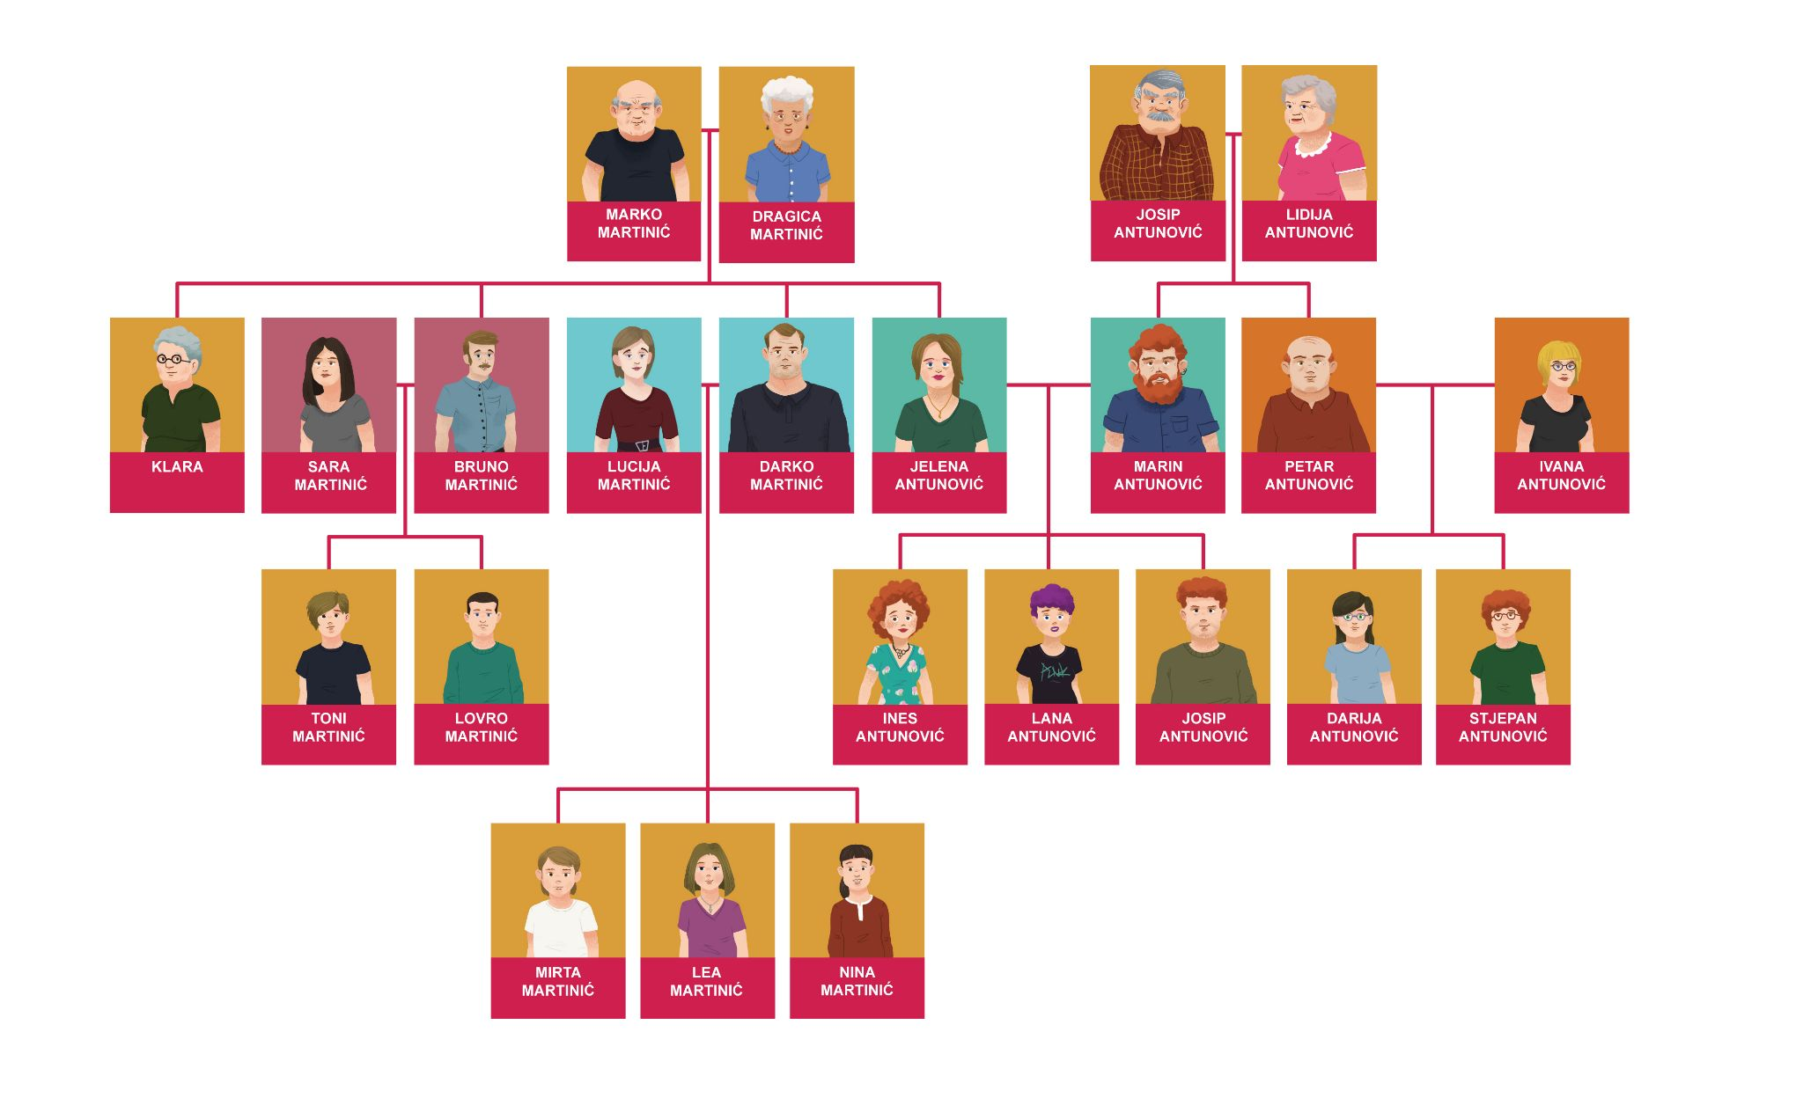

[h5p id="359"]

[h5p id="360"]

Images used in this document are from [these sources](https://docs.google.com/document/d/1kMYX8HXlacJ2b6CK15MfcZyZp8repH_tTJ9BGugRFF0/edit#heading=h.f4ho5a1njb3w).