5.7 - brát / vzít prášek - to take medicine

Taking medicine is never fun, and neither is learning a new verb conjugation. Of course in Czech we have to learn two new verbs, brát - ‘to take’ and vzít - ‘to take’.

brát ‘to take’
(já) | beru ‘I take’ | (my) | bereme we take’
(ty) | bereš ‘you take’ | (vy) | berete ‘you take’
(on/ona/ono) | bere ‘he/she takes’ | (oni/ony/ona) | berou ‘they take’

vzít ‘to take’
(já) | vezmu ‘I take’ | (my) | vezmeme ‘we take’
(ty) | vezmeš ‘you take’ | (vy) | vezmete ‘you take’
(on/ona/ono) | vezme ‘he/she takes’ | (oni/ony/ona) | vezmou ‘they take’

What’s the difference between these two? Well, it’s a little early to go into the specifics, but it’s something that we will learn in a later unit called verbal aspect. However, for now you can easily ignore the difference between them and treat them as synonyms.

Additionally, sometimes Czechs will add the word si ‘for myself’ to the verbs, i.e. brát si / vzít si prášek

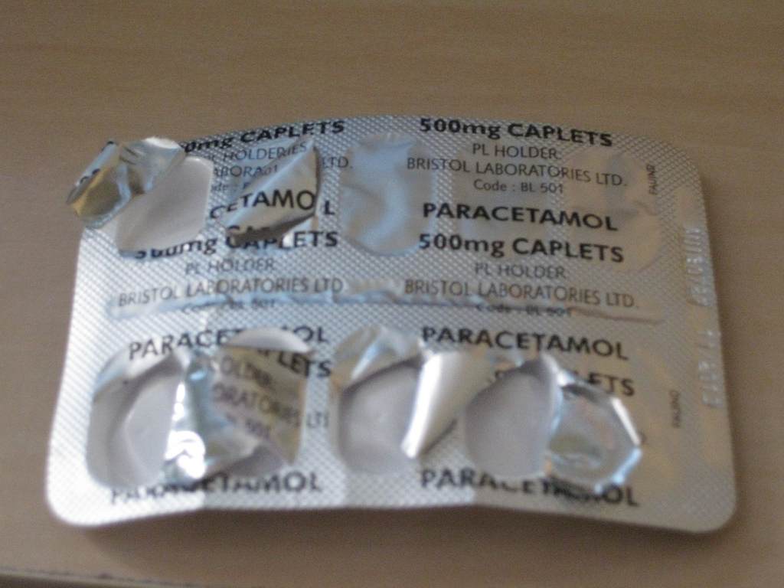  Když Lenku bolí hlava, vezme si někdy prášek. |   Když jsem nachlazená, tak většinou beru vitamíny a piju celý den vodu.

prášek / tableta / tabletka ‘pill’
The word for a pill is prášek or tableta/tabletka. If you want to specify what type of pill it is, you can use the word proti (+DAT) ‘against’:

tabletka proti kašli - cough medicine
prášek proti bolesti - pain pill

Images used in this document come from these sources.

