7 | 3 | Lekcija 2: Studentsko putovanje

# 7.3 Zadatak 5. Kako se kaže?

Based on today’s class session, how would you express the following in Croatian?

|  |  |
| --- | --- |

| 1 | How to tell your friend that you are very tired. (There is a phrase for this.) |
| --- | --- |
| - |
| 2 | How would you say that you are extremely honored [to do something]. |
| - |
| 3 | How to express your best regards? |
| - |
| 4 | How to say in an email that you are taking the opportunity to confirm [...]? |
| - |
| 5 | How to end a conversation in a friendly-informal way? |
| - |
| 6 | How to end an email in a formal way? |
| - |

# 7.3 Zadatak 6. Lukin odgovor na e-mail

From the class dialogue, you already know that Luka instantly replied to a received email. However, he made a mistake and used the school’s general email, instead of replying to Lidija who is the school administrator.

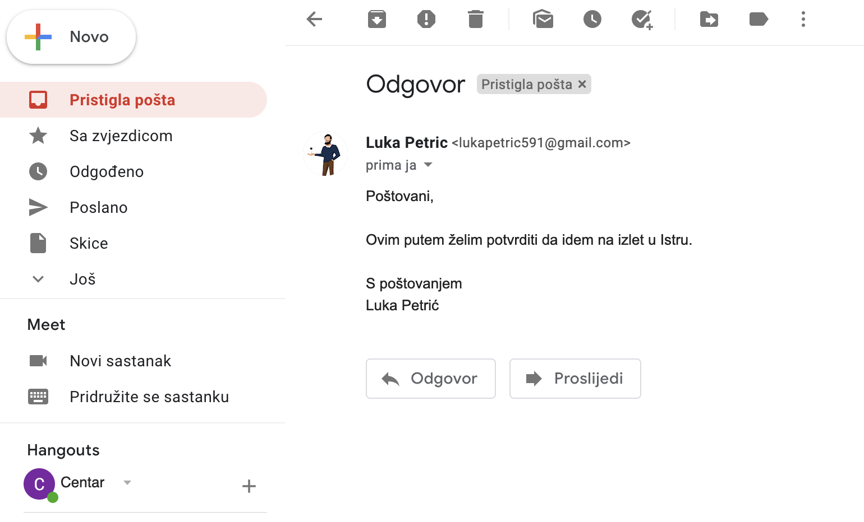

## | In English

Kultura dopisivanja - kako napisati službeni e-mail

|  |  |
| --- | --- |

## | Pitanja

| Read Luka's and James’ email again. What is the difference between their opening lines? Can you explain why they are different (even though both are formal and correct)? |
| --- |
| → |
| Luka and James also have different final lines. What would be their best translation in English? |
| → |

# 7.3 Zadatak 7. Događanja u Hrvatskoj

### Pitanje: Kamo želiš ići? Zašto?

| **Step 1**  INVESTIGATE |  | Investigate the [**link**](https://croatia.hr/hr-HR/Aktivnosti-i-atrakcije/Dogadanja) about *Događanja u Hrvatskoj*. Choose one event that you would like to attend and answer the above question. |
| --- | --- | --- |
| **Step 2**  THINK |  | Since you have already decided to go to this chosen event, your task is to send an email to your school (general email, not to a specific person) saying that you already have plans for the weekend and you won’t be able to join them on a weekend trip. |
| **Step 3**  PREPARE |  | Use class material and the vocabulary section before writing this email. You need to be detailed in your email and say why you are not able to join. Finish your email in the most appropriate way. |
| **Step 4**  WRITE |  | Send the email to your instructor who will be playing the role of a school representative for the purposes of this task. Be sure to finish your email in the most appropriate way. You can expect a follow-up from your instructor. |

# 7.3 Zadatak 8. Moje putovanje

👥 Before you meet with one of your classmates to discuss your weekend plans, answer the following questions.

| **| Pitanja** |
| --- |
| Na koje događanje planiraš ići? Zašto? |
| Čime ideš i skim ideš? |
| U koliko je sati polazak? |
| Koliko traje tvoj put? |
| U koliko sati je povratak? |
| U koliko sati ćeš biti u Splitu? |
| Gdje ćeš spavati? |
| Je li tvoje putovanje jeftino ili skupo? |
| Što sve planiraš raditi za vikend? |

|  |  |
| --- | --- |

When you have all the information, meet with your classmate and present your plans, saying why you can’t join them for the weekend trip. Say where you will go, how you will get there, whether you are going alone, where you will stay, etc. Express your overall opinion about your trip. Be sure to ask for any suggestions. Provide comments on your classmate’s plans. Submit your video recording online.

Images used in this document are from [these sources](https://docs.google.com/document/d/1uWOxGc3WsLyE8VBlh0bnv4IPsle55LB64j_Yz-JgLtU/edit#heading=h.shfvwvk0v5f7).