10 | 2 | Lekcija 2: Po Dubrovniku

# | Where to – KAMO, KUDA, GDJE

|  | **Kuda ideš?** | Idem Frankopanskom ulicom. | + Instrumental case |
| --- | --- | --- | --- |
|  | **Kamo ideš?** | Idem u muzej. | + Accusative case |
|  | **Gdje si?** | Ja sam u muzeju. | + Locative case |

As you can see: ***kamo*** and ***kuda*** are usually followed by the verb to go (*ići*), while ***gdje*** is usually followed by the verb to be (*biti*). All three questions will require using a different case in the answer. However, let us investigate first what these questions mean.

|  | **kuda** | how are you getting there (which path are you taking in order to get somewhere) | |
| --- | --- | --- | --- |
|  | **kamo** | where are you going (your motion toward a certain place/location | |
|  | **gdje** | where are you located (your current, past, or future exact location) | |

When someone asks you one of these questions, your answer has to follow these rules:

|  | **Kuda ideš?**  *Idem Frankopanskom.* | (by way of Frankopanska)  The answer will include the name of the street in the Instrumental case (without the preposition). | |
| --- | --- | --- | --- |
|  | **Kamo ideš?**  *Idem u muzej.* | Answer will include the adequate preposition u / na + the Accusative case | |
|  | **Gdje si?**  *Ja sam u muzeju.* | The answer will include the appropriate preposition u / na + the Locative case | |

# | Directions

When giving direction on how to reach a certain place, these are the most common directions:

|  | ***idite ravno do (+Genitive)*** | go straight until [you reach] | |
| --- | --- | --- | --- |
|  | ***idite ravno … (+Instrumental)*** | go down/up a certain street | |
|  | ***skrenite desno / lijevo*** | turn right / left | |
|  | ***preko ceste je…*** | across the street there is… | |
|  | ***nasuprot je…*** | something is opposite something else | |

Look at the example: 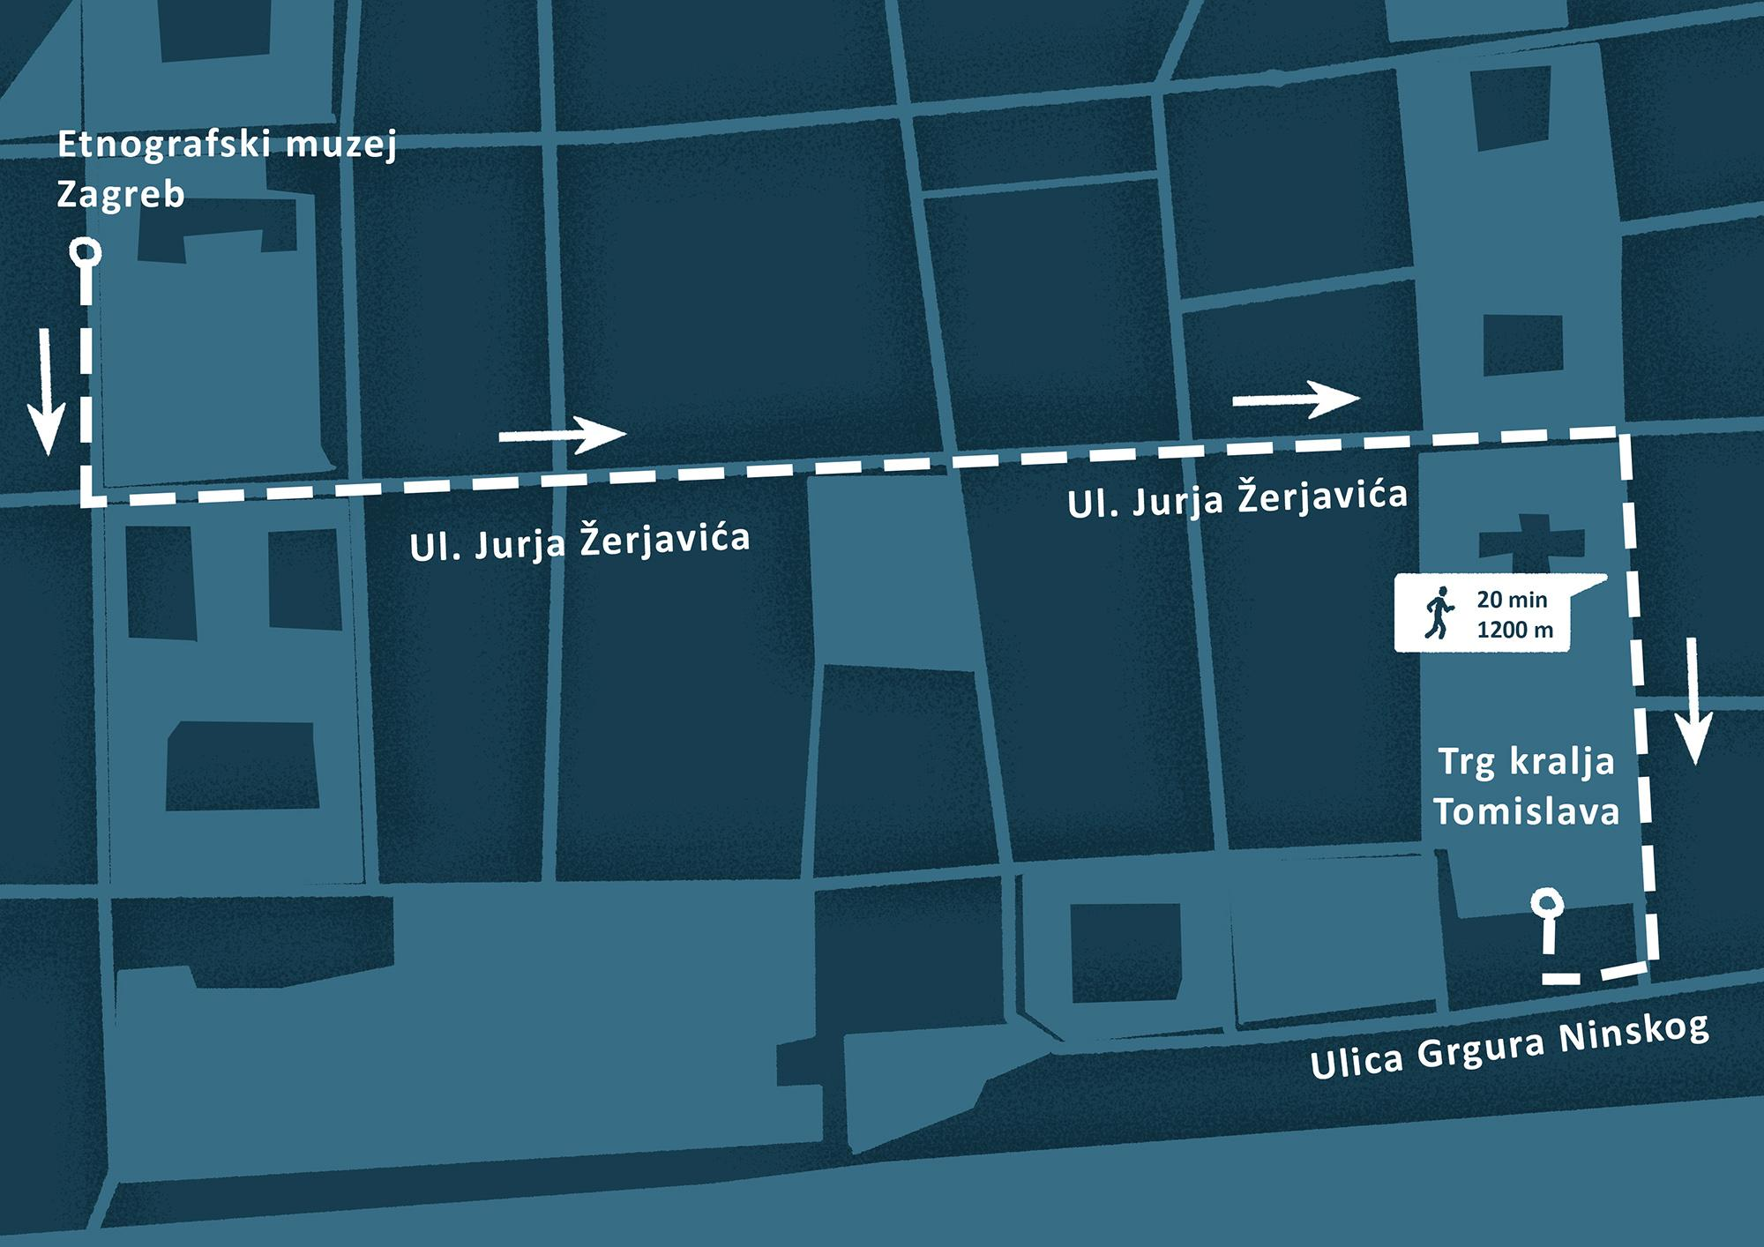

Idite pravo do ulice Jurja Žerjavića i zatim skrenite lijevo. Idite Žerjavićevom do ulice baruna Trenka i idite pravo do trga kralja Tomislava. Skrenite desno i idite pravo do ulice Grgura Ninskog. Skrenite desno i trg kralja Tomislava će biti na desnoj strani.

# 10.2 Zadatak 1. Kamo, kuda, gdje?

Choose the correct word to complete each sentence logically: **kamo**, **kuda**, or **gdje**.

[h5p id="862"]

Images used in this document are from [these sources](https://docs.google.com/document/d/1mXgmfpJqCprIdM1MAJHqYVBoSyciTPrIJE6eohDBgLw/edit#heading=h.ou6sok6ab3dc).