6 | 4 | Lekcija 2: Peglam karticu

# 6.4 Zadatak 7. Tradicionalno i moderno

Look at the following items and mark what you like. Talk with your classmates to find out what they like.

## Što ti se sviđa?

|  |  |  |  |
| --- | --- | --- | --- |
| košulja | majica | jakna | torba |
|  |  |  |  |
| kišobran | kravata | marama | naušnice |
|  |  |  |  |
| majica | dres | kapa | ogrlica |

Answer the following question and then talk with your classmate to see how similar you are.

| **| Što želiš kupiti:** |
| --- |
| * bratu: |
| * sestri: |
| * mami: |
| * tati: |

# 6.4 Zadatak 8. Na ulici

🔊 Listen to **dialogue one** and answer the questions. *Laura i Sandra su u centru. Planiraju kako provesti subotnje popodne.*

|  |  |
| --- | --- |

## | Razumijevanje

| 1 | Gdje su Laura i Sandra? |
| --- | --- |
| - |
| 2 | Kamo idu prvo? |
| - |
| 3 | Gdje one mogu u šoping? |
| - |
| 4 | Što Laura želi kupiti? |
| - |
| 5 | Što Sandra želi pogledati? |
| - |
| 6 | Kamo ide Sandra sljedeći mjesec? |
| - |
| 7 | Što planira odjenuti? |
| - |
| 8 | Što će Laura posuditi Sandri? |
| - |
| 9 | Što će Ivana posuditi Sandri? |
| - |

## | Osobna pitanja

| 1 | Što ti obično nosiš kad ideš na vjenčanje? |
| --- | --- |
| - |
| 2 | Imaš li običaj posuditi nešto za vjenčanje da ne moraš kupovati? |
| - |

# 6.4 Zadatak 9. Hoćemo li?

🔊 Listen to **dialogue two**. Pay attention to text messaging as well.

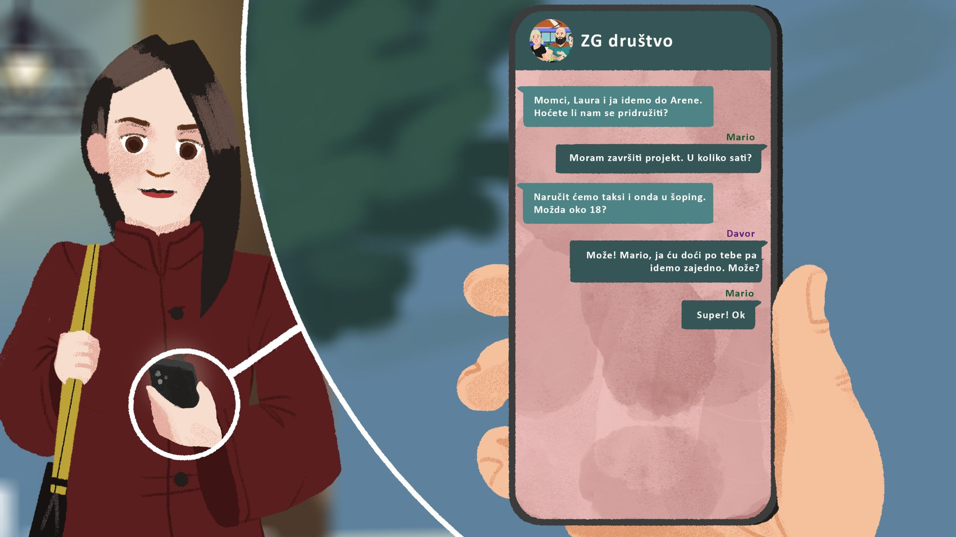

## | Razumijevanje

| 1 | Što planiraju Laura i Sandra? |
| --- | --- |
| - |
| 2 | Kamo idu? |
| - |
| 3 | Koja je adresa? |
| - |
| 4 | Znaš li tko je bio Vice Vukov? |
| - |

## | Osobna pitanja

| 1 | Koristiš li javni prijevoz (autobus, tramvaj) ili obično naručiš taksi? |
| --- | --- |
| - |
| 2 | Gdje ideš u šoping? |
| - |

# 6.4 Zadatak 10. Što nosimo?

👥 Talk with your classmate, and see how much you match.

| **| Pitanja** |
| --- |
| Što nosiš kada je hladno? |
| Što nosiš kada je prohladno? |
| Što nosiš kada je vruće? |
| Što obično nosiš kada ideš u šoping? |
| Što obično nosiš kad ideš u kazalište? |

# 6.4 Zadatak 11. Šoping centri

👥 Talk with your classmate. See how similar you are.

| **| Pitanja** |
| --- |
| Ideš li često/rijetko u šoping centar? |
| U koji šoping centar ideš? |
| Zašto ideš u šoping centar? |
| Što voliš raditi u šoping centru? |
| Što ima tvoj omiljeni šoping centar? |

# 6.4 Zadatak 12. U šoping centru

🔊 Read the text below and listen to **dialogue three**. Then, answer the questions. *Luka je u trgovini i priča s prodavačicom.*

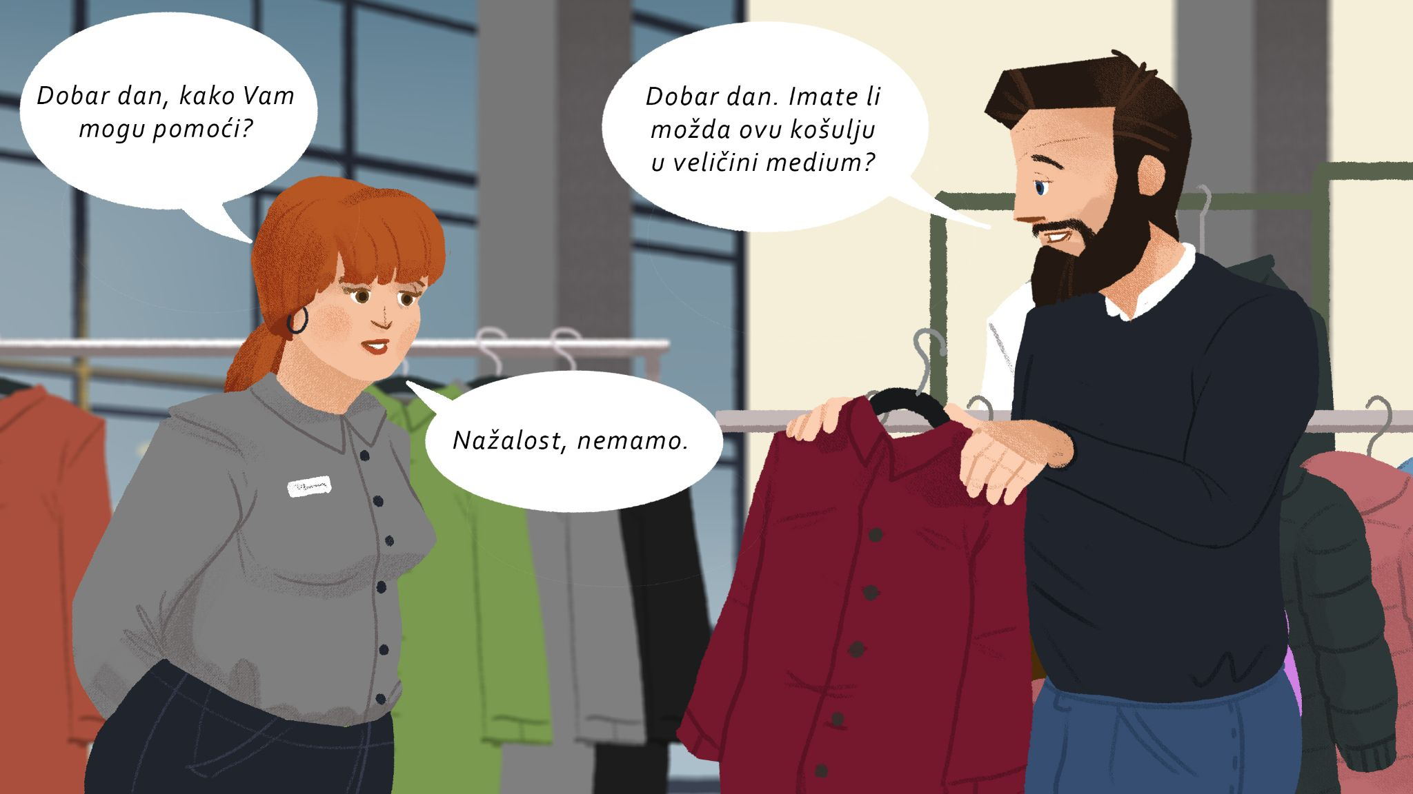

| 1 | Što Luka želi kupiti? |
| --- | --- |
| - |
| 2 | Koju veličinu treba? |
| - |
| 3 | Koju boju želi? |
| - |
| 4 | Koju boju će probati? |
| - |

| **Koju veličinu nosiš?** | | | |
| --- | --- | --- | --- |
| small | large | medium | extra large |

# 6.4 Zadatak 13. Dobar dan, izvolite…

👥 **Rad u paru.** Make a dialogue with your classmate. One of you is a customer, the other one is a salesperson. Your instructor will give you a card with instructions. Follow the instructions and based on the information provided, make a dialogue.

|  |  |  |
| --- | --- | --- |

[Click here to download role-play cards.](https://docs.google.com/document/d/1v9idCXGHCx9CzB5FxmJ8IaoNcGRYekepsSKVlZus2oA/edit)

| **Situacija 1** | **Situacija 2** |
| --- | --- |
|  |  |

# 6.4 Zadatak 14. Koja jakna je ljepša?

🔊 Listen to **dialogue four**. Luka is contemplating which jacket is nicer.

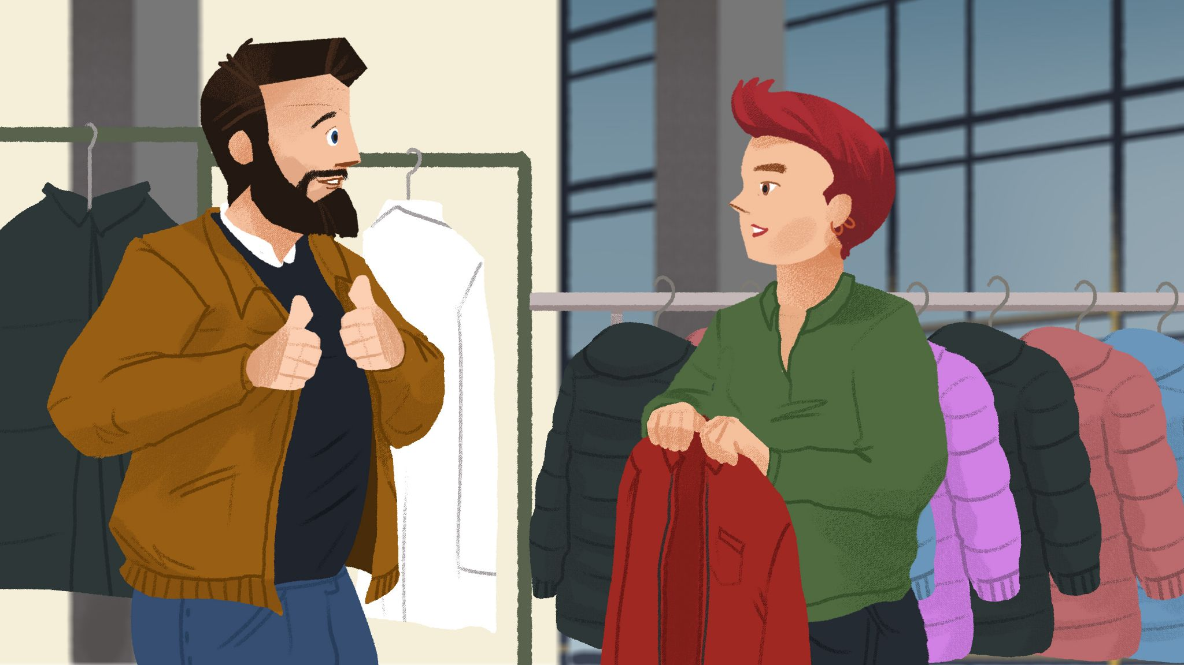

| Smeđa jakna je lijepa, 👍 | ali | crvena jakna je ljepša. 👍 👍 |
| --- | --- | --- |

| **pitanje** | **odgovor** |
| --- | --- |
| Koja je jakna ljepša? | Ja mislim da je ________ jakna ljepša nego ________. |

## | Razumijevanje

| 1 | Što Matija misli, koja je jakna ljepša? |
| --- | --- |
| - |
| 2 | Što Luka misli, koja je jakna ljepša? |
| - |
| 3 | Hoće li Luka kupiti crvenu jaknu? |
| - |
| 4 | Je li jakna skupa ili jeftina? |
| - |

# 6.4 Zadatak 15. Što je ljepše?

Look at the following pictures and decide which item is nicer in each pair. Follow the pattern on how to formulate the answer based on your previous conclusion about jackets.

|  |  |  |  |
| --- | --- | --- | --- |
| košulja | | rukavice | |
|  |  |  |  |
| kravata | | naočale | |
|  |  |  |  |
| kaput | | magneti | |
|  |  |  |  |
| šal | | privjesci | |
|  |  |  |  |
| odijelo | | platna | |

## | Moje mišljenje:

| Mislim da je _________ košulja ljepša nego _________ košulja. |
| --- |
| Mislim da je _________ kravata ljepša nego _________ kravata. |
| Mislim da je _________ kaput ljepši nego _________ kaput. |
| Mislim da je _________ šal ljepši nego _________ šal. |
| Mislim da je _________ odijelo ljepše nego _________ odijelo. |
|  |
| Mislim da su _________ rukavice ljepše nego _________ rukavice. |
| Mislim da su _________ naočale ljepše nego _________ naočale. |
| Mislim da su _________ magneti ljepši nego _________ magneti. |
| Mislim da su _________ privjesci ljepši nego _________ privjesci. |
| Mislim da su _________ platna ljepša nego _________ platna. |

Now talk with your classmates to see which items you all like more. Mark their answers. You will need to present your findings to your instructor for each set. Be careful how you formulate your question and/or answer - what verb, gender, and number you need to use.

| **| Na primjer** |
| --- |
| Koja majica je ljepša? – Plava majica je ljepša. |

# 6.4 Zadatak 16. Koji poklon je bolji/ljepši?

According to your opinion, which gift is better/nicer? What should James or Laura buy for their family members? You will need to discuss your choices with another classmate and your instructor.

|  |  |  |  |
| --- | --- | --- | --- |
|  |  |  |  |

| **| Koji poklon je bolji/ljepši?** |
| --- |
| 1. |
| 2. |
| 3. |
| 4. |

Images used in this document are from [these sources](https://docs.google.com/document/d/1-Zcl_VE1lkbqAZpIzg2Tn-uH-GvG_u9W3NbMItucBXM/edit#heading=h.ktkus0ccq3de).