# 10.1 - *Dovolená*

[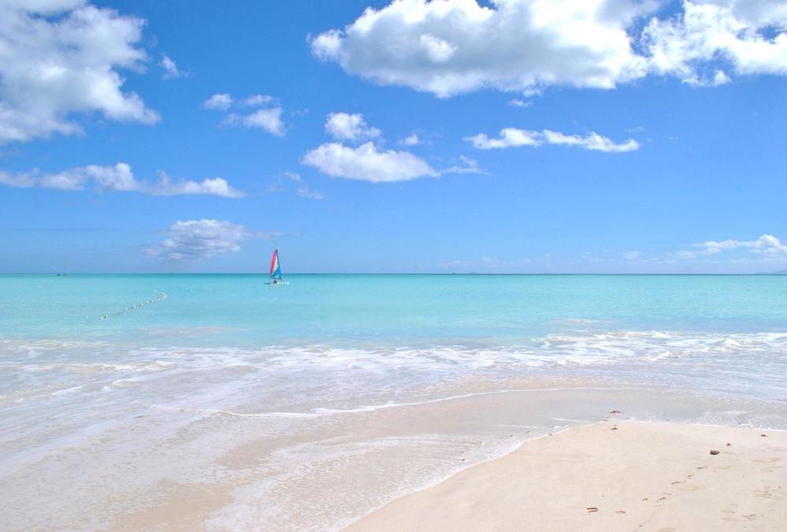](https://pixnio.com/nature-landscapes/beaches/sand-water-beach-summer-sun-sea-ocean-vacation-coast-sky)[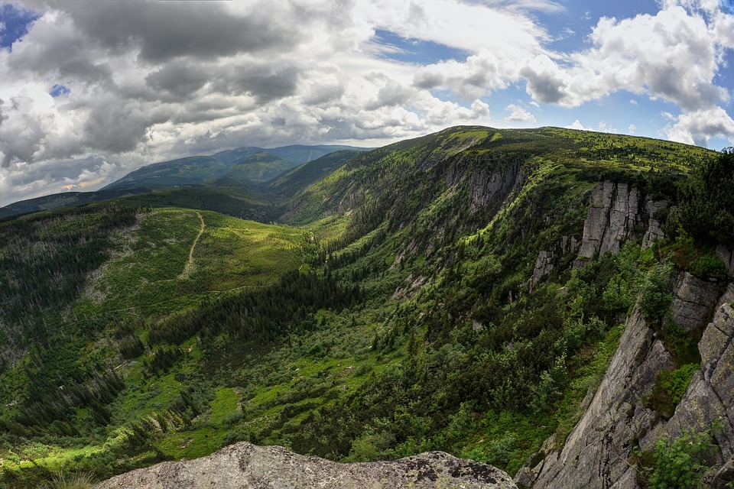](https://pixabay.com/en/czech-republic-the-giant-mountains-1178379/)

*dovolená* - vacation

It ends in *-á*, and this isn’t how most nouns end, right? In fact it looks like an adjective ending…

It turns out that it is an adjective, both in origin and with regards to the endings that go on it. It comes from *dovolená doba* ‘time off (lit. allowed time)’. Now, however, the word *~~doba~~* is never part of the equation, and one just says *dovolená*.[1] However, we need to review the endings:

| **Nominative** | dovolená |
| --- | --- |
| **Genitive** | dovolené |
| **Dative** | dovolené |
| **Accusative** | dovolenou |
| **Vocative** | -- |
| **Locative** | dovolené |
| **Instrumental** | dovolenou |

Accusative Form *dovolenou*

You”ll use this when you say that you are going on (as in a destination) vacation:

*Zítra jedeme* ***na dovolenou****.*

Tomorrow we’re going on vacation.

Or with a verb like *trávit/strávit* ‘to spend (time)’:

*Jak obvykle trávíš* ***dovolenou****?*

How do you usually spend (your) vacation?

Locative form *dovolené*

However, you’ll use the locative form *dovolené* to specify where you were:

*Minulý týden jsme byli* ***na dovolené*** *v Egyptu.*

Last week we were on vacation in Egypt.

*V červnu budu dva týdny* ***na dovolené****.*

In June I’ll be on vacation for two weeks.

Images used in this document come from [these sources](https://docs.google.com/document/d/1yaPhkNEfxYLcwdIwp99HcsdnLA0YtTD8Rs8Mri8AjXk/edit#heading=h.fltu1lf4cnnl).

1. As a further example, we can look at the phrase *mateřská dovolená* ‘maternal leave’, lit. ‘maternal vacation’. Often people joke about this phrasing, stating “To přece není žádná dovolená!” However, it connects to that notion of allowed time off.