6 | 3 | Lekcija 1: Sviđa mi se

# 6.3 Zadatak 1. Tko ti se sviđa?

| Što slušaju mladi u SAD-u? |
| --- |
| Što slušaš? |
| Koji pjevač/pjevačica/grupa ti se sviđa? |

|  |  |  |  |
| --- | --- | --- | --- |
|  |  |  |  |
|  |  |  |  |

# 6.3 Zadatak 2. Što znam o prijateljima?

Let’s play a game – How well do you know each other?! Think of at least two famous people.

|  | **In person class** |
| --- | --- |
| Your instructor will give you two pieces of paper. On each paper write a name of a famous person that you like (along with your name). Write in complete sentences. Face down, place the papers on the desk. Your instructor will read each card and you need to guess who wrote each name. You also need to provide the reason. |
|  | **Online class** |
| Using the chat function, send a message only to your instructor with names of two famous people that you chose for this game. Your instructor will read each name and you need to guess who picked each name. You also need to provide the reason. |

### | Na primjer (your answers):

| [Ani] se sviđa Taylor Swift zato što joj se sviđa pop muzika. |
| --- |
| [Marku] se sviđa Taylor Swift zato što mu se sviđa pop muzika. |

# 6.3 Zadatak 3. Kava i kolači

🔊 Listen to **dialogue one** and complete the task

James i Matija razgovaraju na telefon i planiraju napraviti kratku pauzu od učenja. Treba im odmor i planiraju otići do grada.

|  |  |
| --- | --- |

## | Razumijevanje

| 1 | Što radi Matija? |
| --- | --- |
| - |
| 2 | Što radi James? |
| - |
| 3 | Kamo James želi ići? |
| - |
| 4 | Tko sve ide? |
| - |
| 5 | Kamo želi ići Matija? |
| - |
| 6 | Što James želi kupiti u gradu? |
| - |

## | Osobna pitanja

| 1 | Sviđa li ti se Adele? |
| --- | --- |
| - |
| 2 | Koja ti se pjevačica/pjevač sviđa? |
| - |
| 3 | Koja ti se kava sviđa? Koji ti se kafić sviđa? |
| - |
| 4 | Voliš li čokoladu? Koja ti se čokolada sviđa? |
| - |

## | In English

Investigate the [Kraš](https://www.kras.hr/hr/bonbonniere) brand. What can you tell us about it? Are there any similar products in your country? What would you like to try from the Kraš store?

# 6.3 Zadatak 4. Tko i što ti se sviđa?

Think of five people that you like (actors, singers, artists, etc.) and five things that you like. Then, ask your classmates if they like the same people and things. Who is your best match? An example is given for you in each category (who do you like; what do you like).

| Br. | Pitanje | Odgovor |
| --- | --- | --- |
|  | Sviđa li ti se Adele? |  |
| 1. | Sviđa li ti se… |  |
| 2. |  |  |
| 3. |  |  |
| 4. |  |  |
| 5. |  |  |
|  | Sviđa li ti se hrvatska glazba? |  |
| 6. |  |  |
| 7. |  |  |
| 8. |  |  |
| 9. |  |  |
| 10. |  |  |

# 6.3 Zadatak 5. Simpatija ili nešto više?

🔊

Listen to **dialogue two** and complete the task.

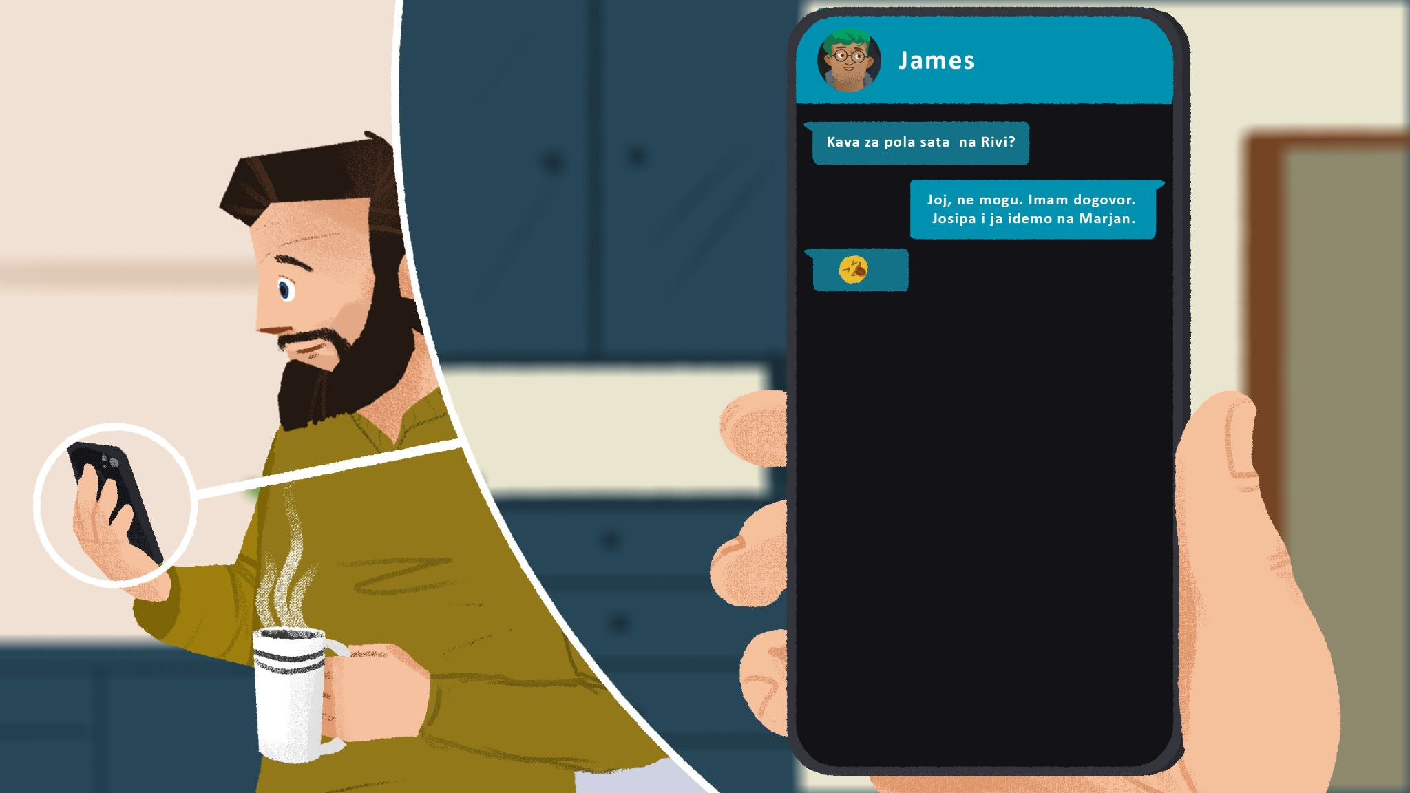

## | Razumijevanje

| 1 | Ima li Matija puno posla? |
| --- | --- |
| - |
| 2 | Što radi Ines? |
| - |
| 3 | Kamo ide Ines? |
| - |
| 4 | Gdje je bila Ines i tko je bio tamo? |
| - |
| 5 | Tko je Filip? |
| - |
| 6 | Tko se kome sviđa? |
| - |

## | Osobno pitanje

If you were Ines or Filip, where would you go on a first date?

| | Što ti misliš, kamo Ines i Filip mogu ići? |
| --- |
| → |

# 6.3 Zadatak 6. Tko se kome sviđa?

🔊 Listen to the sentences and mark who likes who. Mark ***on*** if the sentence states that it’s a he who likes. Mark ***ona*** if the sentence states that it’s a she who likes.

|  |  |  |
| --- | --- | --- |
| [(audio)](https://croatian.takolako.org/wp-content/uploads/01-Filip-joj-se-svidja.mp3) on ili ona | [(audio)](https://croatian.takolako.org/wp-content/uploads/02-Josipi-se-svidja-Luka.mp3) on ili ona | [(audio)](https://croatian.takolako.org/wp-content/uploads/03-Luki-se-svidja-Josipa.mp3) on ili ona |
|  |  |  |
| [(audio)](https://croatian.takolako.org/wp-content/uploads/04-Njemu-se-svidja-ona.mp3) on ili ona | [(audio)](https://croatian.takolako.org/wp-content/uploads/05-Svidja-joj-se.mp3) on ili ona | [(audio)](https://croatian.takolako.org/wp-content/uploads/06-Svidja-mu-se.mp3) on ili ona |

# 6.3 Zadatak 7. Rođendanska zabava

Read the following sentences about who likes who. Figure out the best seating arrangement around a table at a party, so that guests end up sitting next to people they like and far away from the people they don't like. When you have enough information, talk with your classmate to make a good seating arrangement. The following people will probably sit next to each other because:

| Filip i Goran su najbolji prijatelji. | James i Marko su cimeri, međunarodni studenti. |
| --- | --- |
| Ines se sviđa Filipu. | Marini se sviđa Marko. |
| Luki se sviđa Josipa. | Marina se ne sviđa Ines. |
| Goranu se sviđa Matija. | Filip se sviđa Ines. |
| Marini se Ines ne sviđa. | Josipa se sviđa Luki. |

Images used in this document are from [these sources](https://docs.google.com/document/d/1471tgA8nAZ8FezdMNdGdF-NCHOSZPx9ockC0aqjWtl8/edit#heading=h.ktkus0ccq3de).