3 | 1 | Lekcija 6: U posjetu

# 3.1 Zadatak 19. Na Braču

### You were already introduced to Ines’ family and their interaction with James. Here is a continuation of the dialogue that you have encountered in today’s class session.

🔊 The following conversation is between James and Ines’ siblings. Listen to the dialogue below and answer the questions.

[(audio)](https://croatian.takolako.org/wp-content/uploads/Dijalog-Ispred-kuce.mp3)

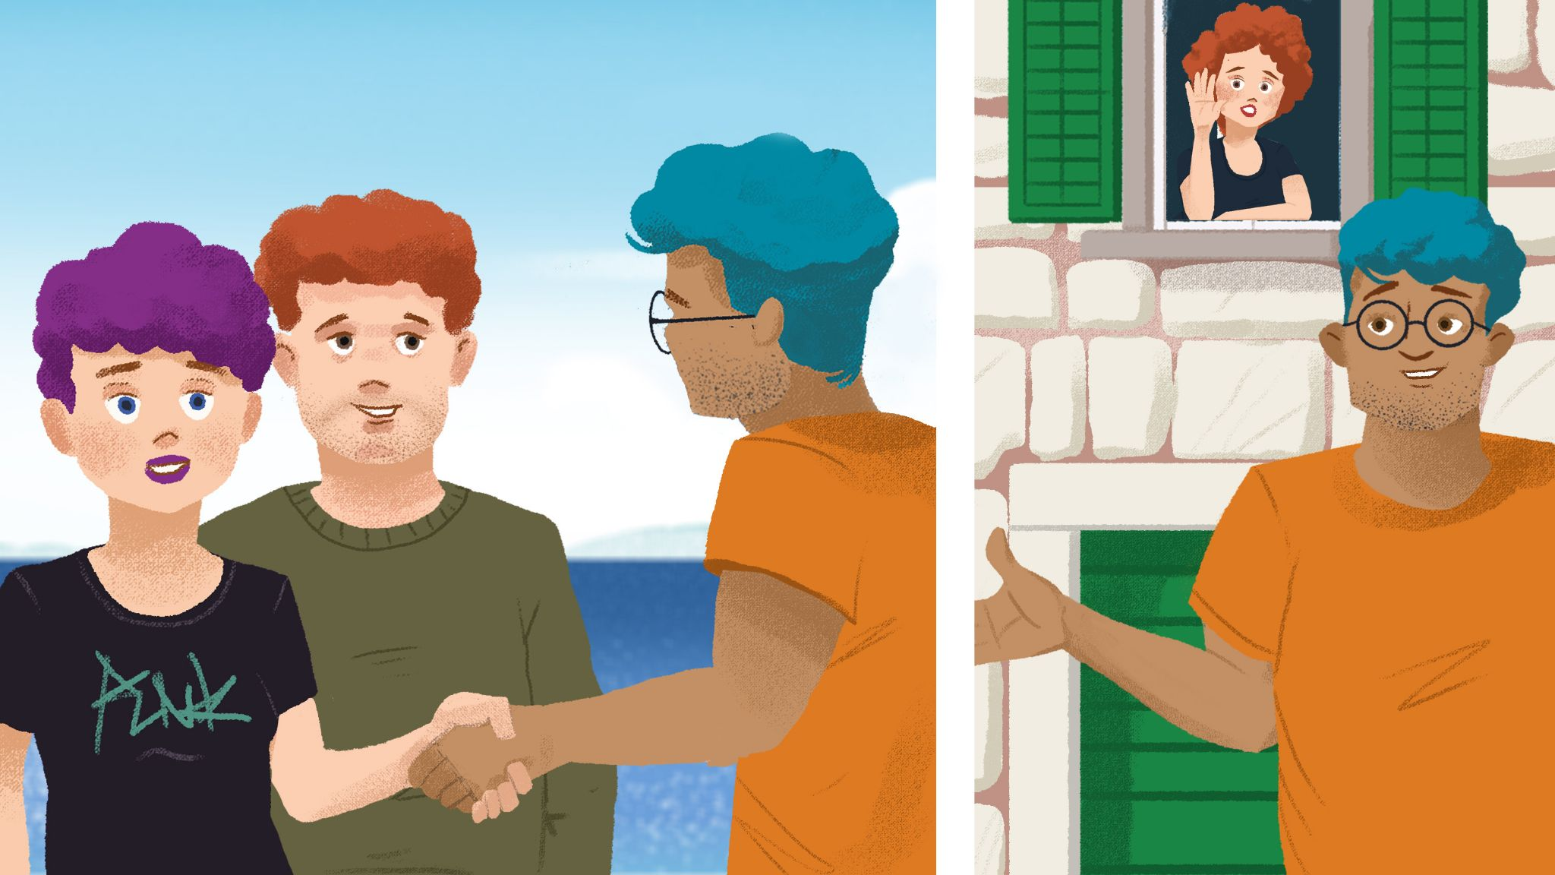

## | Razumijevanje

| 1 | Što planira raditi Lana dok je na Braču? |
| --- | --- |
| - |
| 2 | Što Josip misli kakav je Austin i SAD? |
| - |
| 3 | Što baka Lidija priprema za cijelu obitelj? |
| - |
| 4 | Što kaže James kakav je Austin? |
| - |
| 5 | Gdje žive Jamesovi roditelji? |
| - |
| 6 | Što James i njegova obitelj obično rade? |
| - |
| 7 | Što planiraju raditi Ines i James? |
| - |

## | In English

| 1 | Would you have a conversation like this one with a person that you just met? Why? |
| --- | --- |
| - |
| 2 | What other topic(s) would you potentially touch upon with a person that you just met? |
| - |

# 3.1 Zadatak 20. Kako se kaže?

Based on the class materials, how would you express the following scenarios in Croatian?

|  |  |
| --- | --- |

| 1 | You are always arguing with someone (there is a phrase for this). |
| --- | --- |
| - |
| 2 | How would you ask who takes care of kids? |
| - |
| 3 | How to ask about children’s age? (Croats usually refer to education, not exact age.) |
| - |
| 4 | How would you express that you are more of a city person? |
| - |
| 5 | How would you ask about customs in Croatia? |
| - |
| 6 | How would you say that you do not have any baking skills? |
| - |
| 7 | Coffee represents more than just a drink. |
| - |
| 8 | How would you express your excitement and that you cannot wait to go somewhere? |
| - |
| 9 | How to give a compliment to someone on their language skills. |
| - |
| 10 | How to offer food or drink to someone. |
| - |
| 11 | How to express compliments about someone’s city/country. |
| - |

# 3.1 Zadatak 21. Druženje

Following the dialogue patterns that you have encountered in class and homework materials for today, create a dialogue with your classmate.

|  |  |  |  |
| --- | --- | --- | --- |

| Scenario #1: (pair-work) | Scenario #2: (group-work) |
| --- | --- |
| You are spending time in Croatia. You are making weekend plans with your local friend. Make a cohesive dialogue about what to do, where to go, and discuss traditional Croatian free time activities. Your local friend will invite you to spend the weekend with his/her family. | Work in a group of four at least. You are visiting the family of your local friend for the first time. Make a dialogue that will have an appropriate cultural structure with the local family. |

| ❗ Try to provide opinions during the conversation as well as discussing including components listed below: | | | |
| --- | --- | --- | --- |

| Discuss family members | Usual activities (free time, weekend) | Discuss family gatherings | Conversation topics |
| --- | --- | --- | --- |
| Discuss their characteristics  Describe their interests | Ask about local activities  Compare typical activities | Talk about differences and similarities  Discuss Activities you engage in | Use the appropriate topic  Make comments in the conversation  Give a compliment(s) |

# 3.1 Zadatak 22. Kultura - razgovor

## | Upoznavanje

In English



| 1 | How does Ines’ mother address grandfather Josip? Why do you think that is? |
| --- | --- |
| - |
| 2 | What do you think the message is that Ines' father sends when he greets James? |
| - |
| 3 | What is the father's reaction to Toni’s questions? Do you find it to be a polite reaction? |
| - |



| 4 | Do you think that James responded appropriately to Josip’s and Toni’s questions? Why? |
| --- | --- |
| - |
| 5 | What might an American do in reaction to Josip’s and Toni’s questions? |
| - |
| 6 | How would you react to these questions? Provide your possible reply to Josip and Toni in Croatian. |
| - |
| 7 | What do you think is the overall tone of this dialogue? How do you visualize this gathering? |
| - |

## Listen to the dialogues from today’s lesson again and answer the following questions.

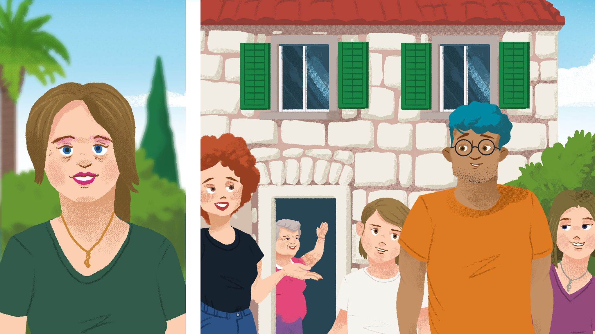

## | Slobodno vrijeme

In English

| 1 | What do you think the main differences are between Croatia and the U.S. in terms of free time activities? |
| --- | --- |
| - |
| 2 | You learned that Croats spend a lot of time together. Why do you think that is? |
| - |
| 3 | What do you think are the most important values for Croats when we consider their family circles? |
| - |
| 4 | Based on the homework dialogue, why do you think Croats do not include topics like jobs as part of their main conversation? What are the values that Croats cherish in their conversation when they meet someone for the first time? Think of everything we discussed in class to make your conclusion. |
| - |

Images used in this document are from [these sources](https://docs.google.com/document/d/1ajMBkMnaIVKhYpiLLOi7gE6fXltLoZPVx-knw38F7fQ/edit#heading=h.3yzclsj55aa4).