6 | 2 | Lekcija 2: Ti si mi u mislima

# 6.2 Zadatak 8. Što pokloniti?

You do not know what to buy for your family members, but you do know what they like. Talk with your classmate and ask what gift you can buy for them. Express what each family member likes when asking for advice. Below there are some ideas on what to buy (divided into categories), your classmate will give you some suggestions. You can use other possible gifts/ideas as well, that are not listed below. When you are done, switch roles.

### Model to follow:

| Student 1 | Ne znam što pokloniti [kome?]. |
| --- | --- |
| Student 2 | A što on/-a voli? |
| Student 1 | On/-a voli [što?]. |
| Student 2 | Možda možeš [kome?] pokloniti [što?]. |

**| Suveniri**

|  |  |  |  |
| --- | --- | --- | --- |
| knjiga | slika | magnet | bašćanska ploča |
| **| Nakit** | | | |
|  |  |  |  |
| ogrlica | naučnice | prsten | privjesak |
| **| Modni dodatak** | | | |
|  |  |  |  |
| torbica | kišobran | marama | kravata |

# 6.2 Zadatak 9. Što darovati?

Read the dialogue between James and his roommate Marko. *Marko ne zna što kupiti roditeljima, bratu, sestri. On i James razgovaraju.*

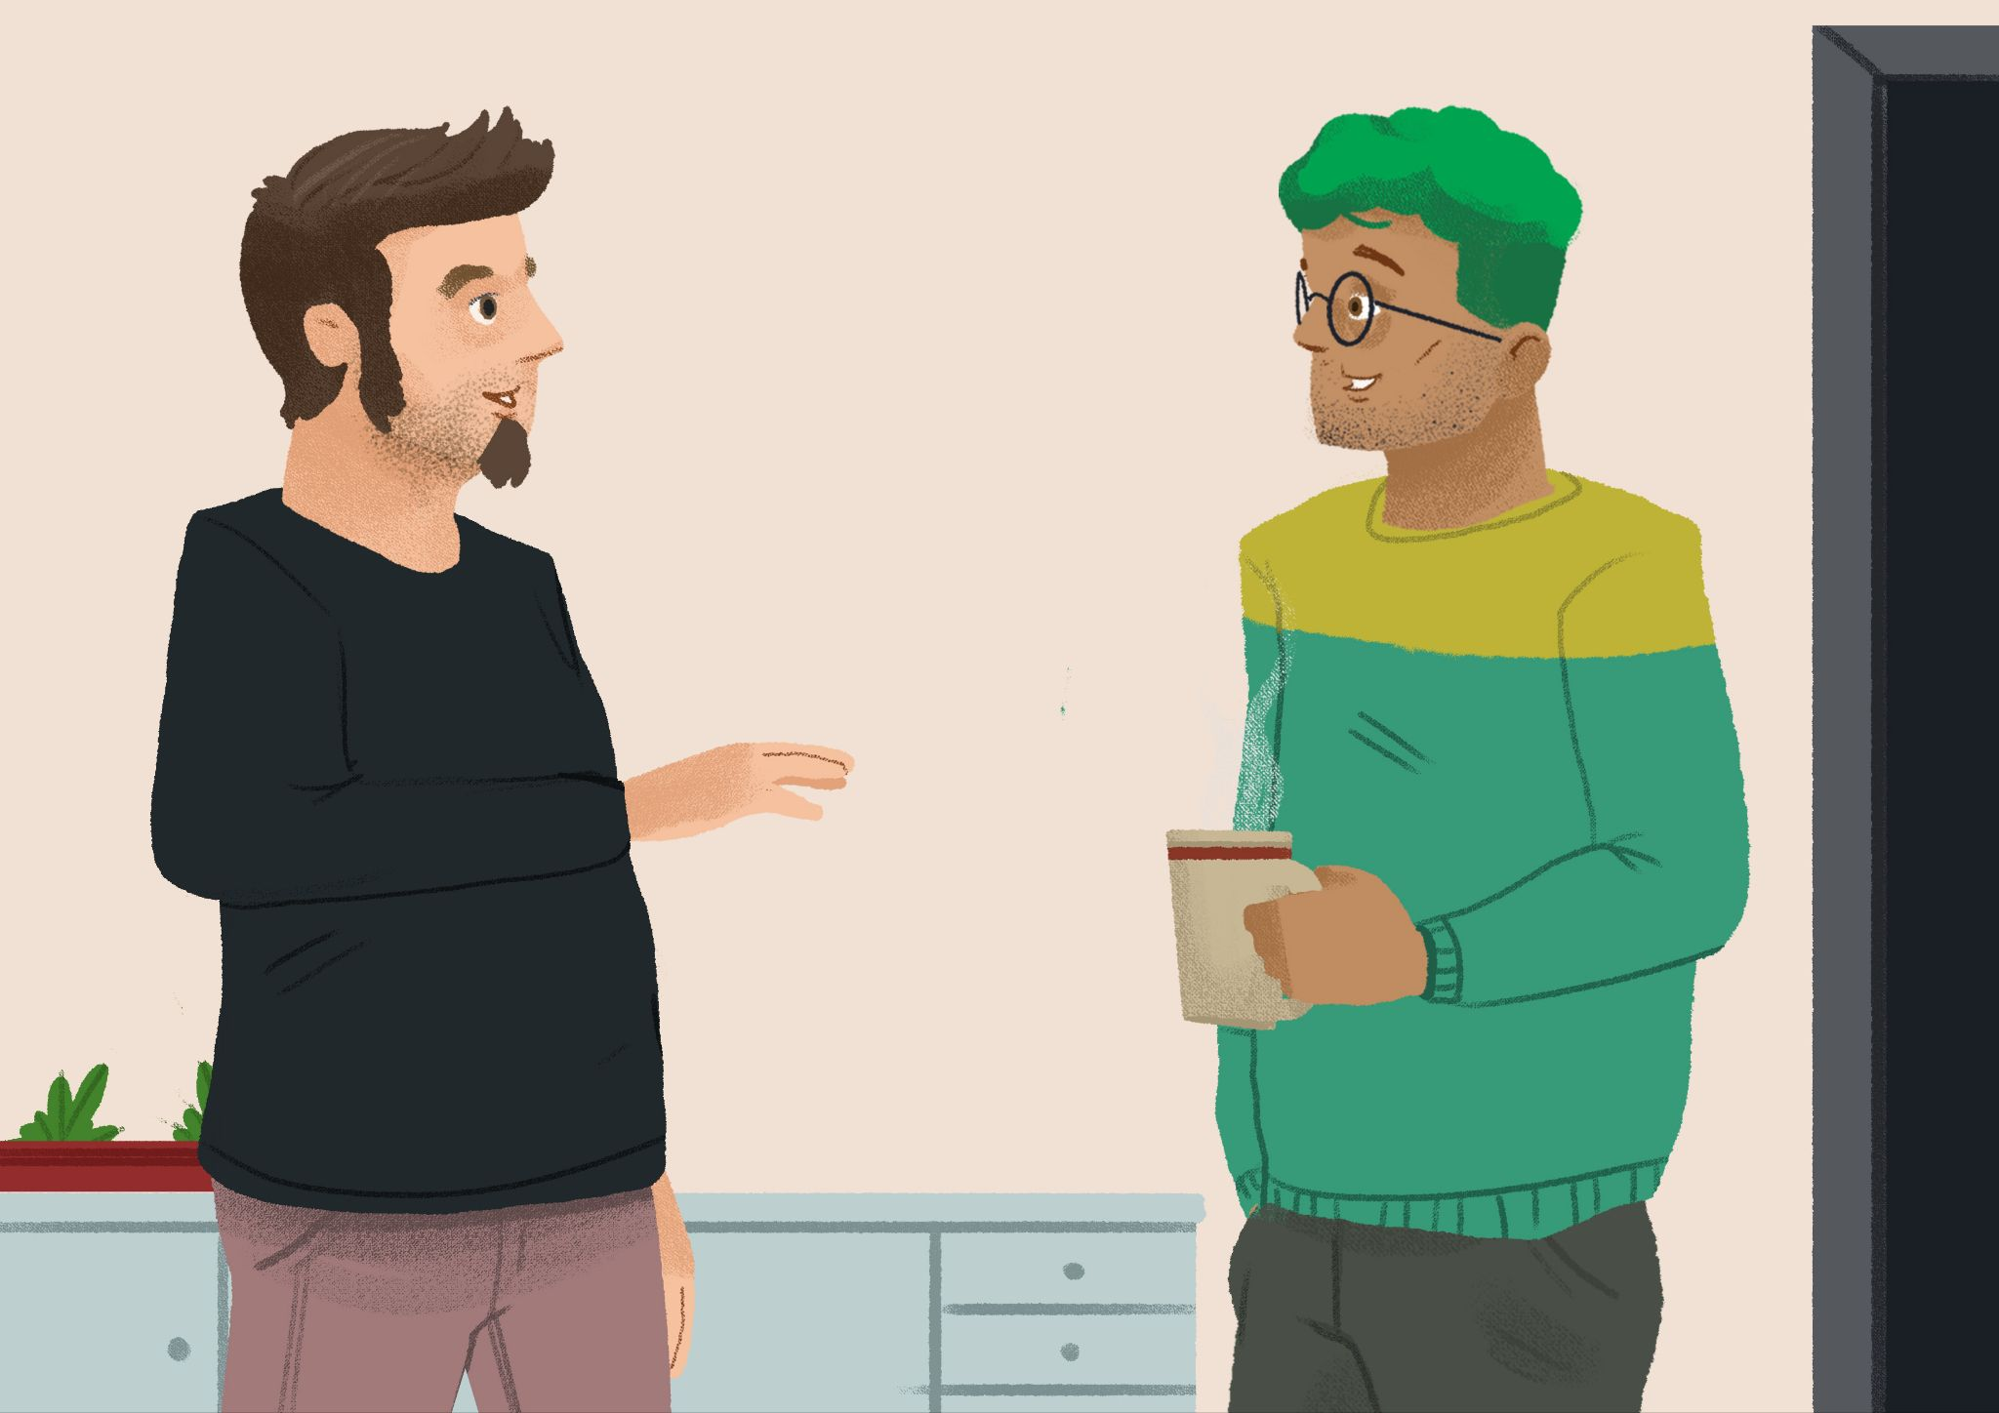

| Marko: | James, potreban mi je tvoj savjet! |
| --- | --- |
| James: | Reci, što ti treba? |
| Marko: | Treba mi tvoja pomoć. Ne znam što kupiti za poklon ni roditeljima, ni bratu, ni sestri. |
| James: | Hm… a što oni vole? |
| Marko: | Moji roditelji vole umjetnost i često idu na operu. |
| James: | Možda im možeš darovati sliku ili CD. A što voli tvoj brat? |
| Marko: | Zanima ga povijest. |
| James: | Možda mu možeš darovati knjigu o Hrvatskoj. Možda neku monografiju? |
| Marko: | Odlična ideja! |
| James: | A tvoja sestra, što ona voli? |
| Marko: | Ona voli modu. Voli odjeću, nakit i modne dodatke. |
| James: | Možda joj možeš darovati tradicionalni hrvatski kišobran ili tradicionalni nakit. |
| Marko: | A gdje ću to sve kupiti? |
| James: | Možemo sutra zajedno ići u šoping. Sutra sam slobodan cijeli dan. |
| Marko: | Izvrsno! Hvala ti puno! |
| James: | Ma ništa, nikakav problem. Drago mi je da ti mogu pomoći. |

### Based on the information in the dialogue, answer the questions.

| 1 | Zna li Marko što kupiti roditeljima? |
| --- | --- |
| - |
| 2 | Može li James pomoći Marku? |
| - |
| 3 | Što James misli, što Marko može kupiti roditeljima? Zašto? |
| - |
| 4 | Što Marko može kupiti bratu? Zašto? |
| - |
| 5 | Što Marko može kupiti sestri? Zašto? |
| - |
| 6 | Gdje Marko može kupiti poklone? |
| - |
| 7 | Kada će prijatelji ići u šoping? |
| - |

# 6.2 Zadatak 10. Moj prijedlog

👥 Talk with your classmate. Based on what you learned about Marko’s family, suggest what else he could buy for his brother, sister, and parents. Give at least two ideas for each family member. Write your answers in complete sentences. For example:

| Bratu - može mu kupiti film. |
| --- |
| Sestri - može joj kupiti maramu. |
| Roditeljima - može im kupiti sliku. |

| Što Marko može kupiti? | bratu | sestri | roditeljima |
| --- | --- | --- | --- |
|  |  |  |
|  |  |  |

# 6.2 Zadatak 11. Idemo u šoping

## Part 1

Look at each picture below. Choose the appropriate description indicating what type of store it is.

|  |  |  | **Type of store:**  **Modni salon** (*šal, kravata*)  **Zlatarna** (*prsten, ogrlica*)  **Music shop**  **Knjižara**  **Suvenirnica**  **Trgovina** (*čokolada*) |
| --- | --- | --- | --- |
|  |  |  |
|  |  |  |
|  |  |  |

## Part 2

Now check the [**link**](https://takolako.dropmark.com/1747744) and browse the stores. Decide where James and Marko should go shopping for the listed gifts from Part 1. Answers may vary.

|  | Kišobran mogu kupiti … |
| --- | --- |
|  | Nakit mogu kupiti … |
|  | Modni dodatak mogu kupiti … |
|  | Tradicionalni nakit mogu kupiti … |
|  | Sliku mogu kupiti … |
|  | Knjigu o Hrvatskoj mogu kupiti … |

# 6.2 Zadatak 12. U knjižari

🔊 Listen to the **dialogues one and two**, and complete the task. *Ines i James idu u šoping*. *James želi kupiti nešto roditeljima*.

## | Na ulici

|  |  |
| --- | --- |
|  |  |

## | Razumijevanje

| 1 | Gdje su James i Ines? |
| --- | --- |
| - |
| 2 | Kamo oni idu? |
| - |
| 3 | Što James želi kupiti? |
| - |
| 4 | Kome on želi kupiti poklon? |
| - |

## | Osobno pitanje

If you want to buy a book about your country/city as a gift to your international friend, what would you buy? You might need to search online for your answer if not sure.

| 1 | Koju knjigu ti želiš kupiti prijatelju/prijateljici? |
| --- | --- |
| - |
| 2 | Gdje možeš kupiti knjigu? |
| - |

## | U knjižari

|  |  |
| --- | --- |

| 1 | Koje knjige je pronašla Ines? [pronaći = to find] |
| --- | --- |
| - |
| 2 | Što voli Jamesova mama? |
| - |
| 3 | Što voli Jamesov tata? |
| - |
| 4 | Koju knjigu je Ines pronašla za mamu? |
| - |
| 5 | Koju knjigu je Ines pronašla za tatu? |
| - |
| 6 | Što će kupiti James? |
| - |
| 7 | Kamo još James želi ići? Zašto? |
| - |

# 6.2 Zadatak 13. Za koga je poklon?

Based on the information you gathered so far in this unit, listen to each sentence and decide who is the intended recipient. Finally, mark if you agree or disagree with each statement (is it a good gift or not?), based on your knowledge of James' family.

|  |  |  |
| --- | --- | --- |
| [(audio)](https://croatian.takolako.org/wp-content/uploads/Ja-cu-im-pokloniti-CD-2-Cellosa.mp3) | [(audio)](https://croatian.takolako.org/wp-content/uploads/Ja-cu-im-pokloniti-kravatu-i-maramu.mp3) | [(audio)](https://croatian.takolako.org/wp-content/uploads/Ja-cu-joj-pokloniti-bombonijeru.mp3) |
|  |  |  |
| [(audio)](https://croatian.takolako.org/wp-content/uploads/Ja-cu-joj-pokloniti-nakit.mp3) | [(audio)](https://croatian.takolako.org/wp-content/uploads/Ja-cu-mu-pokloniti-dok.film-o-Hrvatskoj.mp3) | [(audio)](https://croatian.takolako.org/wp-content/uploads/Ja-cu-mu-pokloniti-parfem.mp3) |

|  | BRATU  (Michaelu ili Dylanu) | SESTRI | RODITELJIMA  (mami i tati) | slažem se  [I agree] | ne slažem se  [I disagree] |
| --- | --- | --- | --- | --- | --- |
| 1 |  |  |  |  |  |
| 2 |  |  |  |  |  |
| 3 |  |  |  |  |  |
| 4 |  |  |  |  |  |
| 5 |  |  |  |  |  |
| 6 |  |  |  |  |  |

Images used above are from [these sources](https://docs.google.com/document/d/1_iDcqQc8y7y8r3wDOlgots3s_3yICntrOx9c6Xlairs/edit#heading=h.ktkus0ccq3de).