8 | 4 | Lekcija 2: Razgovor
Performance-Based Task

| Pre-class assignment preparation
Prepare yourself to make a dialogue (role-play) including the following elements. One of you will be an international student and your instructor will play the role of a local friend. Use all previous tasks in this Unit to make a meaningful dialogue.
 | 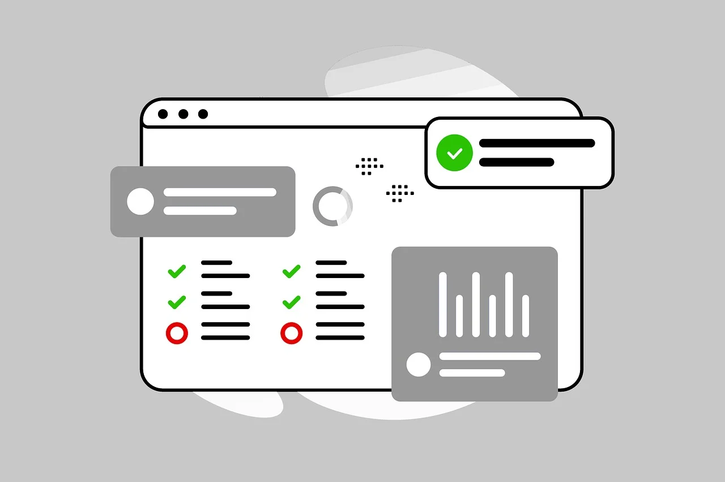

Scenario:
Ordering food in a restaurant. Your instructor will play the role of a waiter and you will be a guest in a restaurant. You will use the menu that your instructor gives you for the dialogue. As the waiter shows you the menu, ask intelligent questions about dishes that interest you.

The role of a guest
You are in Croatia and you have decided to go out for dinner. You are not very familiar with the local food. Ideas for the dialogue:
 | You will need to ask the waiter for some clarifications and recommendations.
 | Mention your possible food allergies, ask more information about specific dishes that interest you.
 | Ask about house recommendations on what to eat and drink at the restaurant.
 | Give a compliment or make a comment on the food.

| In-class assignment
Listen to each of your classmates performing their dialogues. Take notes about their cultural performance in the table below. Your homework assignment will be to write a reflection on the cultural components that you noticed in each of your peers’ dialogues. When your classmate writes a response to your own performance, you will need to provide them with a follow-up and comment on their reflection.
 | 

As a person who is evaluating your peers’ performance, reflect on the following components:
1 | Evaluate how successful they were in navigating the conversation in a culturally appropriate way.
 | -
2 | Did they recognize and-or use expressions that present a figurative meaning?
 | -
3 | Were they able to recognize, understand, and react to non-verbal cues in dialogues with the instructor?
 | -
4 | What else could they have done in performing real-life situational discourse?
 | -

| Post-class assignment
 | 

Submit your notes from the class session on your peers’ performance. As a person who is reading responses from your peers, be sure to include in your comment:
1 | Do you agree with them? If yes/no – why?
2 | What will you do to improve (if needed) your future dialogues?
3 | Any other comments?

Submit this assignment also online.

Images used in this document are from these sources.

