3 | 1 | Lekcija 2: Krv nije voda

# | Obitelj

In today's lesson you learned that there are two different ways of saying the words uncle and aunt. When it comes to family members, Croatian makes a distinction between the mother’s and father’s side family members.

## | Uncle and Aunt:

|  | **Uncle…** |  | **…and His Wife** |
| --- | --- | --- | --- |
| ujak | If we are referring to the mother's brother, we need to use the word ujak. | ujna | The wife of our ujak will be ujna. |
| stric | If we are referring to the father's brother, we need to use the word stric. | strina | The wife of our stric will be strina. |

| Aunt and Her Husband:

|  | **Aunt...** |  | **…and Her Husband** |
| --- | --- | --- | --- |
| **teta / tetka** | If we are referring to either the mother's or father’s sister, we need to use the word teta/tetka. | **tetak** | The husband of our teta/tetka will be tetak. |

## | Cousins:

|  | **Male cousin** |  | **…and Female cousin** |
| --- | --- | --- | --- |
| **rođak /**  **bratić** | There are two forms to express the same meaning of a male cousin. The only difference is that one is used more in the southern parts of Croatia (rođak), while the second term is more used in the northern part of Croatia (bratić). | **rodica / sestrična** | There are two forms to express the same meaning of a female cousin. The only difference is that one is used more in the southern parts of Croatia (rodica), while the second term is more used in the northern part of Croatia (sestrična). |

# | Ines i njezina obitelj

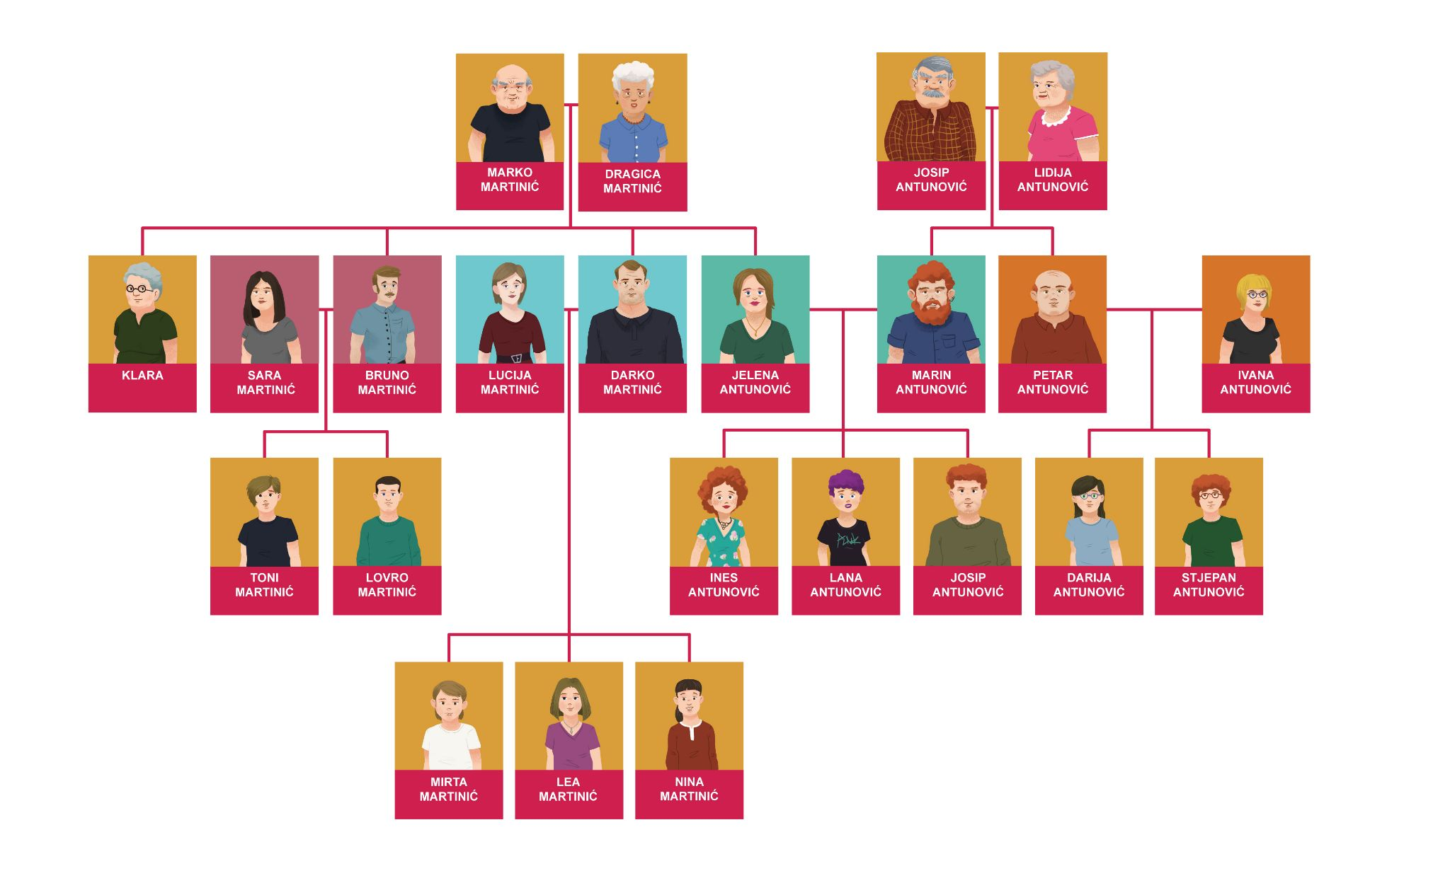

# 3.1 Zadatak 1. Ines i njezina obitelj

Listen to the recording and choose the correct corresponding picture to the audio. Ines is reintroducing some of her family members to us.

[(audio)](https://croatian.takolako.org/wp-content/uploads/Ovo-je-moja-rodica.mp3)

|  |  |  |
| --- | --- | --- |
| Darija | Ivana | Bruno |

[h5p id="319"]

[(audio)](https://croatian.takolako.org/wp-content/uploads/Ovo-je-moj-ujak.mp3)

|  |  |  |
| --- | --- | --- |
| Darko | Marko | Josip |

[h5p id="320"]

[(audio)](https://croatian.takolako.org/wp-content/uploads/Ovo-je-moja-sestra.mp3)

|  |  |  |
| --- | --- | --- |
| Sara | Lana | Ivana |

[h5p id="321"]

[(audio)](https://croatian.takolako.org/wp-content/uploads/Ovo-je-moj-djed.mp3)

|  |  |  |
| --- | --- | --- |
| Darko | Josip | Stjepan |

[h5p id="322"]

[(audio)](https://croatian.takolako.org/wp-content/uploads/Ovo-je-moja-baka.mp3)

|  |  |  |
| --- | --- | --- |
| Klara | Ivana | Lidija |

[h5p id="323"]

[(audio)](https://croatian.takolako.org/wp-content/uploads/Ovo-je-moj-stric.mp3)

|  |  |  |
| --- | --- | --- |
| Toni | Stjepan | Petar |

[h5p id="324"]

[(audio)](https://croatian.takolako.org/wp-content/uploads/Ovo-je-moja-teta.mp3)

|  |  |  |
| --- | --- | --- |
| Dragica | Klara | Lucija |

[h5p id="325"]

[(audio)](https://croatian.takolako.org/wp-content/uploads/Ovo-je-moj-rodjak.mp3)

|  |  |  |
| --- | --- | --- |
| Stjepan | Bruno | Petar |

[h5p id="326"]

# 3.1 Zadatak 2. Tko je ovo?

Some of Ines' relatives are introducing their family members. If you need help, look at Ines’ family tree as you listen to each statement. Choose the relative who could logically be speaking; sometimes more than one answer may be possible. Pay attention to whether you hear a male or female voice speaking, as that will also help you figure out the identity of the speaker.

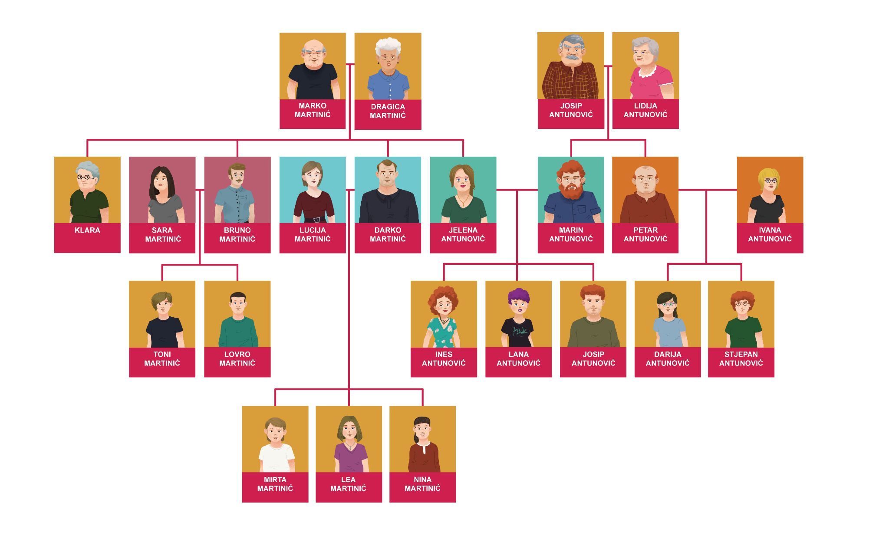

[(audio)](https://croatian.takolako.org/wp-content/uploads/01_H5P_Ovo-je-moja-zena-Jelena.mp3)

[h5p id="328"]

[(audio)](https://croatian.takolako.org/wp-content/uploads/02_h5p_Ovo-je-moja-kci.mp3)

[h5p id="329"]

[(audio)](https://croatian.takolako.org/wp-content/uploads/03-H5P-Ovo-su-moje-sestre.mp3)

[h5p id="330"]

[(audio)](https://croatian.takolako.org/wp-content/uploads/04-H5P-Ovo-je-moja-sestra.mp3)

[h5p id="331"]

[(audio)](https://croatian.takolako.org/wp-content/uploads/05-H5P-Ovo-je-moj-muz.mp3)

[h5p id="332"]

[(audio)](https://croatian.takolako.org/wp-content/uploads/06-H5P-Ovo-je-moj-sin.mp3)

[h5p id="333"]

[(audio)](https://croatian.takolako.org/wp-content/uploads/07-H5P-Ovo-je-moja-rodica.mp3)

[h5p id="334"]

[(audio)](https://croatian.takolako.org/wp-content/uploads/08-H5P-Ovo-je-moj-rodak.mp3)

[h5p id="335"]

[(audio)](https://croatian.takolako.org/wp-content/uploads/09-H5P-Ovo-su-moja-braca.mp3)

[h5p id="336"]

# 3.1 Zadatak 3. Uža i šira obitelj

Look at Ines’ family tree below. For each pair you are given a choice of possible relationships. Choose the statement that describes how these people are related to each other.



[h5p id="337"]

# 3.1 Zadatak 4. Uža i šira obitelj

Read the following sentences and write the missing word that logically makes sense. Be careful, at times more than one option is possible. In that case, choose only one.

[h5p id="327"]

Images used in this exercise are from [these sources.](https://docs.google.com/document/d/1f_3fvQJzYqnKPpeExd5sAPtEVJFYt5YFCXjhcYqrhxQ/edit#heading=h.3jpjkt9u6y06)