5 | 1 | Lekcija 2: Blagdani u mojoj zemlji

5.1 Zadatak 4. Kalendar
Even though minority groups celebrate holidays specific to their culture and / or religion in all B/C/M/S countries, each country traditionally follows a specific calendar (and holidays) based on the predominant religion. Look at the following holidays and sort them according to the appropriate calendar.
[h5p id="439"]

5.1 Zadatak 5. Kalendar i religije
Based on what you learned in class, each of the following countries (in a very general sense) have one main religion. For each of the following countries mark the predominant religion. Note: some dates change every year. This is just an example.
[h5p id="440"]

Traditionally, each of the following countries in the BCMS area is marked by one predominant religion (as is evident in the previous task). This also means that the religious holidays will be celebrated according to a specific calendar. However, keep in mind that minorities in each country are recognized and they have their freedom to practice their religion, religious holidays, national holidays, etc.
[h5p id="441"]

Due to historical events and geographical positioning, Bosnia and Herzegovina went through religious changes throughout the centuries. In present day Bosnia and Herzegovina, all three religions are present. With the influence of the Ottoman Empire, Bosnia and Herzegovina has the biggest Islamic population among all the countries of former Yugoslavia.

5.1 Zadatak 6. Što slavimo?
For each picture choose the appropriate holiday from the drop-down menu.

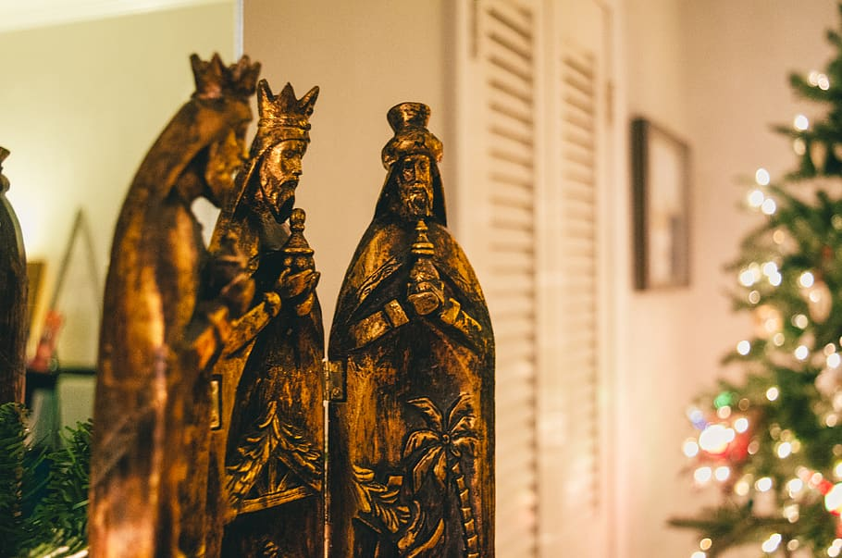 | 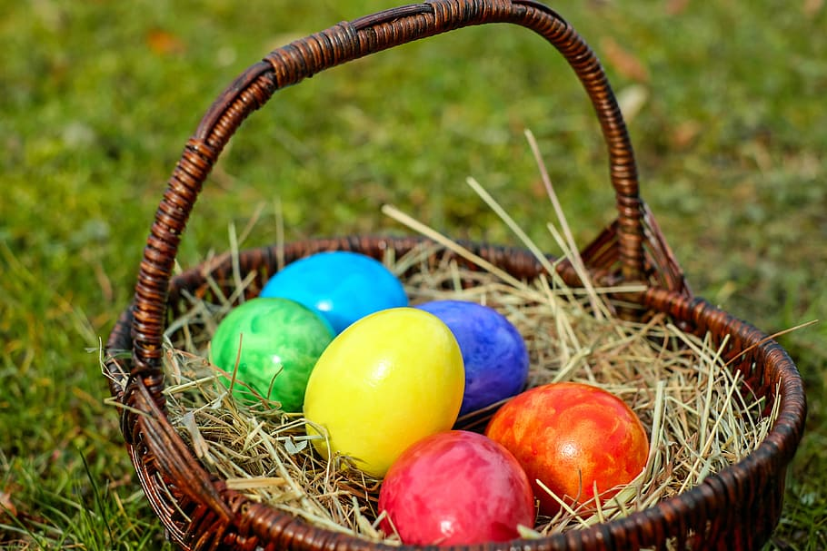
slika 1 | slika 2
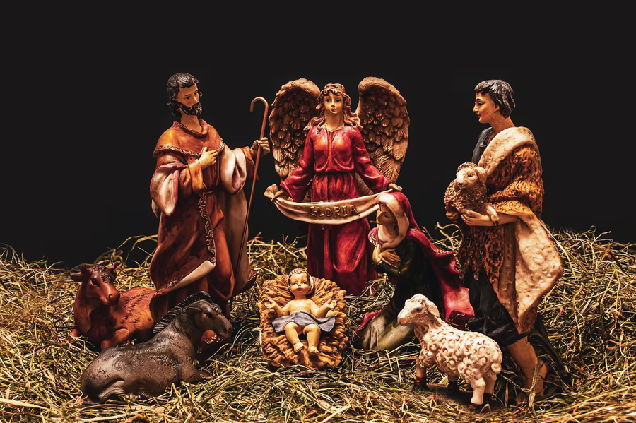 | 
slika 3 | slika 4
[h5p id="442"]

5.1 Zadatak 7. Blagdani i praznici
[h5p id="443"]
[h5p id="444"]

5.1 Zadatak 8. Tko donosi poklone?
Traditional beliefs say that in each of the following events/situations gifts are brought by:
 | 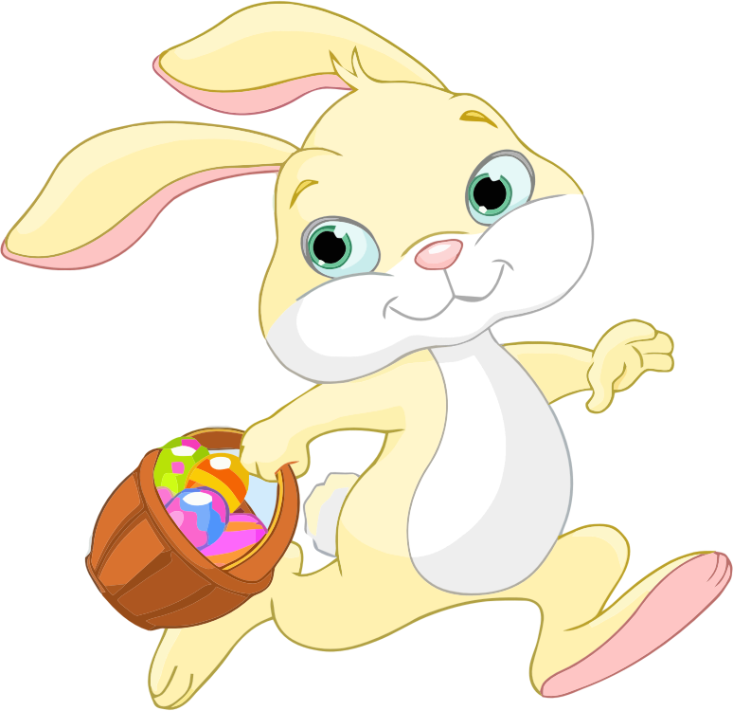 | 
Zubić vila | Zeko | Djed Božićnjak
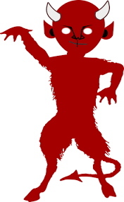 | 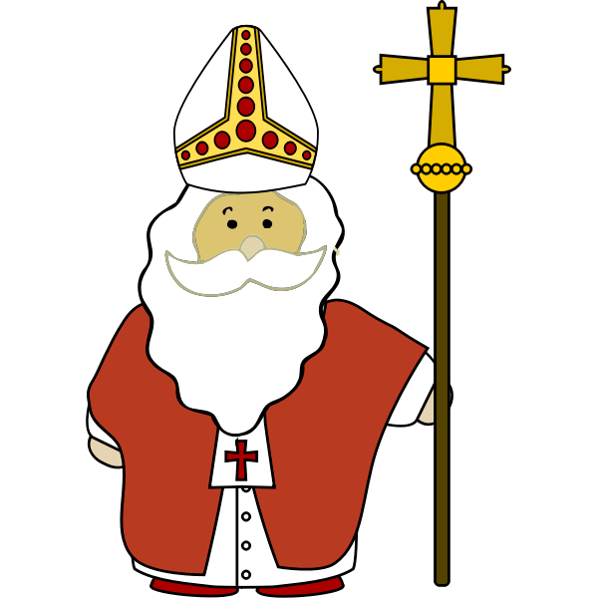
Krampus | sveti Nikola

[h5p id="445"]

5.1 Zadatak 9. Običaji
[h5p id="446"]

Images used in this document are from these sources.

