9 | 1 | Lekcija 4: Izgled i osobine

# 9.1 Zadatak 15. Harry Potter

|  |
| --- |

Let’s talk about the Harry Potter books and/or movies. Answer the following questions. If you did not read any of the books or watch any of the movies, think of another movie you have seen that was based on a book.

| 1 | Sviđaju li ti se knjige/filmovi o Harryju Potteru? |
| --- | --- |
| - |
| 2 | Koji film/knjiga ti je najdraži/-a? Zašto? |
| - |
| 3 | Kada je knjiga napisana i kada je film snimljen? |
| - |
| 4 | Koji ti je najdraži lik u knjizi / u filmu? (lik = character) |
| - |
| 5 | Koji lik ne voliš u knjizi / u filmu? |
| - |
| 6 | Kako izgleda tvoj najdraži lik u filmu? |
| - |

# 9.1 Zadatak 16. Najdraža knjiga

Tell us something about your favorite book and its author. Submit your video recording for others to watch. Your classmates will need to provide comments on your presentation – did they read the book, do they know the book, do they want to read it?

|  |  |
| --- | --- |
| **As a presenter,**  **answer the following questions:** | **As a listener,**  **answer the following questions:** |
| Koja je tvoja najdraža knjiga? | Znaš li koji je to autor/-ica? |
| Tko je napisao knjigu? | Jesi li pročitao/-la tu knjigu? |
| Kad je autor/autorica rođena? | Želiš li pročitati knjigu? Zašto? |
| Kada je on/-a napisao tvoju najdražu knjigu? |  |
| O čemu je knjiga? (o ljubavi, o ratu, o povijesti, o magiji, itd.) |  |
| Koji je tvoj najdraži lik u knjizi? Koje su karakteristike lika? |  |

# 9.1 Zadatak 17. Idealni prijatelj

Think of the personality traits that you cherish in your friends. What personality traits are you drawn to in people? What traits push you away from others? List at least five in each group. One example is given for you.

| Volim da su moji prijatelji: | Ne volim kad su ljudi: |
| --- | --- |
| dobri | arogantni |
|  |  |
|  |  |
|  |  |
|  |  |

# 9.1 Zadatak 18. Poznati ljudi

Come up with a list of six famous people. Say what they do, when they were born and at least one quality you associate with them. You will submit your recording online. You cannot use any of the people we covered in class.

|  |  |  |  |
| --- | --- | --- | --- |
|  | Tko? | Kada je rođen/-a? | Kakav/kakva je? |
| **1** |  |  |  |
| **2** |  |  |  |
| **3** |  |  |  |
| **4** |  |  |  |
| **5** |  |  |  |
| **6** |  |  |  |

# 9.1 Zadatak 19. Moji roditelji

🔊 Listen to the text about Luka's family. Pay close attention to the picture while listening to the text.

[(audio)](https://croatian.takolako.org/wp-content/uploads/U9_-M1-_L4.mp3)

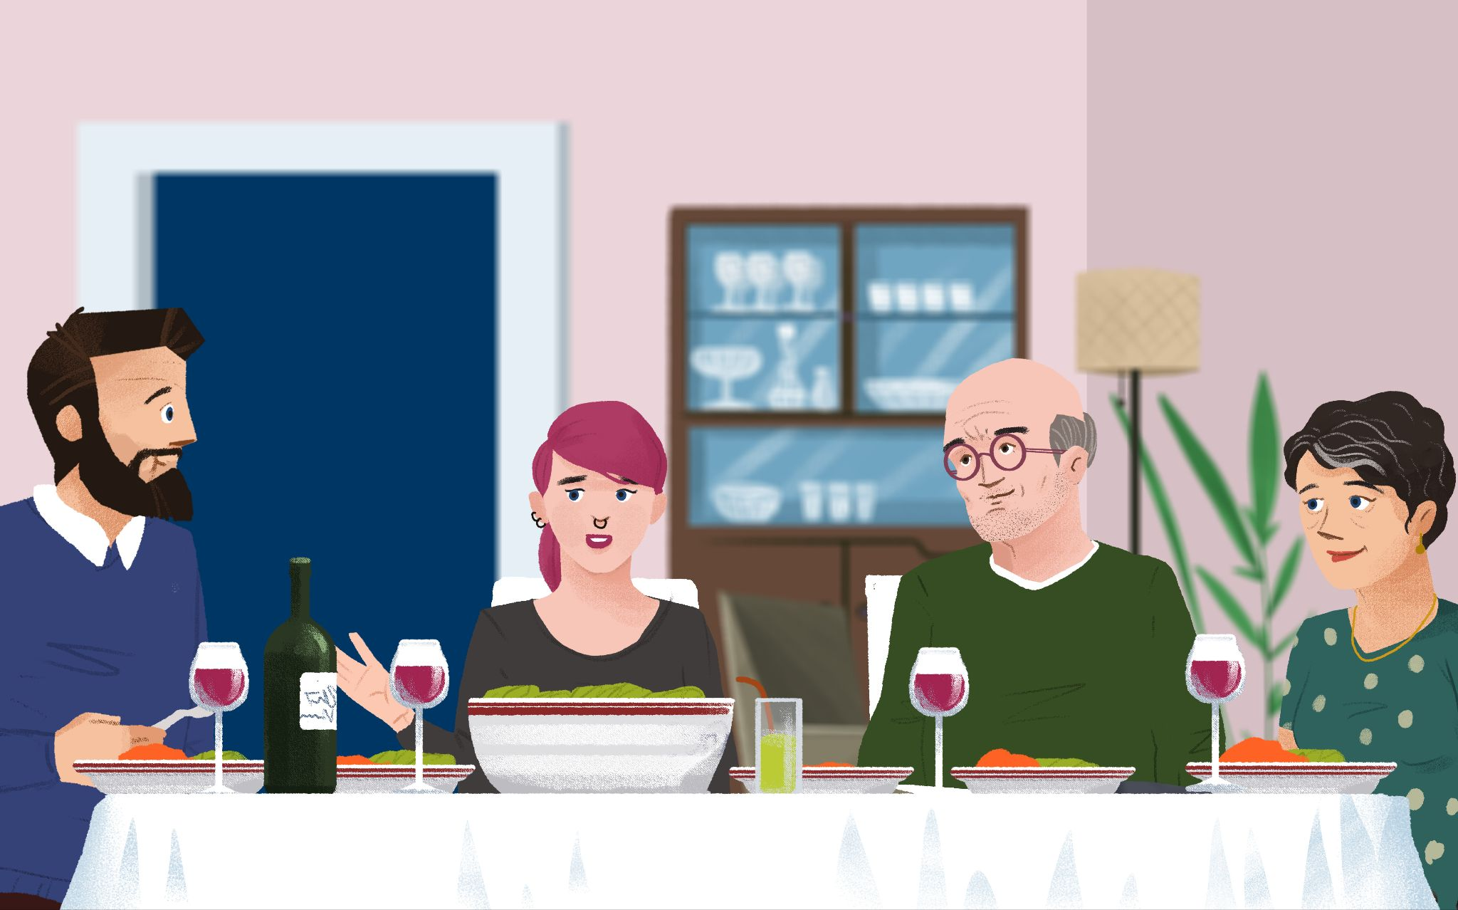

## | Razumijevanje

| 1 | Što je Lukina mama po zanimanju? |
| --- | --- |
| - |
| 2 | Što je Lukin tata po zanimanju? |
| - |
| 3 | Kada je Lukin tata rođen? (dan.mjesec.godina) |
| - |
| 4 | Kada je Lukina mama rođena? (dan.mjesec.godina) |
| - |
| 5 | Kako izgleda Lukina mama? |
| - |
| 6 | Kako izgleda Lukin tata? |
| - |
| 7 | Što je Luka rekao o svojoj mami? Je li ona vrijedna, dobra…? |
| - |
| 8 | Čime se Lukina mama bavi u slobodno vrijeme? Što je zanima? |
| - |
| 9 | Čime se Lukin tata bavi u slobodno vrijeme? Što ga zanima? |
| - |

## | Dodatne informacije

Look at the picture above to answer the following questions.

| 1 | Did Luka’s dad change his look over time? Kakav je njegov tata? |
| --- | --- |
| - |
| 2 | Did Luka’s mom change her look over time? Kakva je njegova mama? |
| - |
| 3 | Kako izgleda Lukina sestra? |
| - |

# 9.1 Zadatak 20. Pogodi tko je!

Let’s play the Guess Who game! Pick one person from the table to be your chosen character. Ask questions about the physical appearance of your partners’ character without using any personal names. By process of elimination you should guess the character your classmate picked. Meet with one of your classmates and play the game by using the images below.

While playing, do not use the gender of the person (on, ona) in your questions or answers. Use the following phrases instead: When asking a question – *Ima li osoba [plavu kosu]?* When answering the question – *Osoba nema/ima [plavu kosu]*. Submit your video online.

|  |  |  |  |  |
| --- | --- | --- | --- | --- |
| Darko | Lidija | Dragica | Marin | Jelena |
|  |  |  |  |  |
| Nina | Klara | Ante | Marko | Dragan |
|  |  |  |  |  |
| Ines | Sara | Stjepan | Toni | Josip |
|  |  |  |  |  |
| Ljubica | Danica | Irena | Marina | Mario |

Images used in this document are from [these sources](https://docs.google.com/document/d/1sVASsAUAsy4ciraTetW10yhO049RPcTvfTM8_b_BUVs/edit#heading=h.shfvwvk0v5f7).