1 | 3 | Lekcija 2: Moji prijatelji

1.3 Zadatak 6. Tko je ovo?

Part 1
Interview one of your classmates. Use the set of questions listed below. You will need to present one of your classmates to the rest of the class and say what you learned about them but without reading. Present only the most important/interesting facts that you found about your classmate.
pitanje: | odgovor:
Kako se zoveš? | ↦
Odakle si?
Jesi li ti student? Što studiraš?
Što voliš?
Kako se zovu tvoji roditelji?
Odakle su tvoji roditelji?
Što su po zanimanju?
Kakvi su tvoji roditelji?
Kako se zove tvoj dobar prijatelj?
Kakav je on?
Je li on student? Što on studira?
Kako se zove tvoja dobra prijateljica?
Kakva je ona?
Je li ona studentica? Što studira?
Koji je tvoj broj telefona?
Koja je tvoja adresa?

Part 2
2️⃣ While presenting about your classmate, you can take a look from time to time, but do not rely solely on your notes. While your classmates present on each other, listen carefully in order to find out who has similar interests as you. Your instructor will ask you to say who (as well: “također”) likes the same things as you.

1.3 Zadatak 7. Tko su oni?
Look at the following set of pictures. Take turns presenting each person. In your presentation you should include as much as possible about the person. Use language elements covered only in this Unit. You have enough for now to ask about their appearance, profession, nationality, etc.
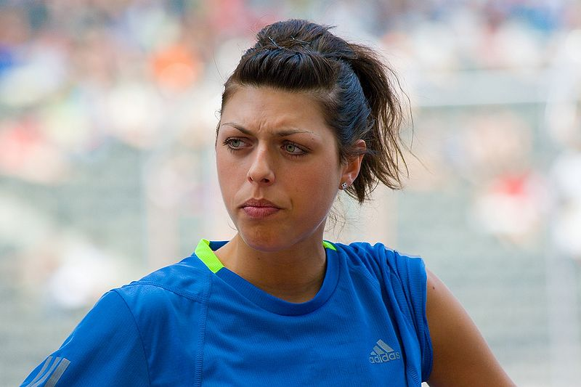 | 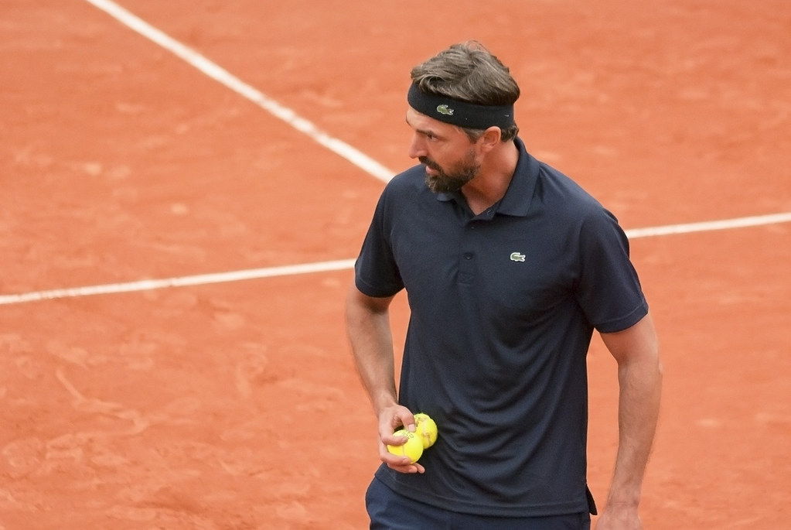 | 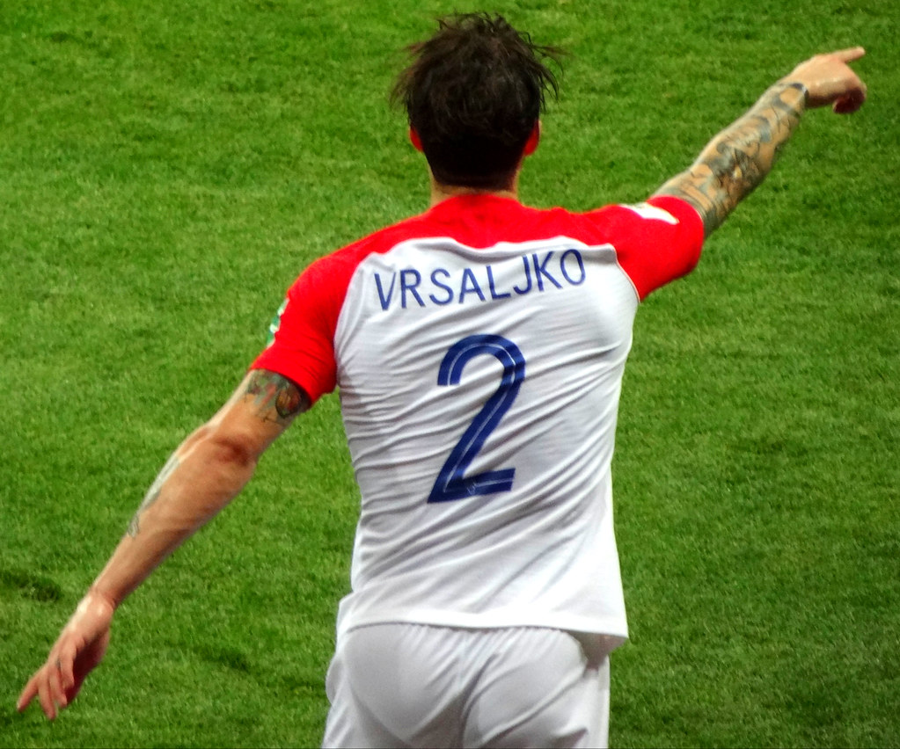
Blanka Vlašić | Goran Ivanišević | Šime Vrsaljko
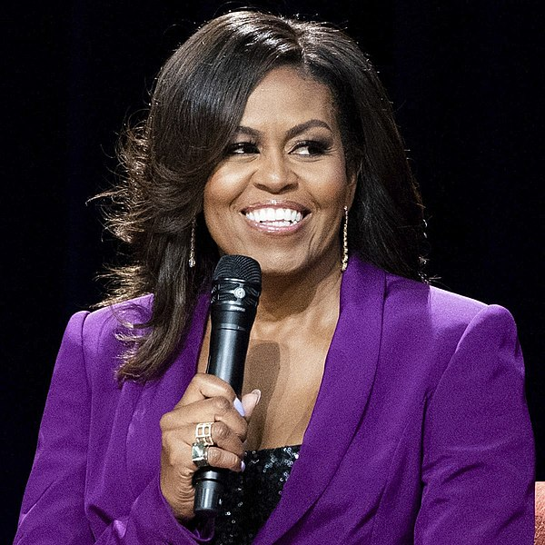 |  | 
Michelle Obama | Shakira | Matthew McConaughey

1.3 Zadatak 8. Moji prijatelji

Part 1
🔊Listen to the text and complete the chart with the appropriate information. Not all elements are present for each character. After you complete the assignment you will need to present one person from the story to your instructor.
ime: | profesija: | nacionalnost: | izgled*: | grad:
*izgled (physical appearance)

Part 2
Investigate the cities mentioned in the listening. Write a sentence or two about each city. What is your opinion, what does each city look like? Use words to describe a city that we used previously when we talked about Zagreb in Lesson 1.
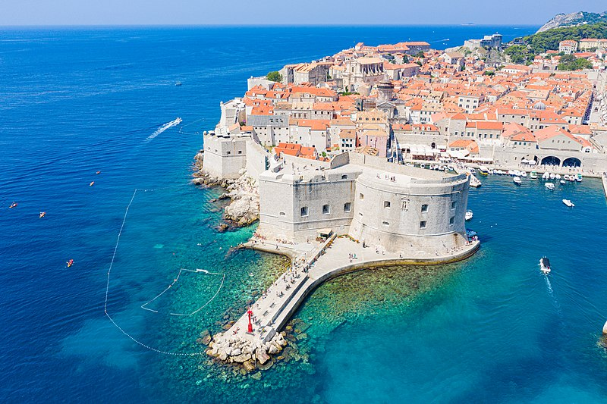 | Kako se zove grad?
 | [odgovor] →
 | Kakav je grad?
 | [odgovor] →

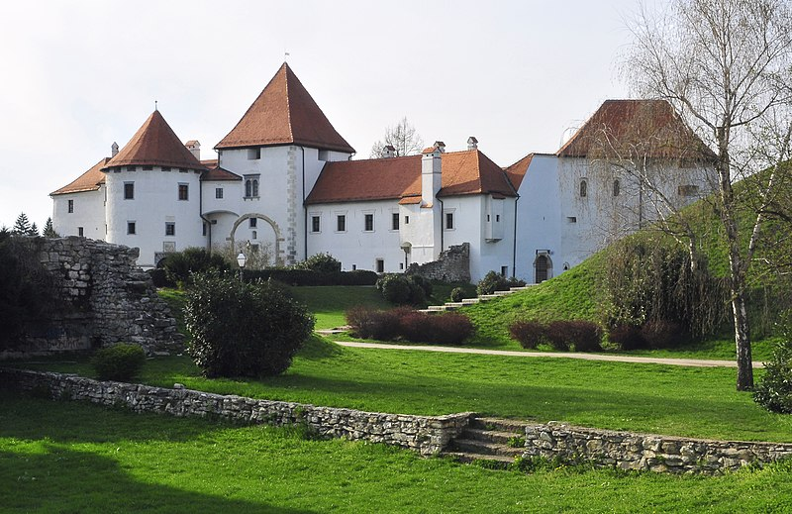 | Kako se zove grad?
 | [odgovor] →
 | Kakav je grad?
 | [odgovor] →

1.3 Zadatak 9. Reci nešto o sebi
 | 
👥 Rad u paru. Practice the following situations with your classmate by using as many language elements as possible. Choose one scenario and submit your recording. Potential scenarios (pay attention to the formality, depending on the situation).
 | A dialogue between two students who met for the very first time.
 | A dialogue between two colleagues who just started working together.
 | A dialogue between a new international student and a professor.
Images used in this document are from these sources.

