6.8 - things you liked - líbit se in the past tense

The verb líbit se forms its past tense like other verbs, i.e.

singular |  | plural
m | líbil se | ma | líbili se
f | líbila se | mi and f | líbily se
n | líbilo se | n | líbila se

The thing you have to remember is that the thing you like is the subject of your sentence. See the examples below:
  Tahle kniha se mi moc líbila. | 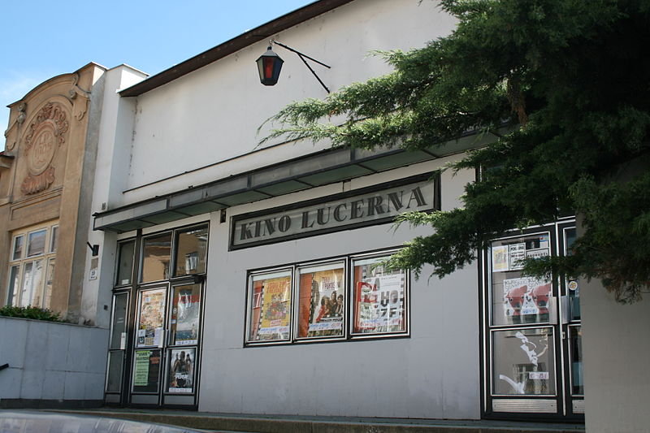  Hodně se nám líbil ten film.
Images used in this document come from these sources.

