8 | 2 | Lekcija 1: Moja košarica

| The Genitive case with IMATI and NEMATI
In Croatian, the verb imati can have the existential meaning (there is, there are) or the possessive meaning (to have). The same goes for the negative form nemati, the existential meaning (there isn’t, there aren’t) and the possessive meaning (not to have). Depending on whether the meaning is existential or possessive, the noun that follows it can be in the Accusative case or Genitive case. This is explained in the table below, what is both possible and not possible to say.
Croatian | existential meaning |  | possessive meaning
 | ima  there is, there are | nema  there isn’t, there aren’t | on ima  He has | on nema  He doesn't have
Accusative | – | – | ima kavu | nema kavu
Genitive | ima kave | nema kave | ima kave | nema kave

8.2 Zadatak 1. Ima ili nema?
Listen to the following sentences and indicate whether they express the existential meaning or possessive meaning.
[h5p id="819"]

| Numbers and Gender
In Croatian, only numbers jedan (one) and dva (two) change their gender based on the noun that they precede. The same rule applies to all numbers which end in 1 or 2, such as dvadeset jedan (twenty one), trideset dva (thirty two) and so on. The numbers jedanaest (eleven) and dvanaest (twelve) are not exceptions. The digits end with 1 and 2 when written down (11, 12), but since the words themselves do NOT end with jedan or dva, these words don't change! All other numbers stay the same, regardless of the gender of the noun.
broj | masculine | feminine | neuter
1 [jedan] | jedan sir | jedna jabuka | jedno mlijeko
2 [dva] | dva sira | dvije jabuke | dva mlijeka

| Numbers and Case
Numbers one and two change their forms based on the case we need to use. Both numbers use the same ending as adjectives. For now, we are only focusing on numbers one and two when talking about quantity. What case should we use when talking about how much of something we have? Look at the explanations below.

| Accusative Case With Number 1
When talking about quantity (i.e., how much of something we have) and referring to number one, we need to use the Accusative case. Look at the following example.
gender: | Croatian | English
masculine | Imam samo jedan kolač za tebe. | I only have one cake left for you.
feminine | Moran u kupnju. Imam još samo jednu jabuku. | I have to go shopping. I only have two apples left.
neuter | Imam samo jedno vrhnje. Moram u trgovinu. | I only have one cream left. I need to go shopping.

As you can see, the masculine form does not change its endings because it refers to an inanimate noun. The feminine form changes its endings based on the general rule for feminine nouns in the Accusative case. The neuter gender does not change its form because that is the general rule for neuter nouns in the Accusative case.

| Genitive Case With Numbers
The numbers 2, 3 and 4 require the use of Genitive singular. This rule also includes any words for numbers that end in dva, tri, četiri – such as 22, 23, 24, 132, 243, 254, etc.
gender: | Croatian | English
masculine | Imam dva pudinga za tebe. | I have two puddings for you.
feminine | Hoćeš li dvije jabuke? | Do you want these two apples?
neuter | Ova dva mlijeka nisu dobra. | These two milks are not good.

The numbers 5 and onward require the use of genitive plural.
gender: | Croatian | English
masculine | Imam pet jogurta u hladnjaku. | I have five yogurts in the fridge.
feminine | Imam pet banana u košari. | I have five bananas in my basket.
neuter | Ovih pet mlijeka je za nas. | These five milks are for us.

8.2 Zadatak 2. Koliko?
You will hear a number of sentences giving a certain quantity. Listen to the start of the expression and pick the correct form of the feminine noun that appropriately finishes the sentence.
[h5p id="820"]

| Few Exceptions in the Genitive Plural
Some words like cent (cent), mjesec (month) or sat (hour) in Genitive plural end in -i:
cent |  | 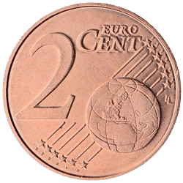 | 
 | jedan cent | dva centa | pet centi
mjesec (month) | 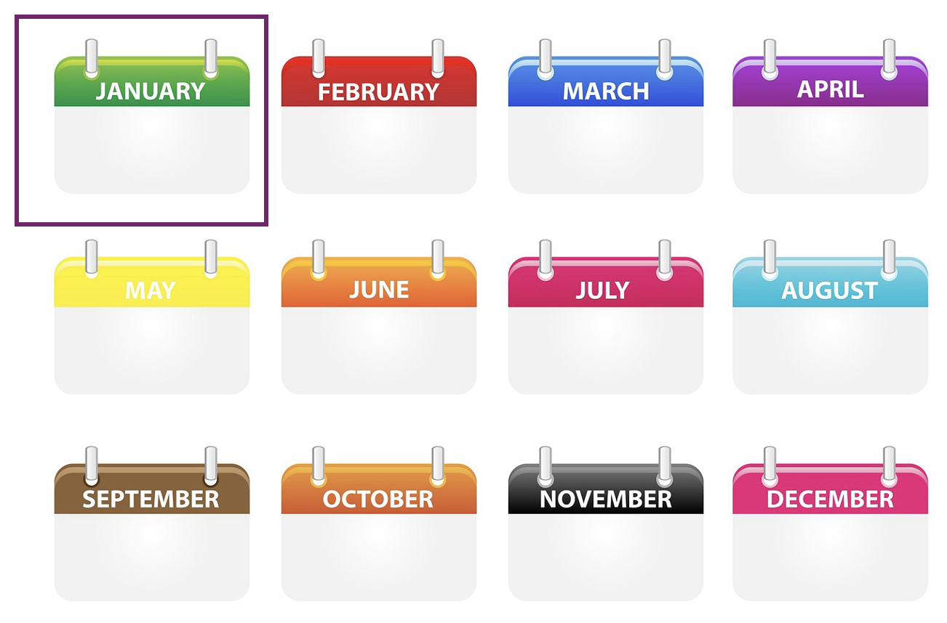 | 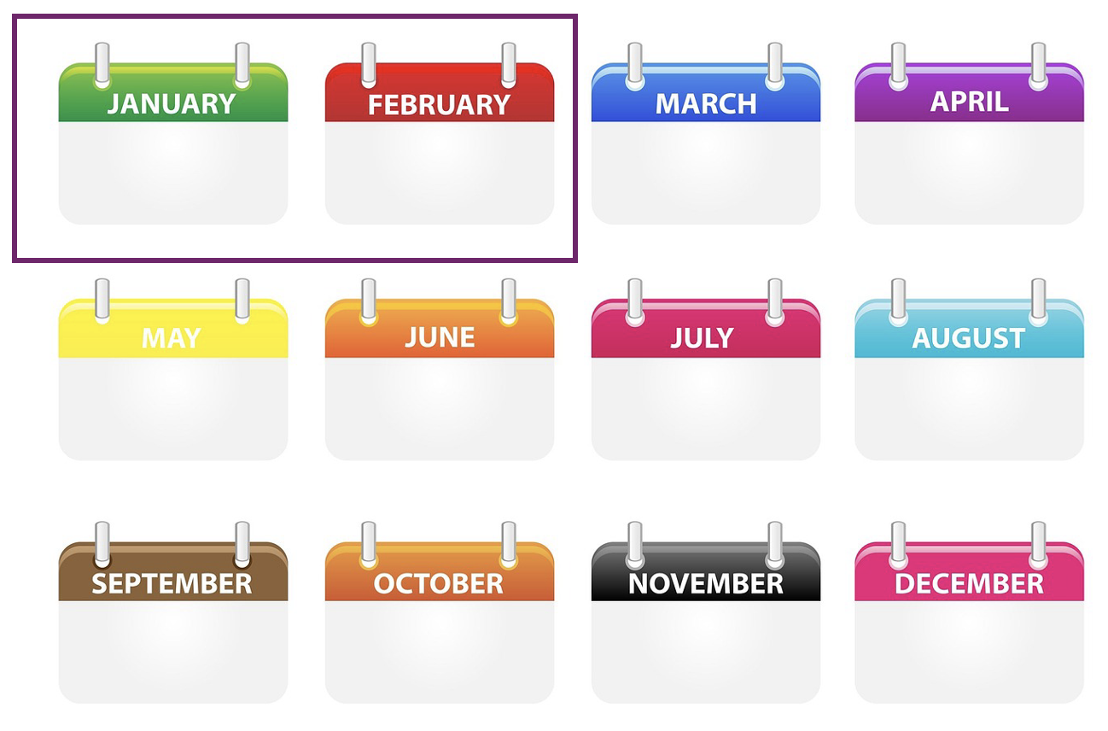 | 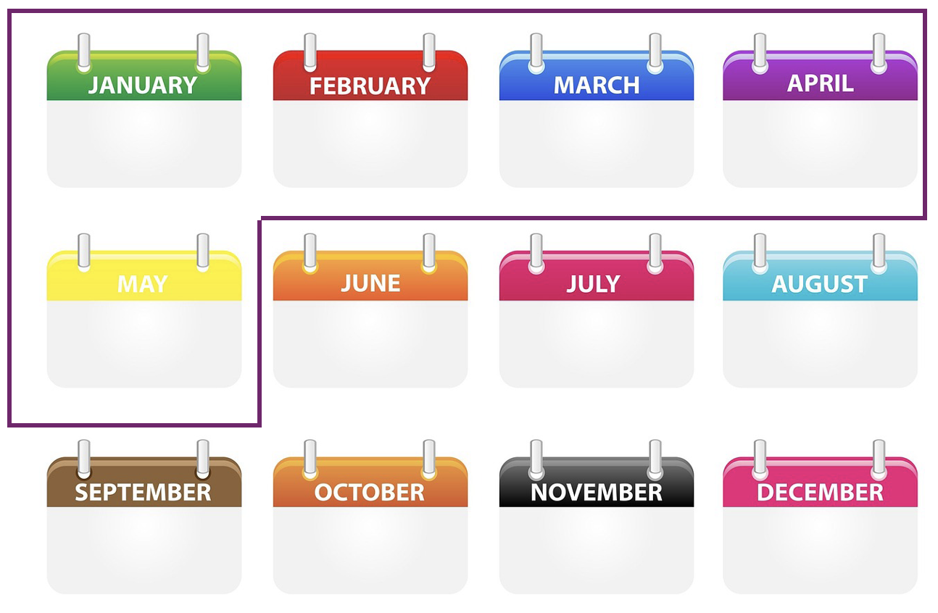
 | jedan mjesec | dva mjeseca | pet mjeseci
sat (hour) |  |  | 
 | jedan sat | dva sata | pet sati

* There are other nouns that in Genitive plural end in -i, but you will learn them as you encounter them throughout the semester.

8.2 Zadatak 3. Koliko?
You will hear a number of sentences giving a certain number. Listen to the start of the expression and pick the correct form of cent–mjesec–sat that appropriately finishes the sentence.
[h5p id="821"]

Images used in this document are from these sources.

